**Capstone Project Report**

**Report 6 – Software User Guides**

– Ho Chi Minh, September 2024 –

**I. Record of Changes** 6

**II. Release Package & User Guides** 6

1. Deliverable Package 6

2. Installation Guides 7

2.1. System Requirements 7

2.2. Installation Instruction 7

2.2.1. Environment Setup 7

2.2.1.1. Mobile Application Development 7

2.2.1.2. Web application 8

2.2.1.3. Back-end Server 8

2.2.1.3.1. Install Intellij 8

2.2.1.3.2. Install Environment 9

2.2.1.3.3 Simulation Student Data Server 9

2.2.1.3.4. SCSS Server 14

2.2.1.3.5. Run Server 20

3. User Manual 23

3.1. Overview 23

3.2. Web Application 23

3.2.1. Authentication 23

3.2.1.1. Login 23

3.2.1.1.1. Description 23

3.2.1.2. Reset Password 24

3.2.1.3. Edit Password 25

3.2.2. Booking counseling appointment 27

3.2.2.1. Quick booking a counselor 27

3.2.2.1.1. Description 27

3.2.2.2. Booking a specific counselor 30

3.2.2.2.1. Description 30

3.2.2.3. Approve an appointment request 34

3.2.2.3.1. Description 34

3.2.2.4. Deny an appointment request 36

3.2.2.4.1. Description 36

3.2.2.5. Take Attendance for Appointment 39

3.2.2.5.1. Description 39

3.2.2.5.1. Guide Steps: 39

3.2.2.6. Give Feedback for Appointment 42

3.2.2.6.1. Description 42

3.2.2.6.2. Guide Steps: 42

3.2.2.7. Create report for an appointment 45

3.2.2.7.1. Description 45

3.2.2.7.2. Guide Steps: 45

3.2.2.8. Cancel an appointment 48

3.2.2.8.1. Description 48

3.2.2.8.2. Guide Steps: 48

3.2.2.9. View counseling schedule 51

3.2.2.9.1. Description 51

3.2.2.9.2. Guide Steps: 51

3.2.3. Question and answer 55

3.2.3.1. Ask a question 55

3.2.3.1.1 Description 55

3.2.3.1.2. Guide Steps: 55

3.2.3.2. Edit a question 58

3.2.3.1.1 Description 58

3.2.3.1.2. Guide Steps: 58

3.2.3.3. Answer a question 60

3.2.3.3.1 Description 60

3.2.3.3.2. Guide Steps: 60

3.2.3.4. Edit your answer 62

3.2.3.5. Chat about a question 64

3.2.3.6. Close a question 67

3.2.3.7. Contribute to FAQ 69

3.2.3.8. Edit contributed FAQ 72

3.2.3.9. Reject a question 75

3.2.3.10. Flag a question 78

3.2.4. Counseling demand 81

3.2.4.1. Create counseling demand 81

3.2.4.2. Create an appointment from demand 85

3.2.4.3. Solve a counseling demand 87

3.2.5. Counselor Management 90

3.2.5.1. Update counselor availability 90

3.2.5.2. Update counselor weekly schedule 94

3.2.5.3. Update counselor date range 97

3.2.5.4. View analytics 100

3.2.5.5. View analytics 101

3.2.6. Account Management 103

3.2.6.1. Create non-academic/academic counselor account 103

3.2.6.2. Create manager/support staff account 110

3.2.6.3. Update account 114

3.2.6.4. Block/Unblock accounts 117

3.2.7. Resource Management 120

3.2.7.1. Create problem tag 120

3.2.7.2. Create problem tag’s category 124

3.2.7.3. Create counseling time slot 127

3.2.7.4. Remove problem tag’s category 130

3.2.7.5. Remove problem tag 134

3.2.7.6. Remove counseling time slot 138

3.2.7.7. Update problem tag 142

3.2.7.8. Update problem tag’s category 146

3.2.7.9. Update counseling time slot 150

3.2.7.10. View academic information 154

3.2.8. Question Management 156

3.2.8.1. Update public question’s public status. 156

3.2.8.2. Update frequently asked question’s visibility status. 159

3.2.8.3. Create frequently asked question’s category. 163

3.2.8.4. Update frequently asked question’s category. 166

3.2.8.5. Remove frequently asked question’s category. 170

3.2.9. Analytics View 174

3.2.9.1. View analytics 174

3.2.9.2. View overview 175

3.3. Mobile Application 177

3.3.1. Authentication 177

3.3.1.1. Login 177

3.3.1.2. Reset Password 179

3.3.1.3. Edit Password 182

3.3.2. Booking counseling appointment 185

3.3.2.1. Quick booking a counselor 185

3.3.2.2. Booking a specific counselor 192

3.3.2.3. Approve Appointment Request 201

3.3.2.4. Deny Appointment Request 210

3.3.2.5. Take Attendance for Appointment 217

3.3.2.6. Write Feedback for Appointment 224

3.3.2.7. Write Report for Appointment 232

3.3.2.8. Cancel Appointment 242

3.3.3. Question and Answer 258

3.3.3.1. Create a question 258

3.3.3.2. Edit a question 267

3.3.3.3. Delete a question 271

3.3.3.4. Answer a question 274

3.3.3.5. Edit Answer of a question 281

3.3.3.6. Create a chat session 284

3.3.3.7. Accept a question’s answer 288

3.3.3.8. Close a question 291

3.3.3.9. Create a contribution question 300

3.3.3.10. Edit a contribution question 307

3.3.3.11. Delete a contribution question 311

3.3.4. Counseling Demands 314

3.3.4.1. View Demands List 314

3.3.4.2. Create Appointment through Demand 319

3.3.4.3. Solve Demand 322

# **I. Record of Changes**

|  |  |  |  |
| --- | --- | --- | --- |
| Date | A*  M, D | In charge | Change Description |
| 10/11/2024 | A | Đoàn Tiến Phát | Initialize document |
| 15/11/2024 | A | Phạm Trần Sơn Nguyên | Added content:   * Deliverable Package * Installation Guides   User Manual |
| 20/11/2024 | M | Trình Vĩnh Phát | Modified Installation Guides |
| 25/11/2024 | M | Vũ Ngọc Hải Đăng | Modified Installation Guides |
| 01/12/2024 | M | Nguyễn An Khánh | Modified User Manual |

*A - Added M - Modified D - Deleted

# **II. Release Package & User Guides**

## 1. Deliverable Package

|  |  |  |
| --- | --- | --- |
| **No.** | **Deliverable Item** | **Description** |
| 1 | Source Codes | Web: [Frontend.zip](https://drive.google.com/file/d/178jBcB9dLVSknZ2j1u8xB83JxwOjFmVe/view?usp=drive_link)  Backend:  [SCSS_Backend_Server.zip](https://drive.google.com/file/d/1V9xV3sul-VEdIiW40CK-hwJinptc9IGP/view?usp=sharing)  [Simulation_Student_Data_Server.zip](https://drive.google.com/file/d/1o1P7m7w44_Hj8V1AY7rd5Ld8CTnkFo1r/view?usp=drive_link)  Mobile: |
| 2 | Database Script(s) | [SCSS.sql](https://drive.google.com/file/d/1V9xV3sul-VEdIiW40CK-hwJinptc9IGP/view?usp=sharing)  [Simulation_Student_Data_Server_Server_Database_Script.sql](https://drive.google.com/file/d/1-DJ_OU0kC2FI0kfJqOzGbt8YK9WFV4cW/view?usp=drive_link) |
| 3 | Final Report Document | A document file that summarizes the project information. |
| 4 | Test Cases Document | [GFA24SE27-Test-Report](https://docs.google.com/spreadsheets/d/1hvsthMjcUTw9Bgdl9XRwjIgiAAiwfSyVjGNcgt06Gzo/edit?usp=sharing) |
| 5 | Slide | [FA24SE111_HuynhCongVietNgu_LeVoMinhThu_Slide](https://drive.google.com/file/d/1usW1x0fpabSQRJP_Xi3FOqWWknwBBsNV/view?usp=drive_link) |

## 

## 2. Installation Guides

### 2.1. System Requirements

|  |  |  |
| --- | --- | --- |
| **Componet** | **Minimum** | **Recommended** |
| CPU | At least 2 (GHz) x64-bit | Core i5 or i7 |
| Memory | At least 4GB RAM | At least 6GB RAM |
| Storage | 10GB HDD | 20GB HDD |
| Network | Internet Connection | Internet Connection |

### 2.2. Installation Instruction

#### 2.2.1. Environment Setup

##### 2.2.1.1. Mobile Application Development

Step1: Download Visual Studio Code:

* Go to the [Visual Studio Code download page](https://code.visualstudio.com/download).
* Download the latest stable version of Visual Studio Code (version 1.95 or newer).

Step2: Install Visual Studio Code:

* Follow the on-screen instructions to install Visual Studio Code on your machine.

Step 3: Setup for React Native Development:

* Open Visual Studio Code after installation.
* Install the **React Native CLI** if you haven't already by opening a terminal and running:  
  Npx create-expo-app scss-mobile
* Install **Node.js** (required for React Native) from [Node.js website](https://nodejs.org/).

Step 4: Install Required Extensions in Visual Studio Code:

* Open Visual Studio Code.
* Go to the **Extensions** view by clicking on the Extensions icon in the Activity Bar.
* Search for and install the **React Native Tools** extension to enhance support for React Native development.

##### 2.2.1.2. Web application

Step 1: Install Visual Studio Code:

* Download the [Visual Studio Code setup file.](https://code.visualstudio.com/Download)
* After the download is complete, run the VSCodeUserSetup.exe file.
* Click Next to proceed with the installation. Then, agree to the terms of use.
* Choose the installation location (it's recommended to keep the default) and click Next.
* In the subsequent steps, continue clicking Next until the installation is complete.

Step 2: Install npm through Visual Studio Code or you can install npm via NodeJS: [Link.](https://nodejs.org/en/)

##### 2.2.1.3. Back-end Server

###### 2.2.1.3.1. Install Intellij

Step 1: Go to the JetBrains Website

1. Open your web browser and navigate to the JetBrains IntelliJ IDEA homepage at<https://www.jetbrains.com/idea/>.

Step 2: Choose the IntelliJ IDEA Edition

1. On the IntelliJ IDEA homepage, click the Download button.
2. You’ll see two editions:
   * Ultimate: A paid edition with full features for professional development.
   * Community: A free edition suitable for learning and open-source projects.
3. Select the edition that fits your needs, then click Download.

Step 3: Download IntelliJ IDEA for Your Operating System

1. The download page will detect your operating system (Windows, macOS, or Linux) automatically.
2. Click the Download button for your operating system.

Step 4: Run the Installation File

1. Once the download completes, open the installation file (.exe on Windows, .dmg on macOS, or .tar.gz on Linux).
2. On Windows:
   * Double-click the .exe file and follow the installation instructions.
3. On macOS:
   * Open the .dmg file, then drag and drop the IntelliJ IDEA icon into the Applications folder.
4. On Linux:
   * Extract the .tar.gz file and move the folder to a suitable location. You can add an alias or shortcut to open IntelliJ from the terminal.

Step 5: Launch IntelliJ IDEA and Initial Setup

1. Open IntelliJ IDEA for the first time.
2. Choose Do not import settings if this is your first installation.
3. IntelliJ will prompt you to configure initial settings such as theme (Light or Dark), plugins, and other options. Choose your preferred settings.
4. Once done, click Start using IntelliJ IDEA to begin.

###### 2.2.1.3.2. Install Environment

Step 1: Install Java 21 or Higher

1. Download Java: Visit the [Oracle JDK](https://www.oracle.com/java/technologies/downloads/) or [OpenJDK](https://openjdk.org/) website and download Java 21 or higher.
2. Install:
   * Windows/macOS: Follow the installer’s instructions.
   * Linux: Use a package manager (e.g., sudo apt install openjdk-21-jdk on Ubuntu).
3. Set JAVA_HOME Environment Variable (if needed): Point JAVA_HOME to your Java installation path.
4. Verify: Run java -version to ensure Java is correctly installed.

Step 2: Install Maven 3.9.8 or Higher

1. Download Maven: Go to the [Maven download page](https://maven.apache.org/download.cgi) and download version 3.9.8 or higher.
2. Install:
   * Windows/macOS: Extract and move the folder to a suitable location (e.g., C:\Program Files\Apache\Maven).
   * Linux: Extract and move to a system directory (e.g., /usr/local/apache-maven).
3. Add to PATH: Ensure the Maven bin directory is in your PATH.
4. Verify: Run mvn -version to check the Maven installation.

Step 3: Install Git

1. Download and Install Git: Go to [Git’s official website](https://git-scm.com/downloads) and download the appropriate version for your OS.
2. Clone the Project: Run the following command in your terminal or command prompt:  
   git clone <project-repo-url>

###### 2.2.1.3.3 Simulation Student Data Server

Step 1: Clone source code from github

1. Access source code online through link: <https://github.com/Capstone-FA24SE111-GFA24SE27/scss-student-data-API-server>
2. Copy source code URL 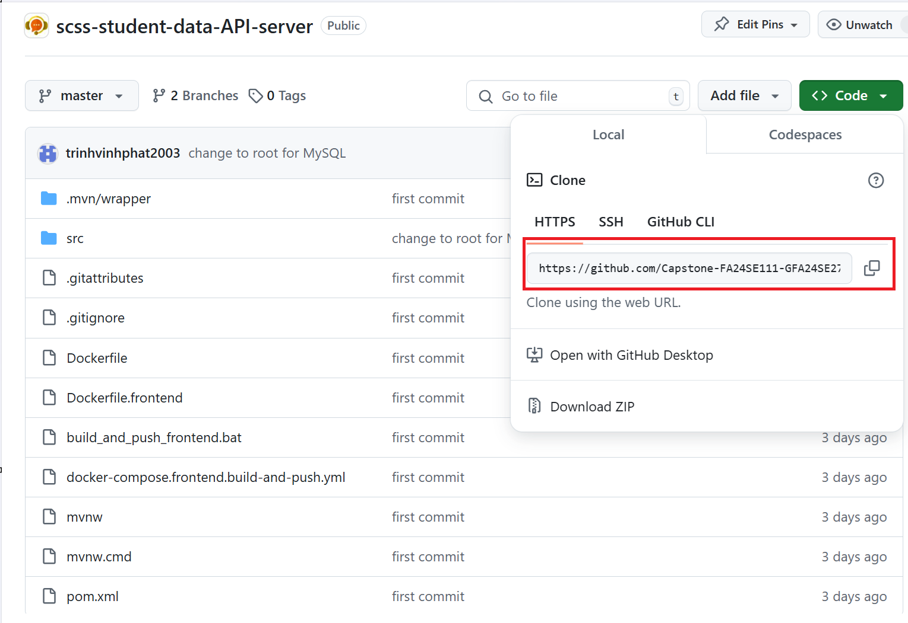
3. Open terminal and run 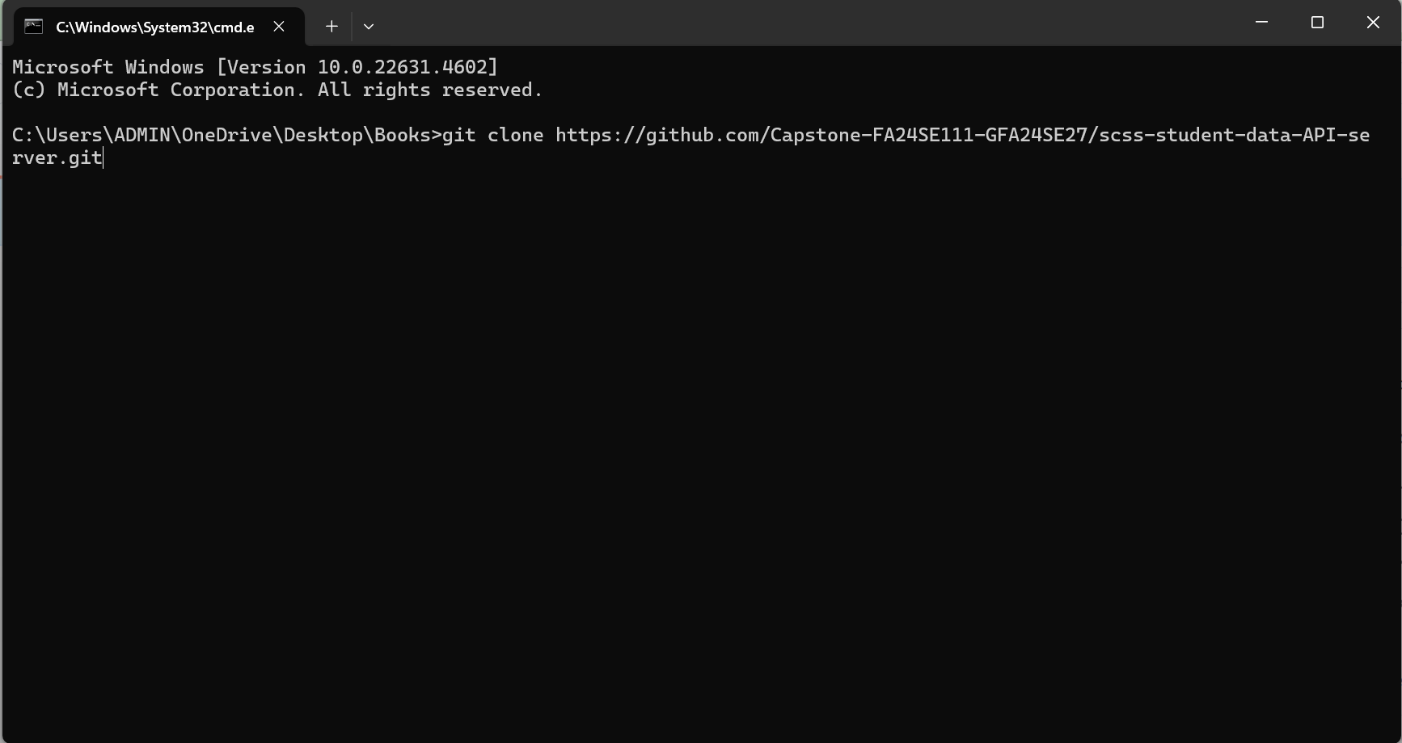
4. After clone project, you will get folder with source code 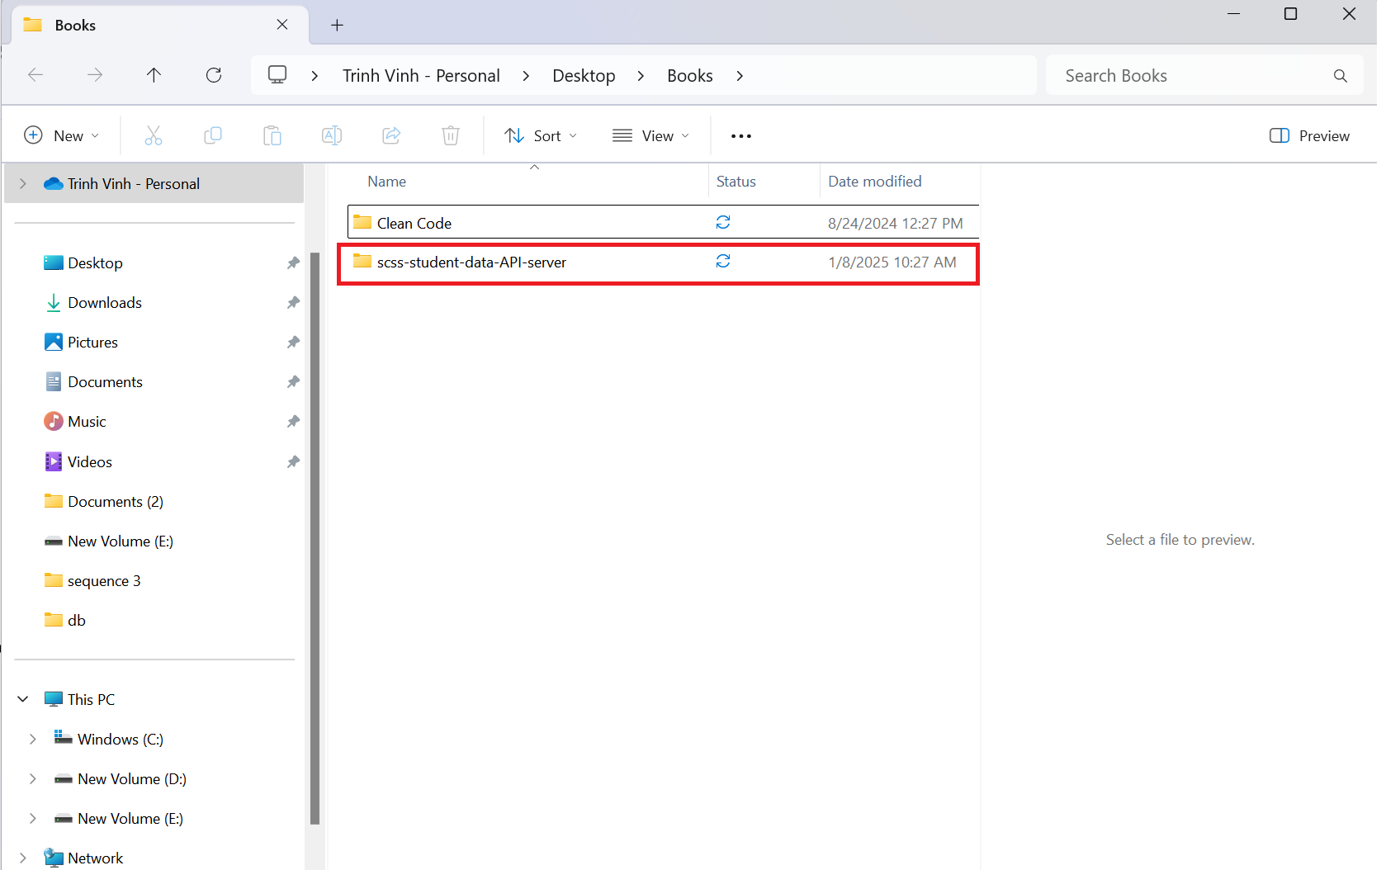

Step 2: Open source code with coding editor

1. Open intellj, click file -> open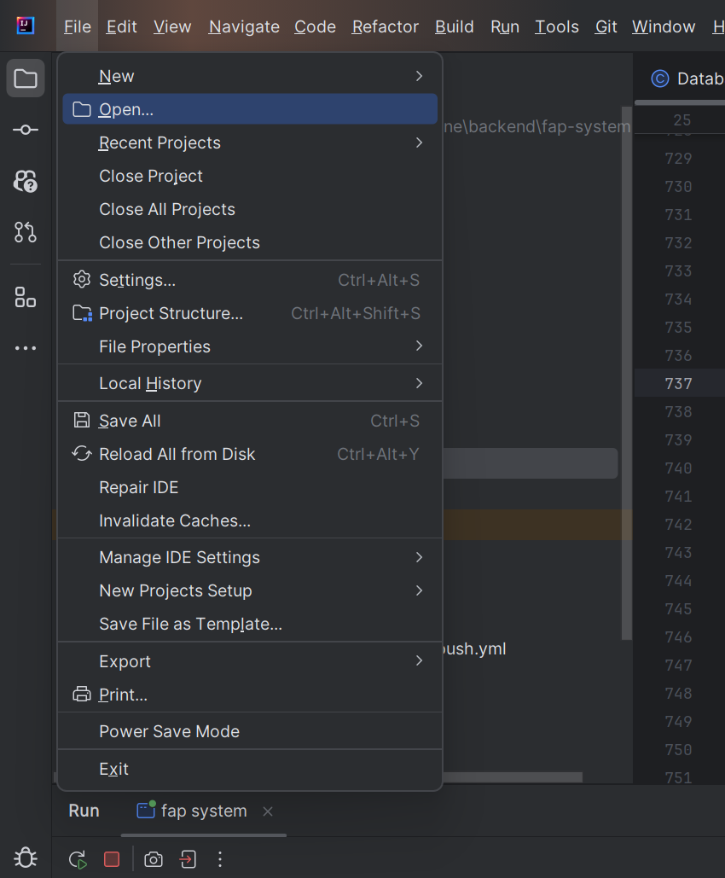
2. Select folder containing source code and click OK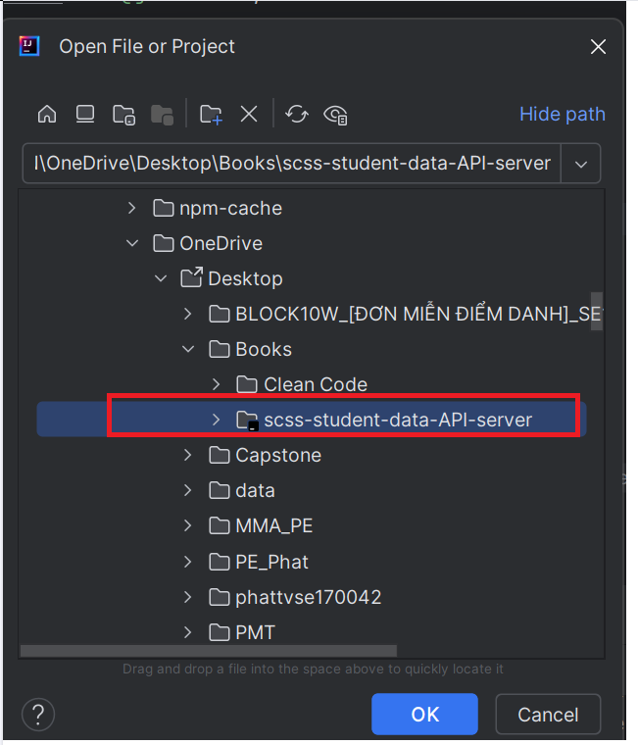
3. Folder will be opened in intellj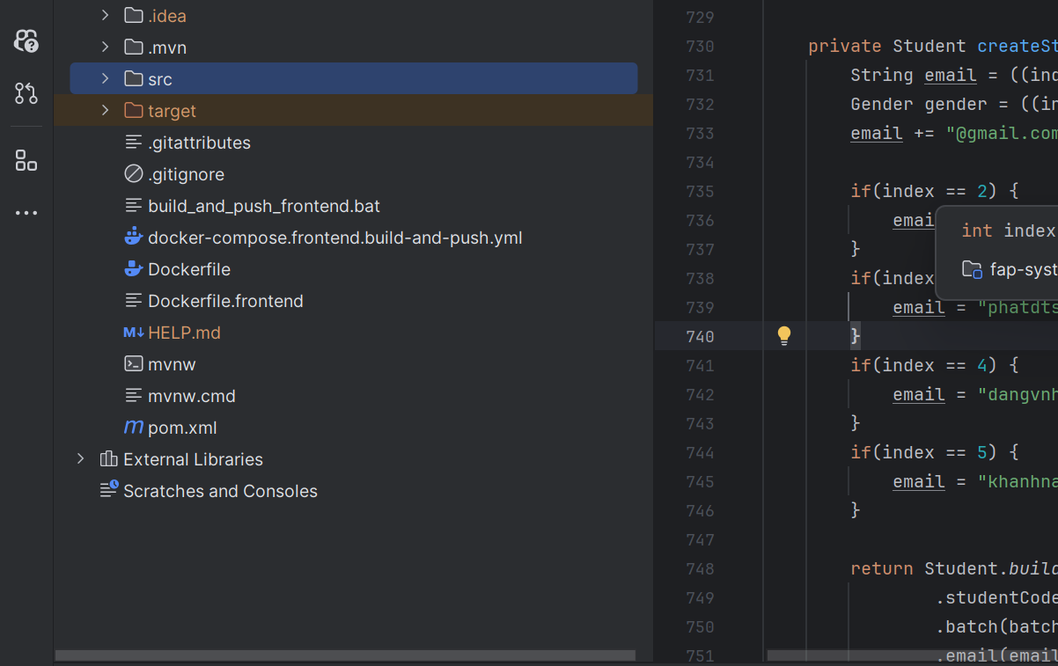

###### 2.2.1.3.4. SCSS Server

Step 1: Clone source code from github

1. Access source code online through link: <https://github.com/Capstone-FA24SE111-GFA24SE27/scss-backend>
2. Copy source code URL 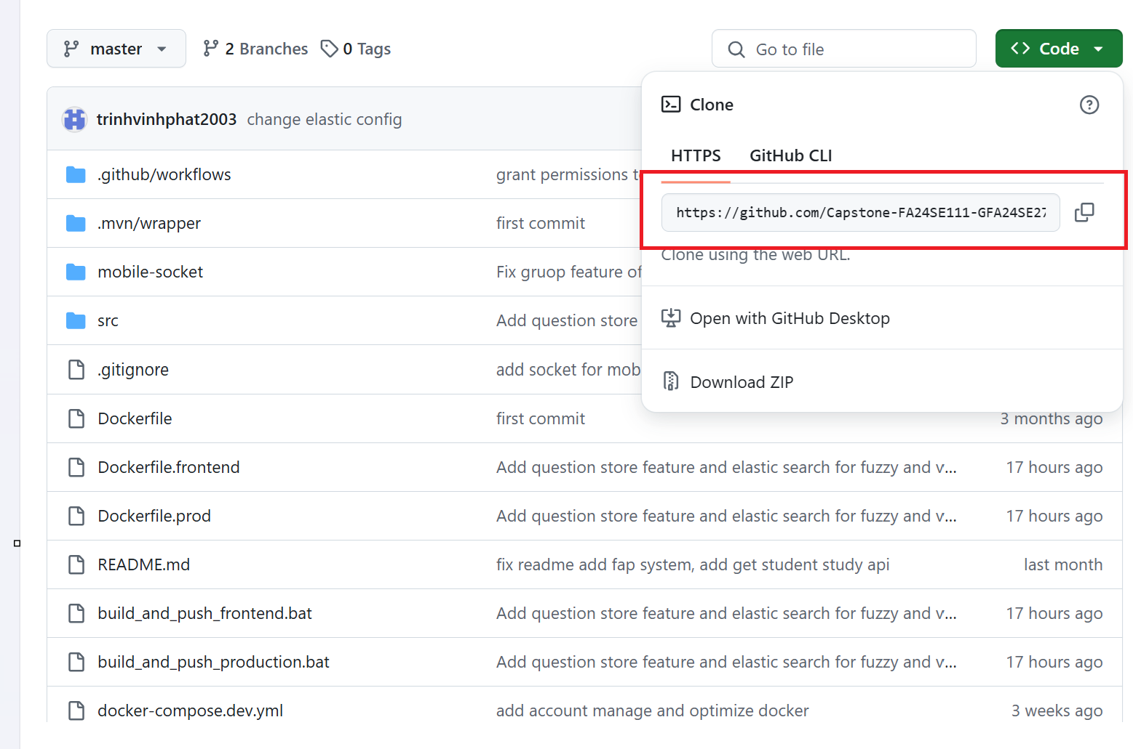
3. Open terminal and run 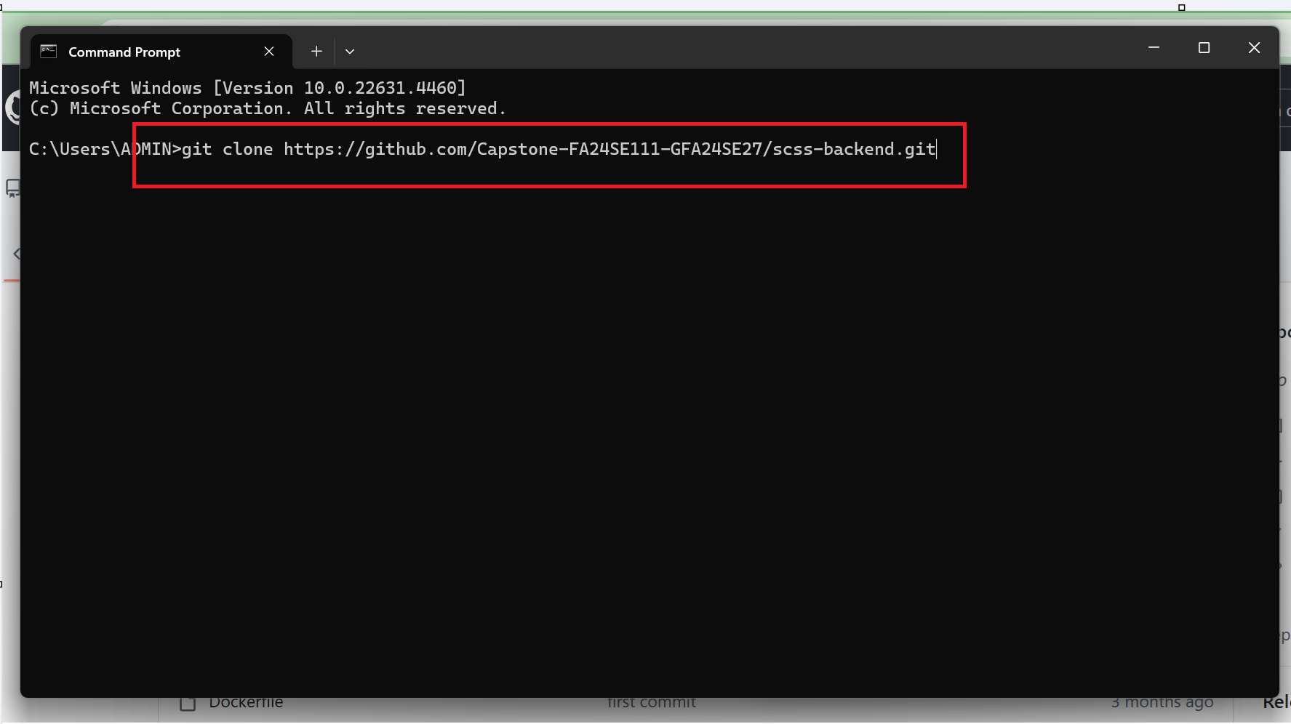
4. After clone project, you will get folder with source code 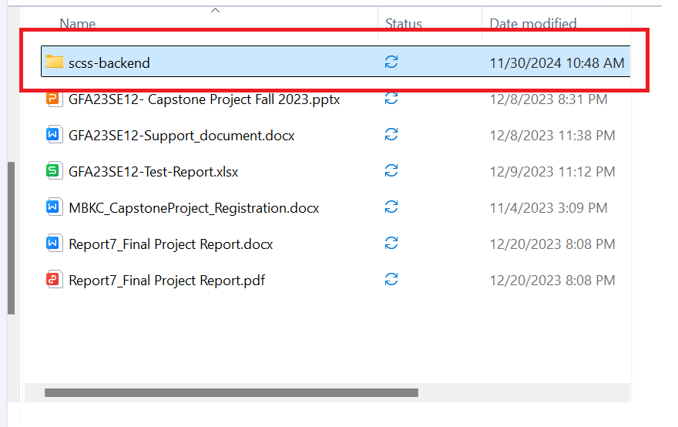

Step 2: Set up service using by system

1. Open Docker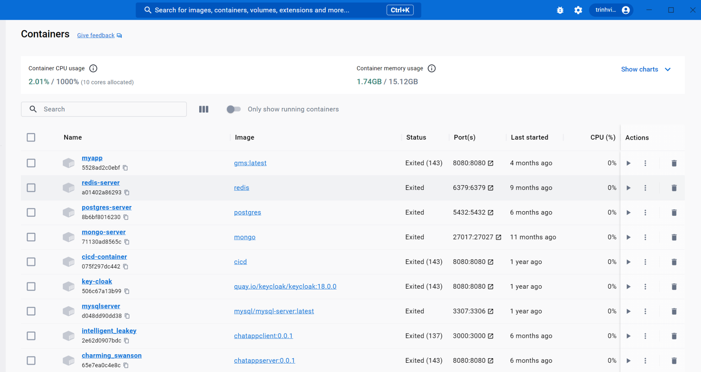
2. Run CMD command at root of project 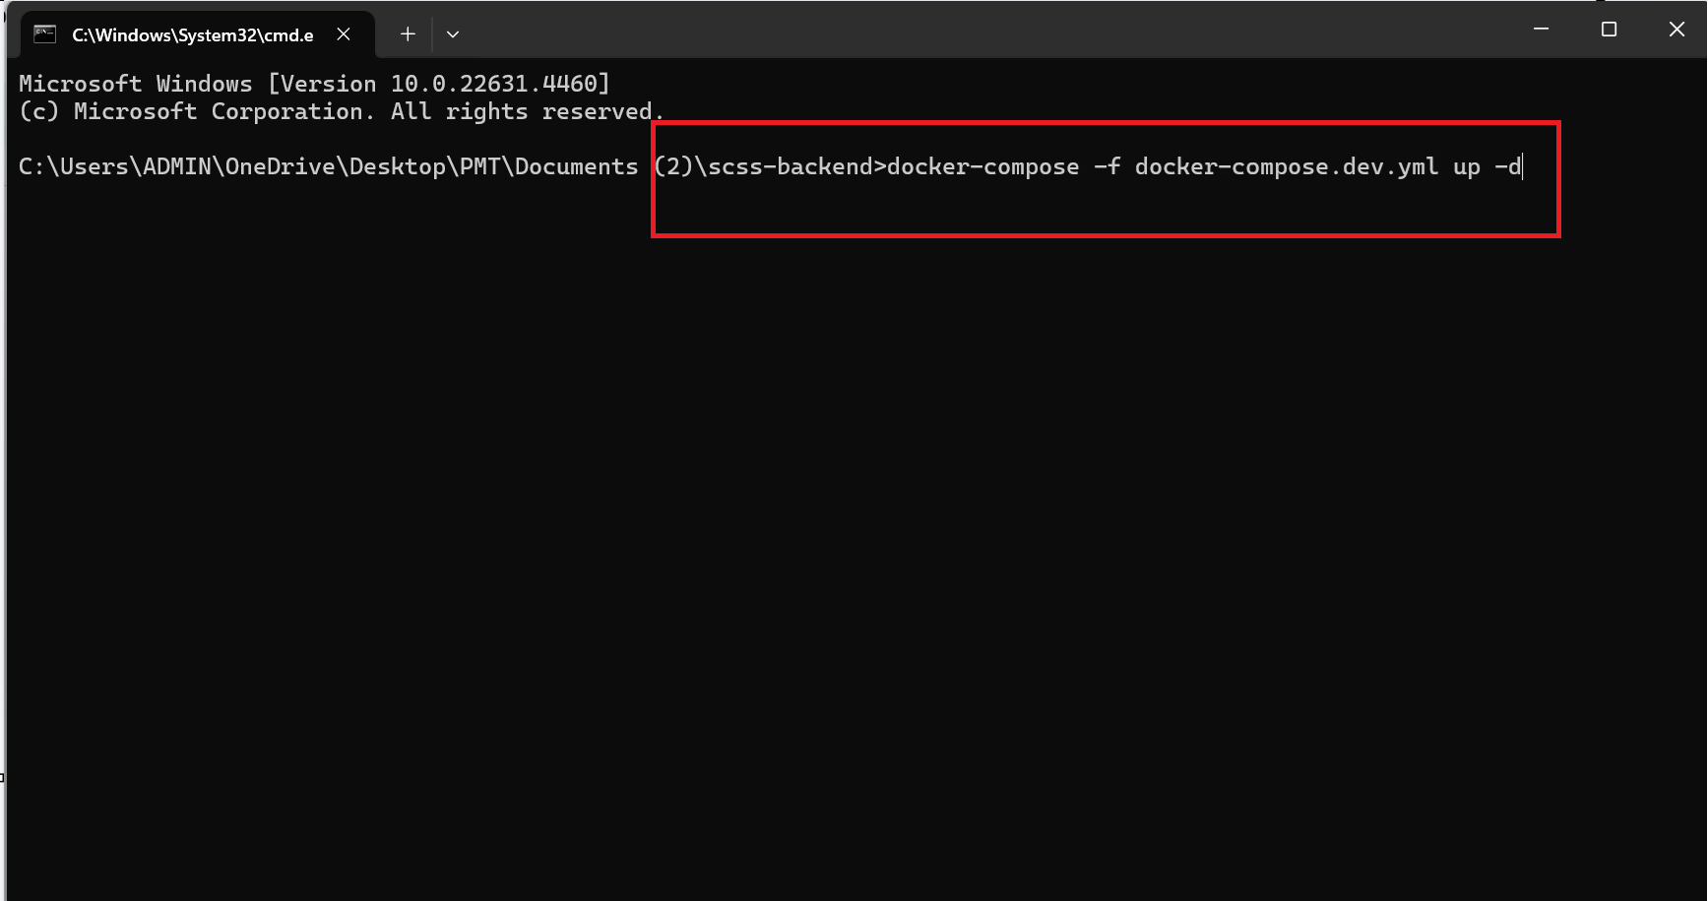
3. After waiting for service to up, some necessary container will up 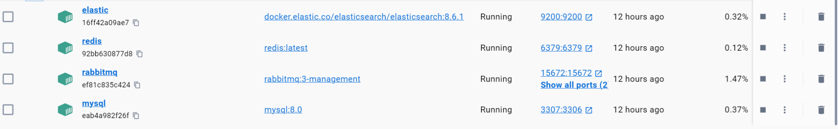

Step 3: Open source code with coding editor

1. Open intellj, click file -> open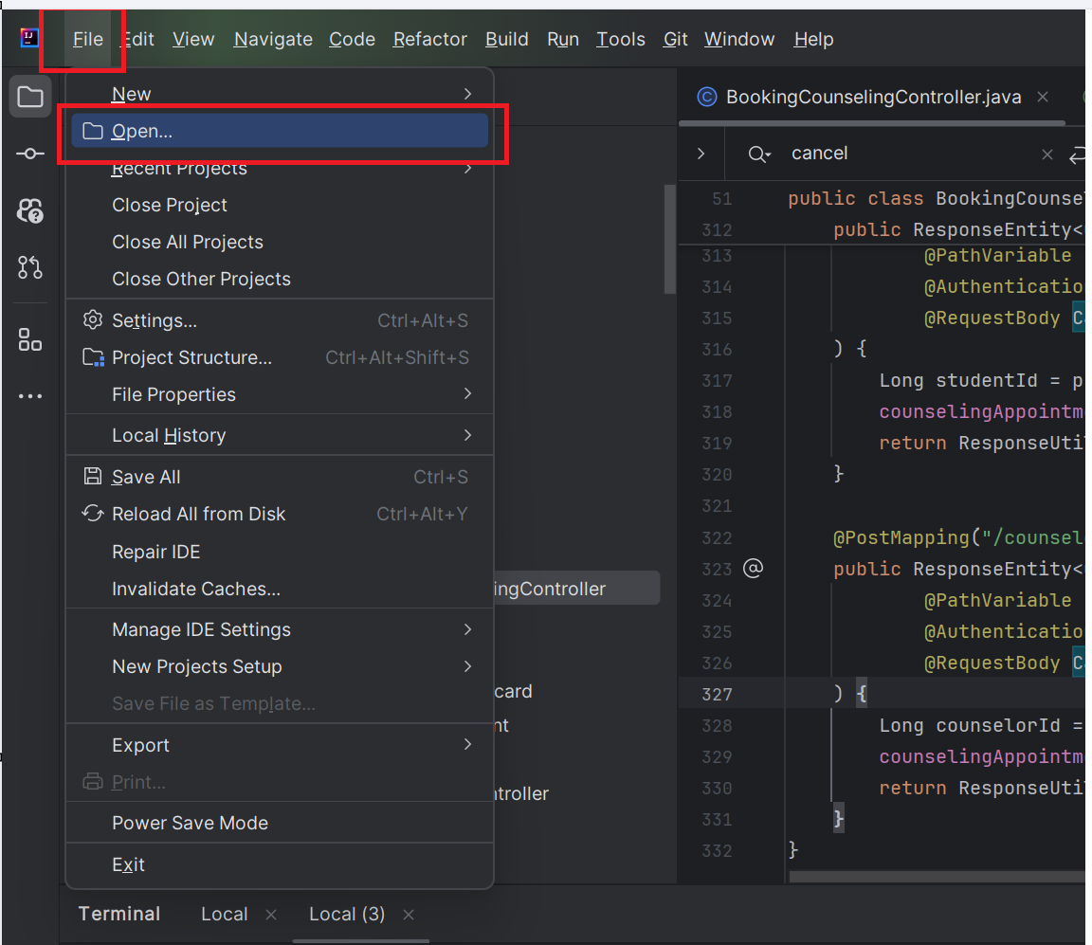
2. Select folder containing source code and click OK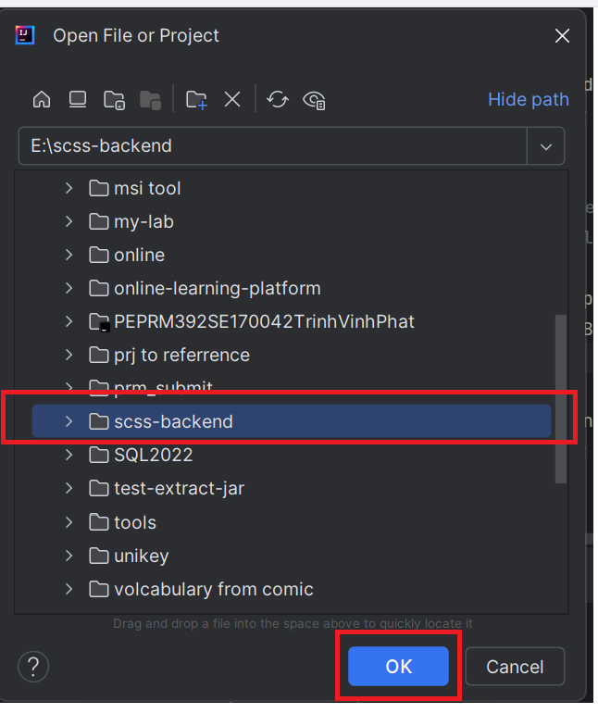
3. Folder will be opened in intellj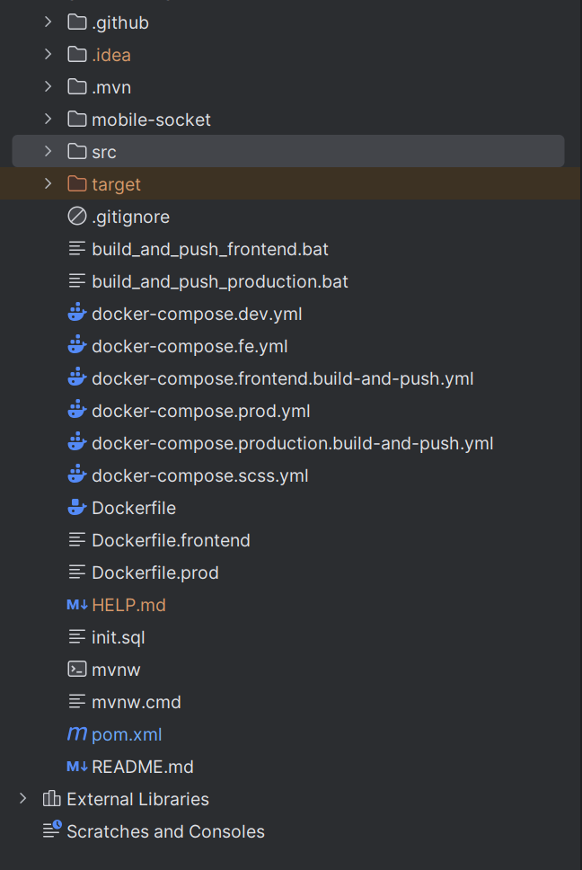

###### 2.2.1.3.5. Run Server

Step 1: Run Student Data Simulation Server

1. In intellj, click icon terminal at the left corner to open terminal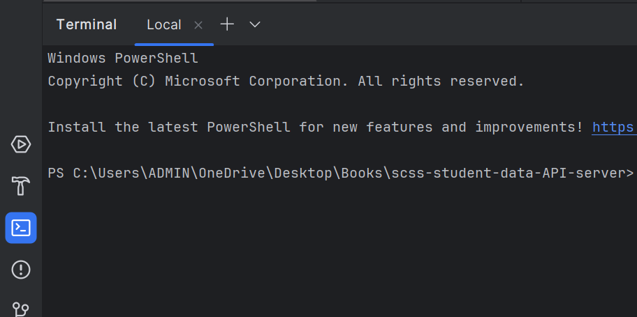
2. Run command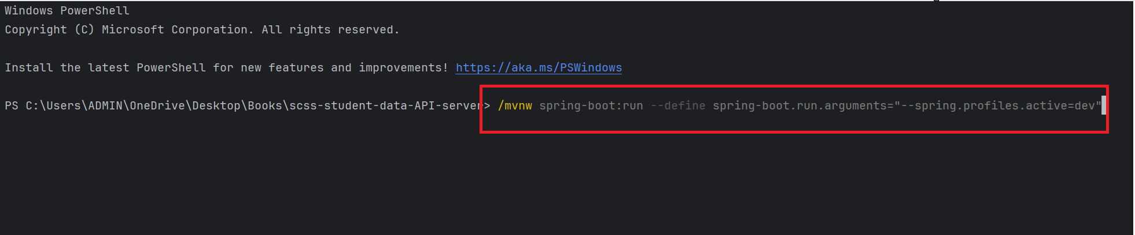
3. Waiting for application to finish building and up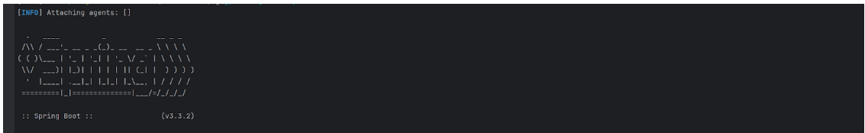

Step 2: Run SCSS Server

1. In intellj, click icon terminal at the left corner to open terminal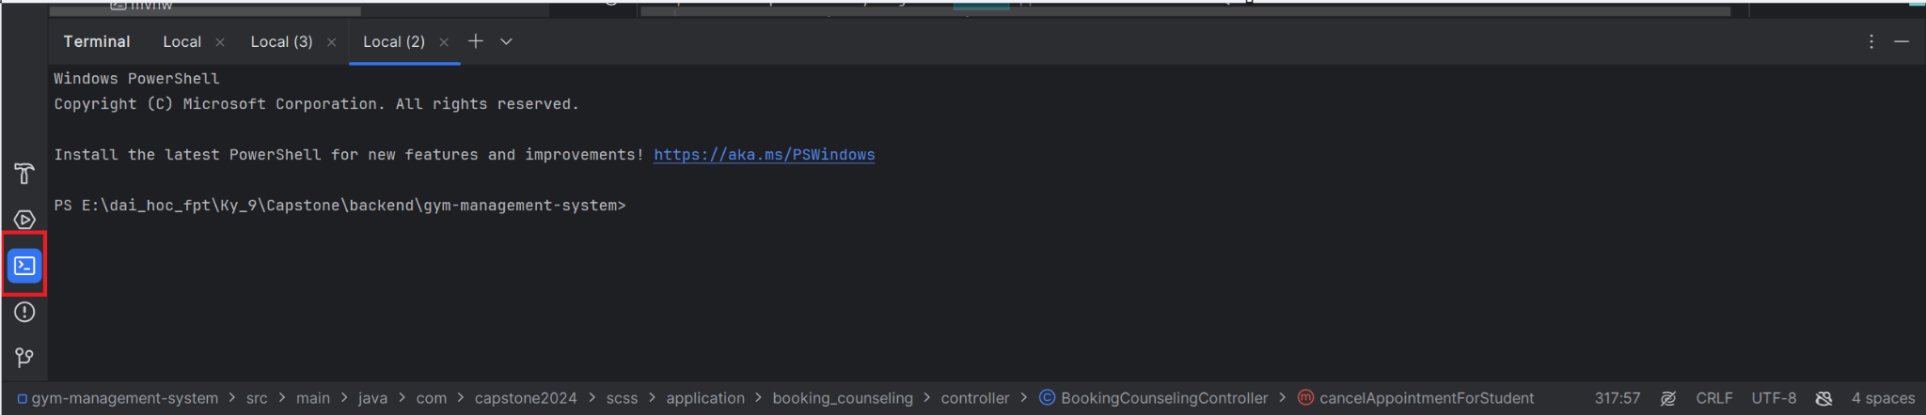
2. Run command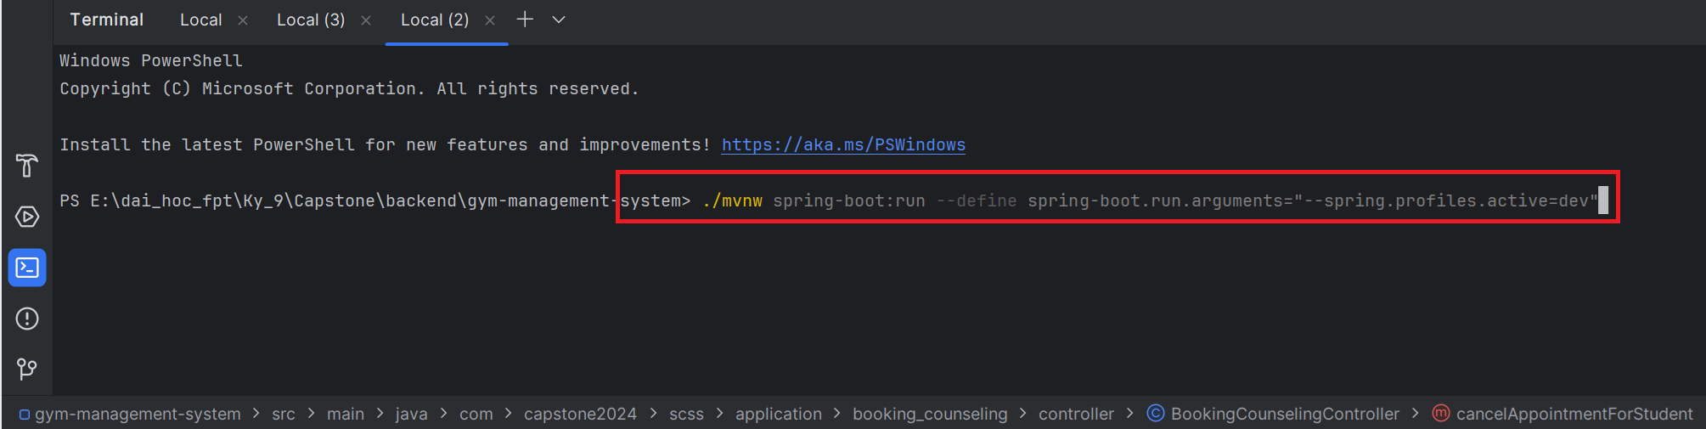
3. Waiting for application to finish building and up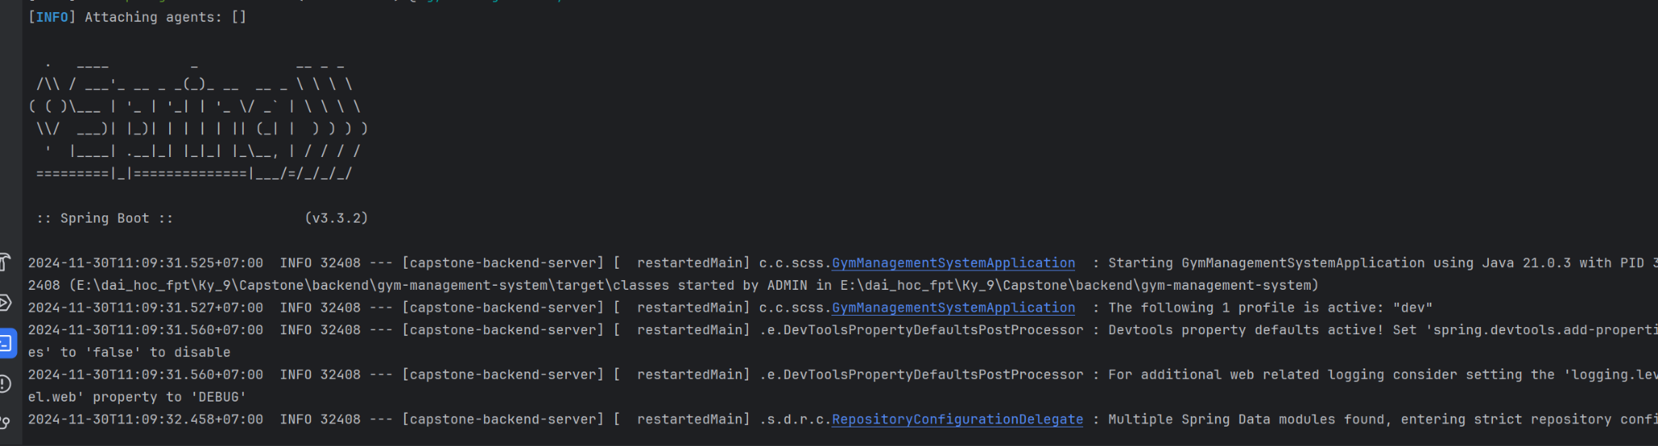

**2.2.2. Run Frontend web application**

Step 1: Clone the repository or extract “SCSS_WebApplication.zip” and open folder with Visual Studio Code.

Step 2: Create .env file at root of the project with content: *VITE_SERVER_BASE_URL=http://scss-server.southafricanorth.cloudapp.azure.com*

Step 3: Open the terminal and enter npm install:

Open terminal and enter npm install:

* npm i
* npm run dev

**2.2.4. Run Frontend mobile application**

Step 1: Access source code online through link: <https://github.com/Capstone-FA24SE111-GFA24SE27/scss-mobile>

Step 2: Copy the source code URL:

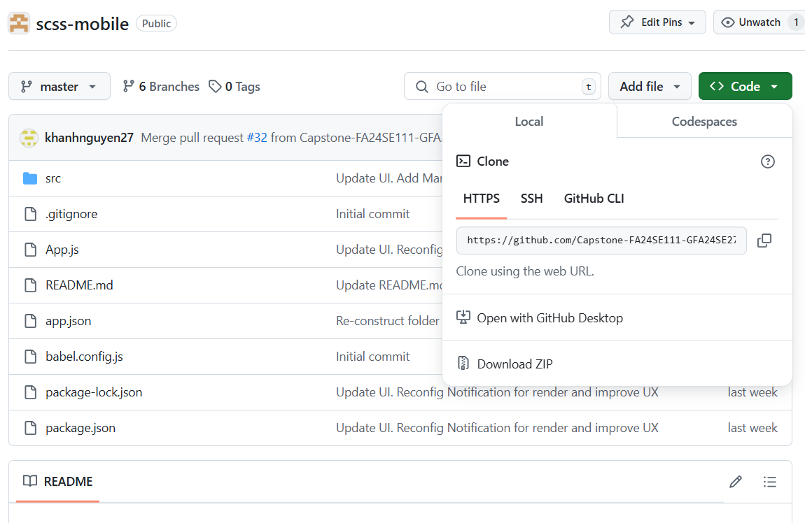

Step 3 : Clone this repository by opening terminal, input this command and press Enter: .

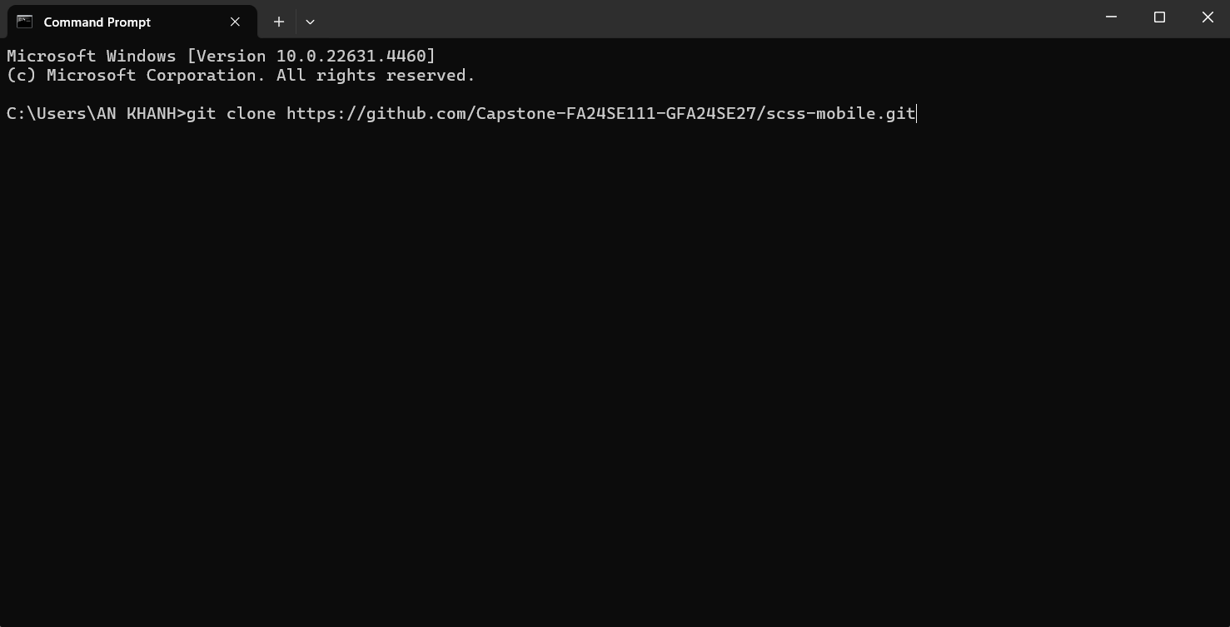

Step 4: Open the code folder with Visual Studio Code.

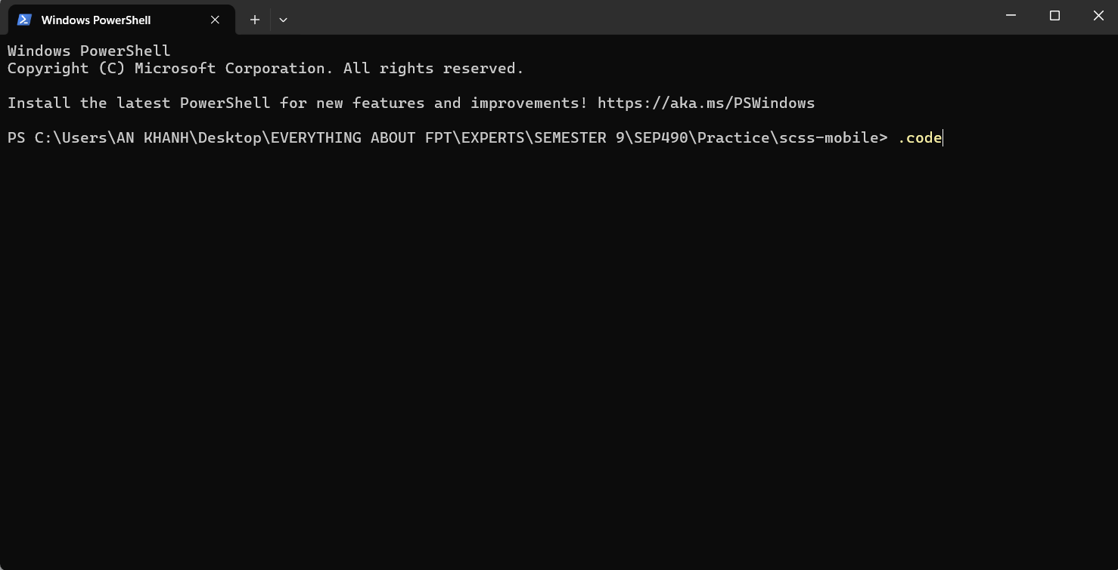

Step 5: After VS Code open with scss- folder, open VS Code terminal, input 2 commands in sequence: “npm install” and press Enter to install “node_modules” folder, then “npm run android” and press Enter to start mobile application





## 3. User Manual

### 3.1. Overview

### 3.2. Web Application

#### 3.2.1. Authentication

##### 3.2.1.1. Login

###### 3.2.1.1.1. Description

Use this guideline to login into SCSS with an email account. This web application supports login with email account that has been added as a admin, manager, counselor, support staff, student.

3.2.1.1.2. Guide Steps

Step 1: Access SCSS at http://scss-fe.azurewebsites.net/ **.** Then fill in “Email” and “Password”

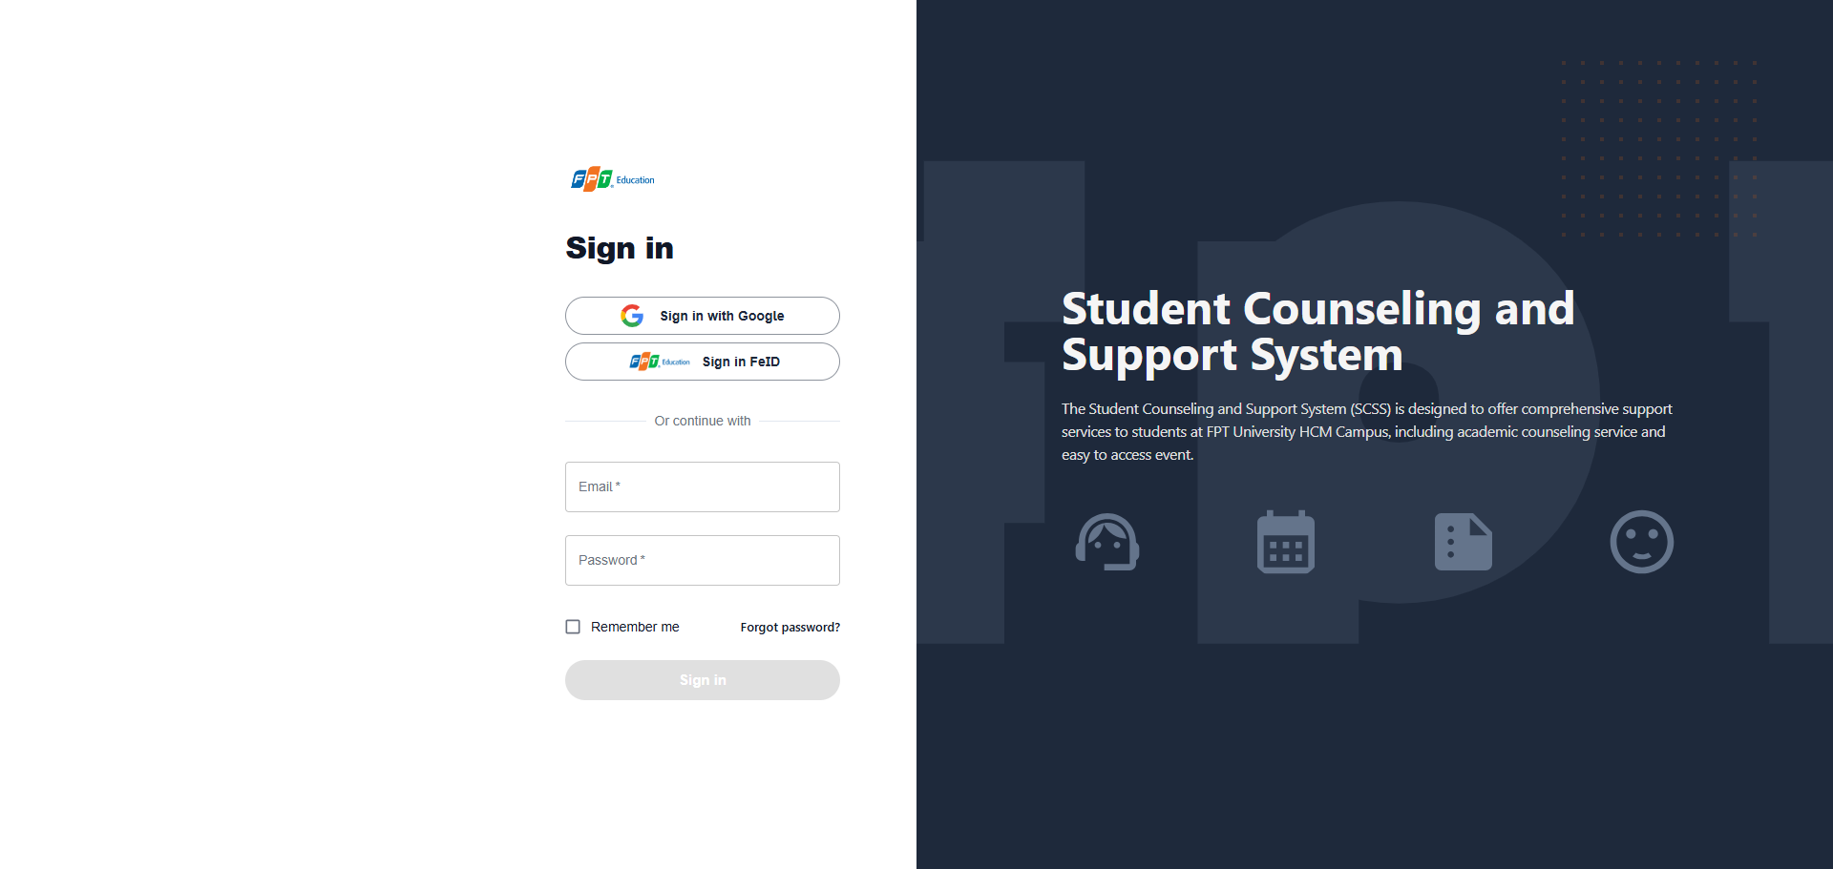

**Step 2:** Click “Sign in” Button

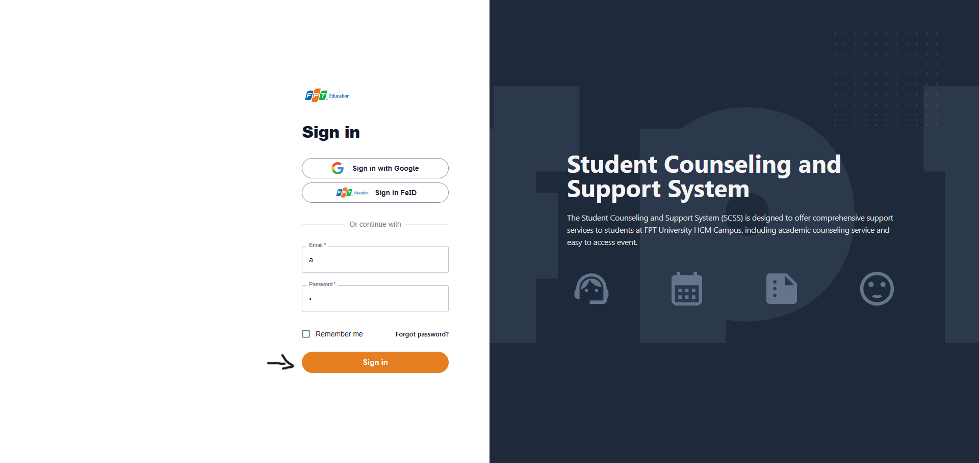

After logging in successfully, user is directed to the Dashboard Page with account authenticated.

##### 3.2.1.2. Reset Password

Use this guide so users can reset their email account password when they forget their password.

**3.2.1.2.1. Description**

Use this guide so users can reset their email account password when they forget their password.

**Step 1:** Access SCSS at http://scss-fe.azurewebsites.net/. Then press “Forgot password”.

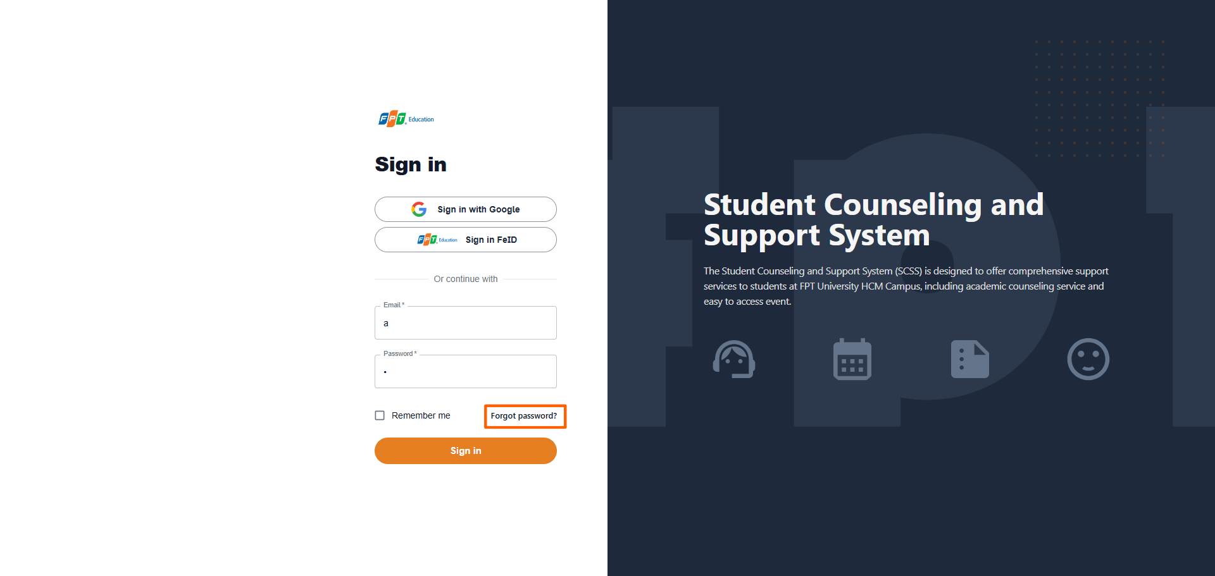

**3.2.1.2.2. Guide Steps**

**Step 2:** Then fill in “Email”

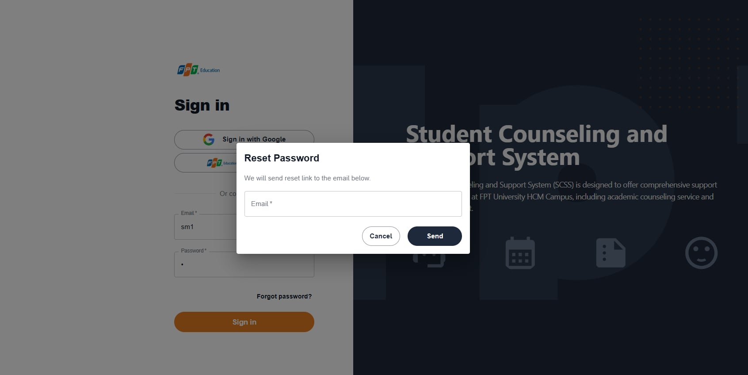

**Step 3:** Click “Send Email” button

After sending the email successfully, the user is redirected to the Verify OTP Page with the email that sent the OTP authentication code.

##### 3.2.1.3. Edit Password

**3.2.1.3.1. Description**

Use this guide so users can update their email account password when they want to edit their password.

This web application supports updating passwords for actors: Admin, manager, counselor, support staff, student.

**3.2.1.4.2. Guide Steps**

Step 1: Access SCSS at http://scss-fe.azurewebsites.net/. After logging in successfully, click the box avatar on the header and click “Settings” menu item.

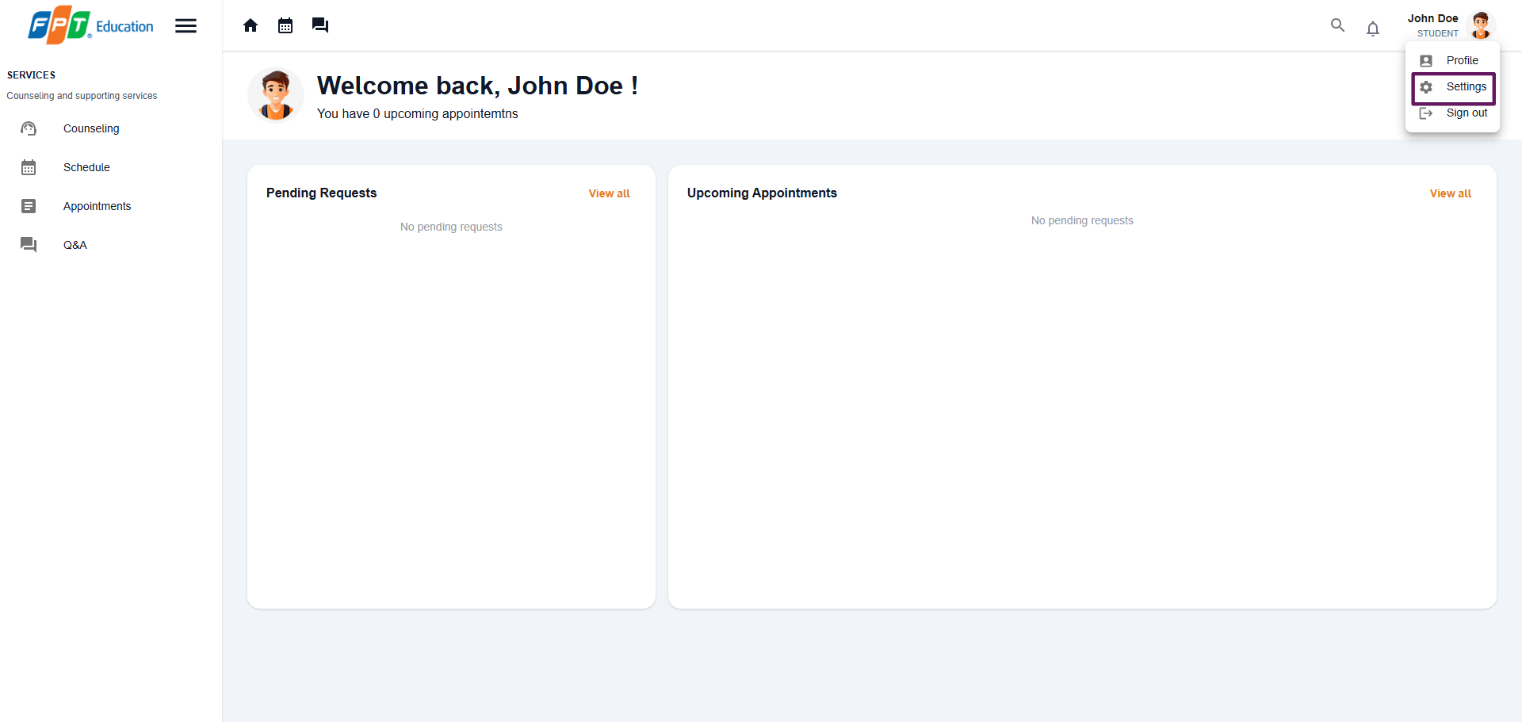

After click “Settings” menu item, the user is redirected to the Settings Page.

**Step 2:** Click menu icon button and click “Edit” button.

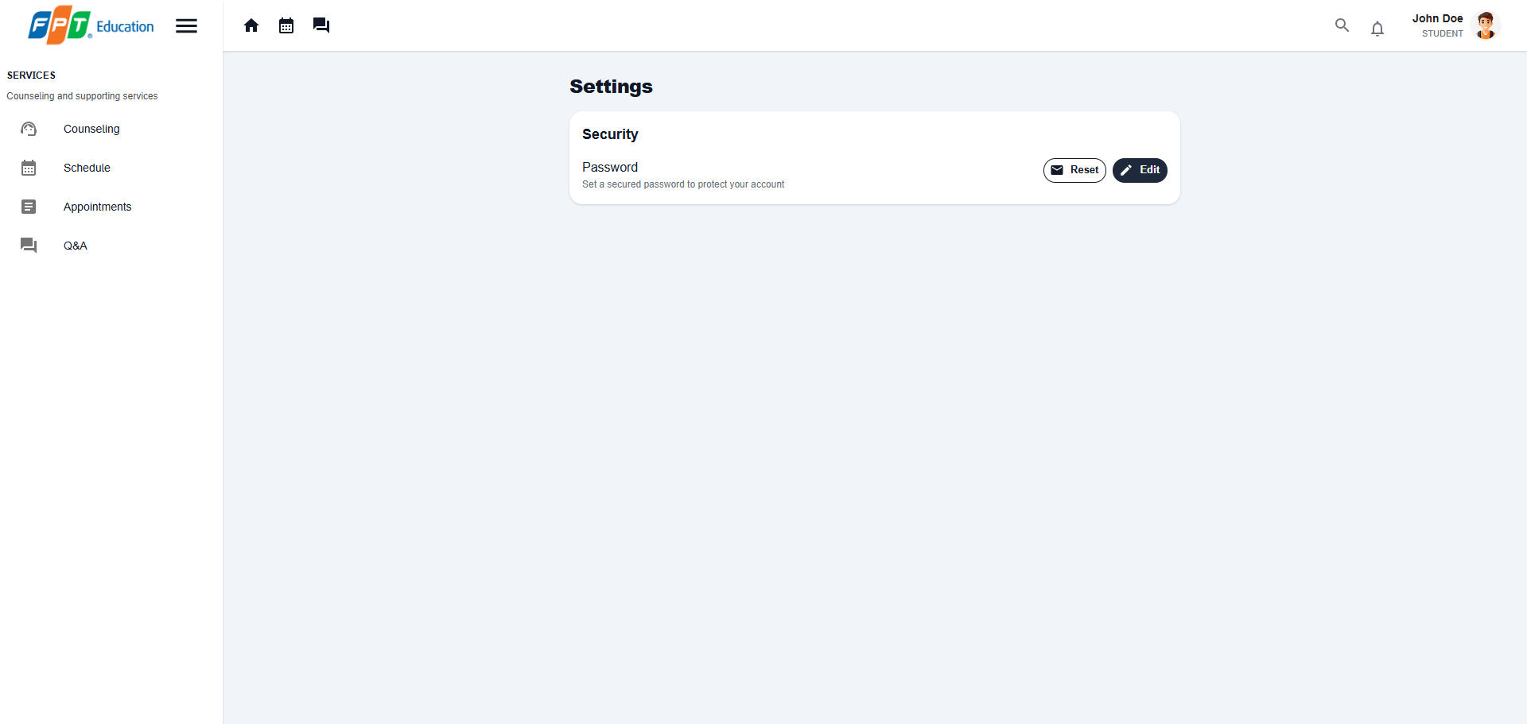

**Step 3:** Fill in “Current password”, “New password” and “Confirm new password”, then click “Save” button

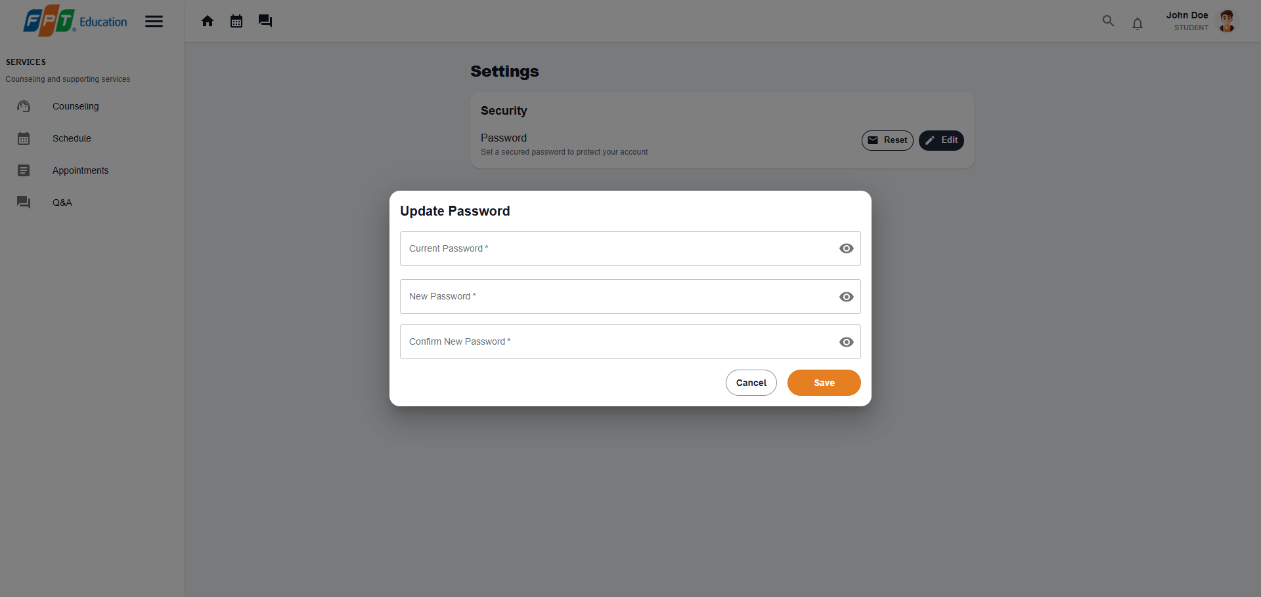

#### 3.2.2. Booking counseling appointment

##### 3.2.2.1. Quick booking a counselor

###### 3.2.2.1.1. Description

Use this guideline to login into SCSS student account to quick booking counseling appointments.

Step 1: Access SCSS at http://scss-fe.azurewebsites.net/. Then fill in “Email” and “Password” of the student account.

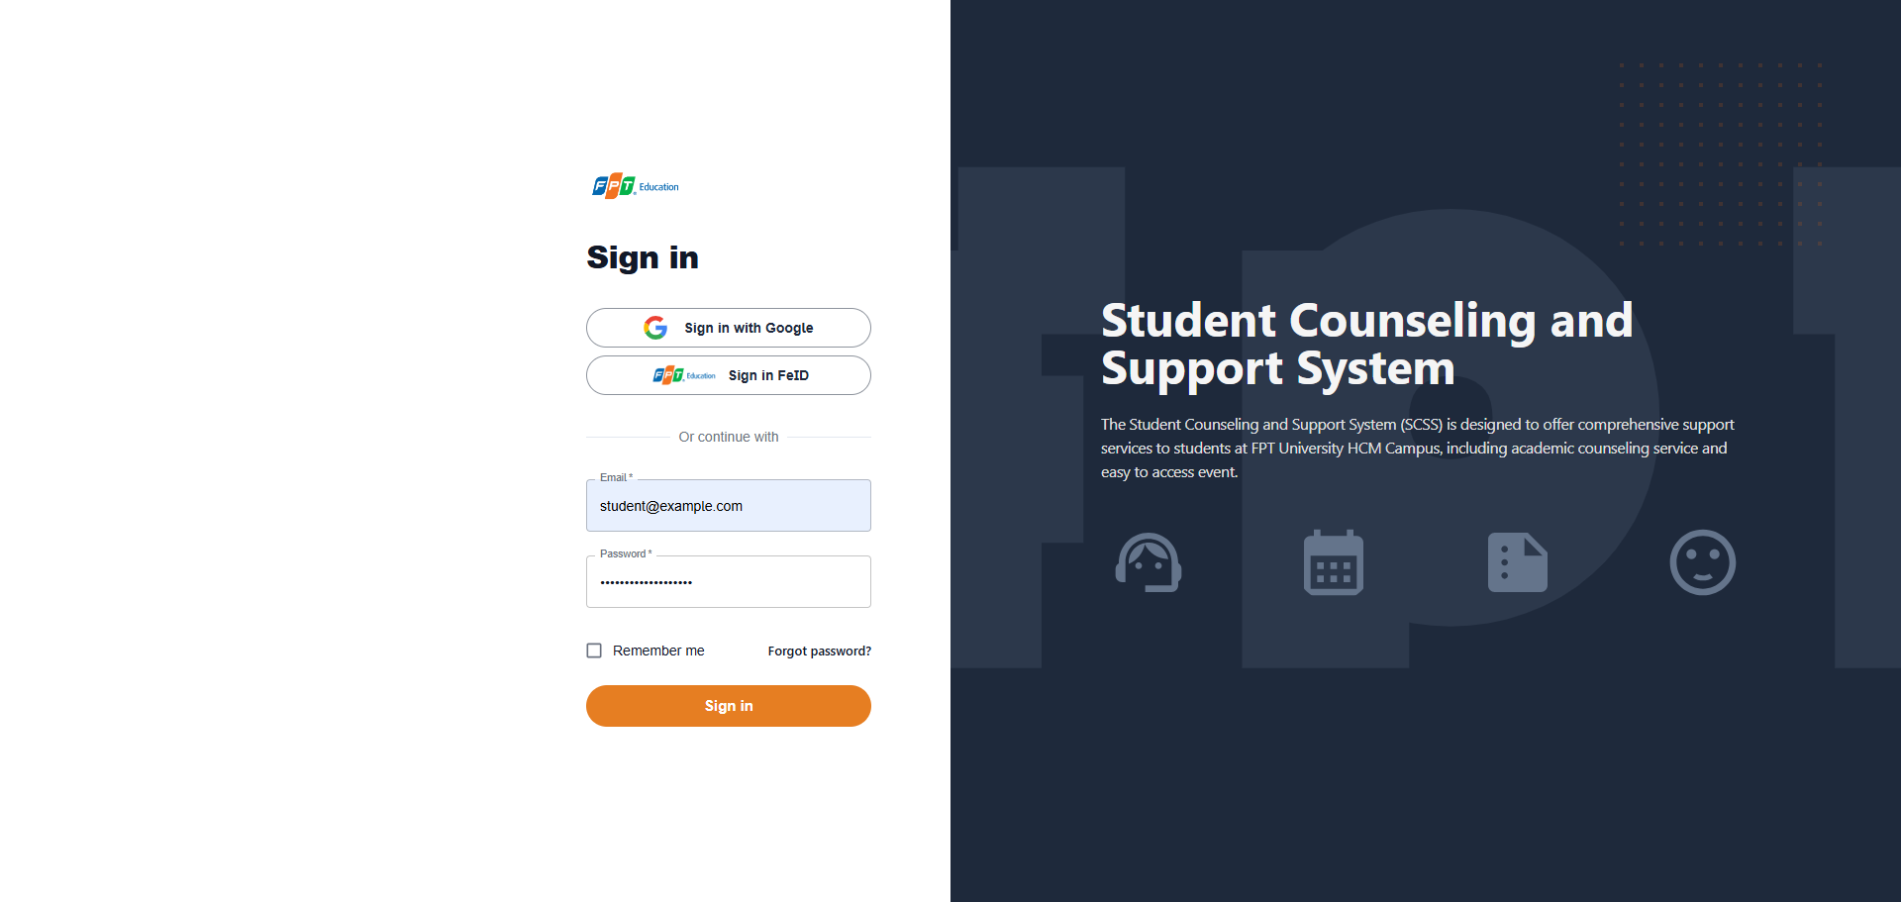

**Step 2:** Click “Sign in ” button.

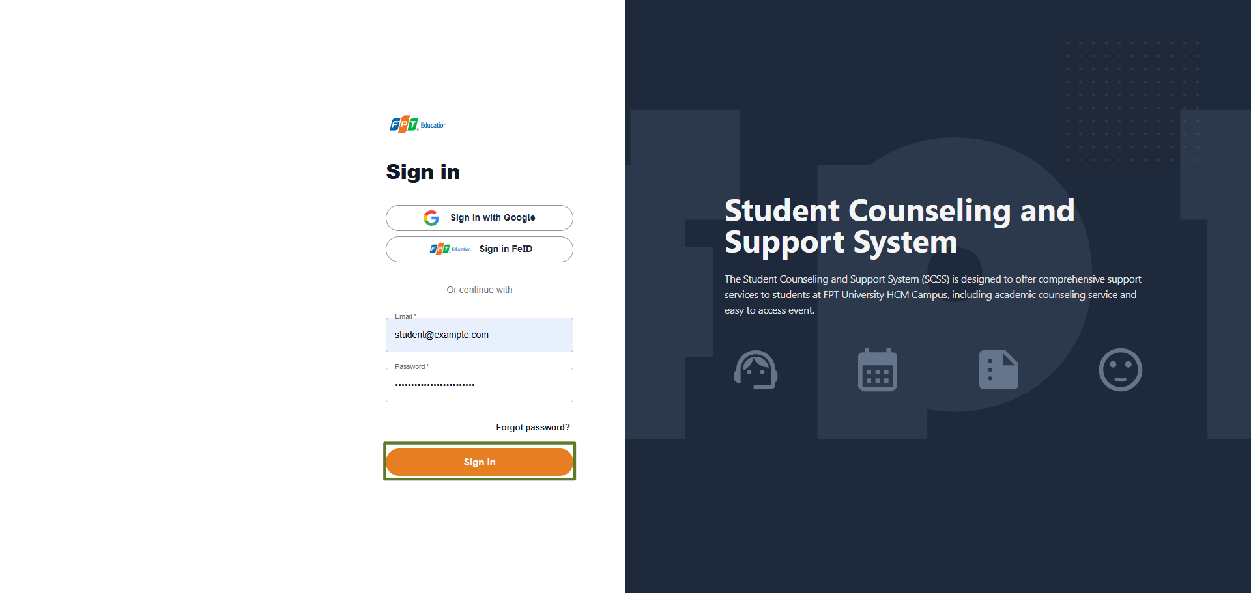

**Step 3:** From the homepage, choose “Counseling” from the left sidebar.

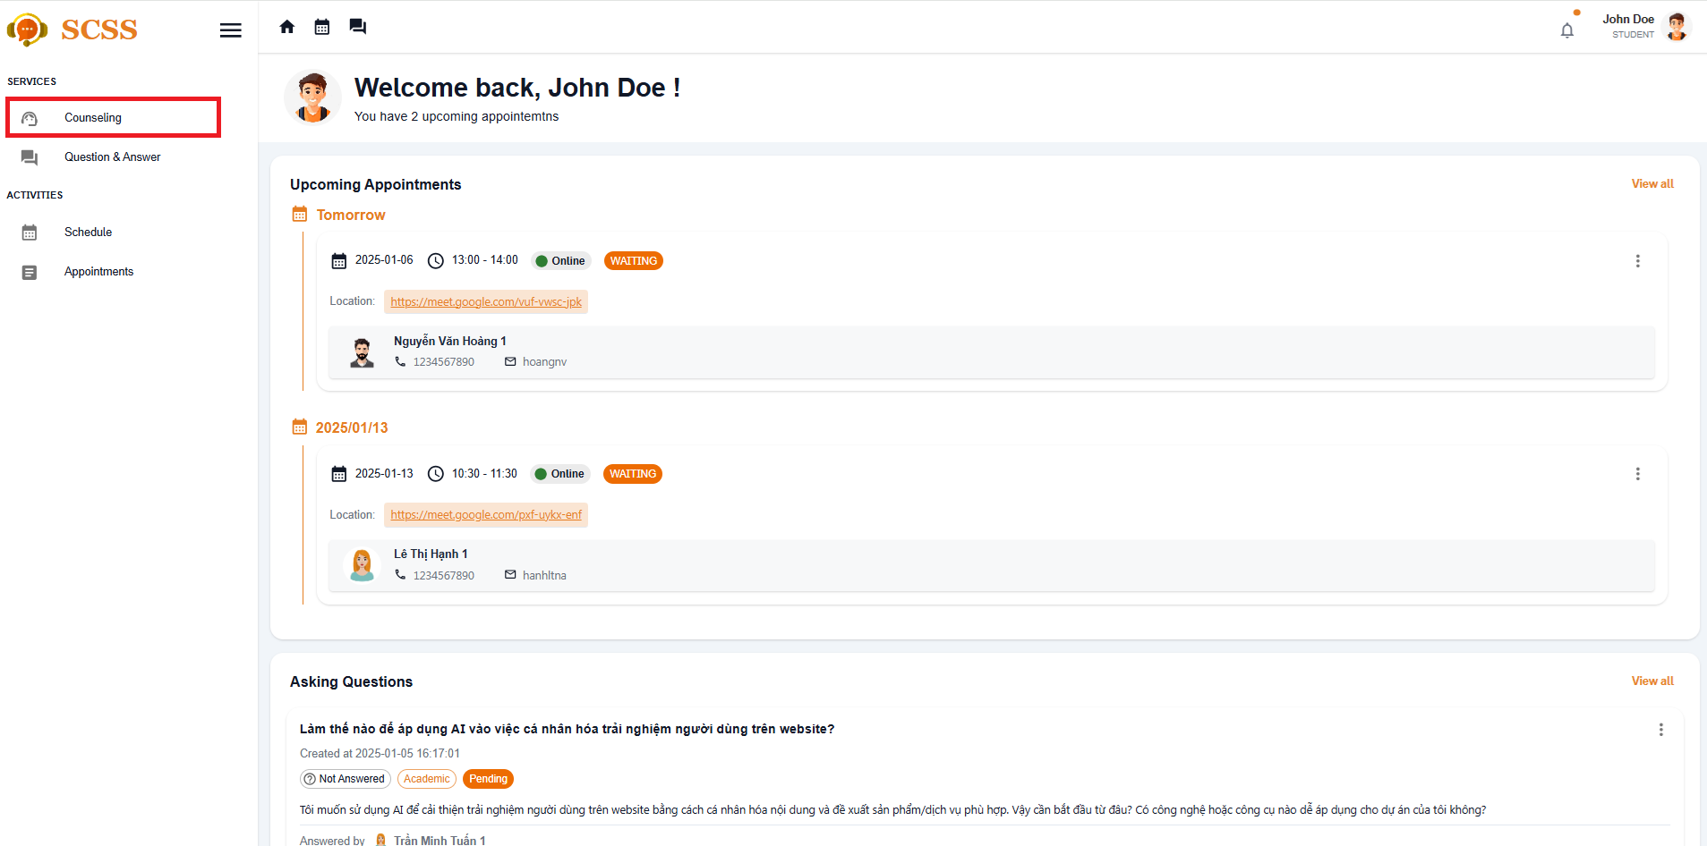

**Step 4:** At Quick Booking tab, enter all the the required information to booking counseling appointment including: Reason, gender (optional), date (optional), slot (optional), gender (optional)

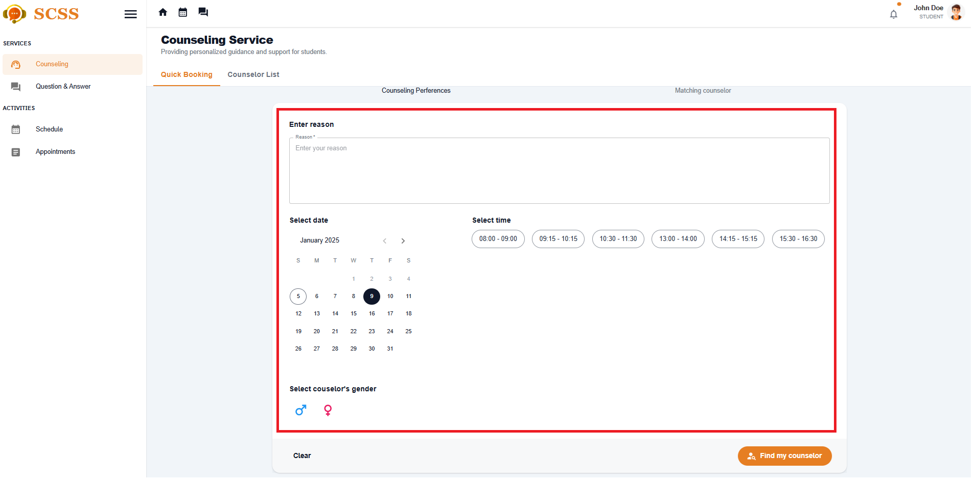

**Step 5:** If you give a valid reason, select the 'Find my counselor' button and the system will find the counselor that matches your preferences.

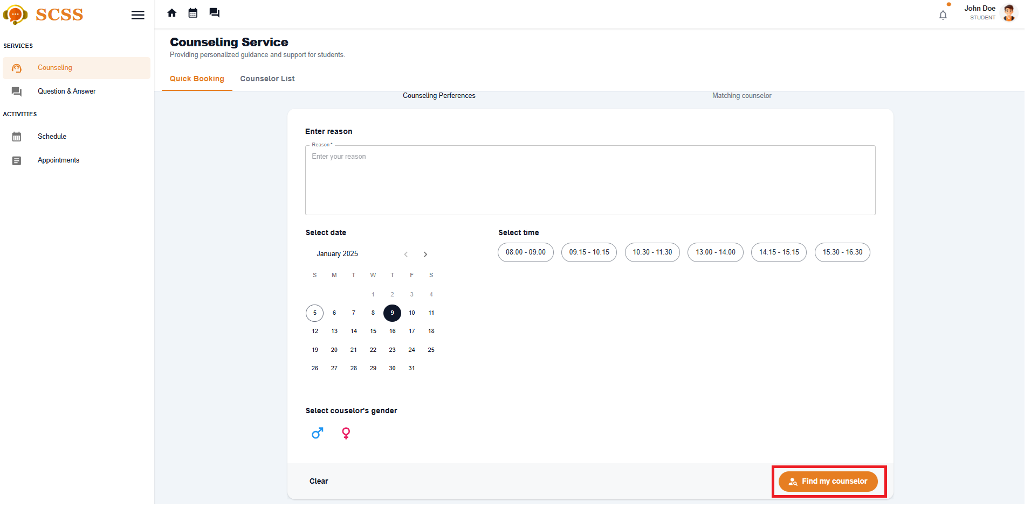

**Step 6:** If there are matched counselors, continue to select your counselor and select date and time (if you haven't), meeting type. Then select the 'Confirm booking' button, after you confirm, booking success.

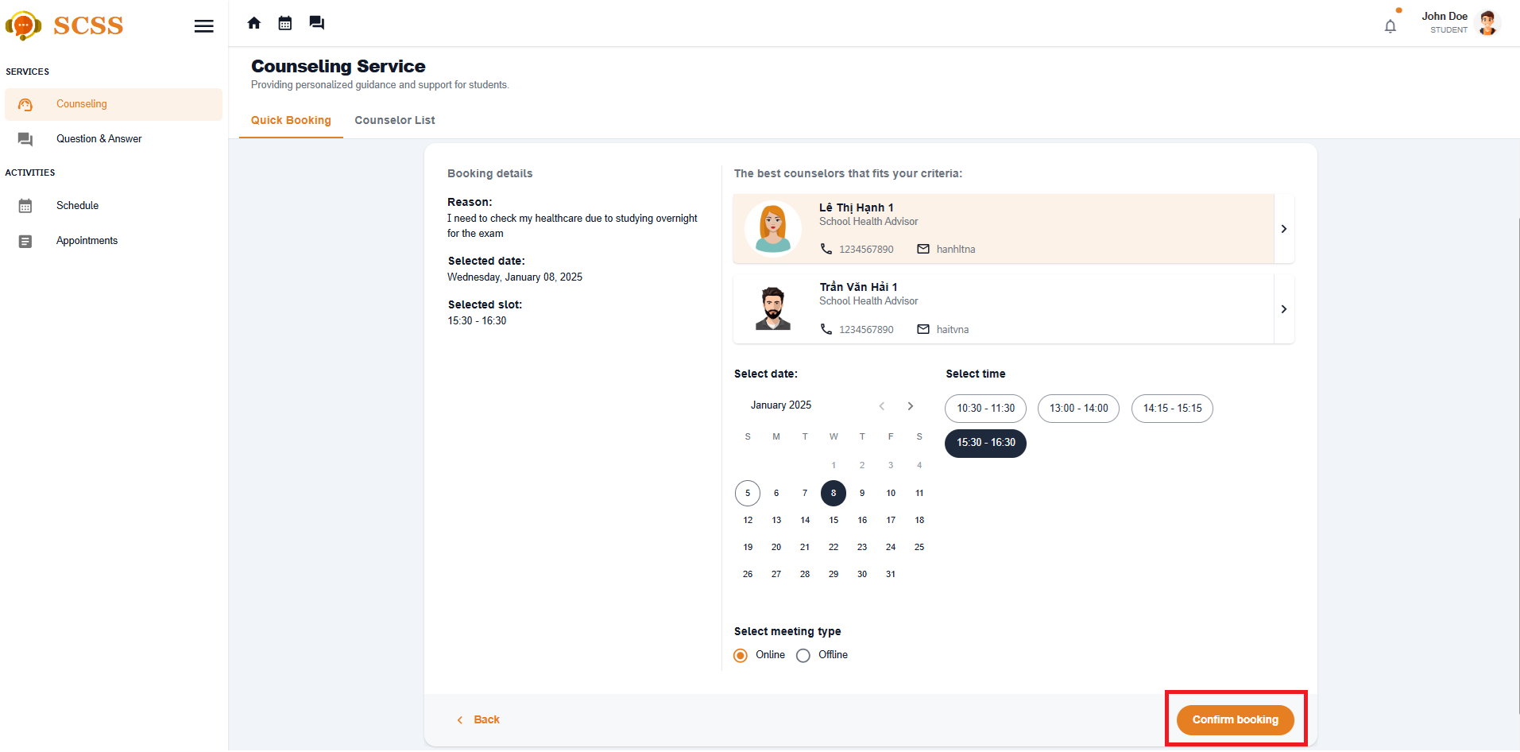

##### 3.2.2.2. Booking a specific counselor

###### 3.2.2.2.1. Description

Use this guideline to login into the SCSS student account to book a specific counselor.

**Step 1:** Access SCSS at http://scss-fe.azurewebsites.net/. Then fill in “Email” and “Password” of the student account.



**Step 2:** Click “Sign in ” button.



**Step 3:** From the homepage, choose “Counseling” from the left sidebar.

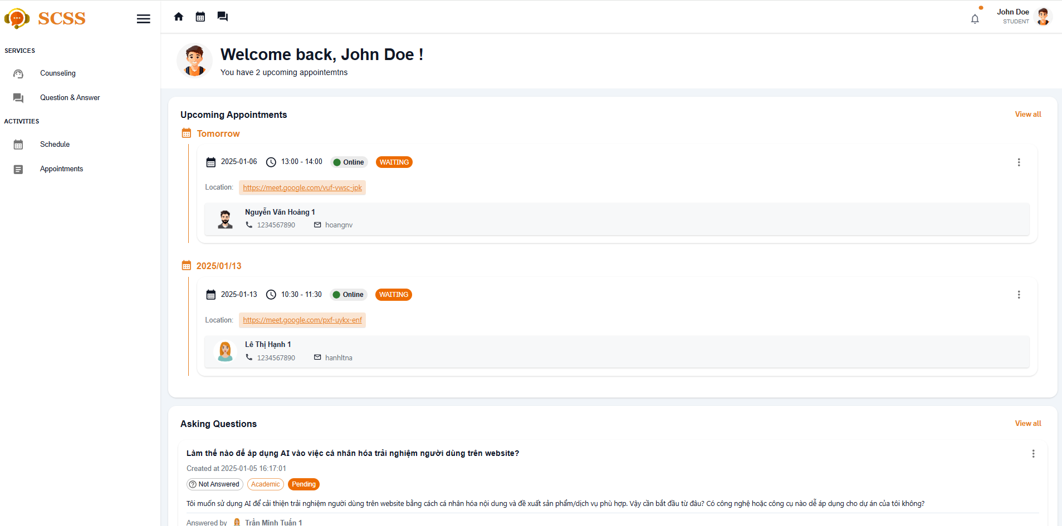

**Step 4:** Select ”Counselor List” tab

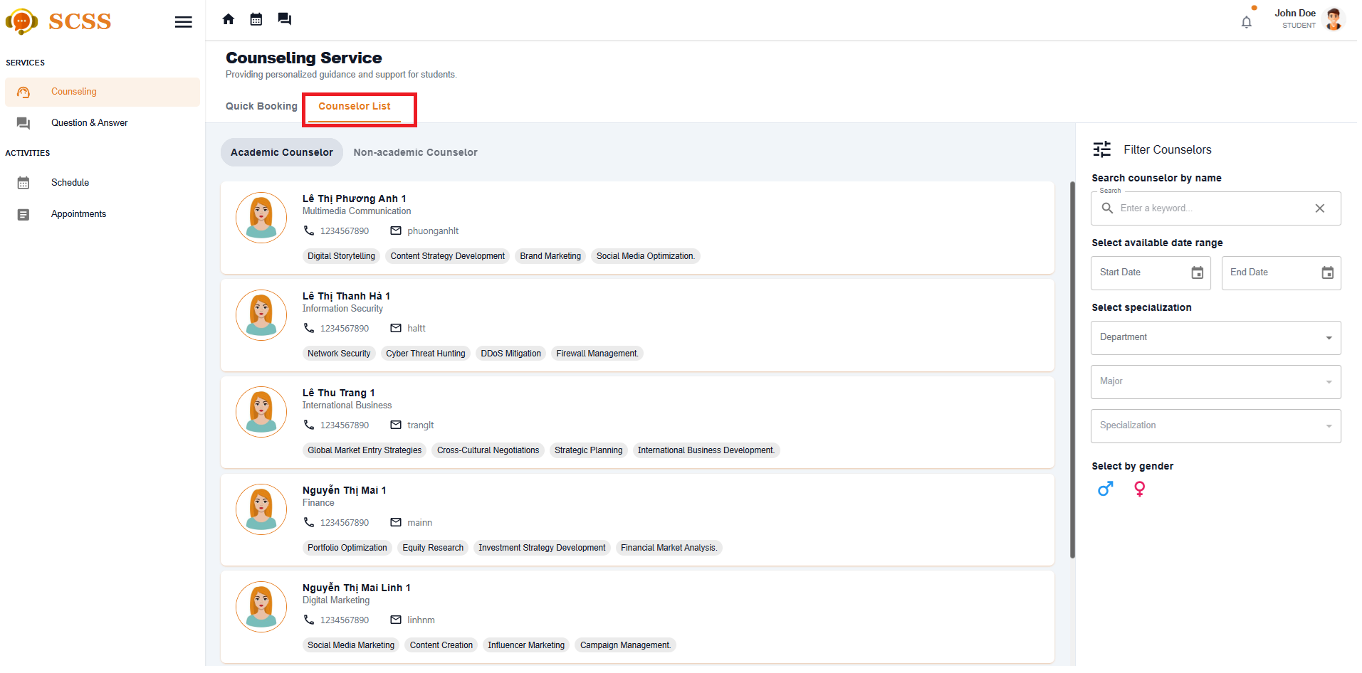

**Step 5:** Select filter options to narrow down counselors based on preferences of students, including: counseling type, availability, department, major, specialization, expertise, gender or search by keyword.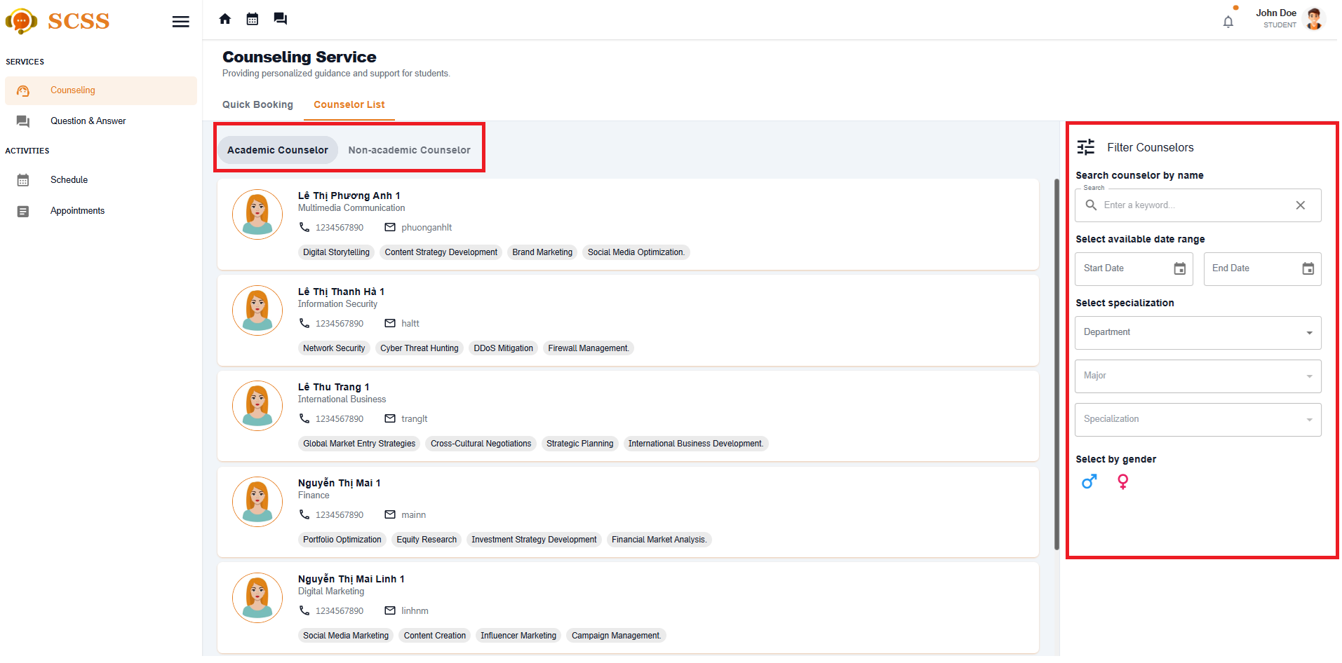

**Step 6:** Select a counselor and click the button “Book counselor”

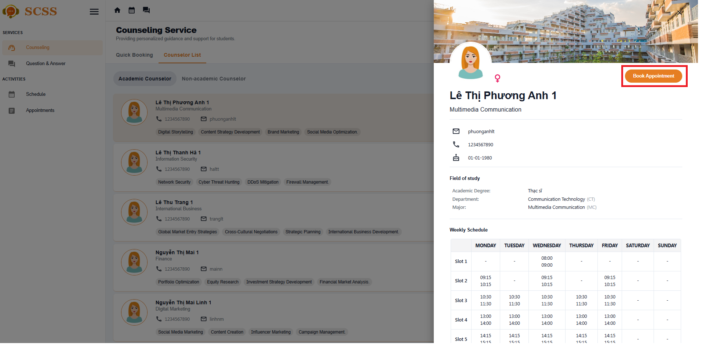

**Step 7:**  Select all the required information to book an appointment including: “Select date”, “Select slot”, “Select meeting type“, Fill “Reason“:

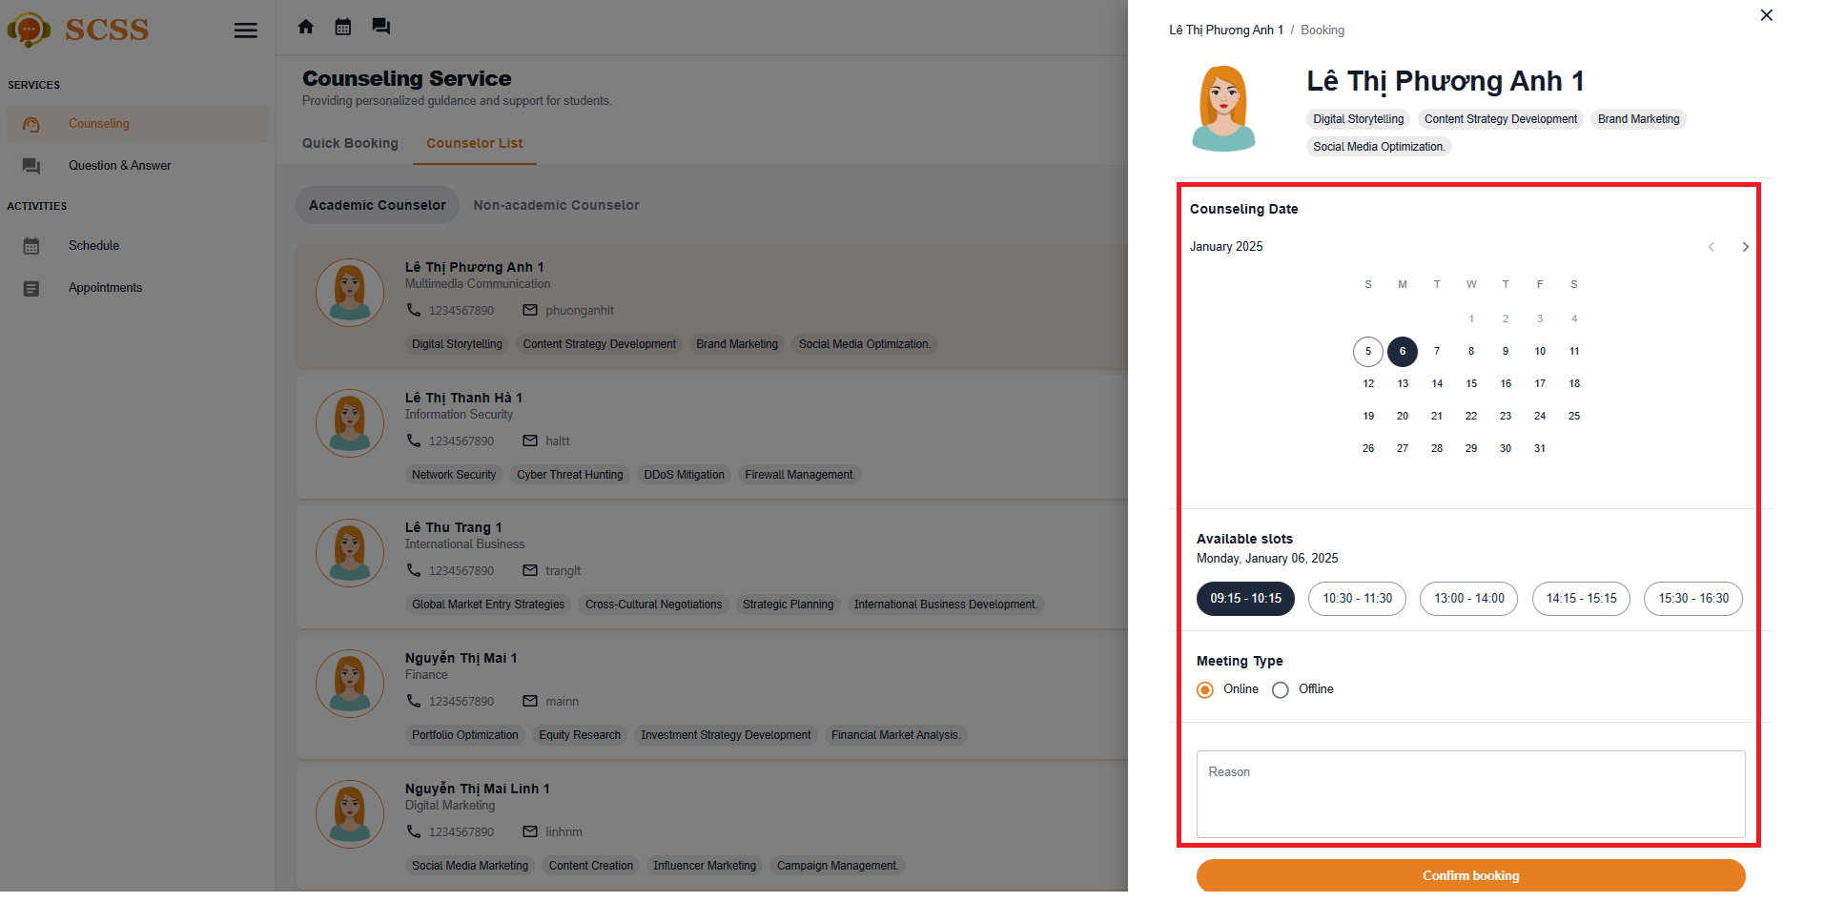

**Step 8:** Select confirm booking, after confirm, booking success

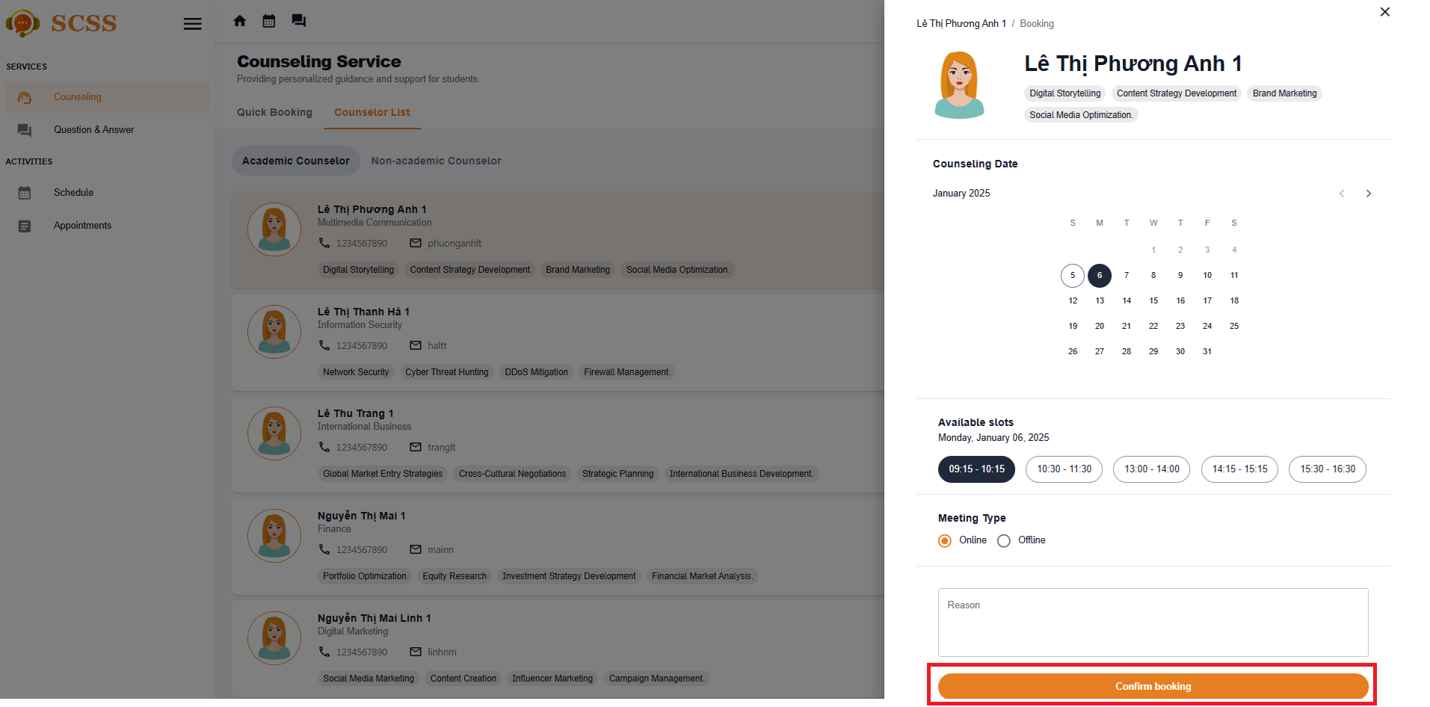

##### 3.2.2.3. Approve an appointment request

###### 3.2.2.3.1. Description

Use this guideline to log into the SCSS counselor account to approve a student appointment request.

**Step 1:** Access SCSS at http://scss-fe.azurewebsites.net/. Then fill in “Email” and “Password” of the counselor account.



**Step 2:** Click “Sign in ” button.



**Step 3:** From the homepage, choose “Requests” from the left sidebar.

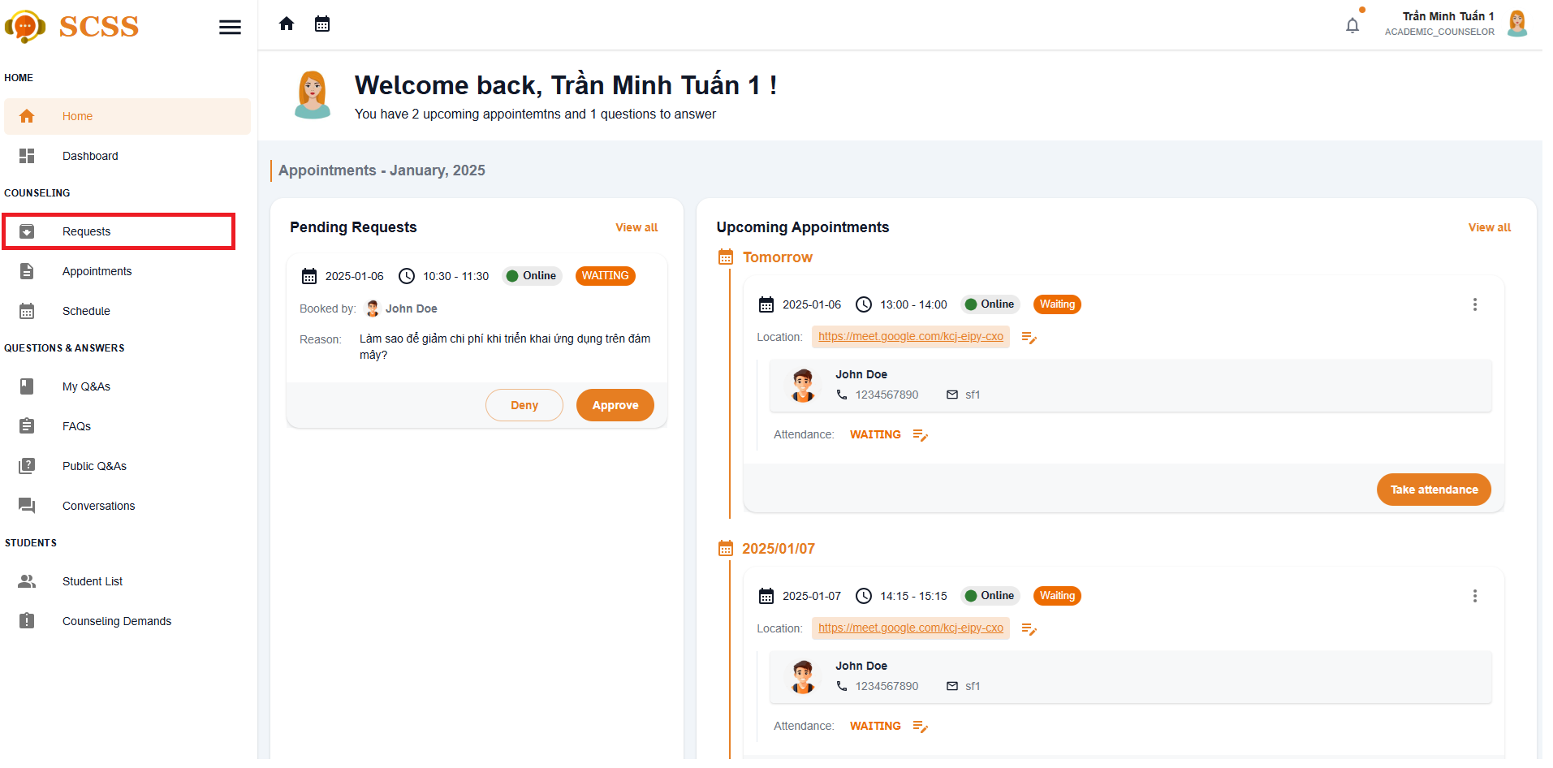

**Step 3:** In “Requests” page, select the ”Approve” button.

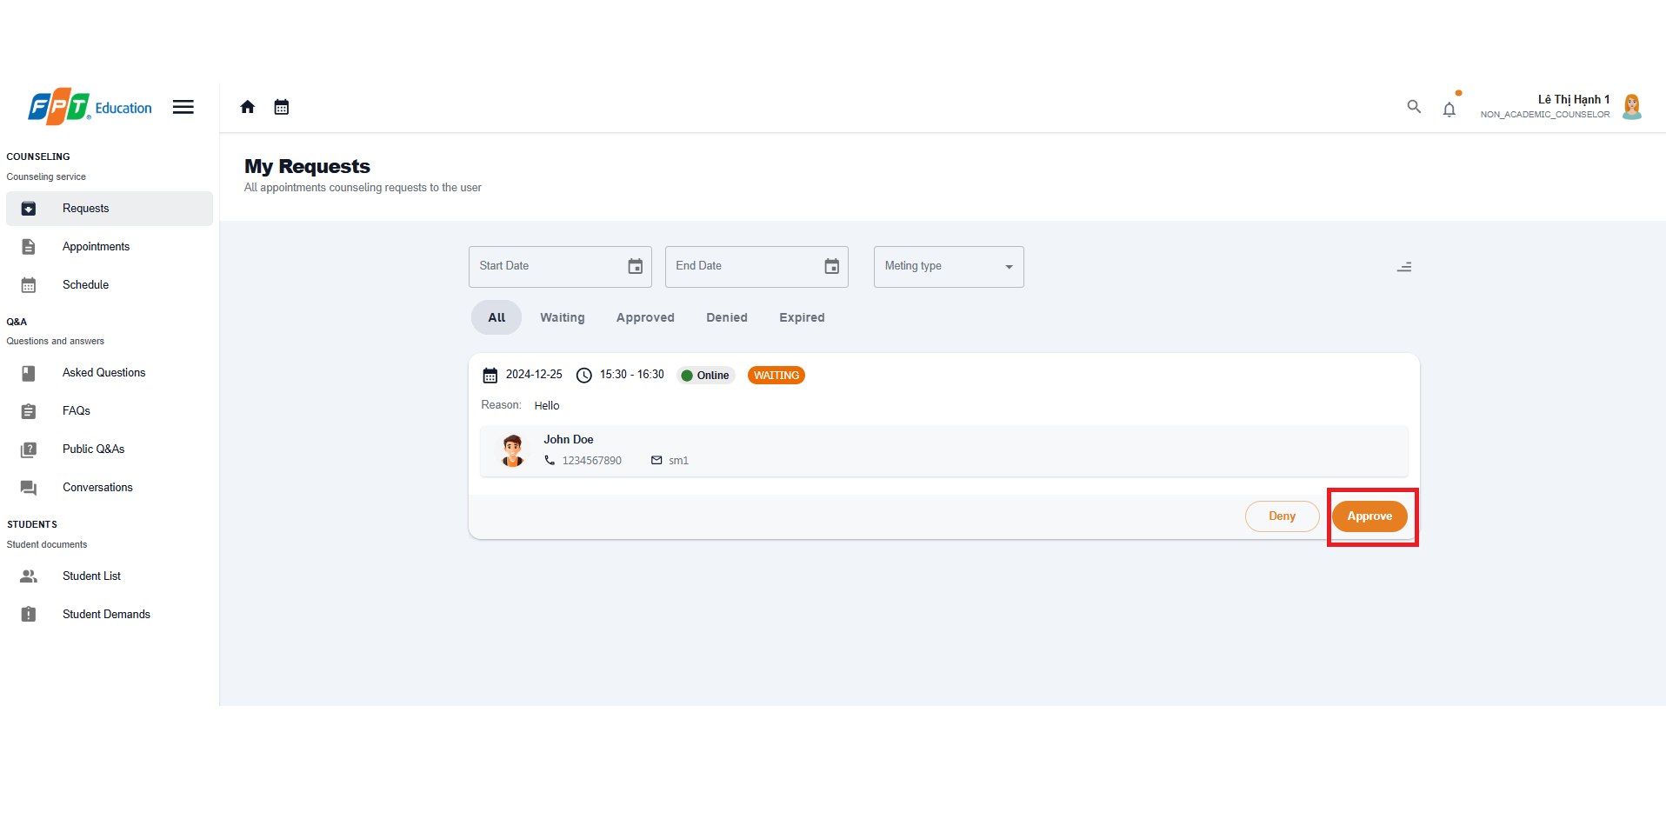

**Step 4:** There is a dialog displayed, if the appointment request meeting type is ”Online”, fill in the meeting URL, if it is ”Offline”, fill in the address. After fill required field, press “Confirm” Button to approve the request.

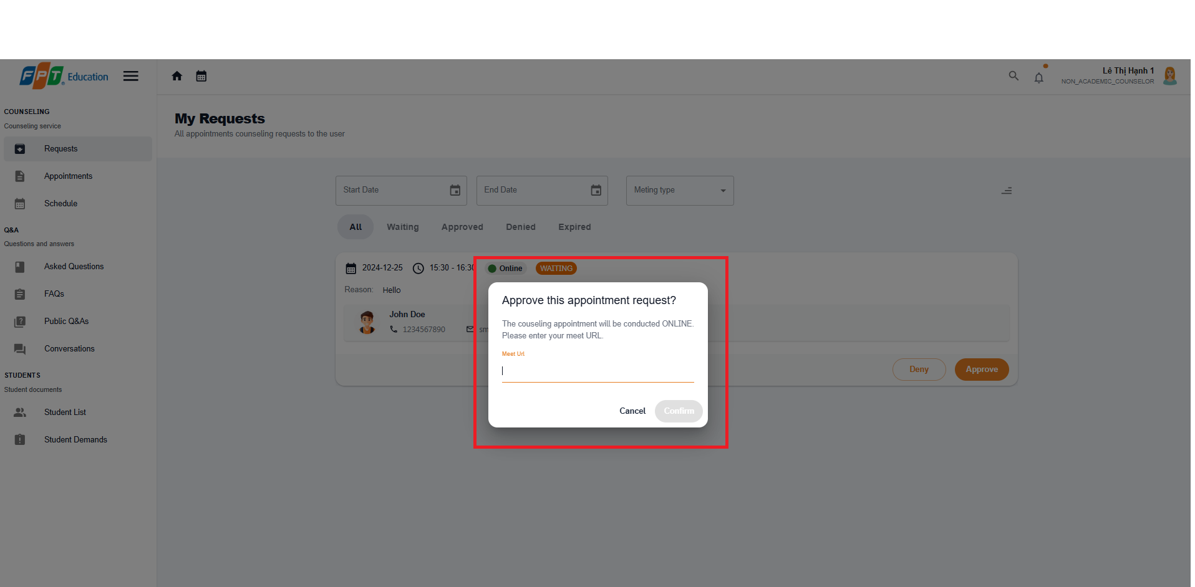

##### 3.2.2.4. Deny an appointment request

###### 3.2.2.4.1. Description

Use this guideline to log into the SCSS counselor account to deny a student appointment request.

**Step 1:** Access SCSS at http://scss-fe.azurewebsites.net/. Then fill in “Email” and “Password” of the counselor account.



**Step 2:** Click “Sign in ” button.



**Step 3:** From the homepage, choose “Requests” from the left sidebar.

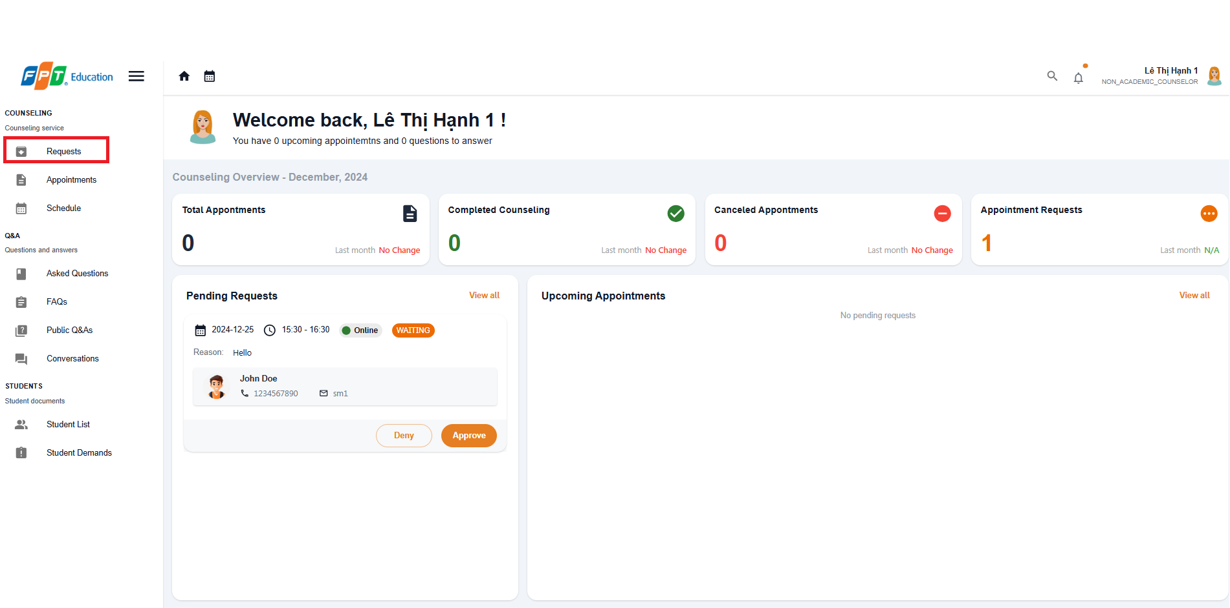

**Step 3:** In “Requests” page, select the ”Deny” button.

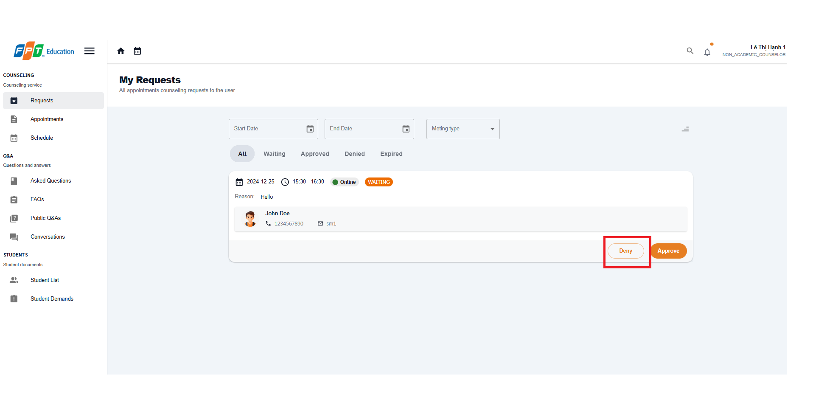

**Step 4:** There is a confirmation dialog displayed, press “Confirm” Button to deny the request.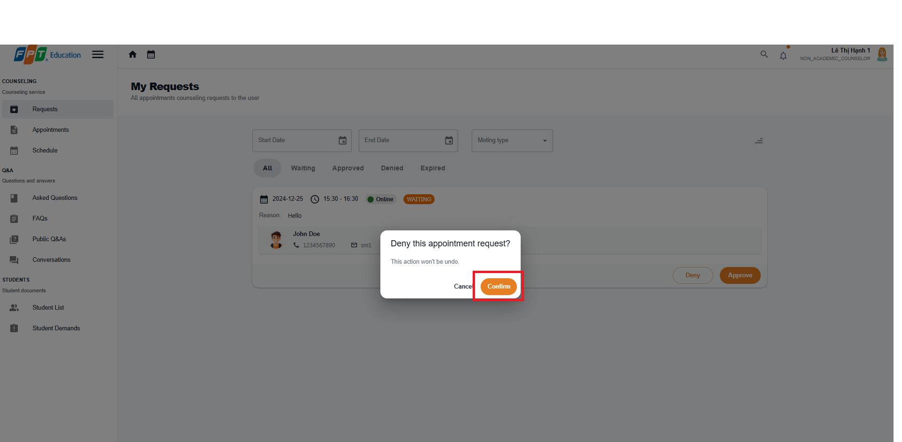

##### 3.2.2.5. Take Attendance for Appointment

###### 3.2.2.5.1. Description

Use this guideline to log into the SCSS counselor account to take attendance for appointment

###### 3.2.2.5.1. Guide Steps:

**Step 1:** Access SCSS at http://scss-fe.azurewebsites.net/. Then fill in “Email” and “Password” of the counselor account.



**Step 2:** Click “Sign in ” button.



**Step 3:** From the homepage, choose “Appointments” from the left sidebar.

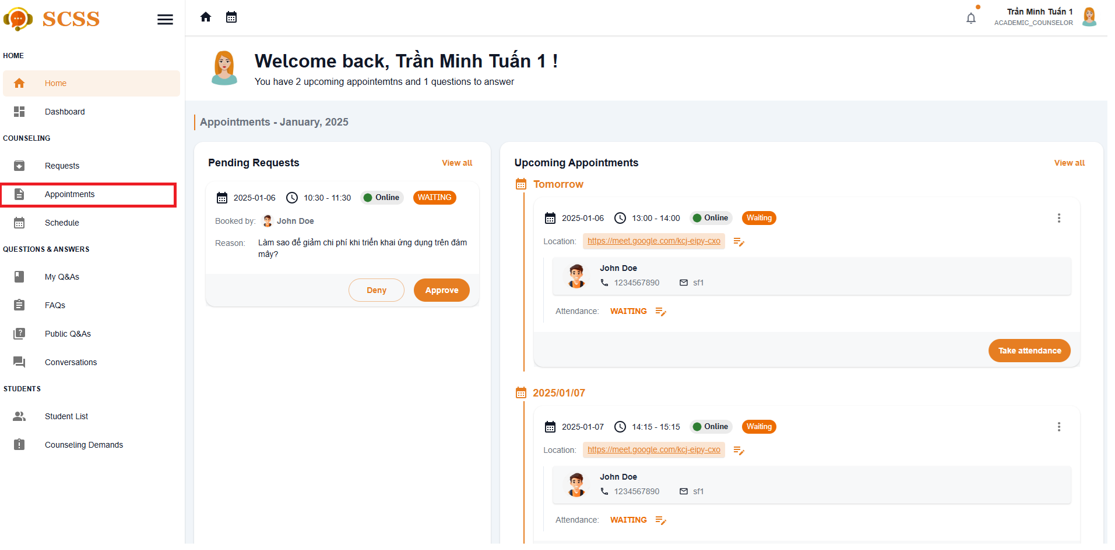

**Step 4:** In “Appointments” page, find an appointment using filter section by meeting date, and status. After finding an appointment, press “Take attendance” button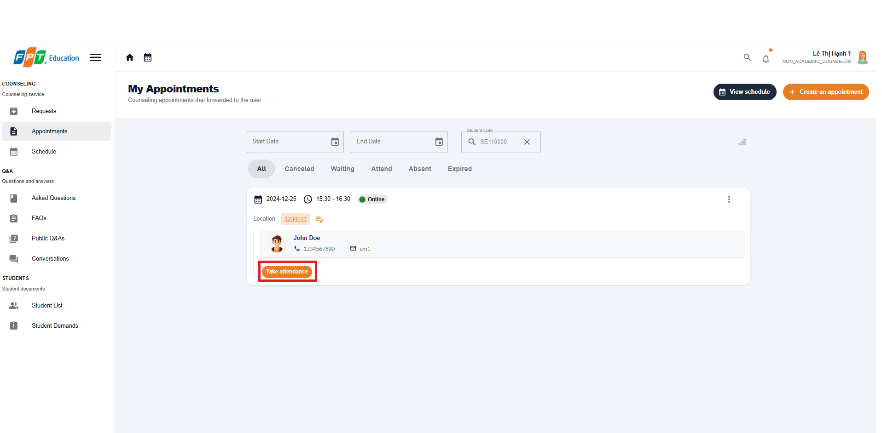

**Step 5:** There will be Take Attendance dialog, a take attendance confirmation will open. Press “ATTEND” or “ABSENT” to change the status of the chosen appointment.

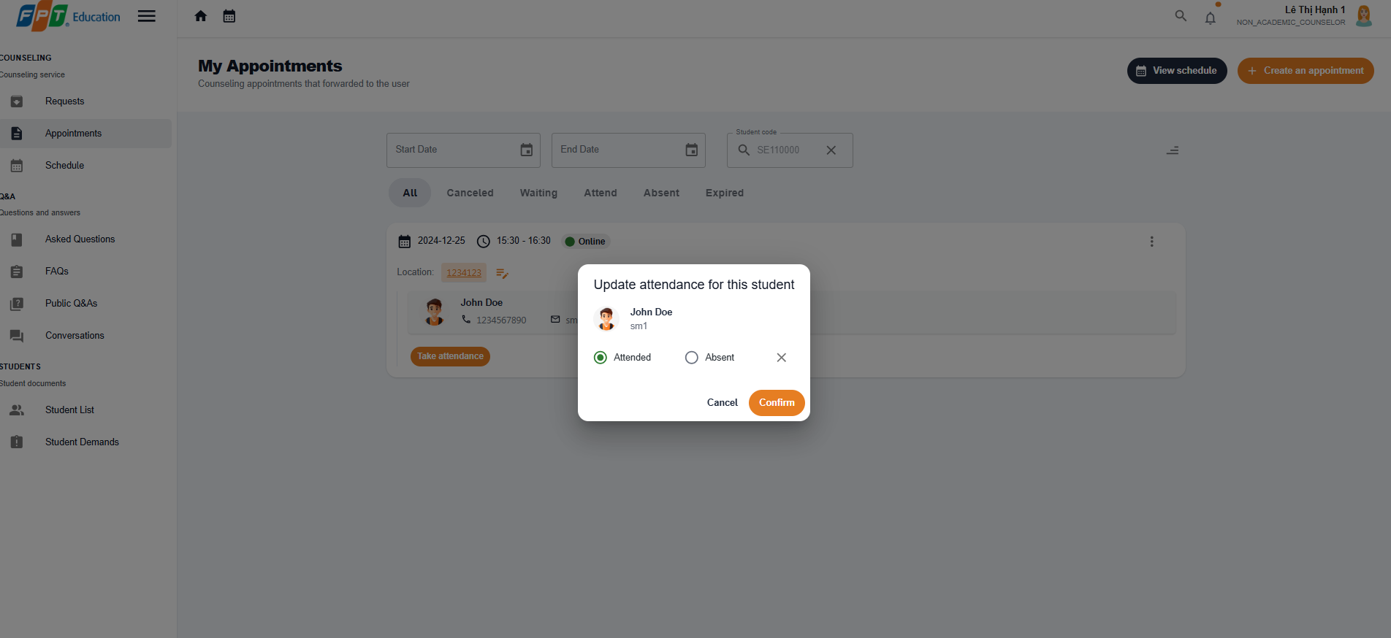

**Step 6:** After taking attendance, the status of appointment will change to “ATTEND” or “ABSENT”

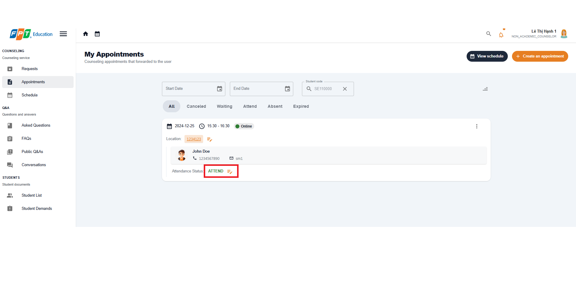

##### 3.2.2.6. Give Feedback for Appointment

###### 3.2.2.6.1. Description

Use this guideline to log into the SCSS student account to write feedback for appointment

###### 3.2.2.6.2. Guide Steps:

**Step 1:** Access SCSS at http://scss-fe.azurewebsites.net/. Then fill in “Email” and “Password” of the student account.



**Step 2:** Click “Sign in ” button.



**Step 3:** From the homepage, choose “Appointments” from the left sidebar.



**Step 4:** In Appointment page, find an appointment using filter section by meeting date, and status. After finding a appointment (which status is “ATTEND”), press “Leave a review” button.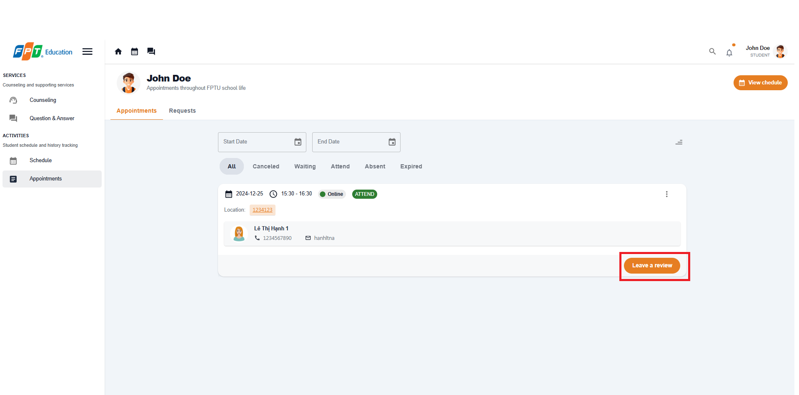

**Step 5:** Fill in feedback content including message and rating. Then submit it by pressing “Save” Button, or cancel by pressing “Cancel” Button

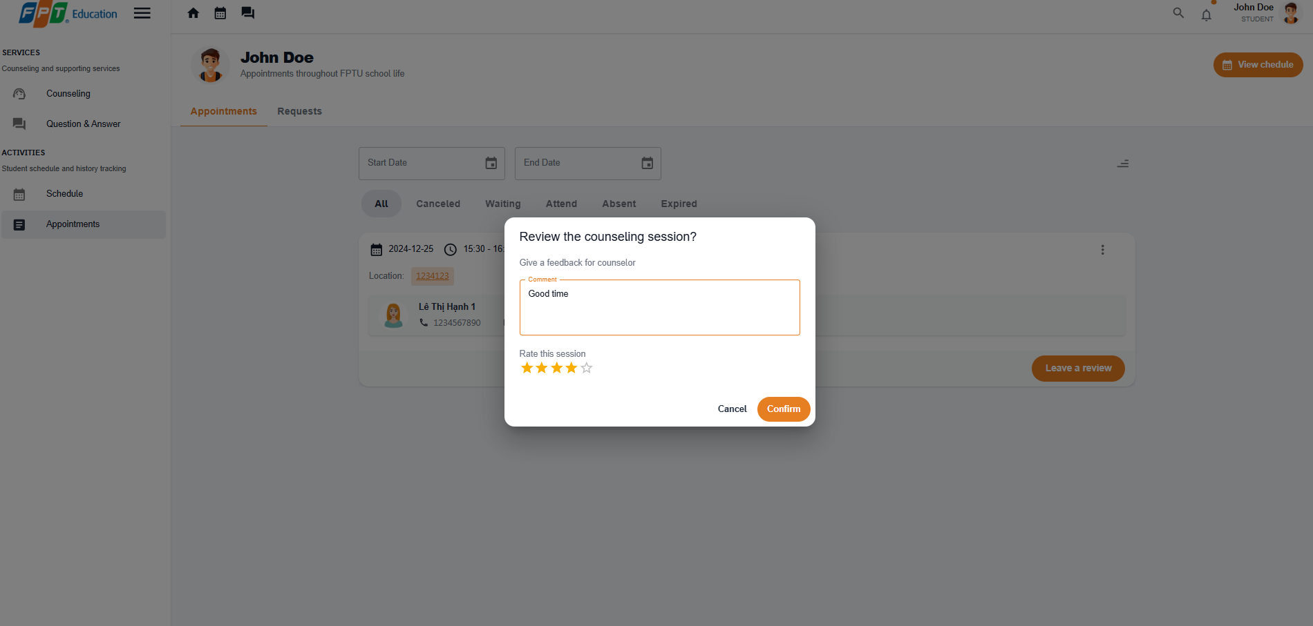

**Step 8:** View feedback after submitting in the appointments page.

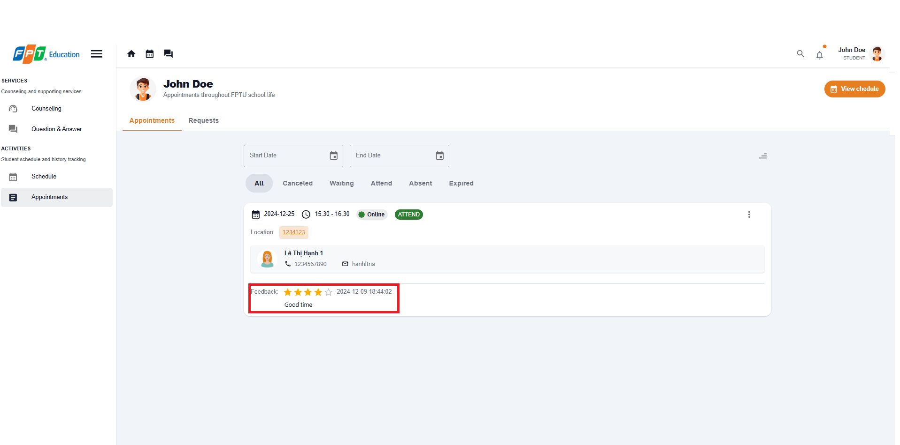

##### 3.2.2.7. Create report for an appointment

###### 3.2.2.7.1. Description

Use this guideline to log into the SCSS student account to write report for appointment

###### 3.2.2.7.2. Guide Steps:

**Step 1:** Access SCSS at http://scss-fe.azurewebsites.net/. Then fill in “Email” and “Password” of the counselor account.



**Step 2:** Click “Sign in ” button.



**Step 3:** From the homepage, choose “Appointments” from the left sidebar.



**Step 4:** In the Appointment page, find an appointment using the filter section by meeting date, and status. After finding an appointment (which status is “ATTEND”), press the more vert icon button, then choose the “Create Report” option.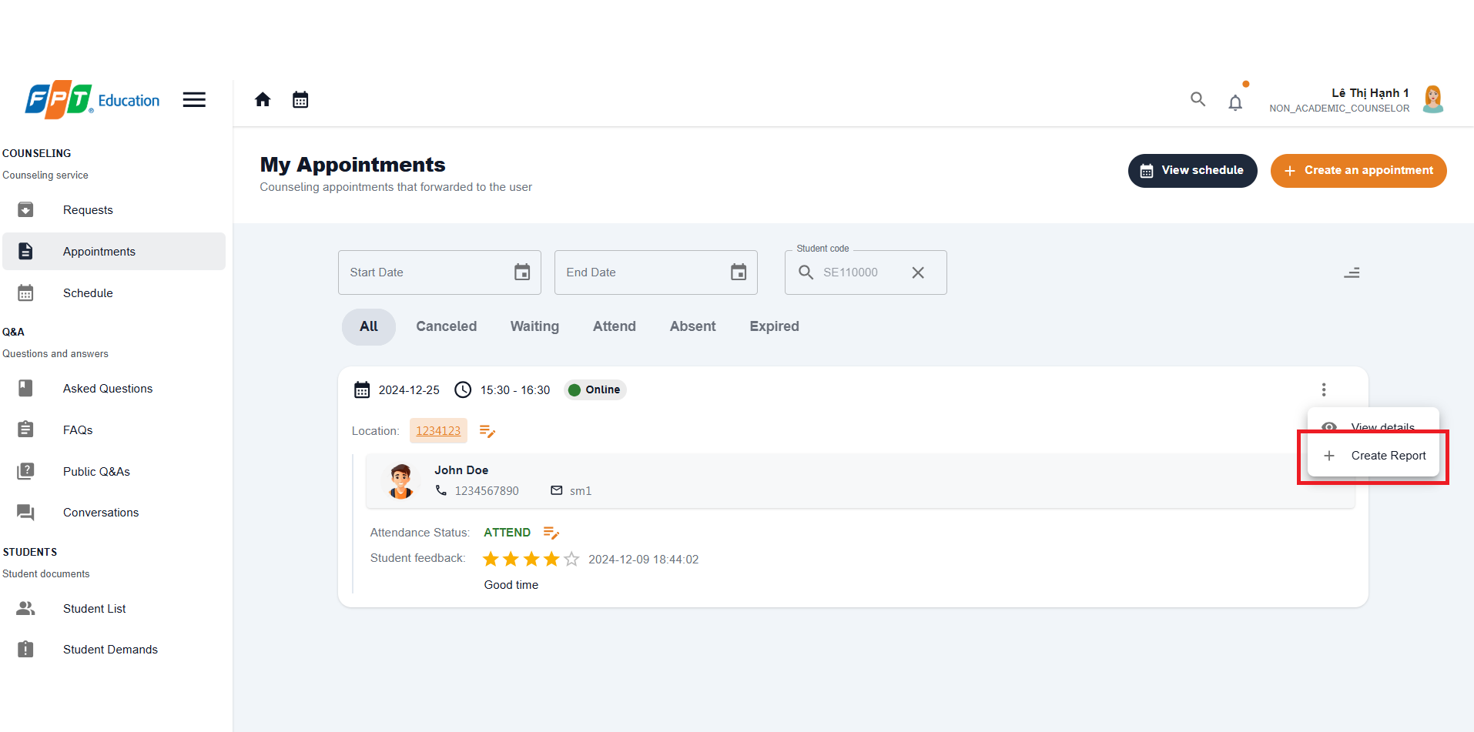

**Step 5:** Fill in the report form which requires 4 steps, including Goal, Content, Conclusion, Intervention. You can select Preview button before submitting to check full report.

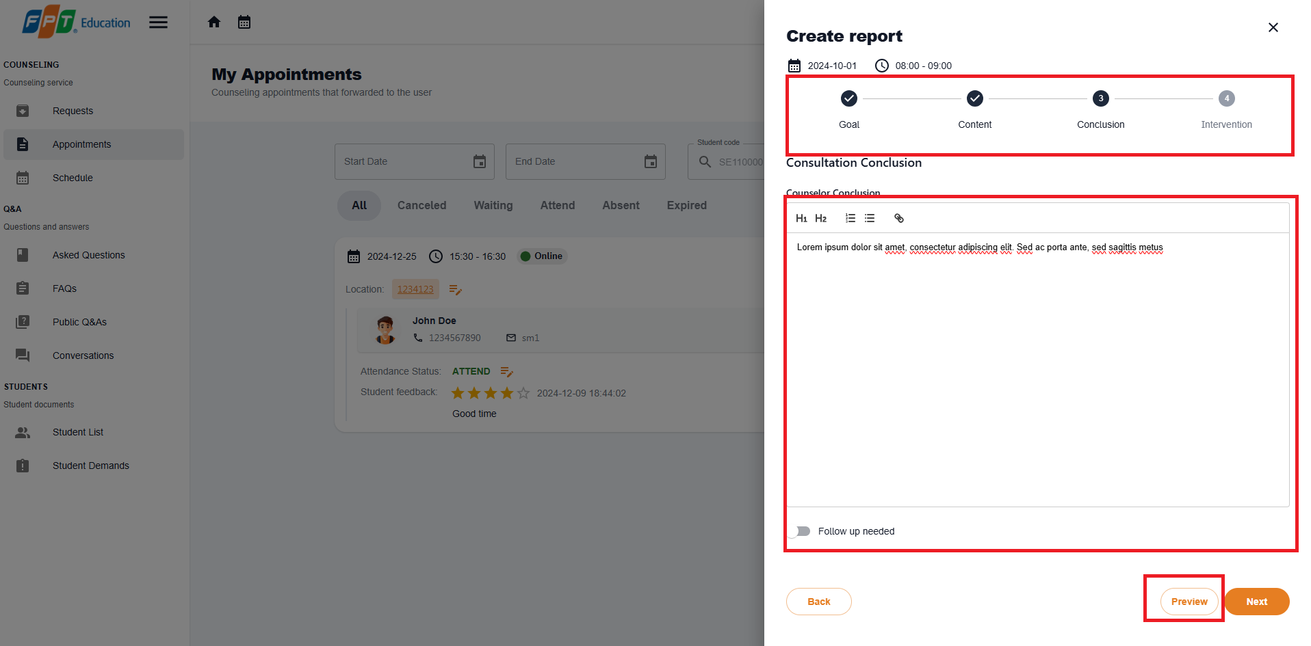

**Step 6:**.Select submit button. After confirmation, report will be created, then select more vert icon button again select View report option.

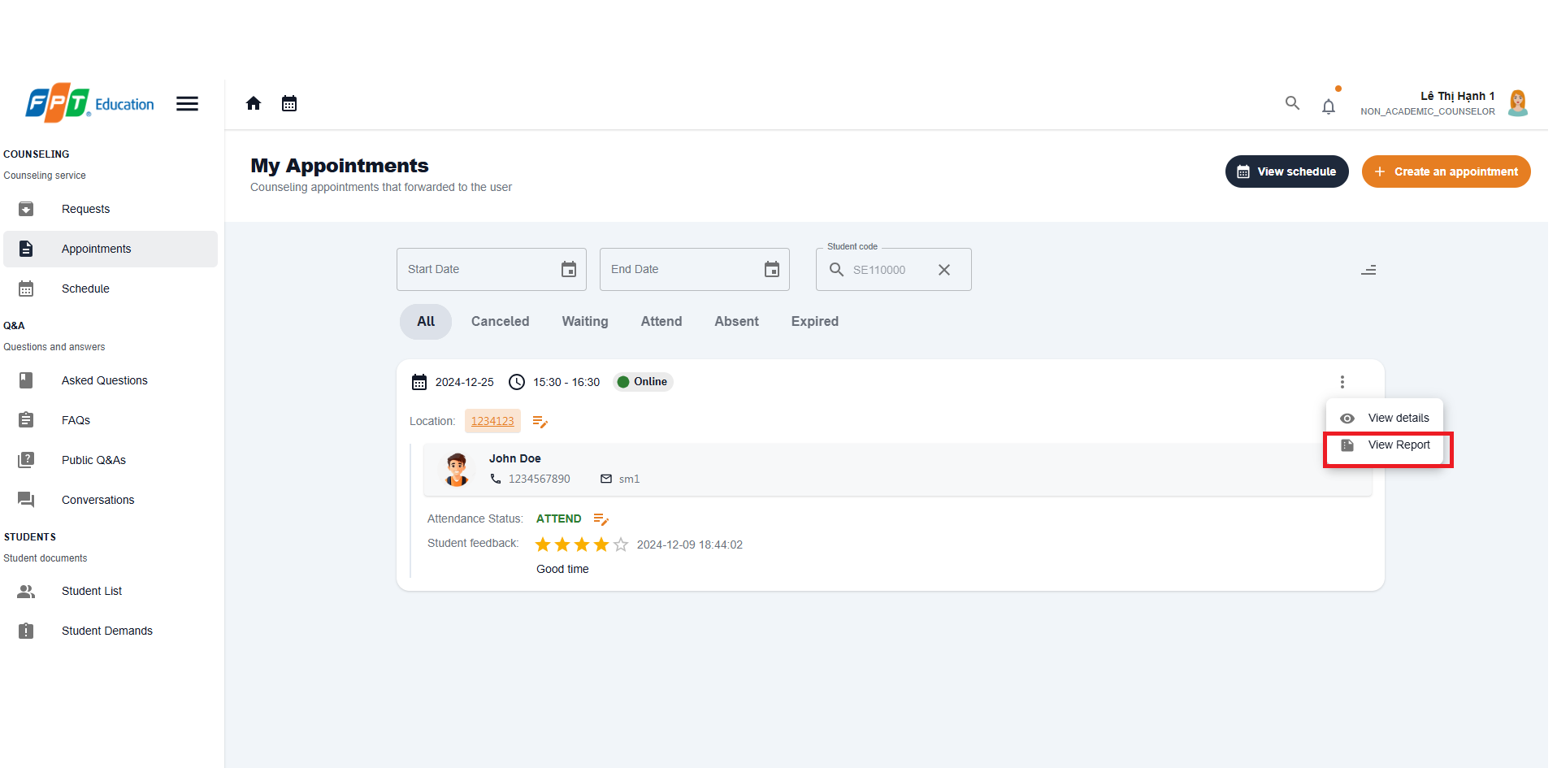

**Step 7:**.Check on newly created report.

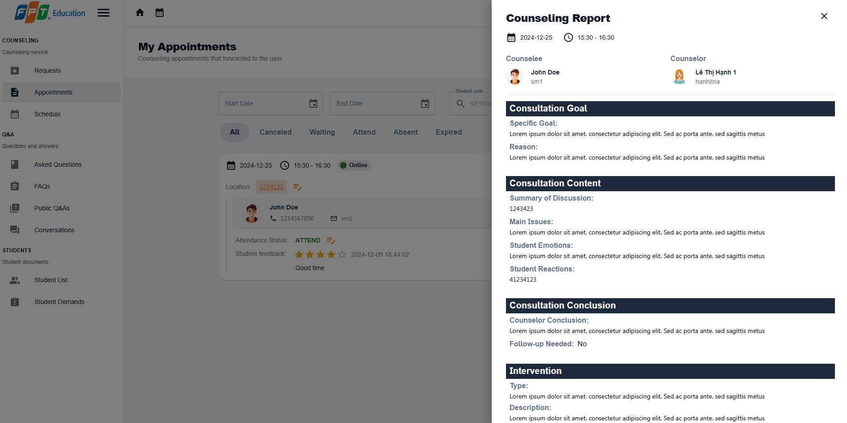

##### 3.2.2.8. Cancel an appointment

###### 3.2.2.8.1. Description

Use this guideline to log into the SCSS student account to cancel an appointment

###### 3.2.2.8.2. Guide Steps:

**Step 1:** Access SCSS at http://scss-fe.azurewebsites.net/. Then fill in “Email” and “Password” of the counselor or student account.



**Step 2:** Click “Sign in ” button.



**Step 3:** From the homepage, choose “Appointments” from the left sidebar.



**Step 4:** In the Appointment page, find an appointment using the filter section by meeting date, and status. After finding an appointment (which status is “ATTEND”), press the more vert icon button, then choose the “Cancel” option.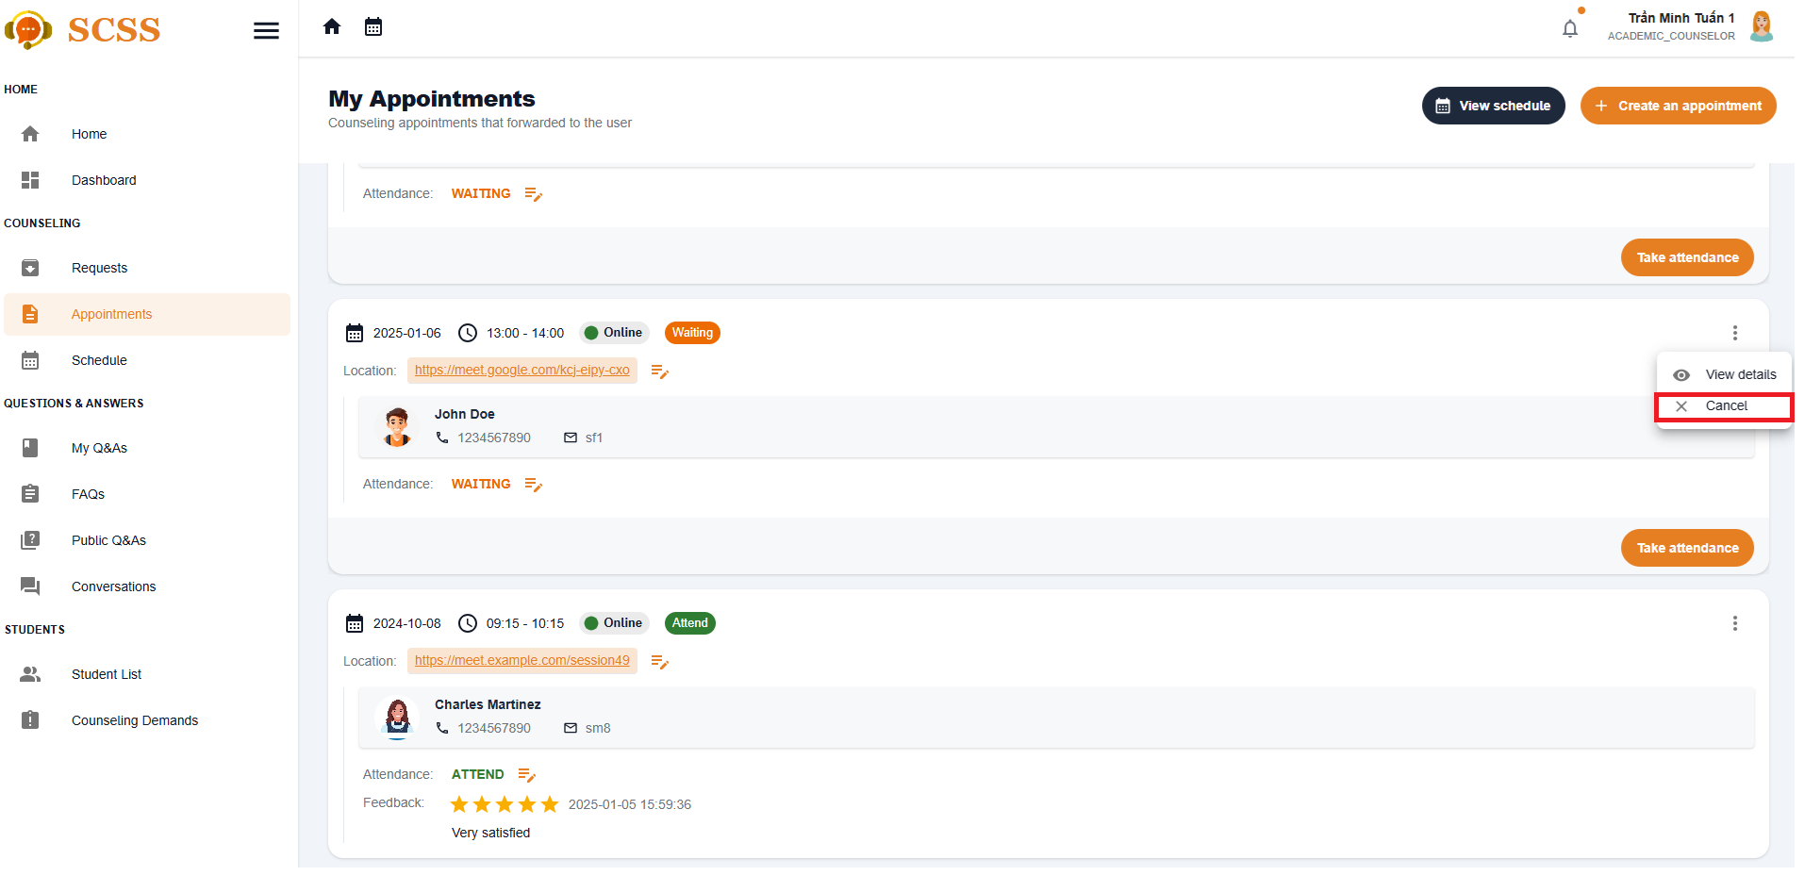

**Step 5:** Fill in the cancel reason, then press the “Confirm” button.

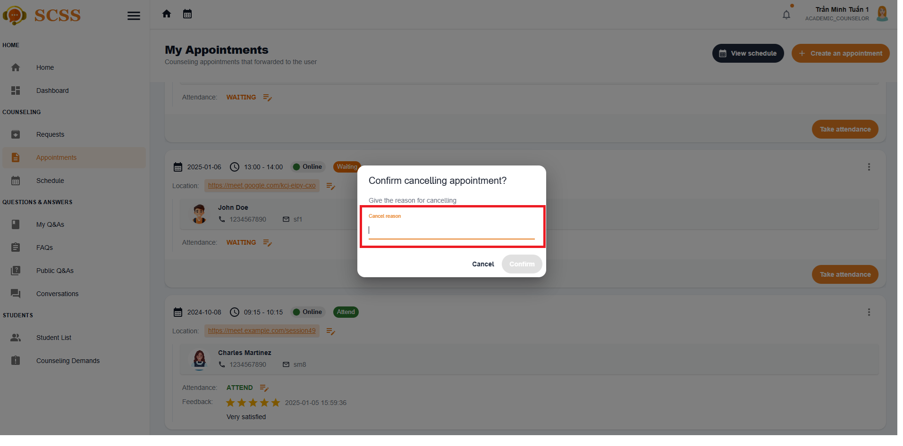

**Step 6:** The appointment status will be “Canceled”, and both student and counselor can see the cancel the reason.

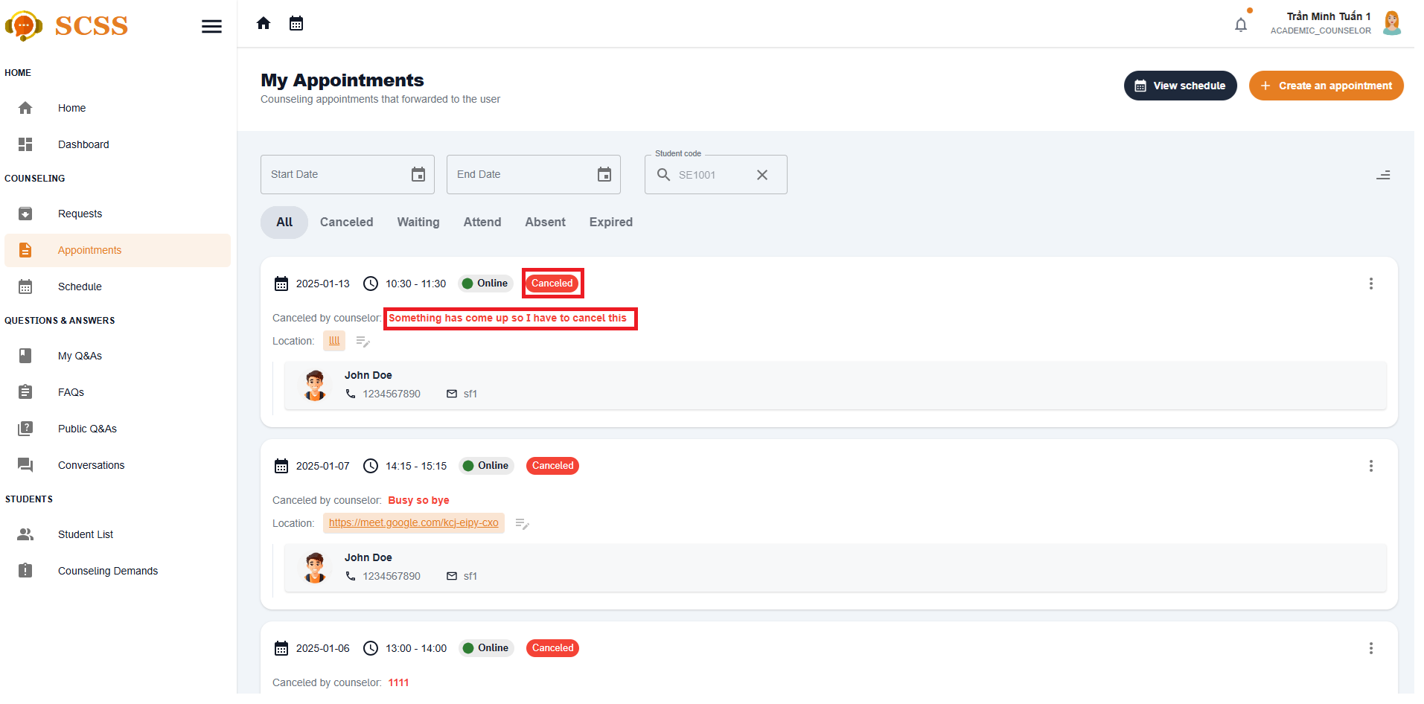

##### 3.2.2.9. View counseling schedule

###### 3.2.2.9.1. Description

Use this guideline to log into the SCSS student account to view counseling shedule

###### 3.2.2.9.2. Guide Steps:

**Step 1:** Access SCSS at http://scss-fe.azurewebsites.net/. Then fill in “Email” and “Password” of the counselor or student account.



**Step 2:** Click “Sign in ” button.



**Step 3:** From the homepage, choose “Appointments” from the left sidebar.

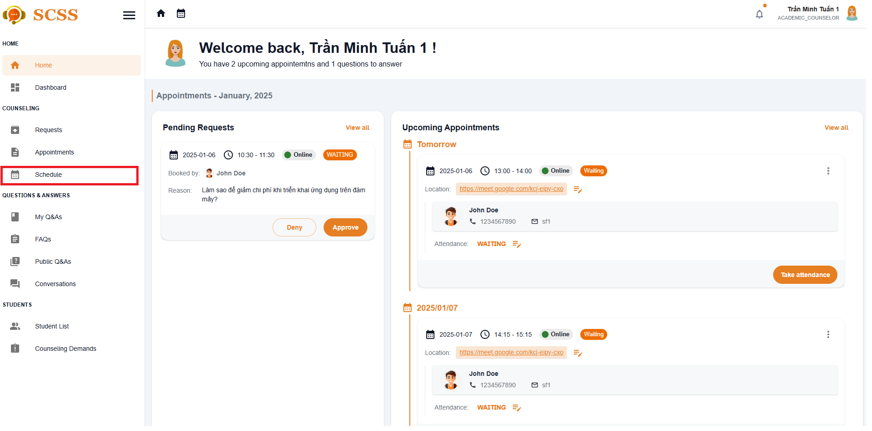

**Step 4:** In the schedule page, students or counselors can view their counseling schedule by monthly, weekly or daily.

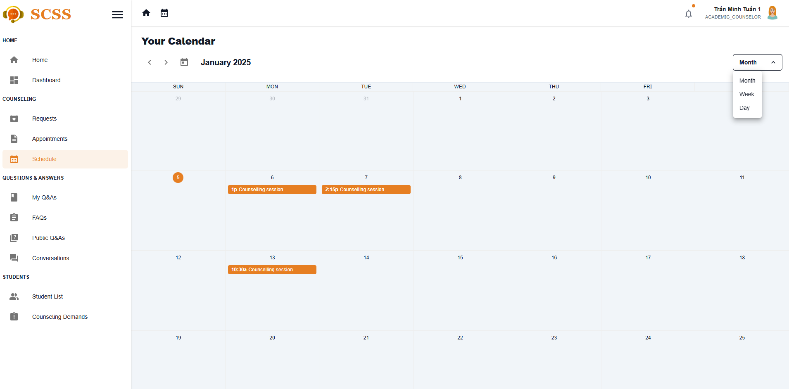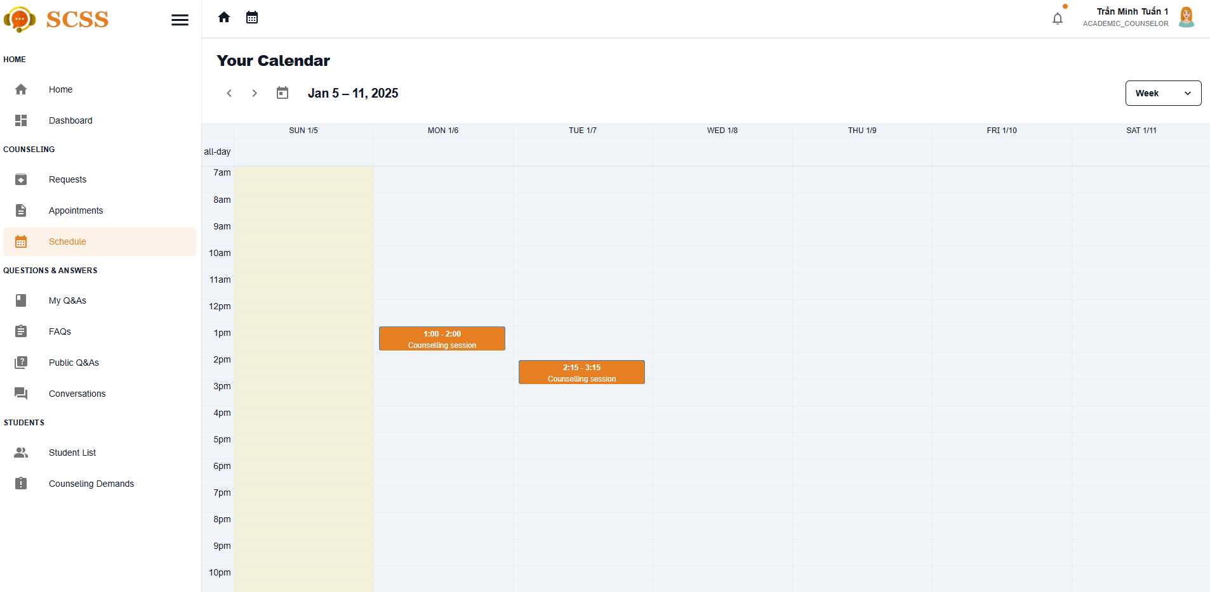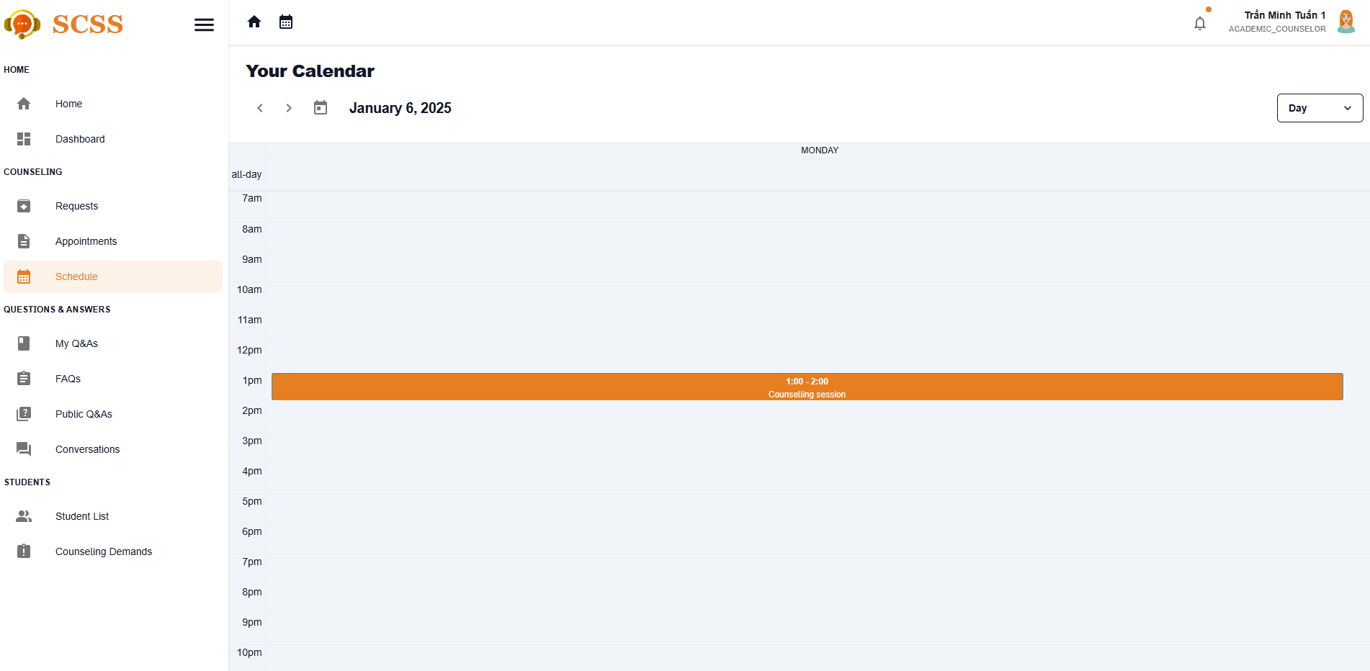

**Step 5:** Fill in the cancel reason, then press the “Confirm” button.



**Step 6:** The appointment status will be “Canceled”, and both student and counselor can see the cancel the reason.



#### 3.2.3. Question and answer

##### 3.2.3.1. Ask a question

###### 3.2.3.1.1 Description

Use this guideline to create a question for counselor

###### 3.2.3.1.2. Guide Steps:

**Step 1**: Access SCSS at http://scss-fe.azurewebsites.net/. Then fill in “Email” and “Password” of the student account.



**Step 2:** Click the “Sign in ” button.



**Step 3:** From the homepage, choose “Question & Answer” from the left sidebar.

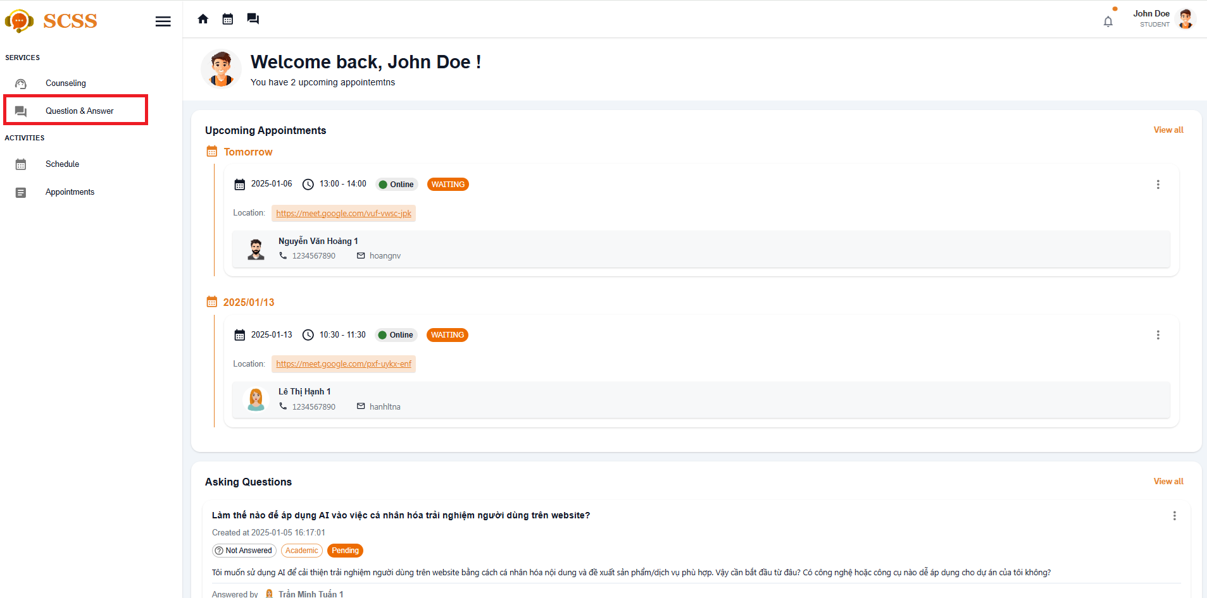

**Step 4:** In Q&A page, choose “Ask a button” at top right

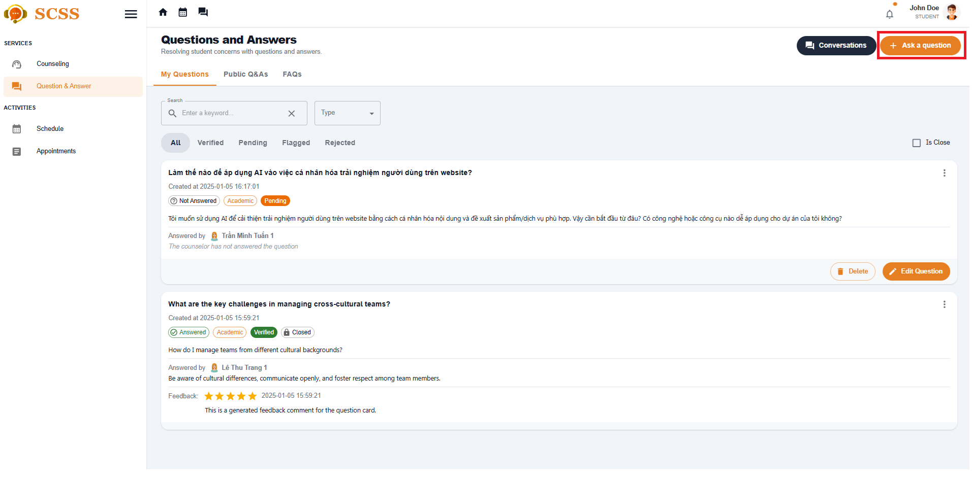

**Step 5:** Fill in question, content, question type and major, department, and expertise, then select “Submit” button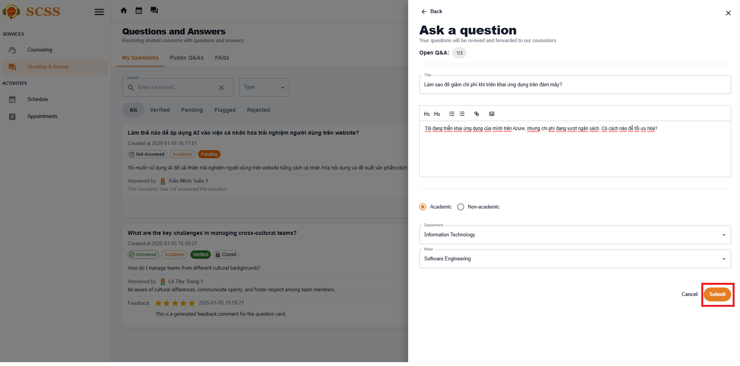

**Step 6:** There a dialog showed up to suggest similar Q&As before submitting. Then choose “Continue to proceed” and the question will be forwarded to suitable counselors.

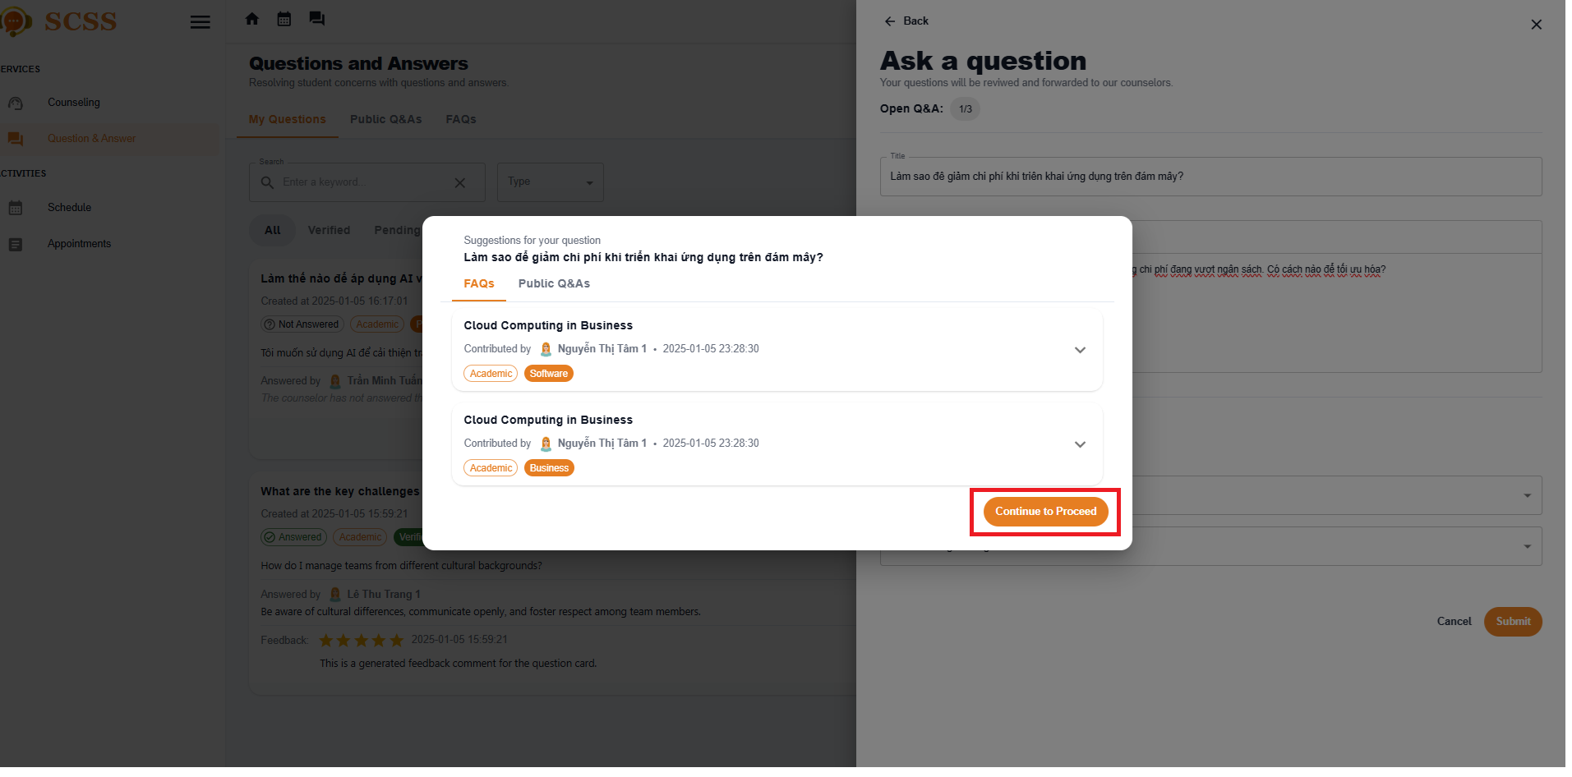

##### 3.2.3.2. Edit a question

###### 3.2.3.1.1 Description

Use this guideline to create a question for counselor

###### 3.2.3.1.2. Guide Steps:

**Step 1**: Access SCSS at http://scss-fe.azurewebsites.net/. Then fill in “Email” and “Password” of the student account.



**Step 2:** Click the “Sign in ” button.



**Step 3:** From the homepage, choose “Question & Answer” from the left sidebar.

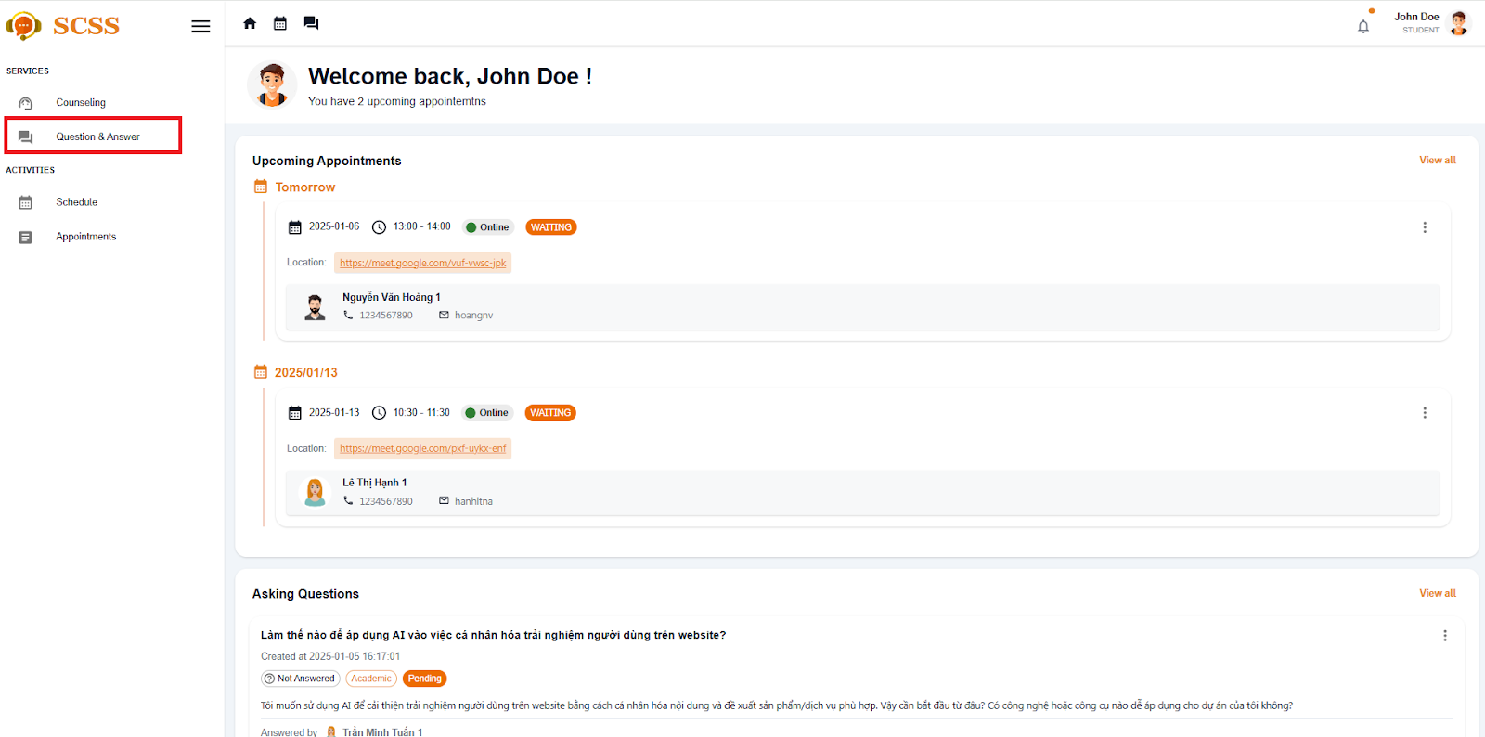

**Step 4:** Select “edit question“ button if the question is not answered yet.

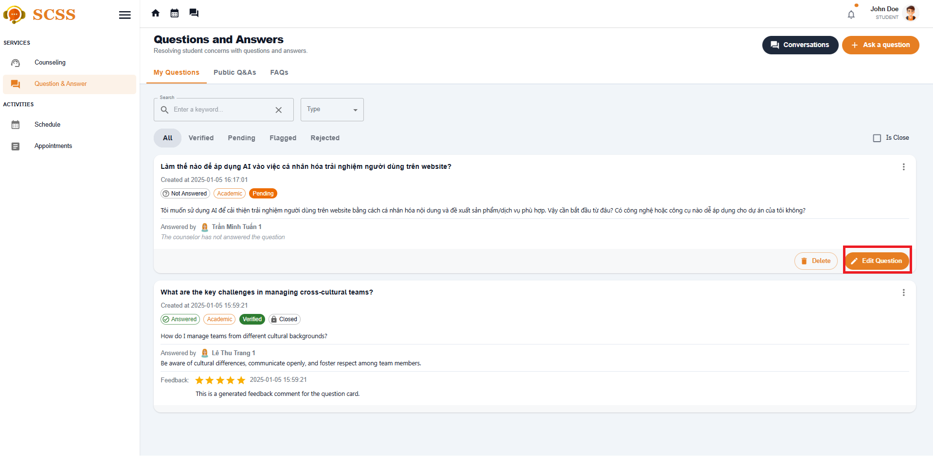

**Step 5:** Update title and content of question then select Save button.

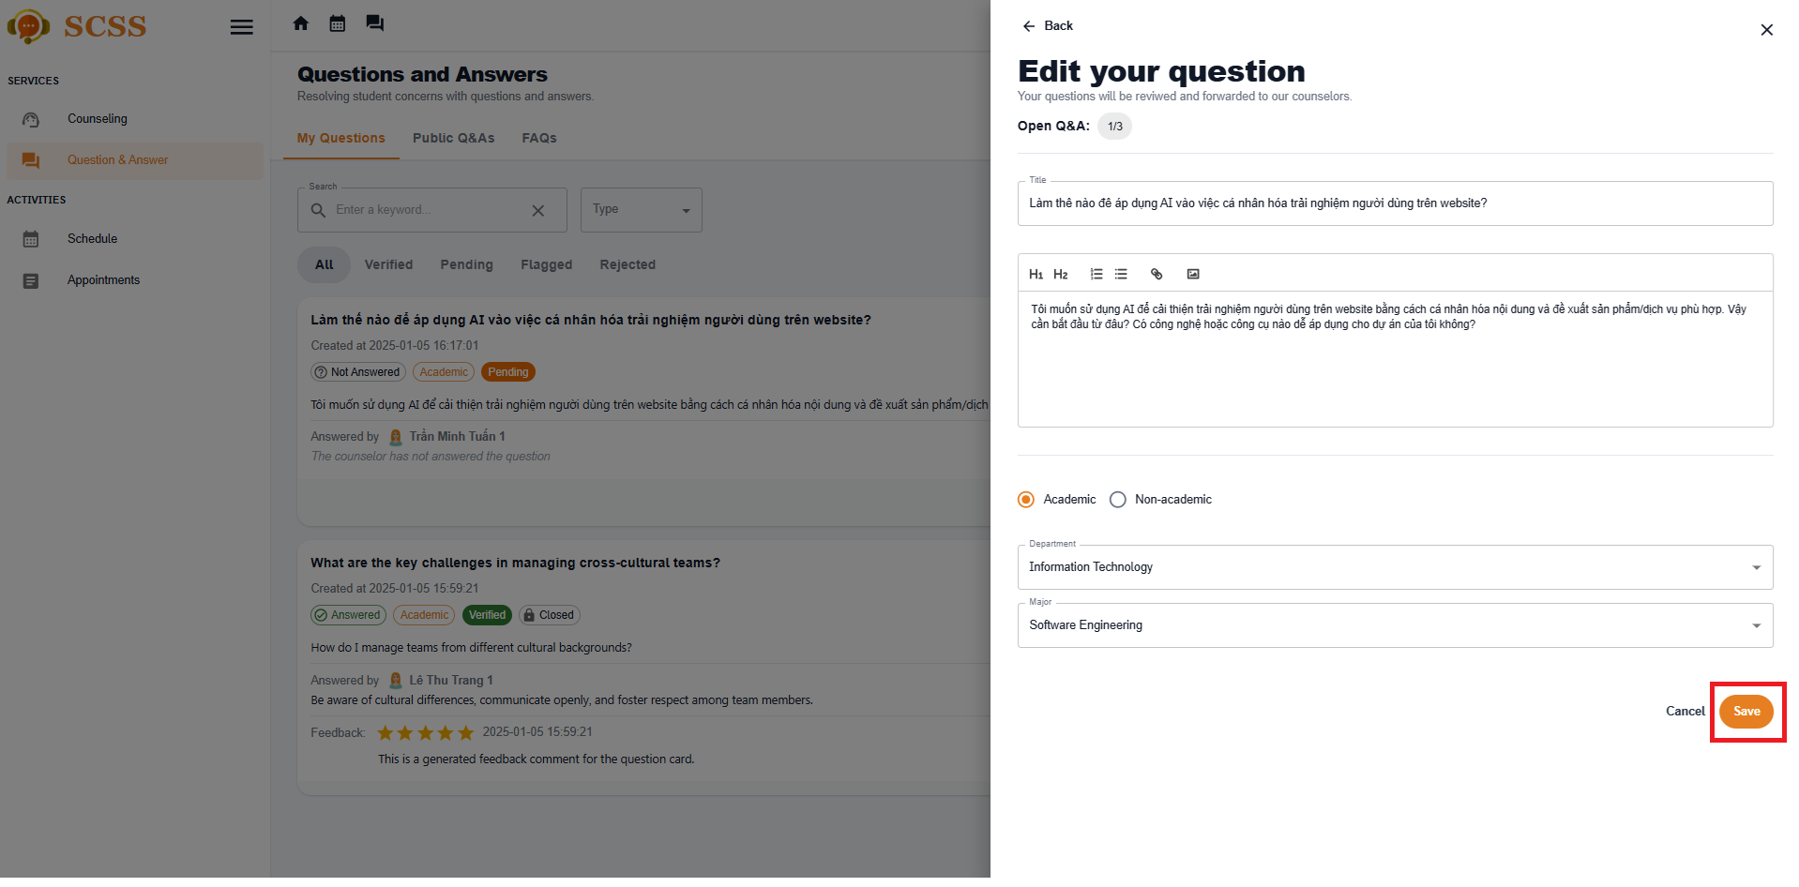

##### 3.2.3.3. Answer a question

###### 3.2.3.3.1 Description

Use this guideline to create a question for counselor

###### 3.2.3.3.2. Guide Steps:

**Step 1**: Access SCSS at http://scss-fe.azurewebsites.net/. Then fill in “Email” and “Password” of the counselor account.



**Step 2:** Click the “Sign in ” button.



**Step 3:** From the homepage, choose “My Q&A” from the left sidebar.

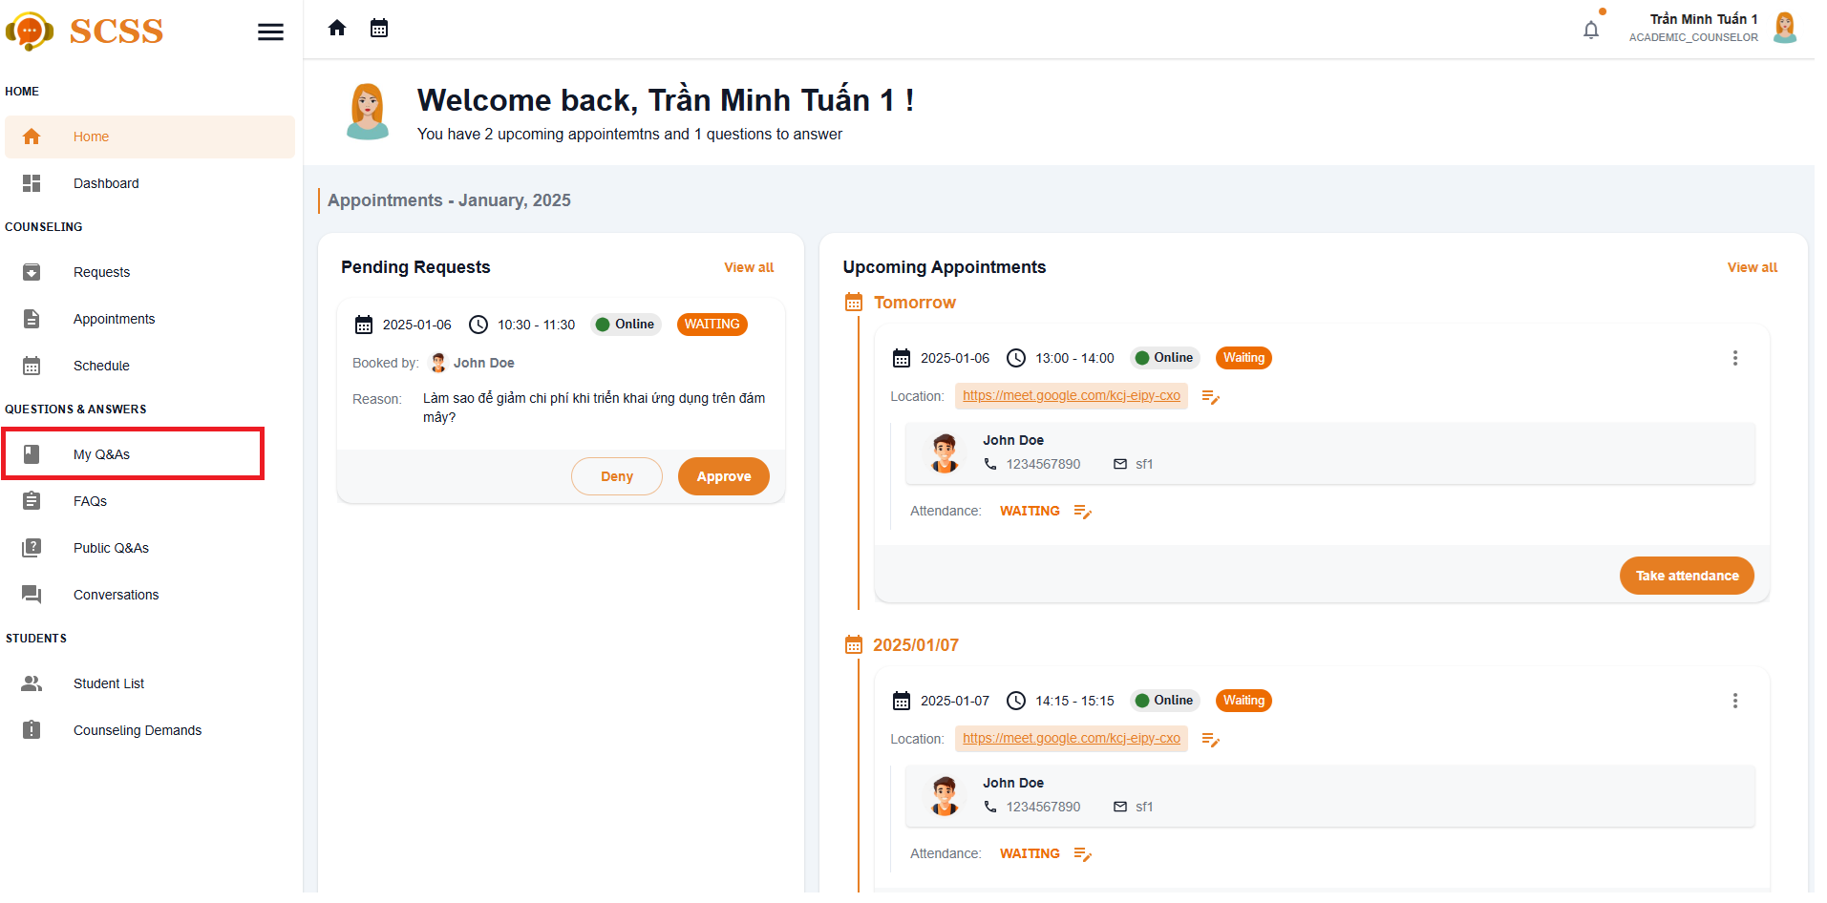

**Step 4:** Select “Answer“ button and a Answer dialog will show up

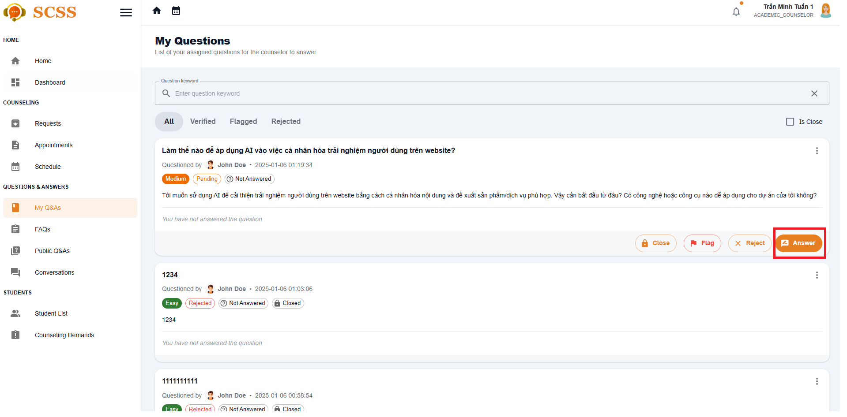

**Step 5:** Fill in the answer for the question then select the Submit button.

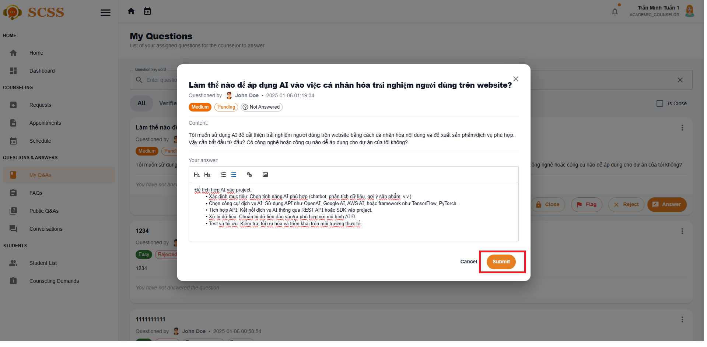

##### 3.2.3.4. Edit your answer

3.2.3.4.1 Description

Use this guideline to create a question for counselor

3.2.3.4.2. Guide Steps:

**Step 1**: Access SCSS at http://scss-fe.azurewebsites.net/. Then fill in “Email” and “Password” of the counselor account.



**Step 2:** Click the “Sign in ” button.



**Step 3:** From the homepage, choose “My Q&As” from the left sidebar.



**Step 4:** Select “Edit your answer·“ button and a Answer dialog will show up

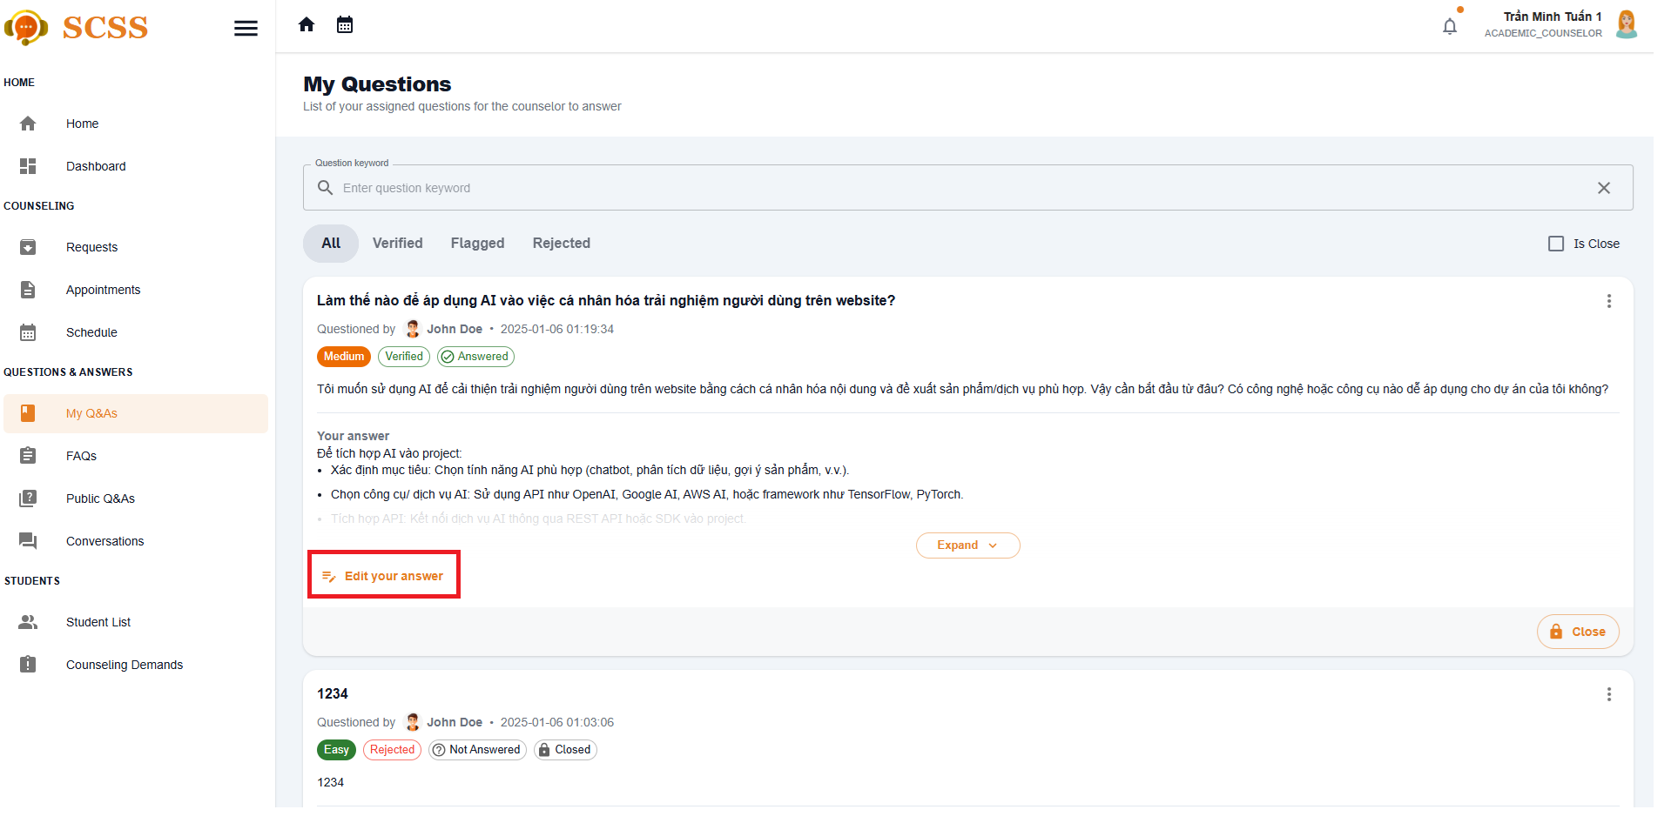

**Step 5:** Fill in the answer for the question then select the save button.



##### 3.2.3.5. Chat about a question

3.2.3.5.1 Description

Use this guideline to create a question for counselor

3.2.3.5.2. Guide Steps:

**Step 1**: Access SCSS at http://scss-fe.azurewebsites.net/. Then fill in “Email” and “Password” of the student account.



**Step 2:** Click the “Sign in ” button.



**Step 3:** From the homepage, choose “Question & Answer” from the left sidebar.



**Step 4:** In Q&A page, select the question which has already been answered, and select Start to chat button

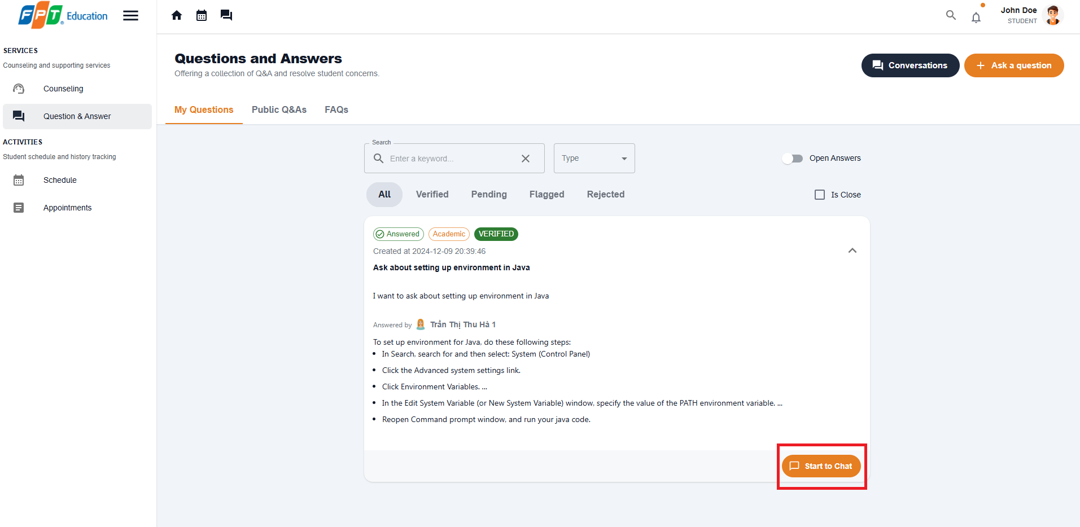

**Step 5:** A chat session will show up and you can chat with the counselor for the question is closed.

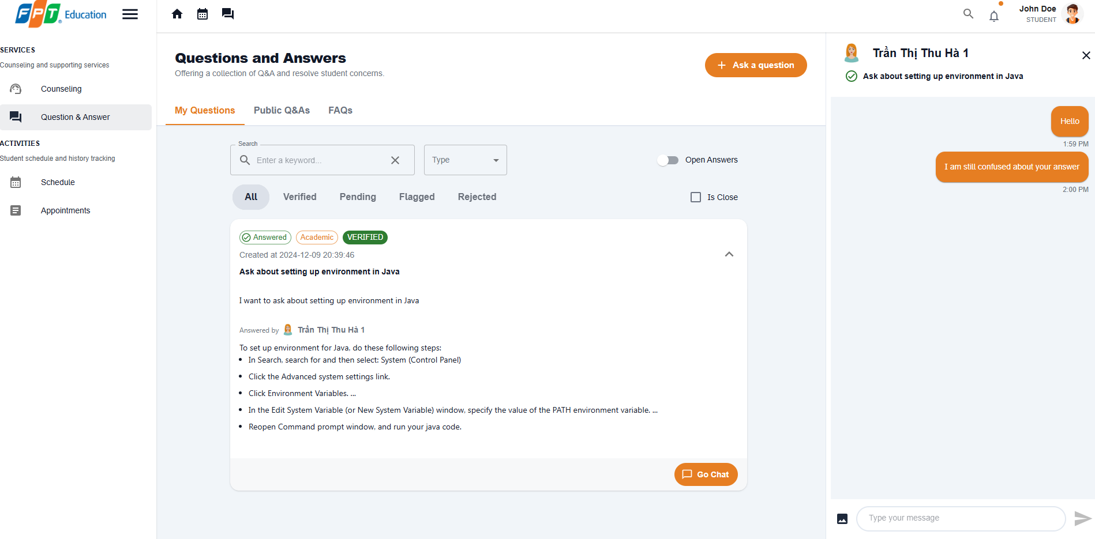

##### 3.2.3.6. Close a question

3.2.3.6.1 Description

Use this guideline to create a question for counselor

3.2.3.6.2. Guide Steps:

**Step 1**: Access SCSS at http://scss-fe.azurewebsites.net/. Then fill in “Email” and “Password” of the student account.



**Step 2:** Click the “Sign in ” button.



**Step 3:** From the homepage, choose “My Q&As” from the left sidebar.



**Step 4:** Select “Close“ button and a confirmation dialog will show up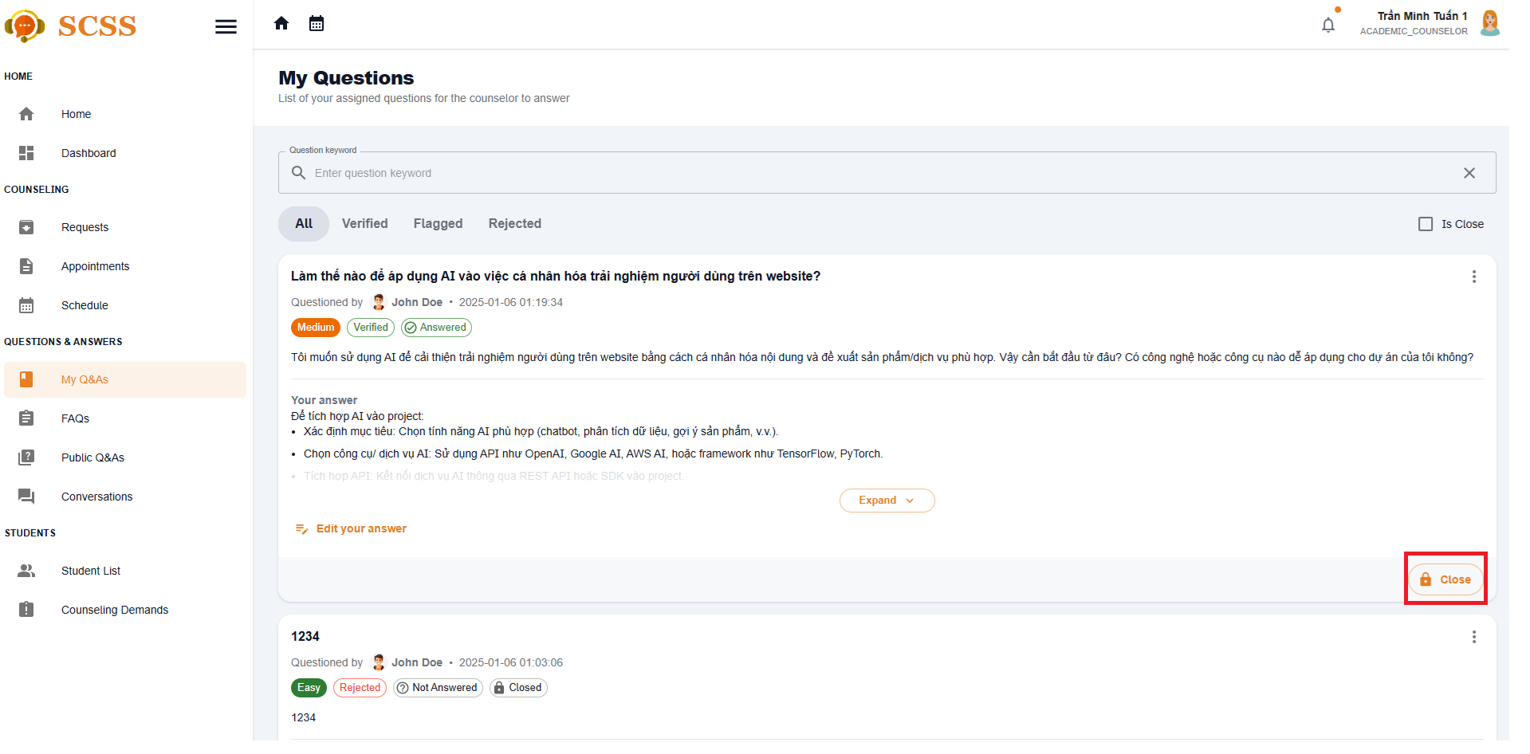

**Step 5:** After confirming, the question will be closed and the asked student will no longer be able to chat.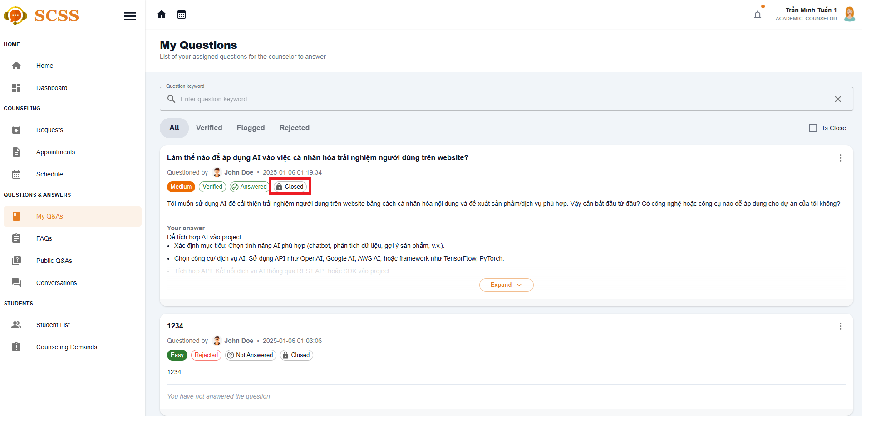

##### 3.2.3.7. Contribute to FAQ

3.2.3.3.7 Description

Use this guideline to create a question for counselor

3.2.3.3.7. Guide Steps:

**Step 1**: Access SCSS at http://scss-fe.azurewebsites.net/. Then fill in “Email” and “Password” of the counselor account.



**Step 2:** Click the “Sign in ” button.



**Step 3:** From the homepage, choose “FAQ” from the left sidebar.

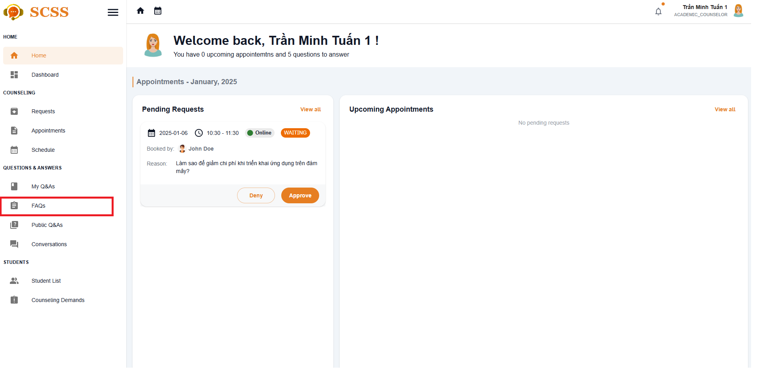

**Step 4:** Select “Contribute to FAQ“ button in FAQ page 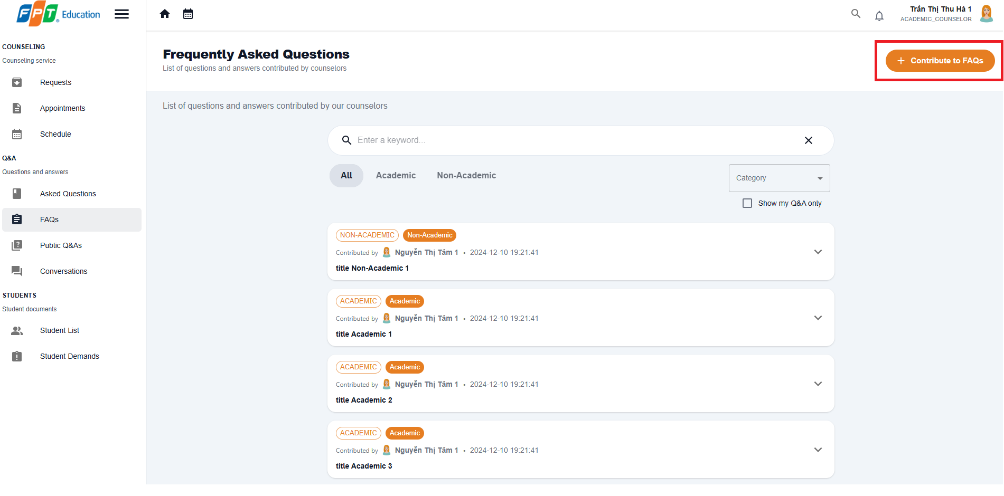

**Step 5:** Enter category, title, question content, answer. Then select “Submit“ button

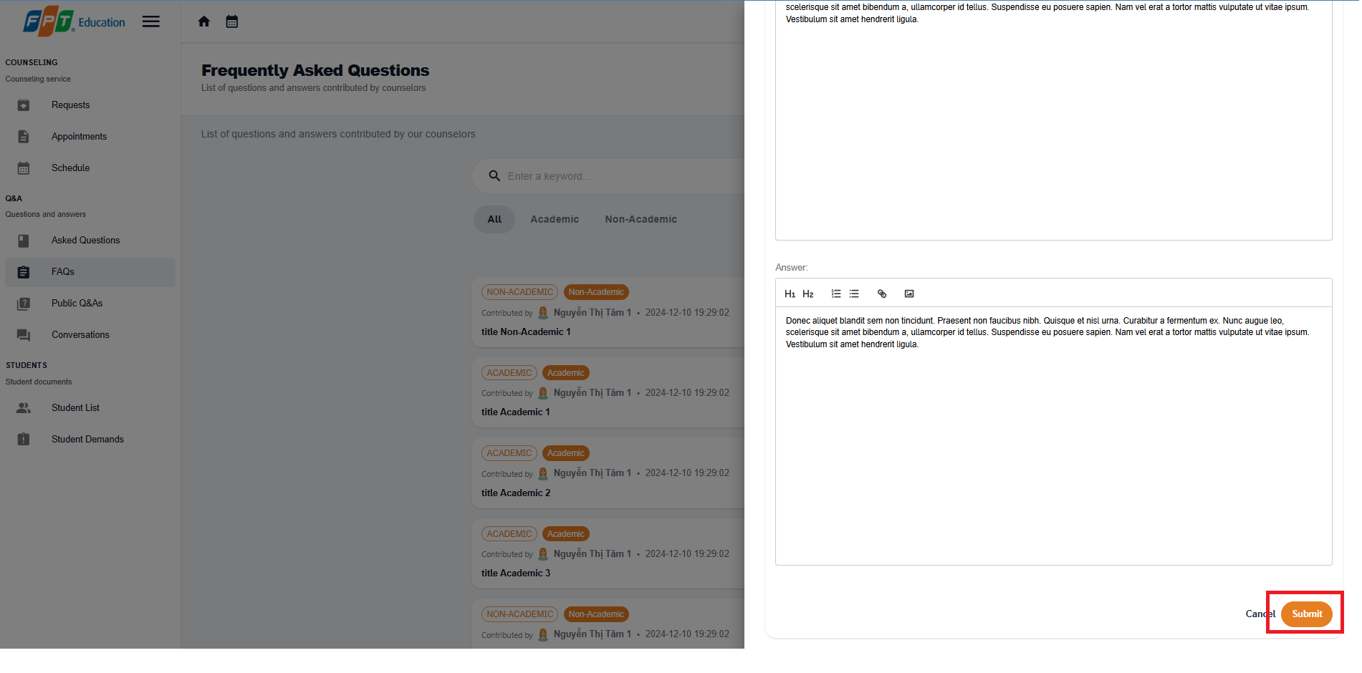

**Step 6:** In the FAQ page, you can select the “Show my Q&A only“ button to view your created Q&A.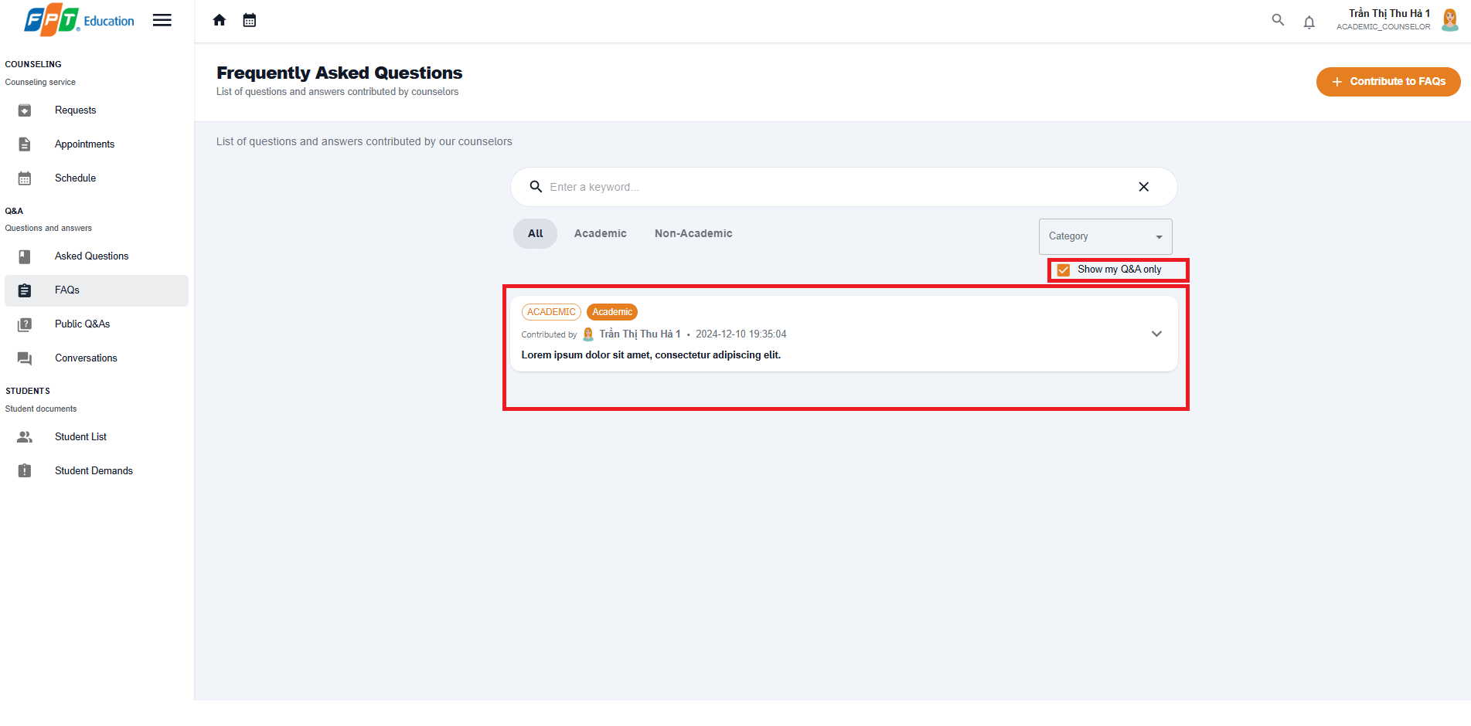

##### 3.2.3.8. Edit contributed FAQ

3.2.3.3.8 Description

Use this guideline to create a question for counselor

3.2.3.3.8. Guide Steps:

**Step 1**: Access SCSS at http://scss-fe.azurewebsites.net/. Then fill in “Email” and “Password” of the counselor account.



**Step 2:** Click the “Sign in ” button.



**Step 3:** From the homepage, choose “FAQ” from the left sidebar.



**Step 4:** Select “Edit“ button in FAQ page 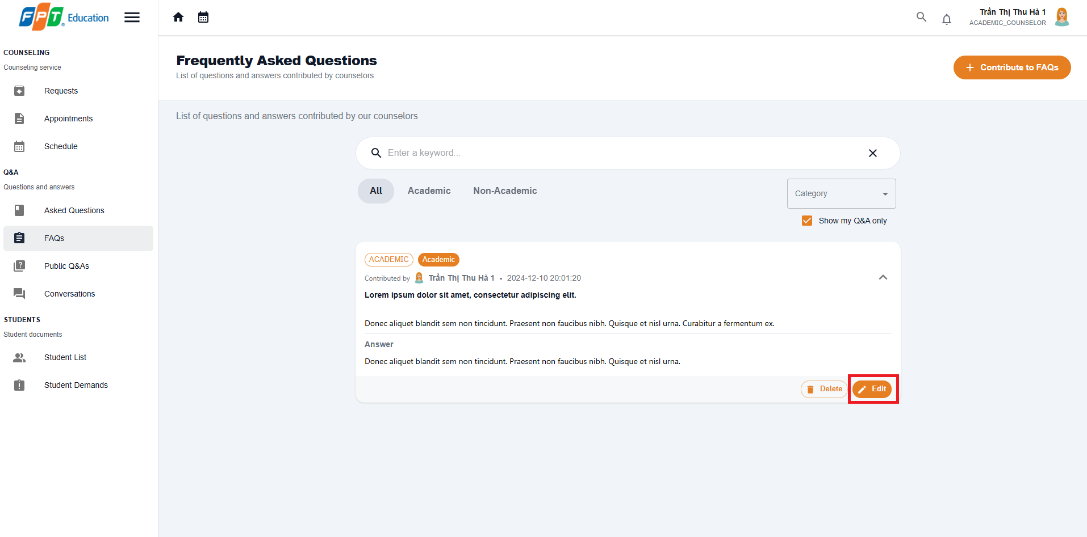

**Step 5:** Enter new category, title, question content, answer. Then select “Submit“ button



**Step 6:** In the FAQ page, you can select the “Show my Q&A only“ button to view your Q&A.

##### 3.2.3.9. Reject a question

3.2.3.9.1 Description

Use this guideline to reject a question for counselor

3.2.3.9.2. Guide Steps:

**Step 1**: Access SCSS at http://scss-fe.azurewebsites.net/. Then fill in “Email” and “Password” of the counselor account.



**Step 2:** Click the “Sign in ” button.



**Step 3:** From the homepage, choose “My Q&A” from the left sidebar.



**Step 4:** Select “Reject“ button and a Reject dialog will show up

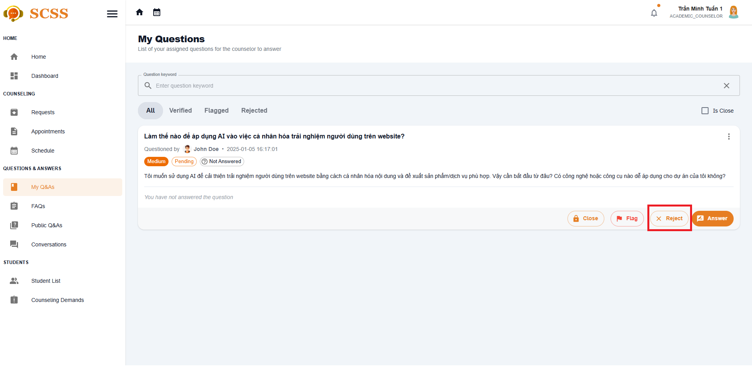

**Step 5:** Fill in the reject reason for the question then select the Submit button.

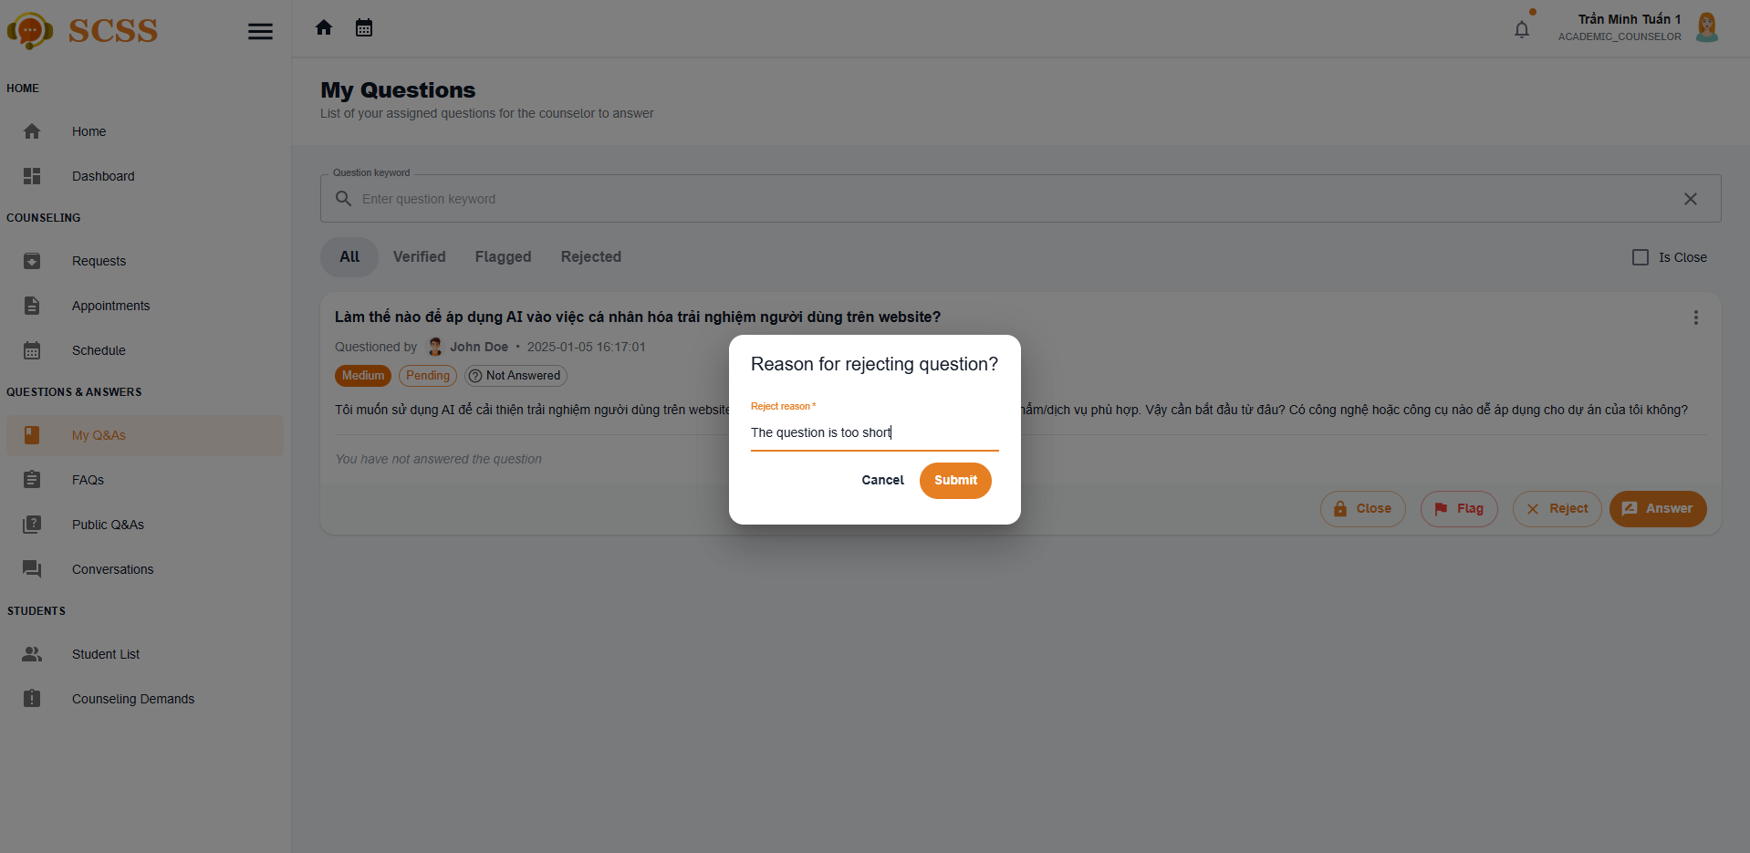

**Step 6:** The reject reason will be showed with rejected status

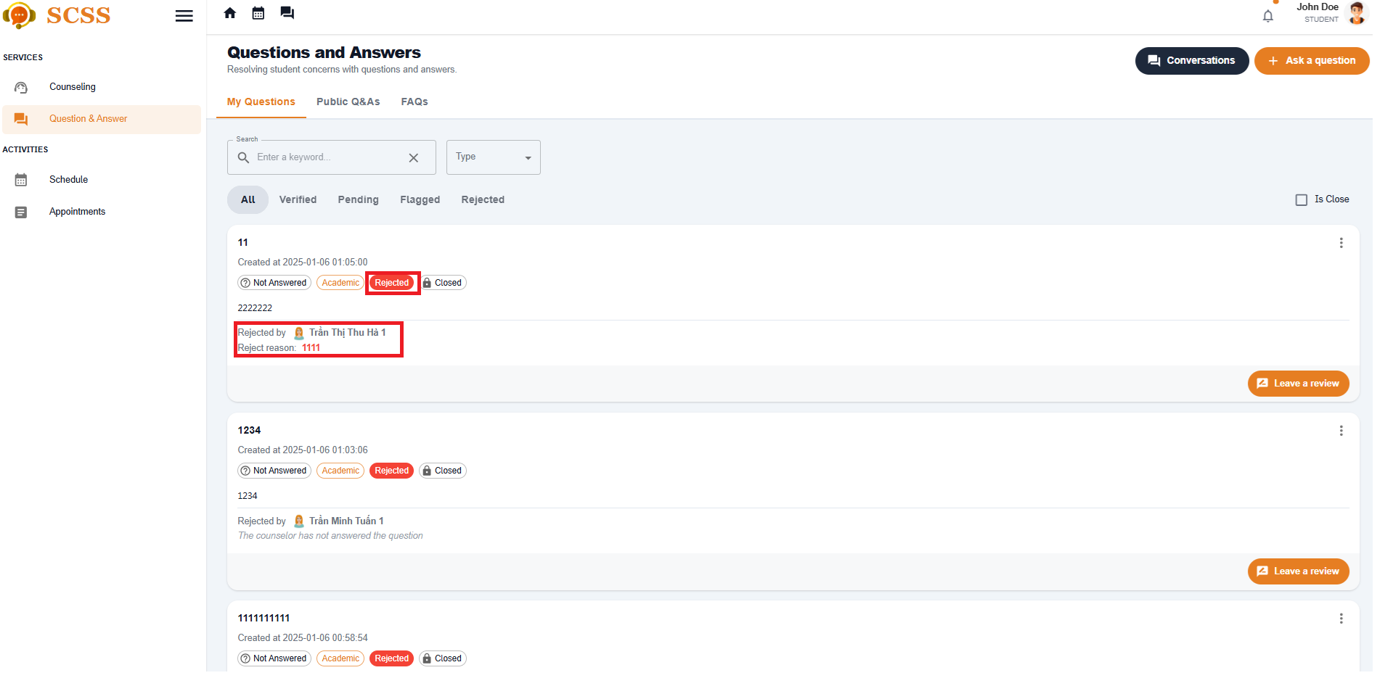

##### 3.2.3.10. Flag a question

3.2.3.10.1 Description

Use this guideline to flag a question for counselor

3.2.3.10.2. Guide Steps:

**Step 1**: Access SCSS at http://scss-fe.azurewebsites.net/. Then fill in “Email” and “Password” of the counselor account.



**Step 2:** Click the “Sign in ” button.



**Step 3:** From the homepage, choose “My Q&A” from the left sidebar.



**Step 4:** Select “Reject“ button and a Reject dialog will show up

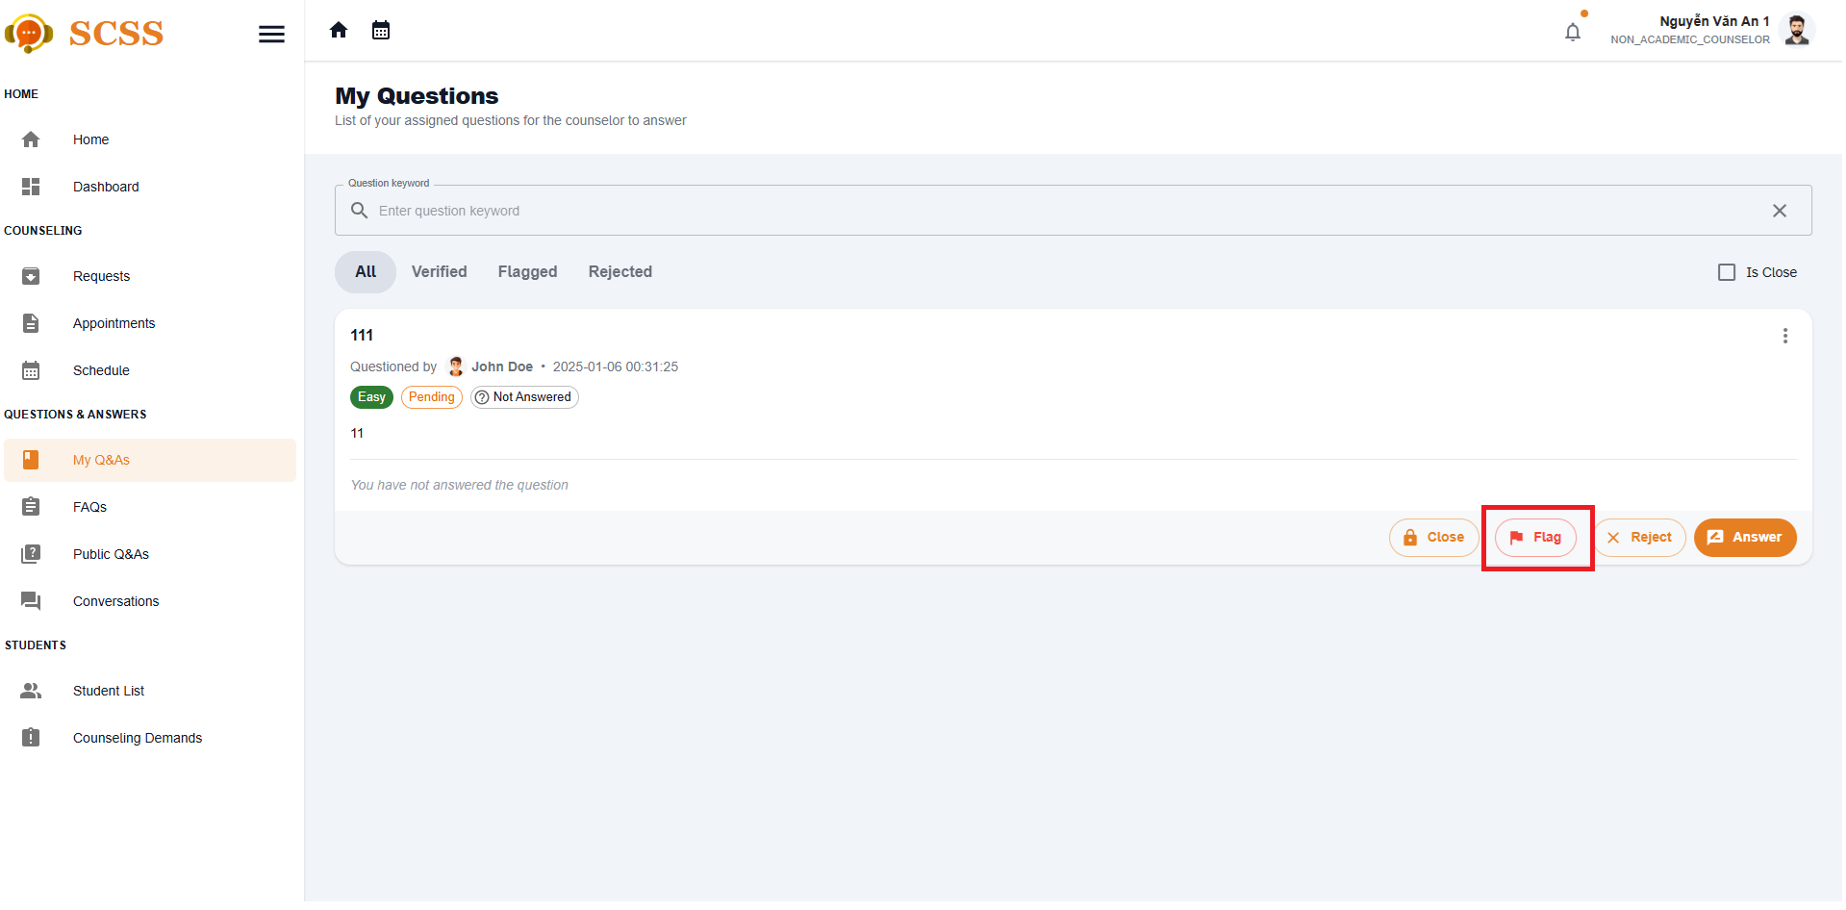

**Step 5:** Fill in the reject reason for the question then select the Submit button.



**Step 6:** The flag reason will be showed with flag status

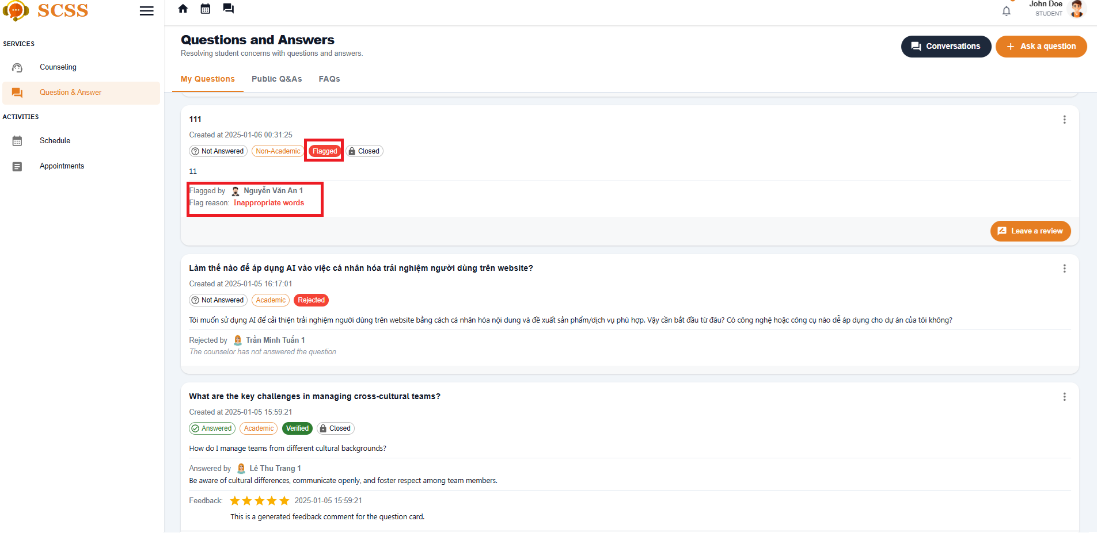

#### 3.2.4. Counseling demand

##### 3.2.4.1. Create counseling demand

3.2.4.1.1 Description

Use this guideline to create a counseling for a student

3.2.4.1.2. Guide Steps:

**Step 1**: Access SCSS at http://scss-fe.azurewebsites.net/. Then fill in “Email” and “Password” of the support staff account.



**Step 2:** Click the “Sign in ” button.



**Step 3:** From the homepage, choose “Recommended Students” new problematic students or ”Student List” for all students from the left sidebar.

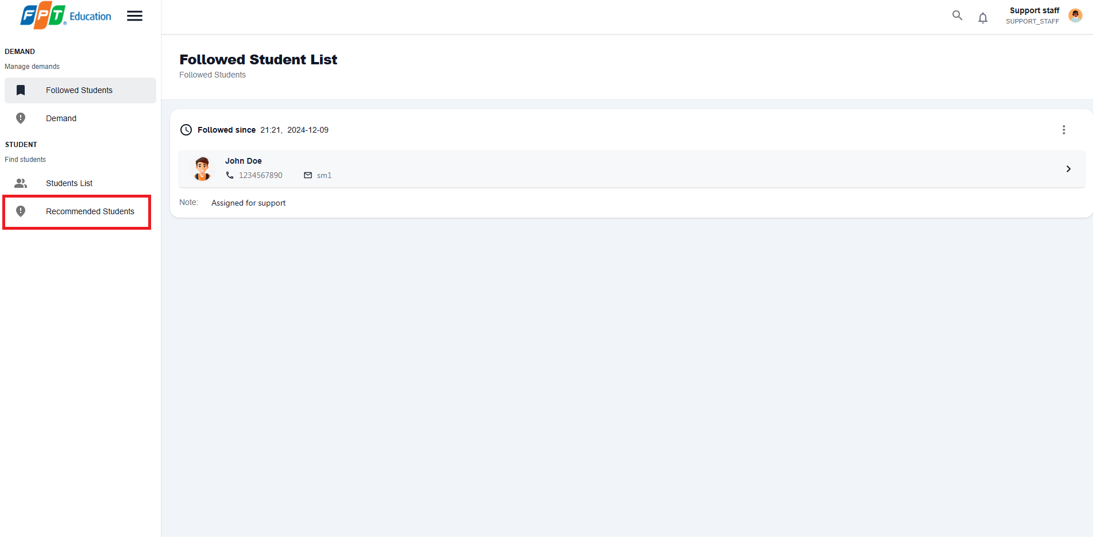

**Step 4:** Select a student, in student detail, select “Follow Student“ button to the added the student to the Followed List for further actions.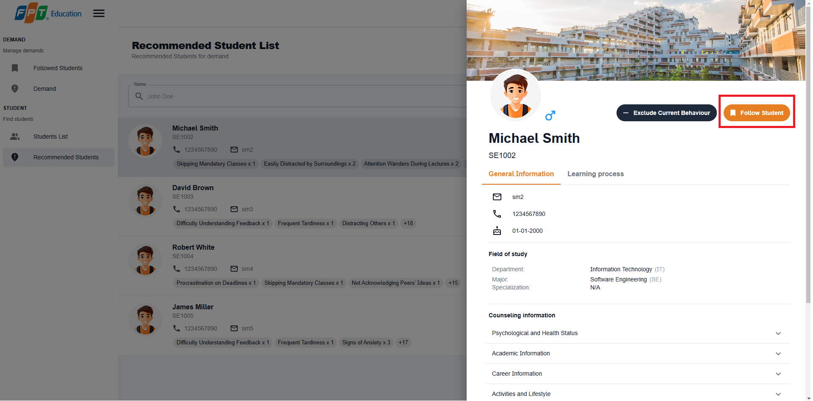

**Step 5:** Choose “Student List” from the left sidebar.

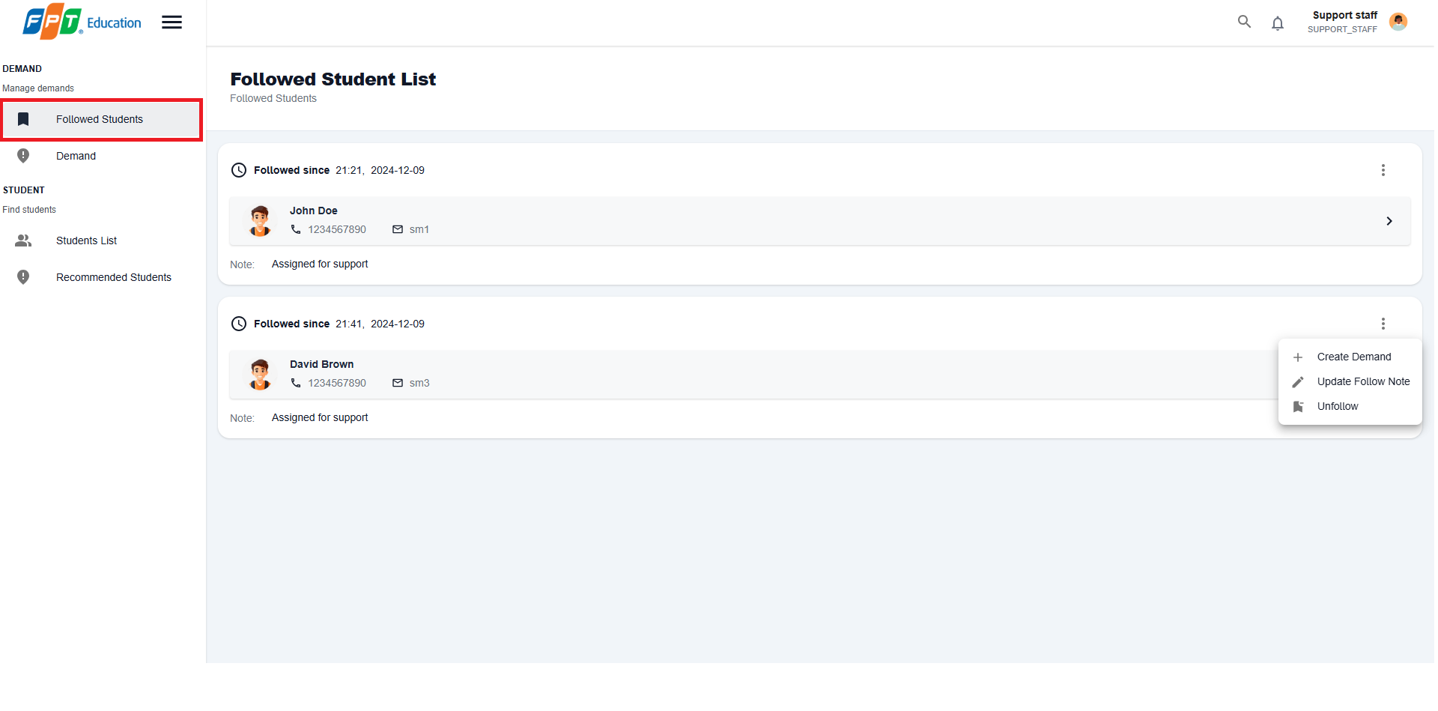

**Step 6:** Select more vert icon button from a student, then select Create Demand option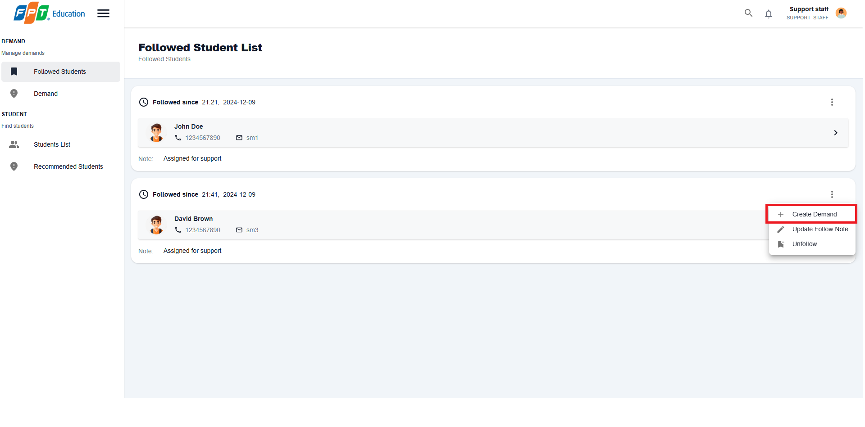

**Step 6:** Select a suitable counselor and fill in counseling demand form

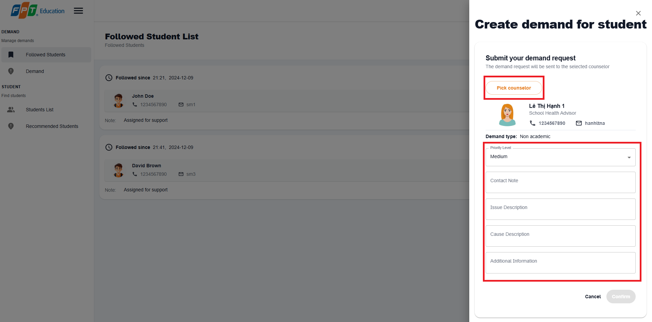

**Step 7:** Select confirm button and new demand will be created

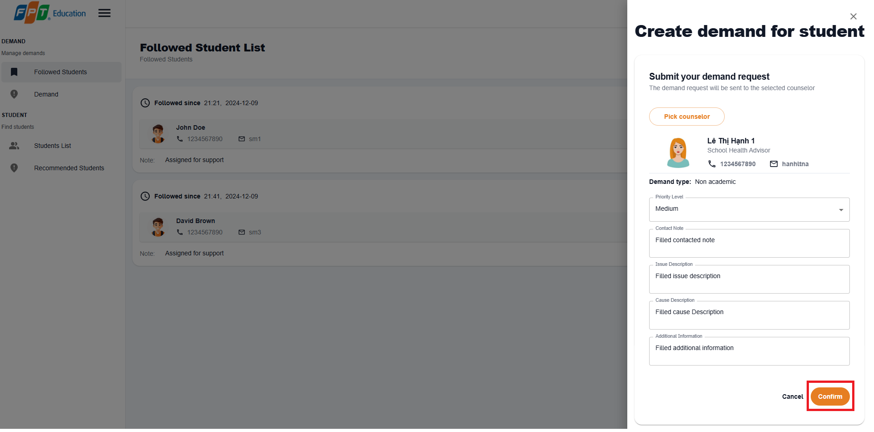

**Step 8:** Choose ” Demand” from the left sidebar and view your newly created demand

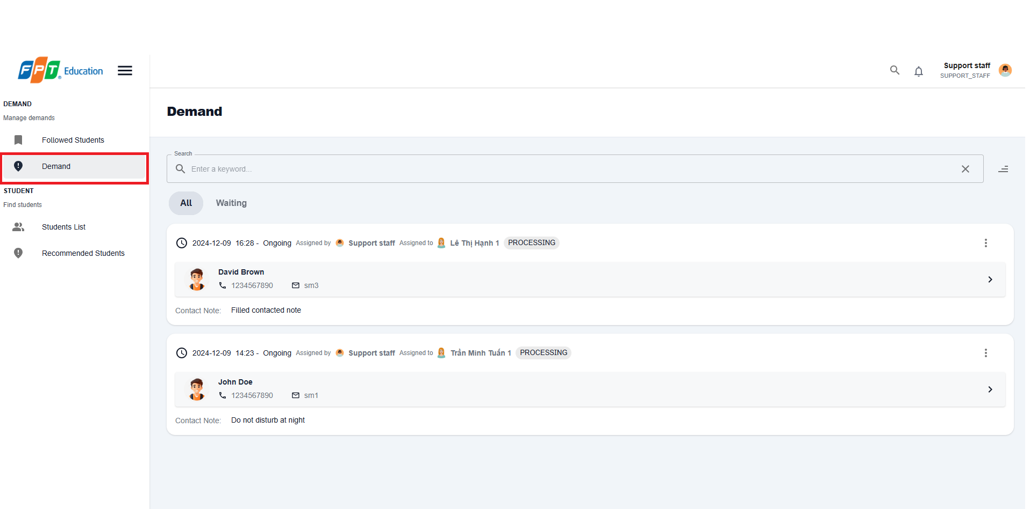

##### 3.2.4.2. Create an appointment from demand

3.2.4.2.1 Description

Use this guideline to create a counseling for a student

3.2.4.2.2. Guide Steps:

**Step 1**: Access SCSS at http://scss-fe.azurewebsites.net/. Then fill in “Email” and “Password” of the counselor account.



**Step 2:** Click the “Sign in ” button.



**Step 3:** From the homepage, choose “Student Demands” from the left sidebar.

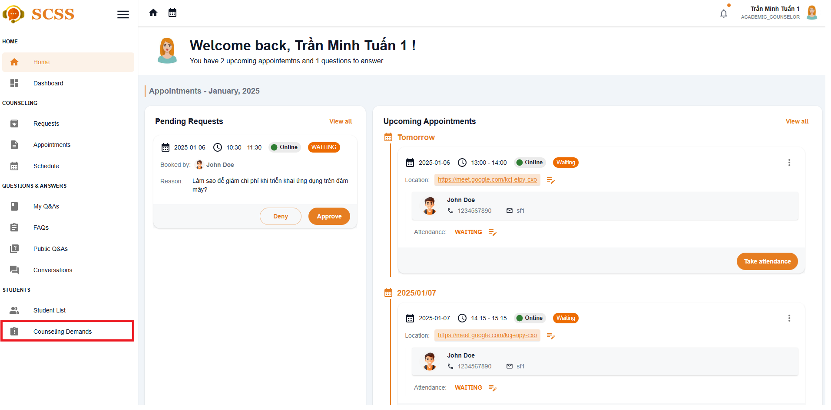

**Step 4:** IN Student Demand page, select more vert icon button form a student, then choose “Create an appointment“ option

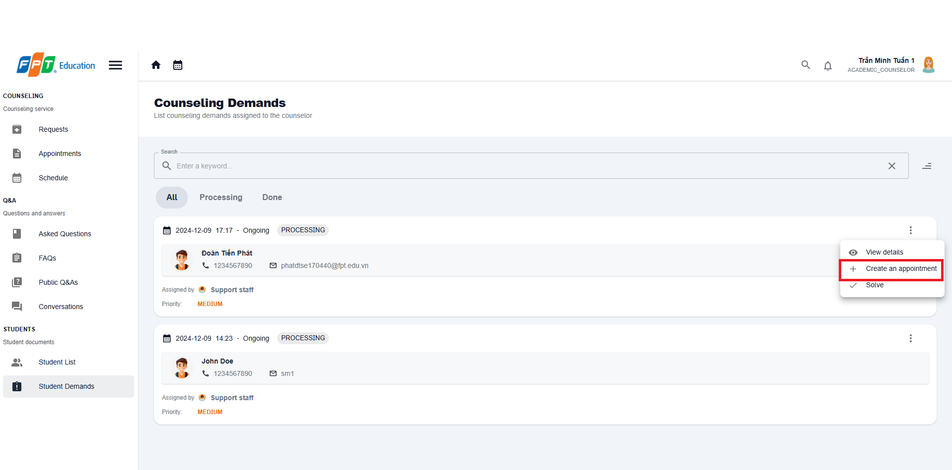

**Step 5:** After filling in counseling fields, then select confirm booking and new appointment with the student will be created.

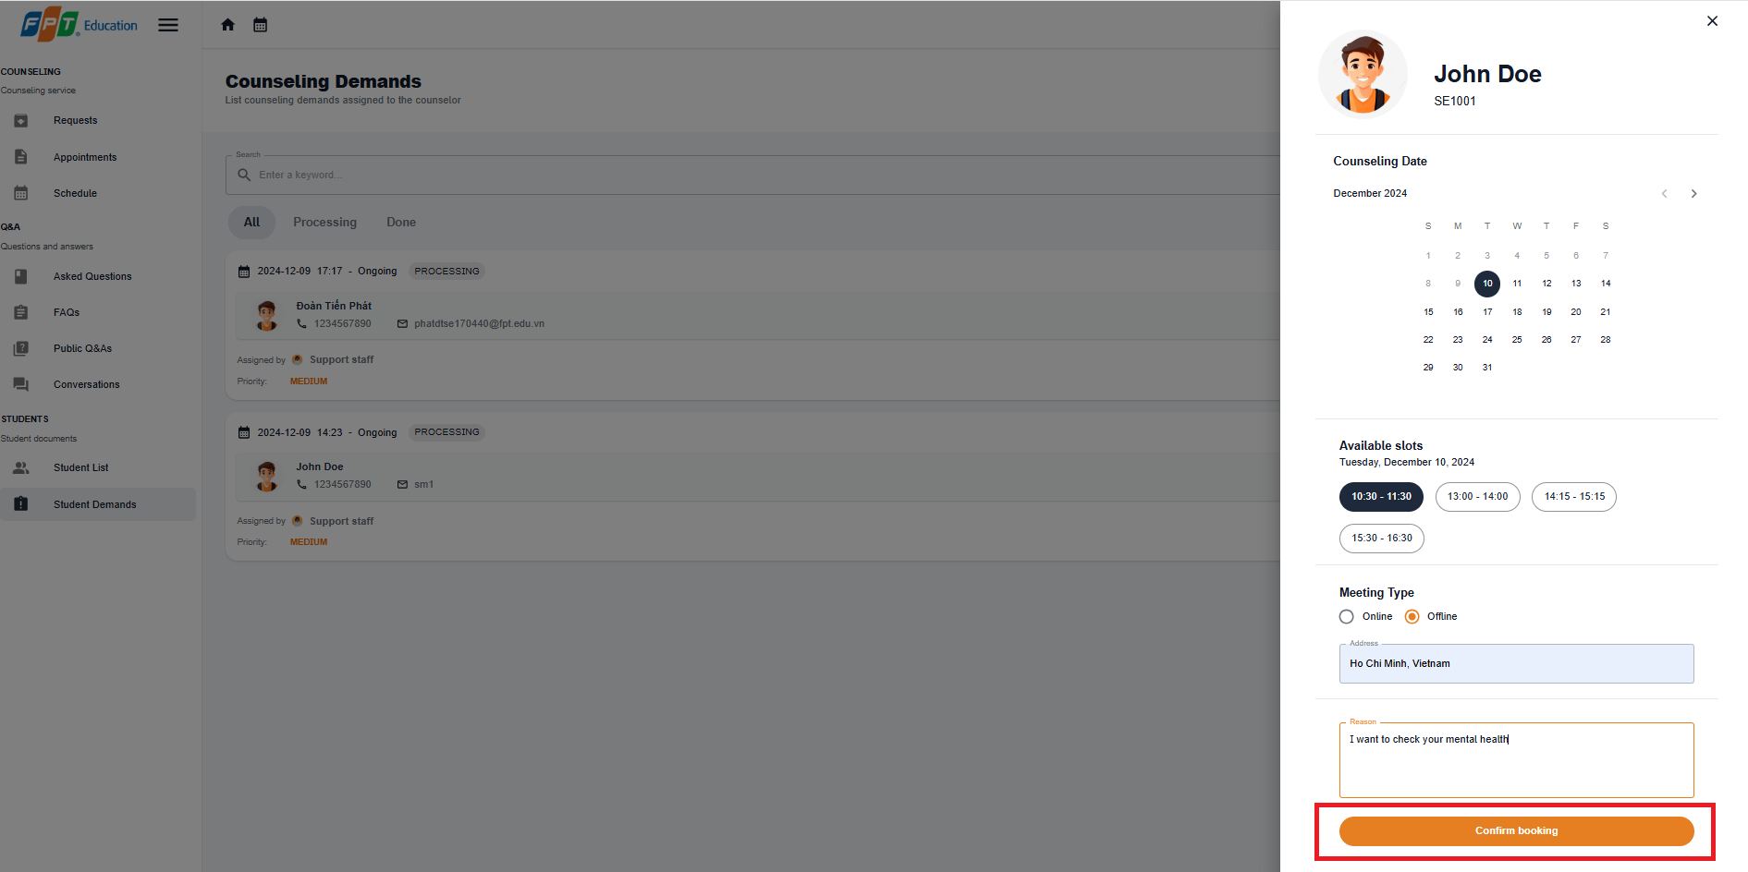

##### 3.2.4.3. Solve a counseling demand

3.2.4.3.1 Description

Use this guideline to create a counseling for a student

3.2.4.3.2. Guide Steps:

**Step 1**: Access SCSS at http://scss-fe.azurewebsites.net/. Then fill in “Email” and “Password” of the counselor account.



**Step 2:** Click the “Sign in ” button.



**Step 3:** From the homepage, choose “Student Demands” from the left sidebar.

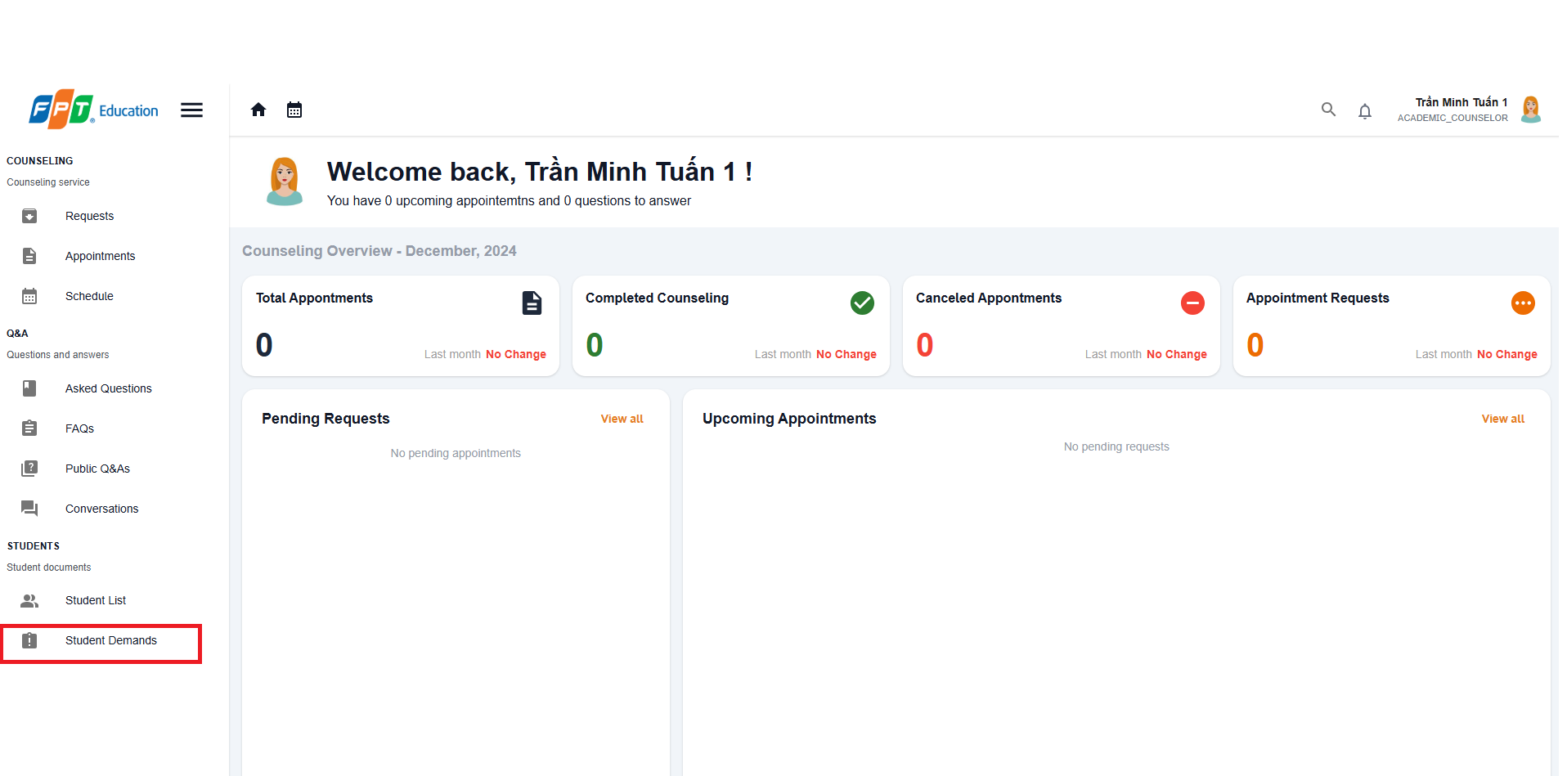

**Step 4:** In Student Demand page, select more vert icon button form a student, then choose “Solve“ option

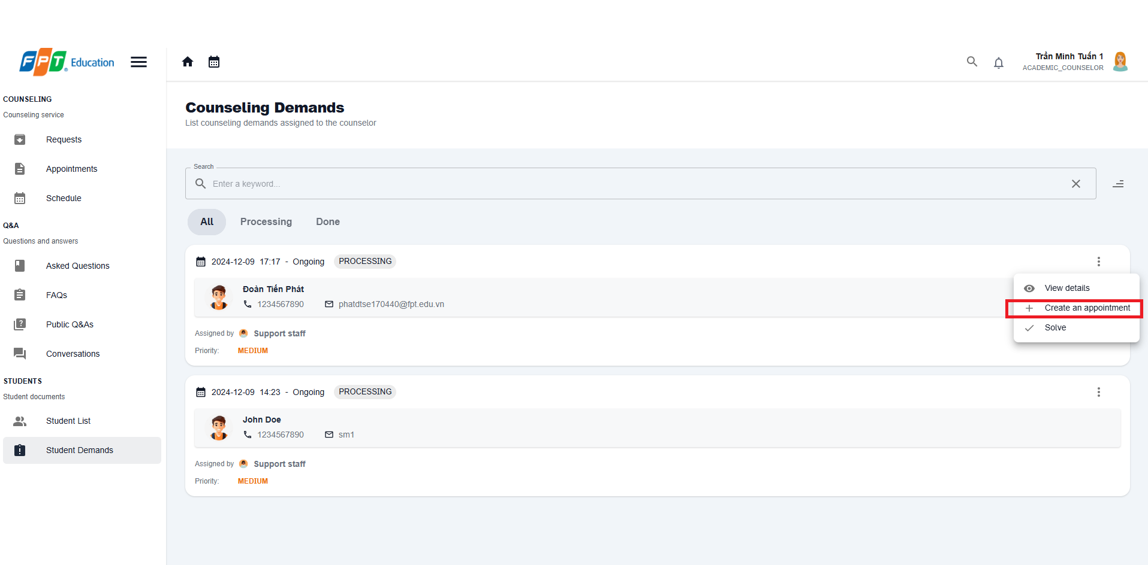

**Step 5:** After filling in the summary field, then select confirm button to solve the demand.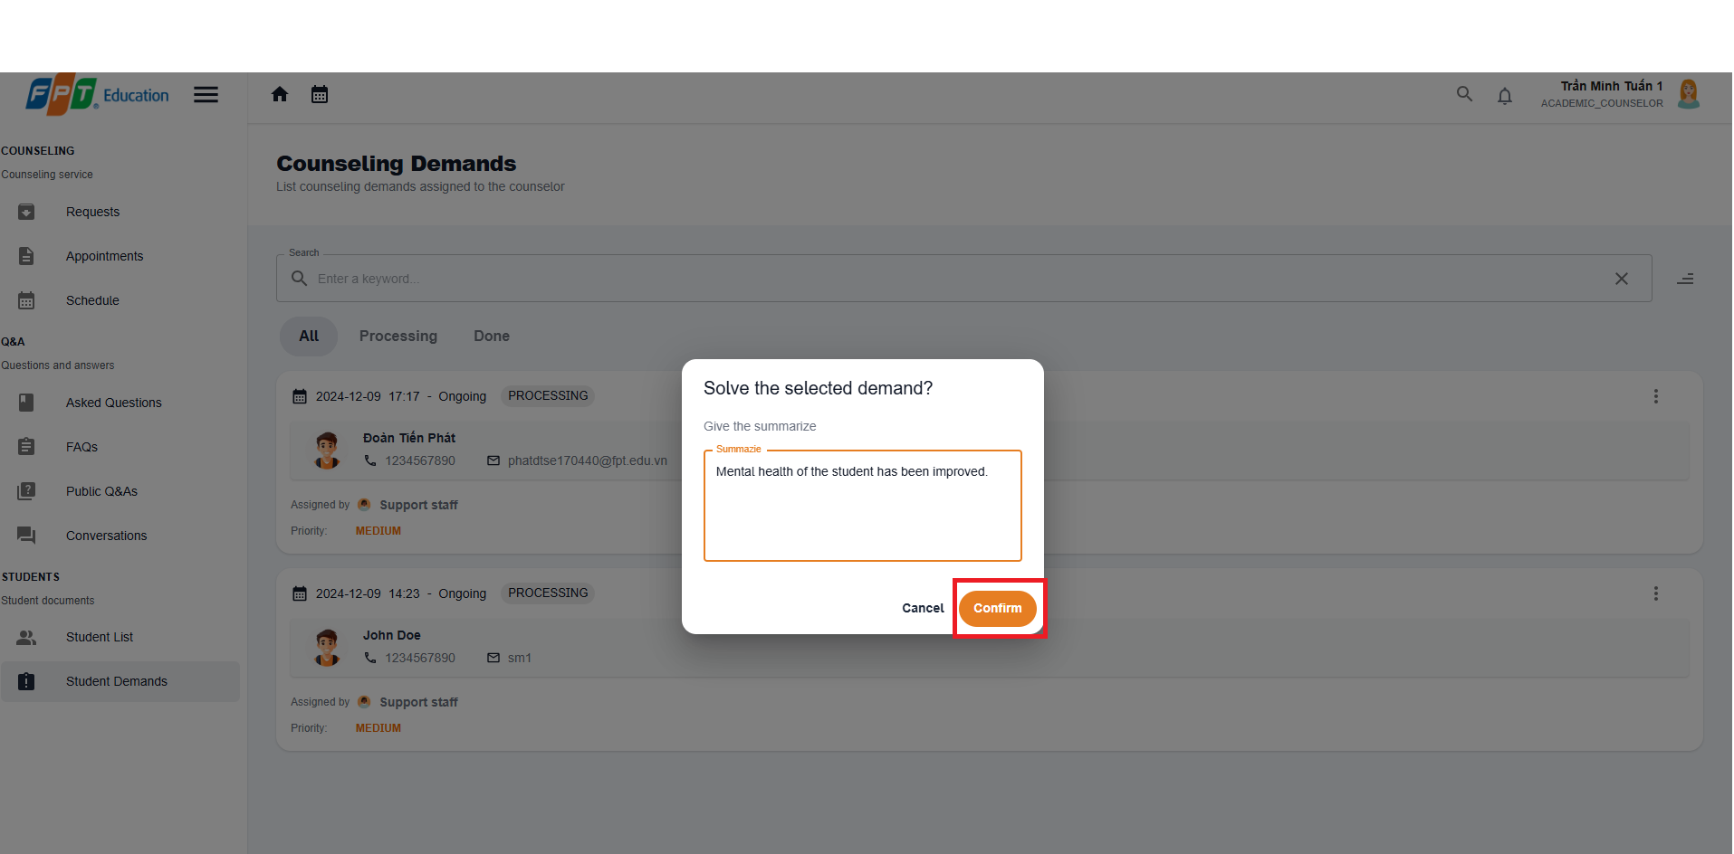

**Step 6:** Solved demand will be marked with DONE status

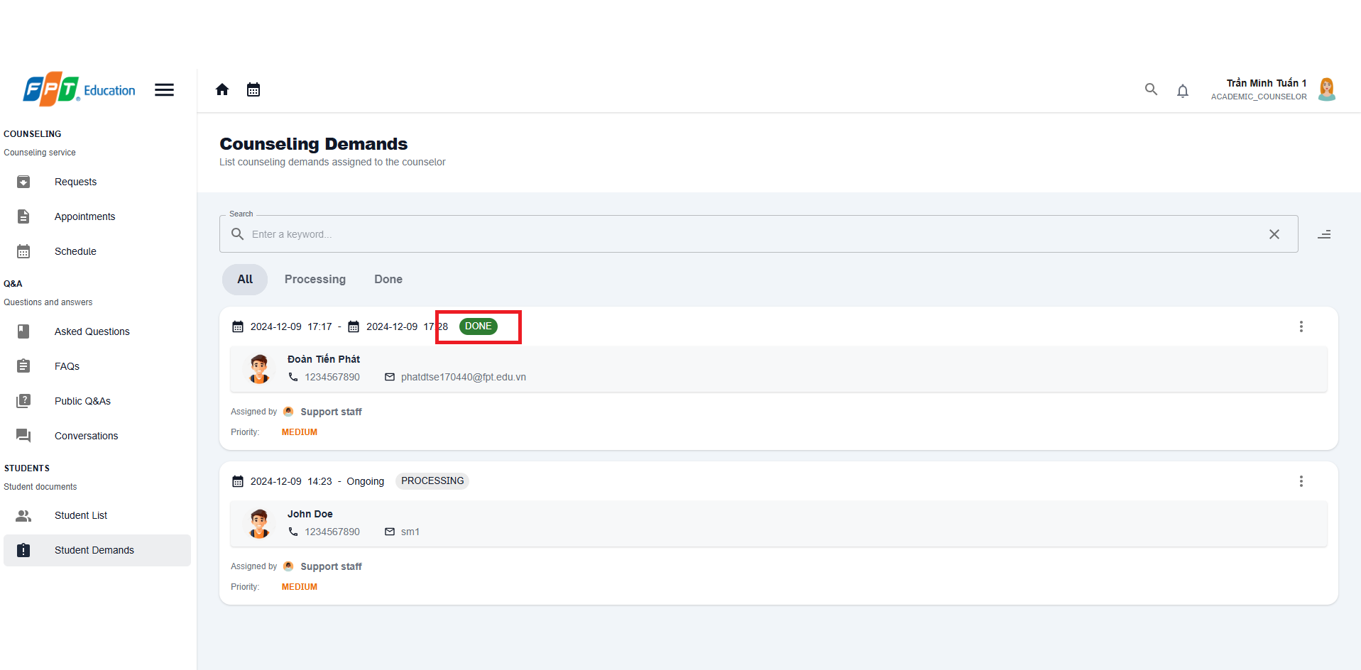

#### 3.2.5. Counselor Management

##### 3.2.5.1. Update counselor availability

3.2.5.1.1 Description

Use this guideline to update counselor availability

3.2.5.1.2 . Guide Steps:

**Step 1**: Access SCSS at http://scss-fe.azurewebsites.net/. Then fill in “Email” and “Password” of the manager account.

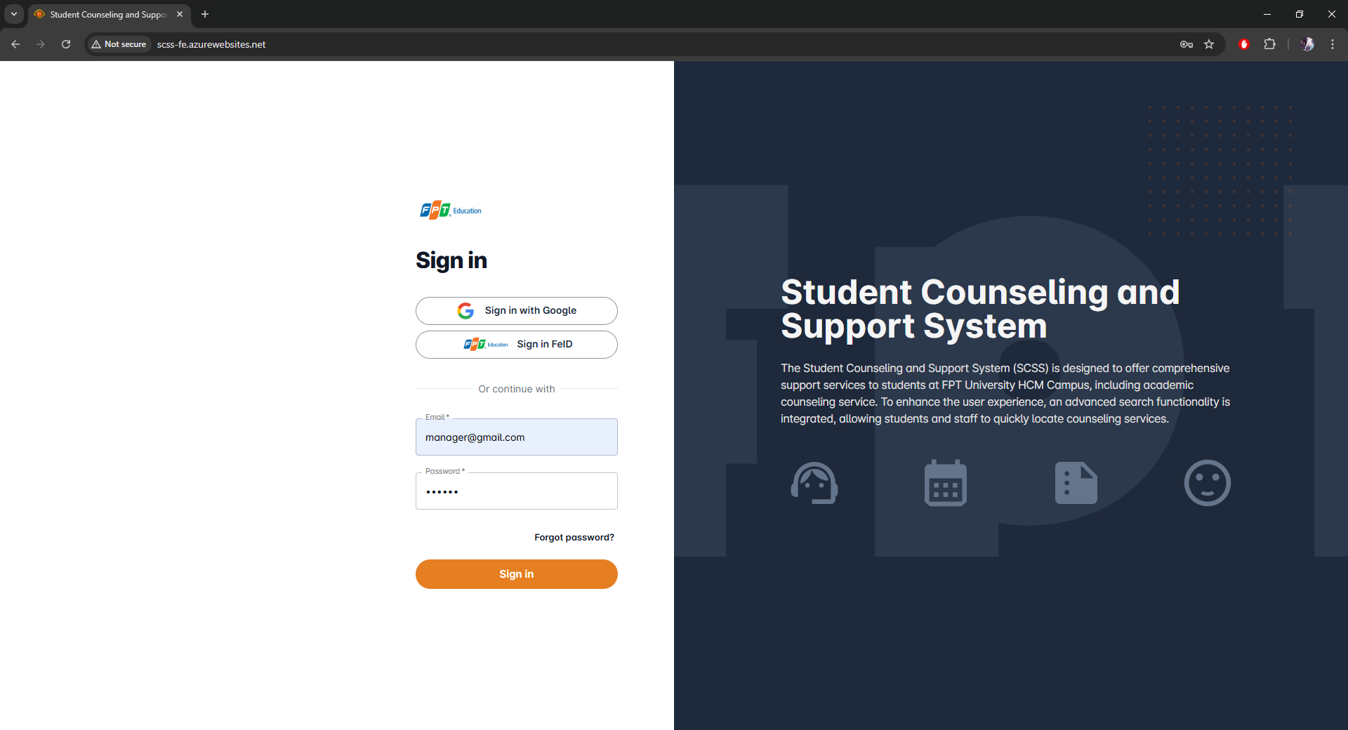

**Step 2:** Click the “Sign in ” button.

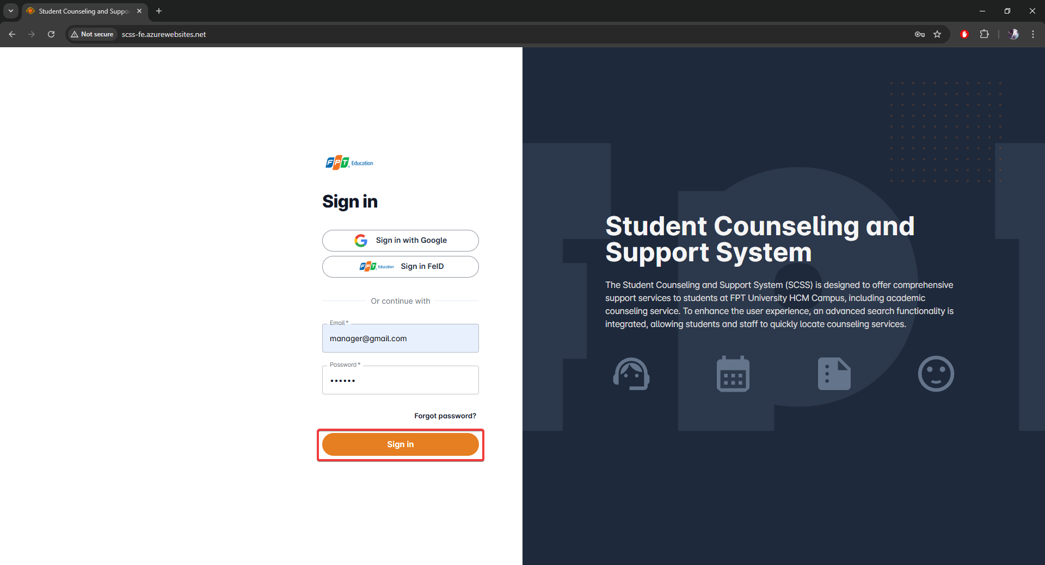

**Step 3:** From the homepage, choose “Counselors” from the left sidebar.

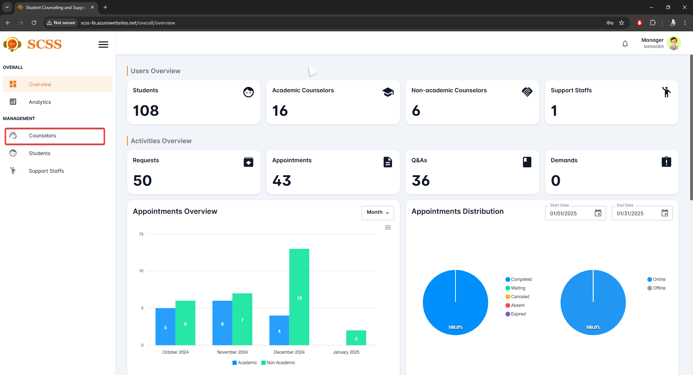

**Step 4:** In Counselor Management page, select a counselor at Full name field

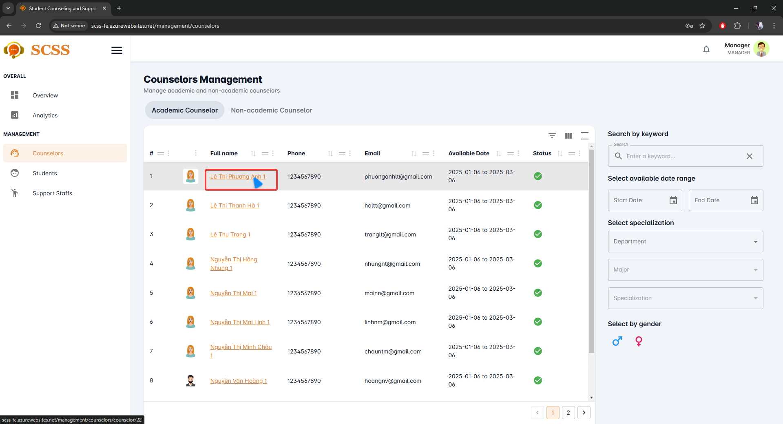

**Step 5:** In Counselor detail management page, select between “Availability ” and “Unavailability ”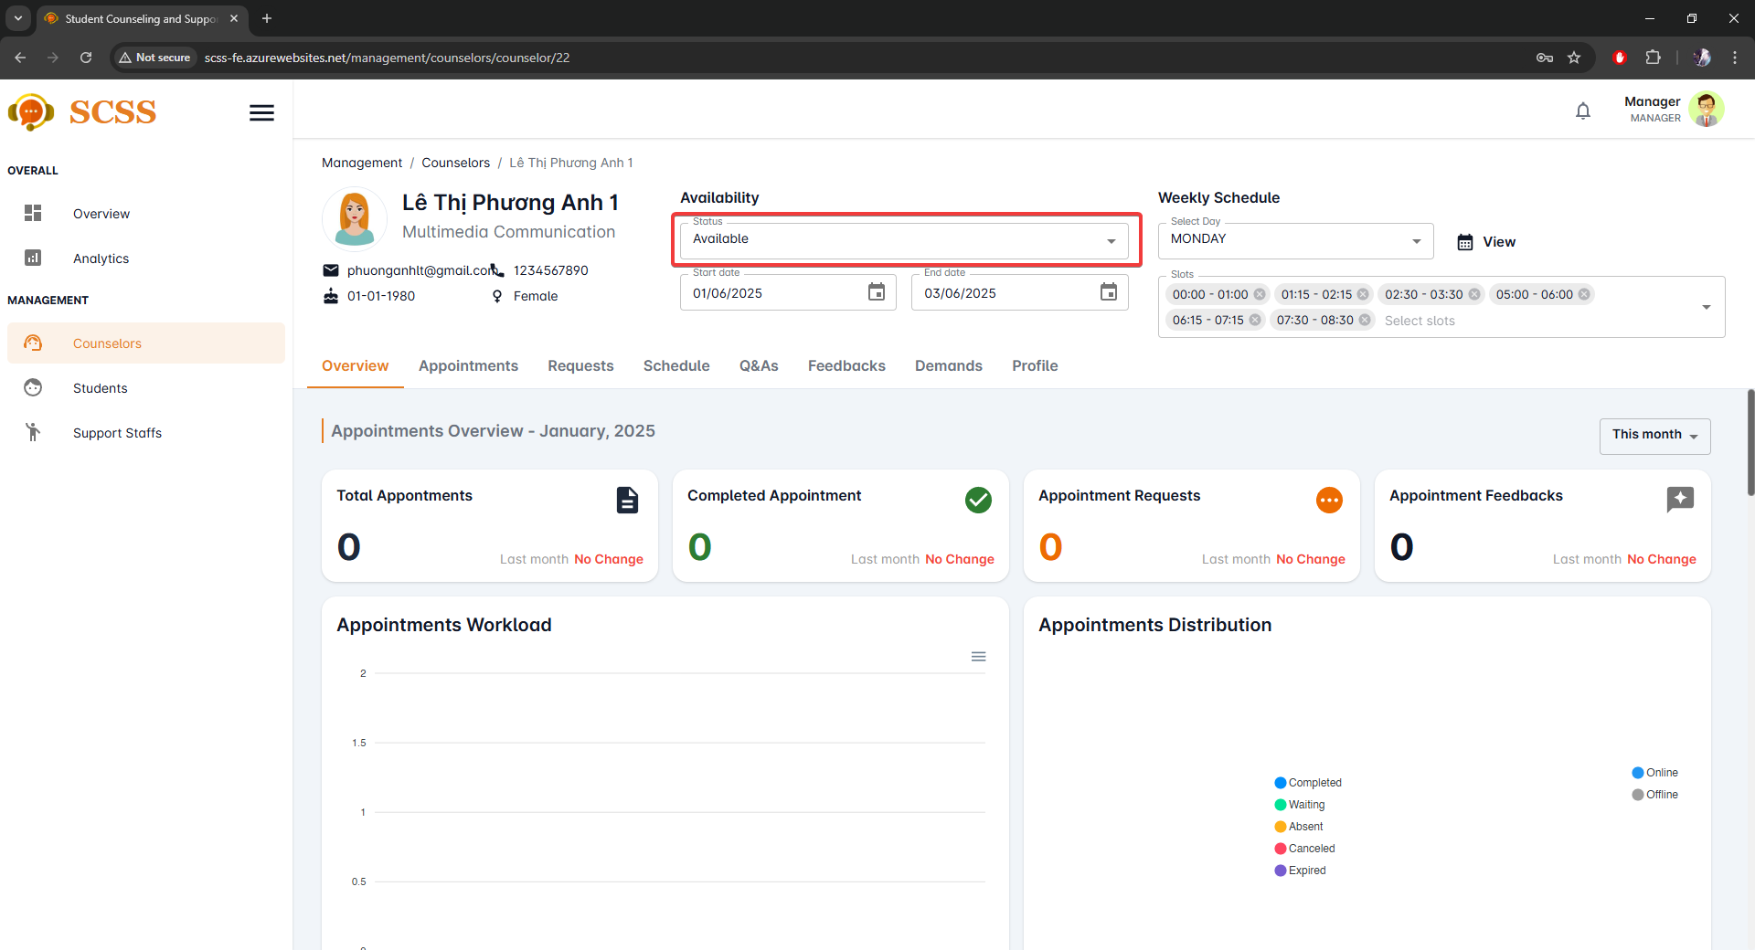

**Step 6:** Select “Confirm”

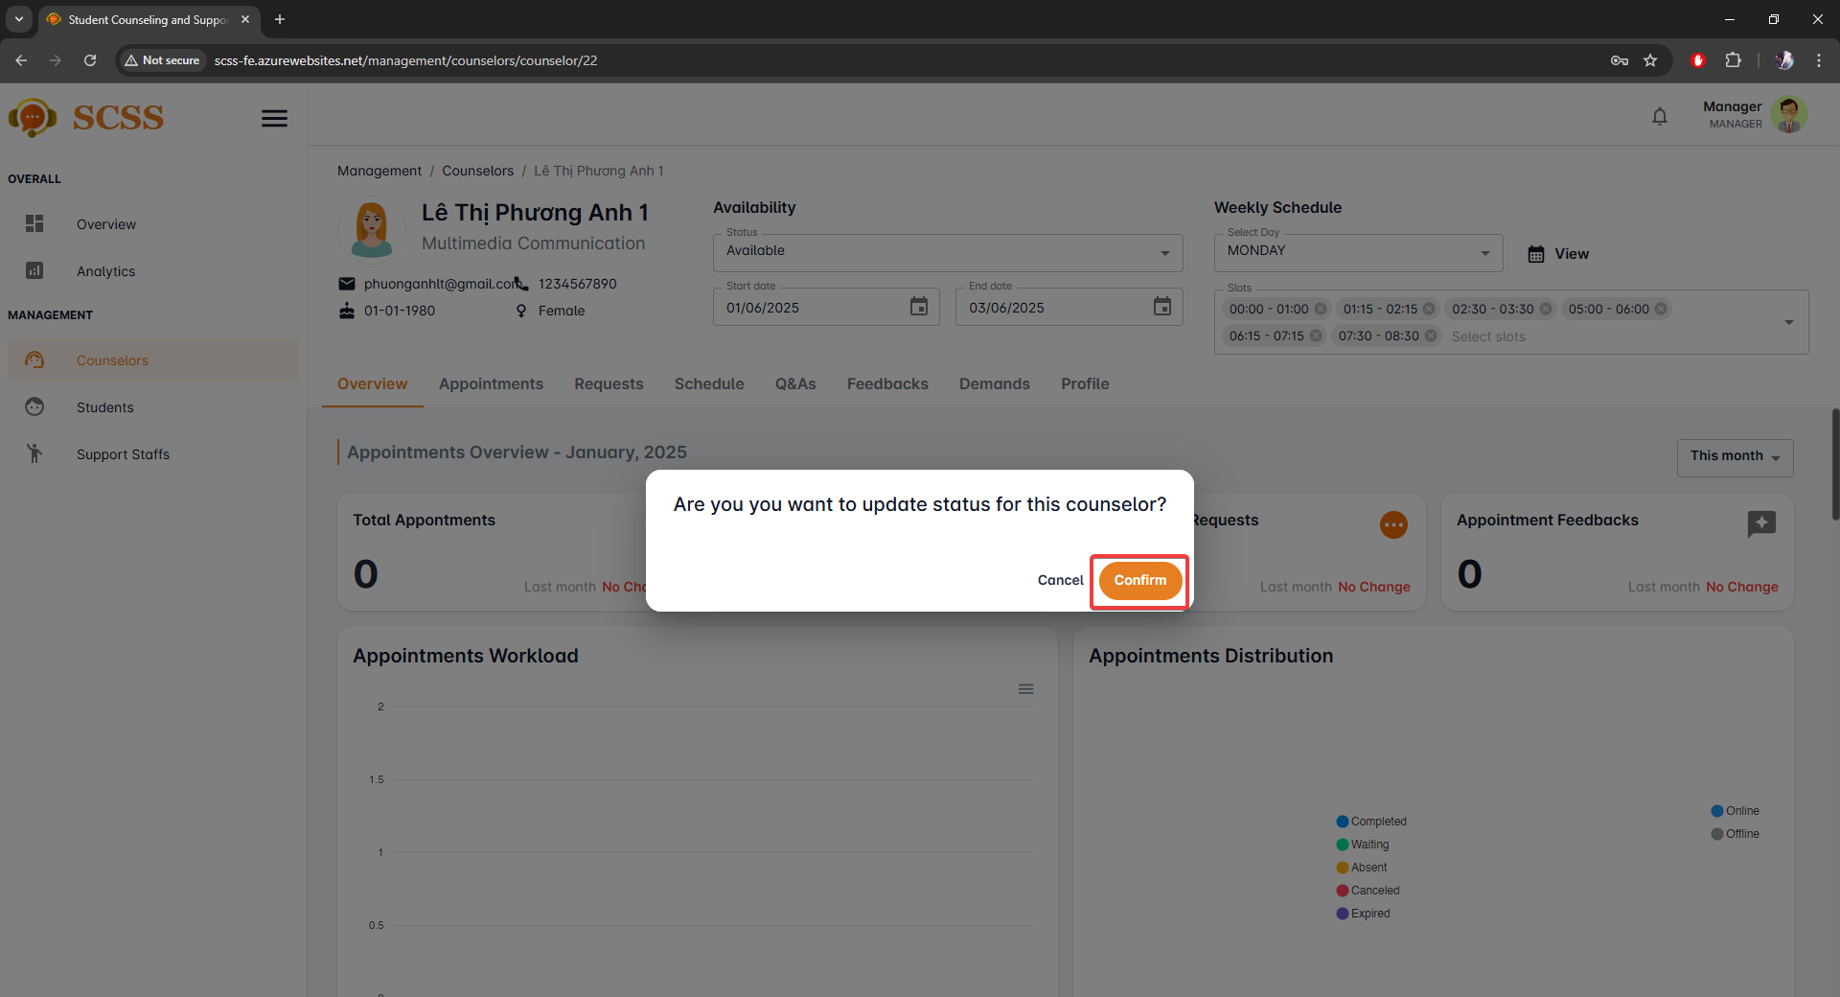

**Step 7:** Select “Ok”

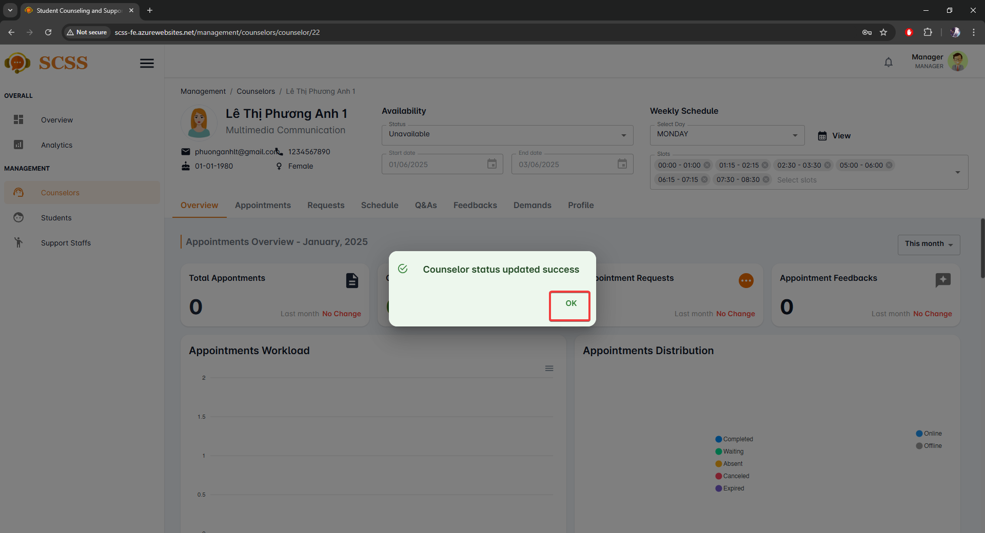

##### 3.2.5.2. Update counselor weekly schedule

3.2.5.2.1 Description

Use this guideline to update counselor weekly schedule

3.2.5.2.2 . Guide Steps:

**Step 1**: Access SCSS at http://scss-fe.azurewebsites.net/. Then fill in “Email” and “Password” of the manager account.



**Step 2:** Click the “Sign in ” button.



**Step 3:** From the homepage, choose “Counselors” from the left sidebar.



**Step 4:** In Counselor Table page, select a counselor at Full name field

**Step 5:** In Counselor detail management page, select from “Select Days” and select slots from “Select slots”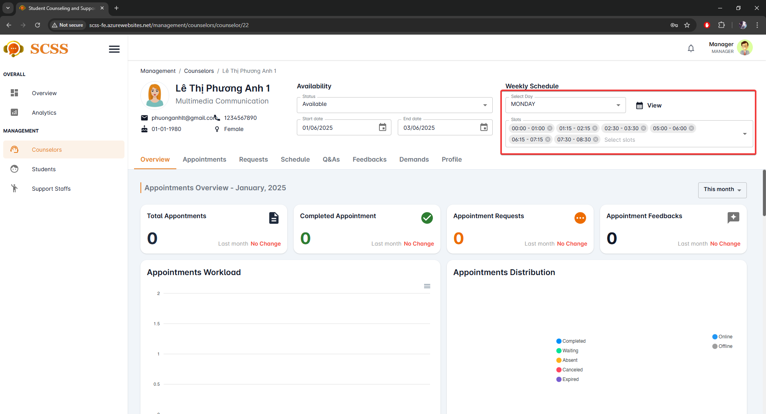

**Step 6:** In Counselor detail management page, select “Weekly Schedule” to view full schedule of the counselor for a week.

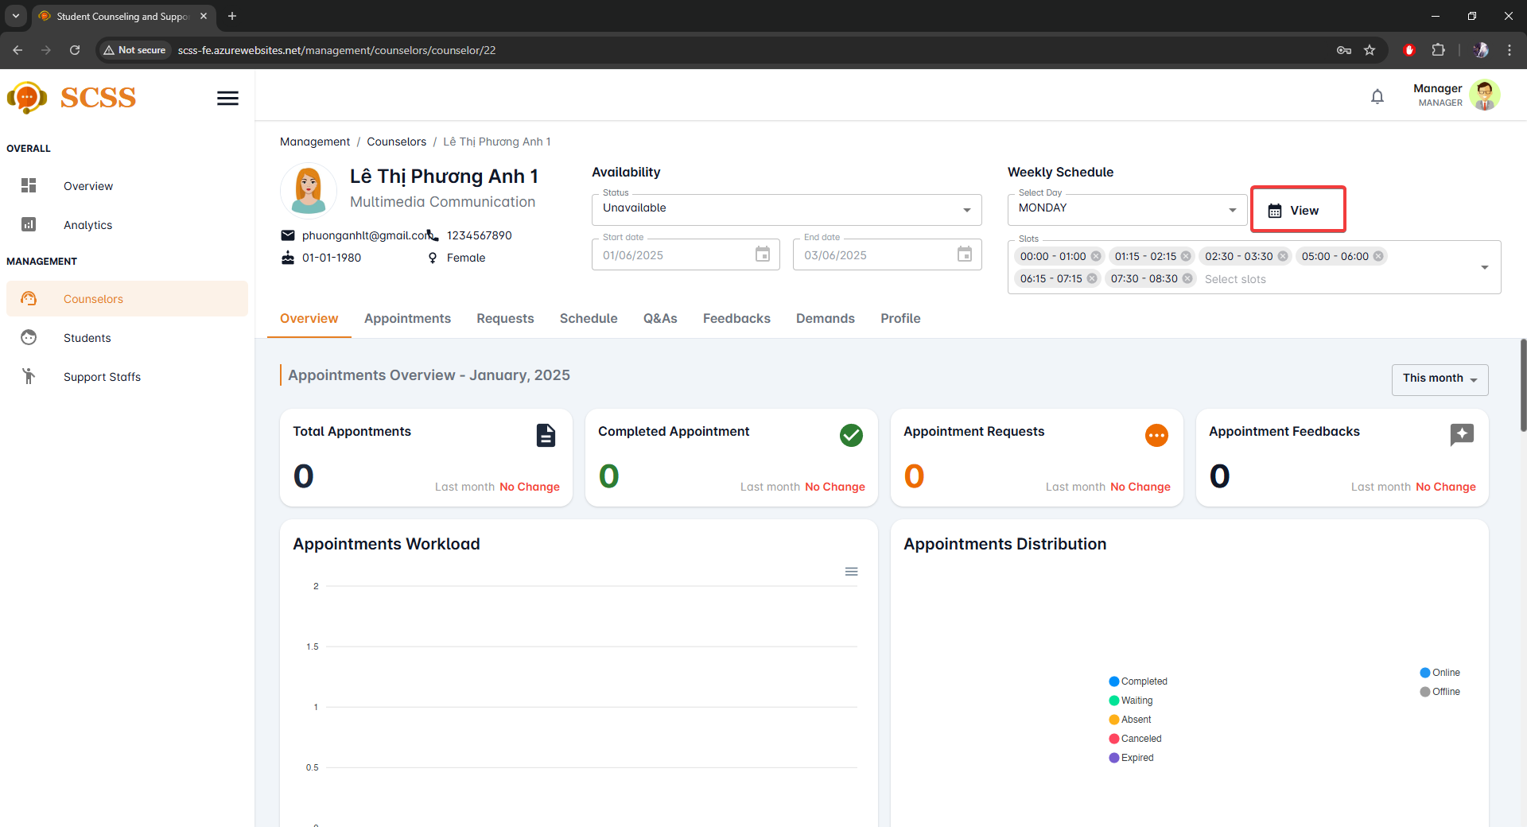

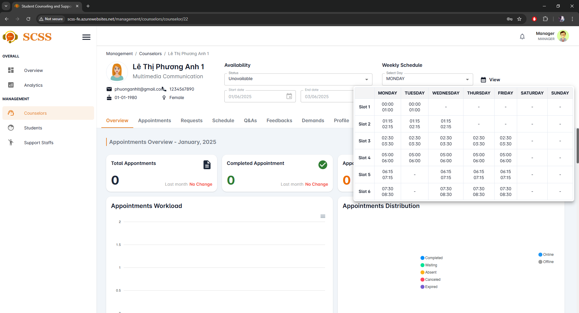

##### 3.2.5.3. Update counselor date range

3.2.5.1.1 Description

Use this guideline to update counselor available date range

3.2.5.1.2 . Guide Steps:

**Step 1**: Access SCSS at http://scss-fe.azurewebsites.net/. Then fill in “Email” and “Password” of the manager account.



**Step 2:** Click the “Sign in ” button.



**Step 3:** From the homepage, choose “Counselors Table” from the left sidebar.



**Step 4:** In Counselor Table page, select a counselor at Full name field

**Step 5:** In Counselor detail management page, pick “Start date” and “End date”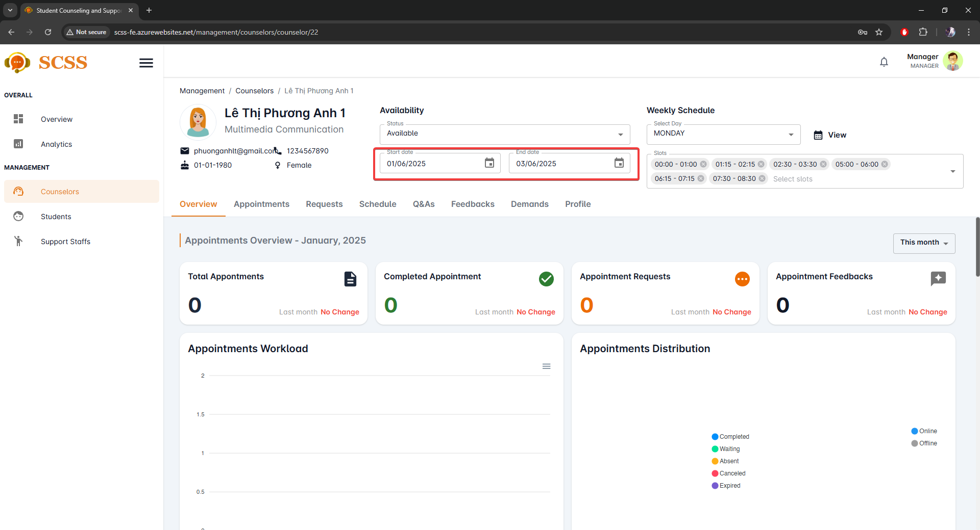

##### 3.2.5.4. View analytics

3.2.5.4.1 Description

Use this guideline to view analytics.

3.2.5.4.2 . Guide Steps:

**Step 1**: Access SCSS at http://scss-fe.azurewebsites.net/. Then fill in “Email” and “Password” of the manager account.



**Step 2:** Click the “Sign in ” button.



**Step 3:** From the homepage, choose “Analytics” from the left sidebar.

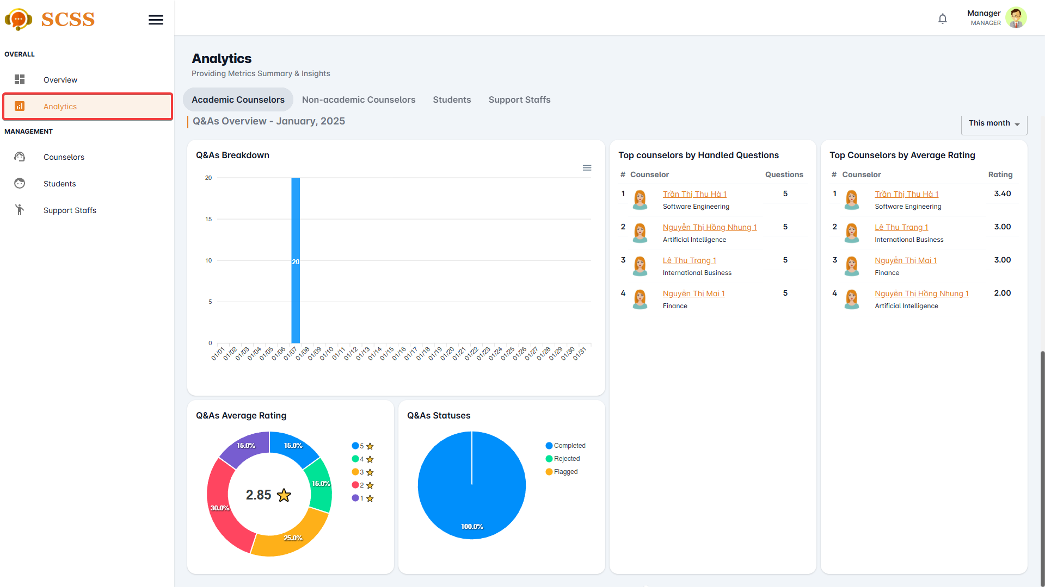

##### 3.2.5.5. View analytics

3.2.5.5.1 Description

Use this guideline to view analytics.

3.2.5.5.2 . Guide Steps:

**Step 1**: Access SCSS at http://scss-fe.azurewebsites.net/. Then fill in “Email” and “Password” of the manager account.



**Step 2:** Click the “Sign in ” button.



**Step 3:** From the homepage, choose “Overview” from the left sidebar.

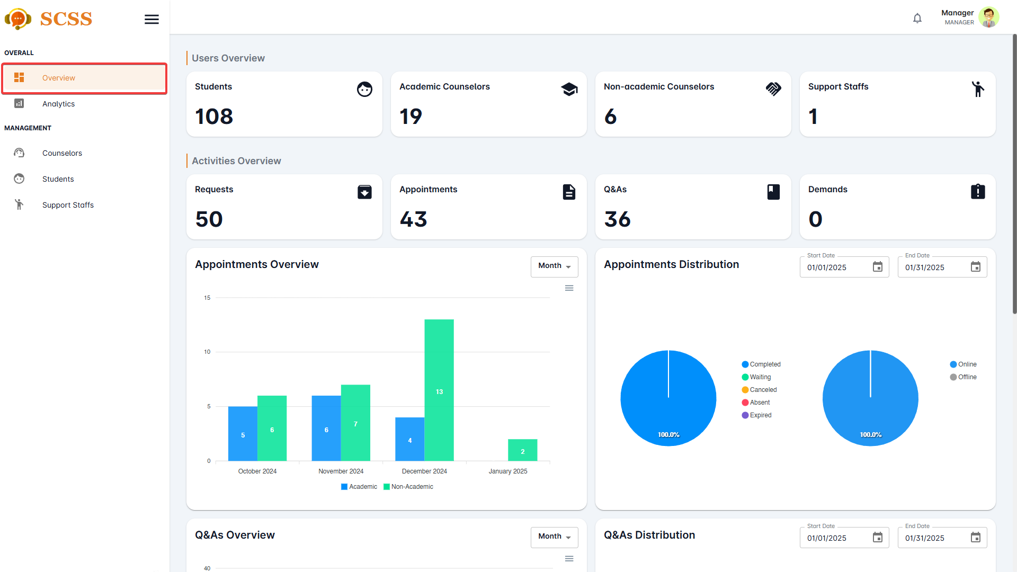

#### 3.2.6. Account Management

##### 3.2.6.1. Create non-academic/academic counselor account

3.2.6.1.1. Description

Use this guide so administrators can create non-academic or academic counselor account.

3.2.6.1.2. Guide Steps

**Step 1**: Access SCSS at http://scss-fe.azurewebsites.net/. Then fill in “Email” and “Password” of the administrator account.

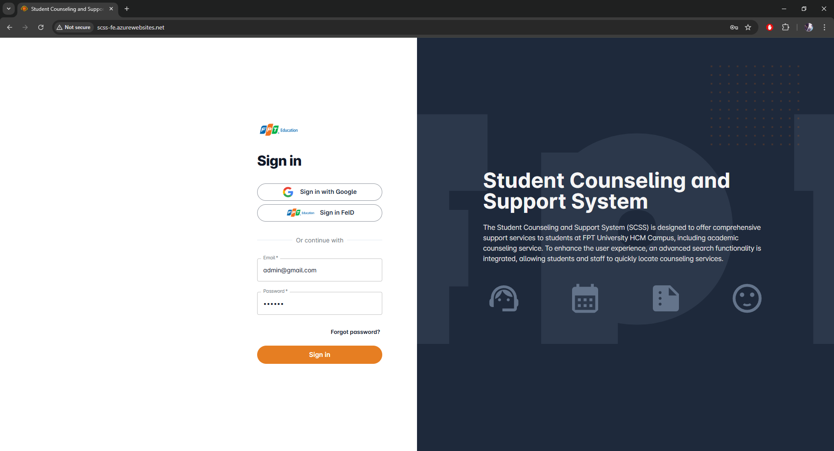

**Step 2:** Click the “Sign in ” button.

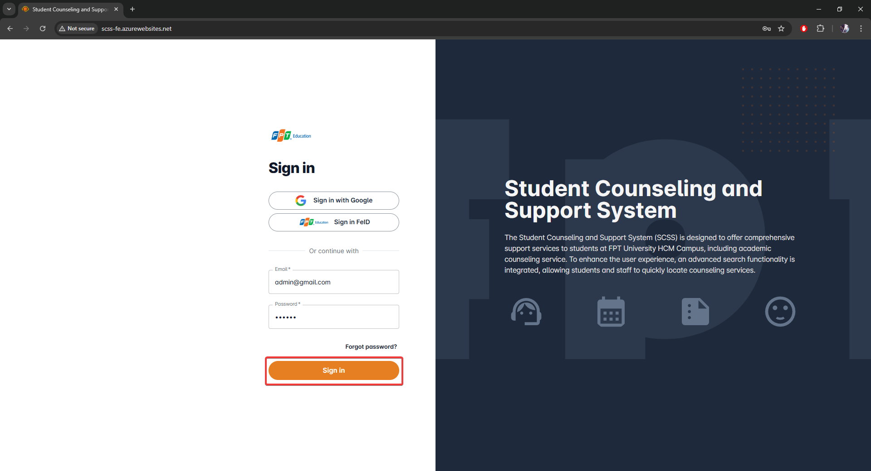

**Step 3:** From the homepage, choose “Create Account” from the left sidebar.

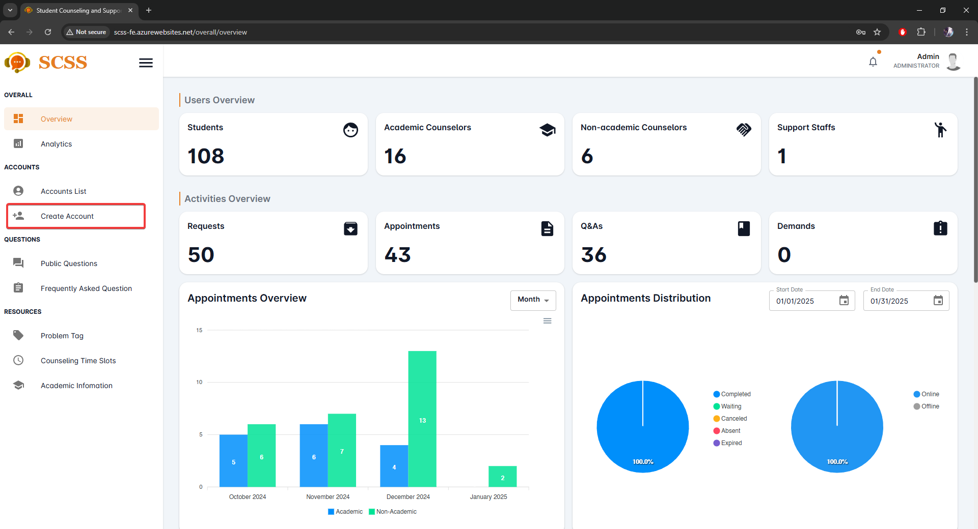

**Step 4:** Select “Academic Counselor” or “Non-academic Counselor” tab accordingly.

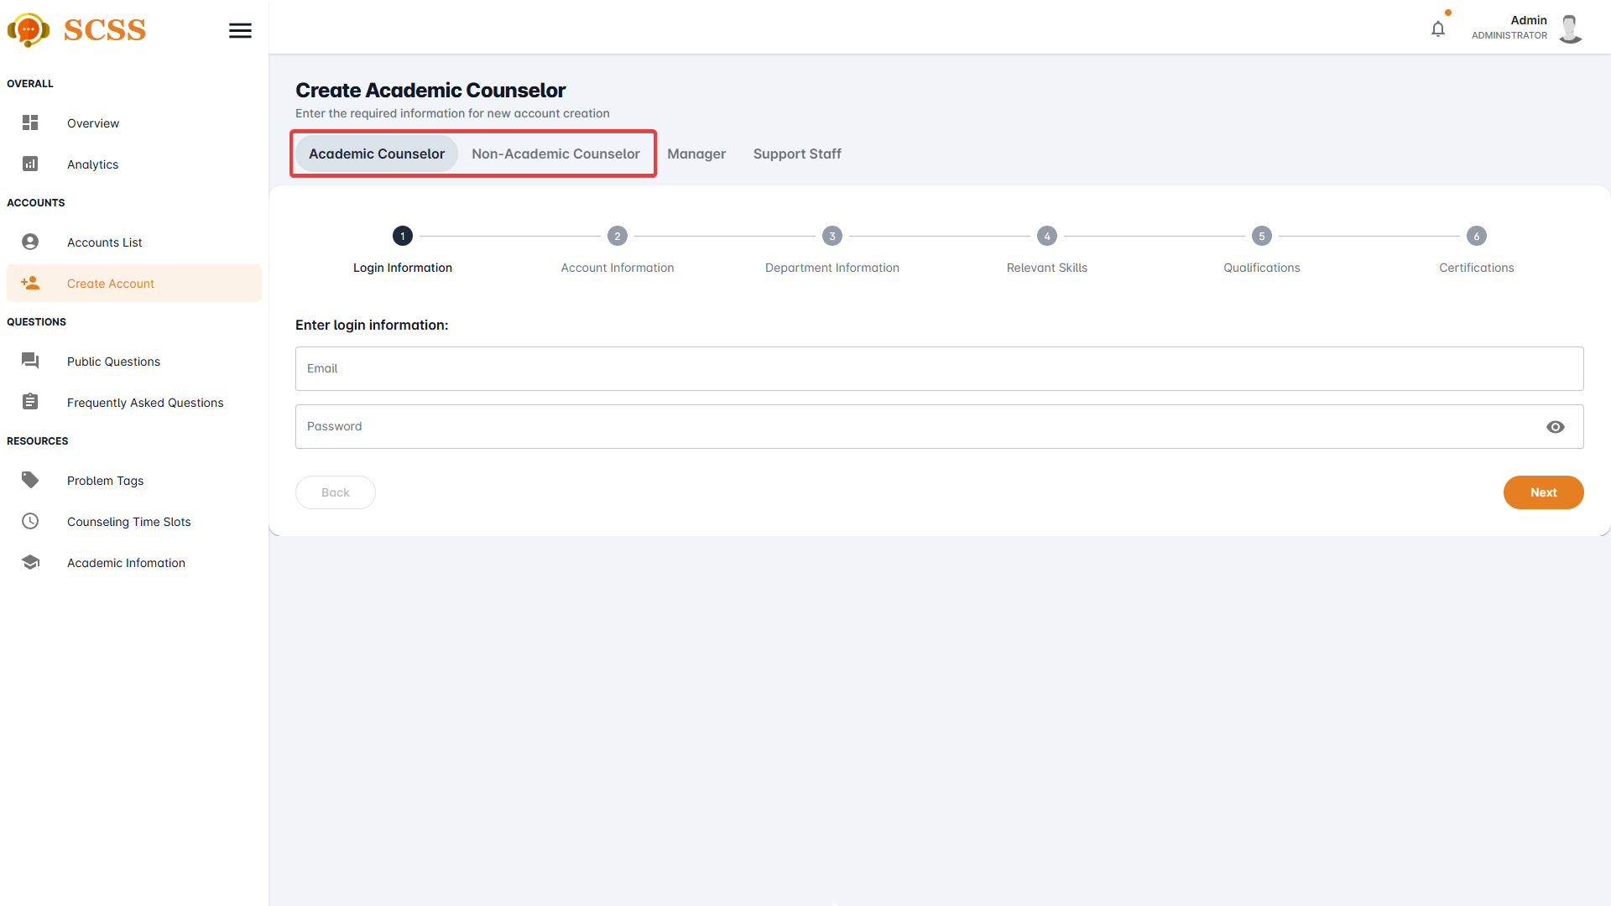

**Step 5:** Fill out “Email”, “Password” fields and press the “Next” button at the bottom of the form when all the fields shown have been filled.

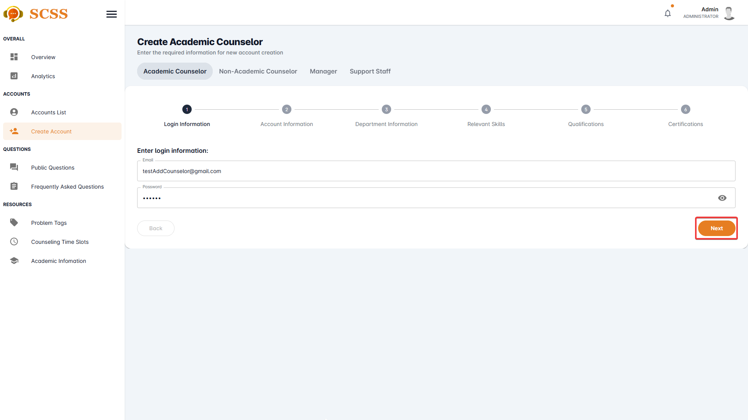

**Step 6:** Fill out “Full name”, “Phone number”, “Email”, “Gender”, “Date of birth”, “Email”, “Password”, and “Avatar” field and press the “Next” button at the bottom of the form when all the fields shown have been filled.

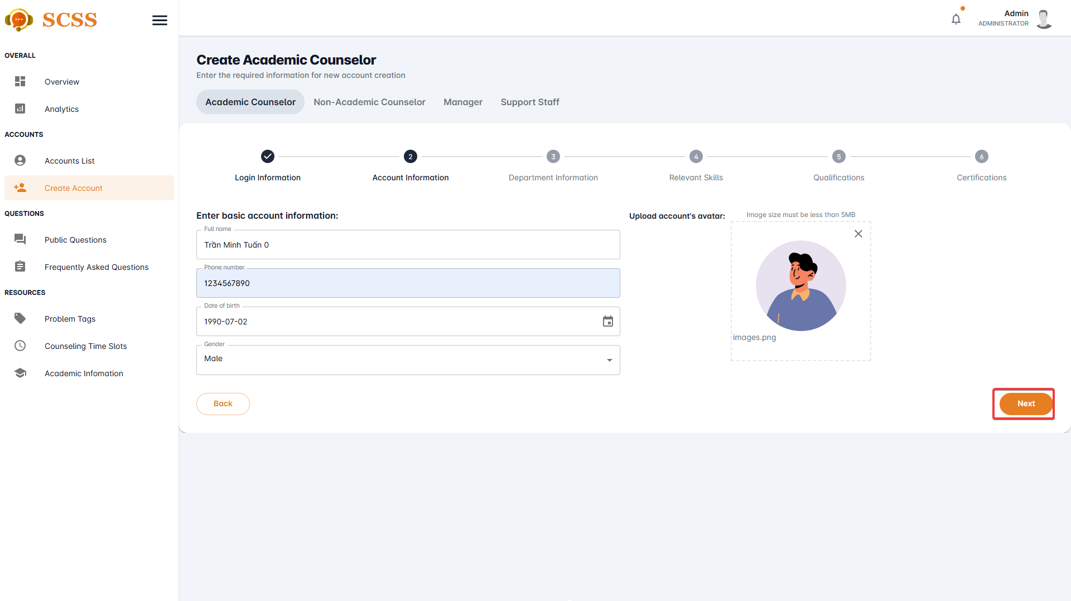

**Step 7.1:** Fill out “Department”, and “Major” field if creating an academic counselor account and press the “Next” button at the bottom of the form when all the fields shown have been filled.

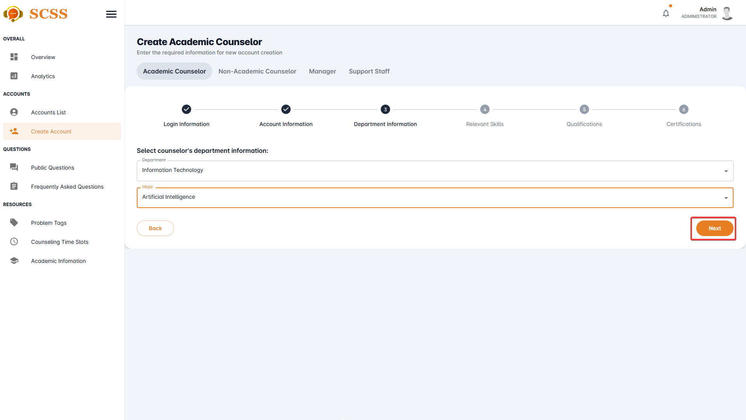

**Step 7.2:** Fill out the “Expertise” field if creating a non-academic counselor account and press the “Next” button at the bottom of the form when all the fields shown have been filled.

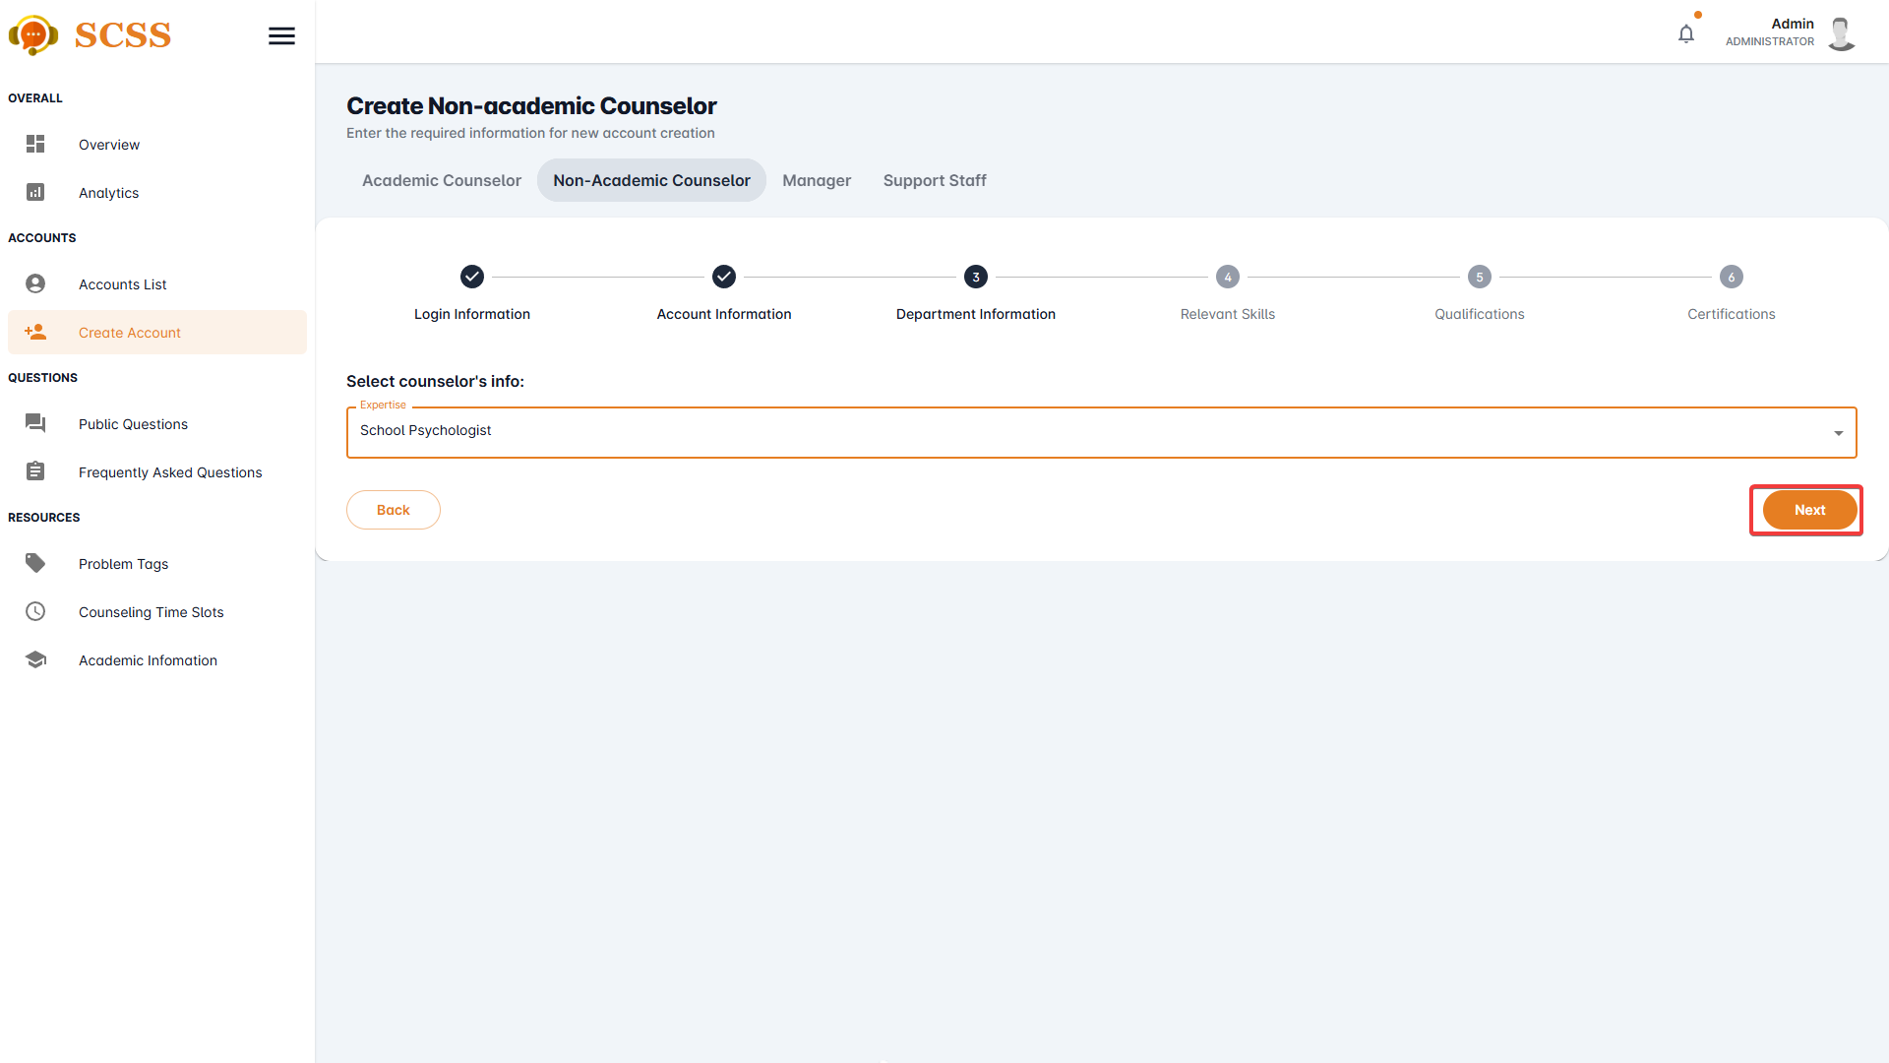

**Step 8:** Fill out the “Specialized skill”, “Other skills”, “Achievements”, and “Work History” fields and press the “Next” button at the bottom of the form when all the fields shown have been filled.

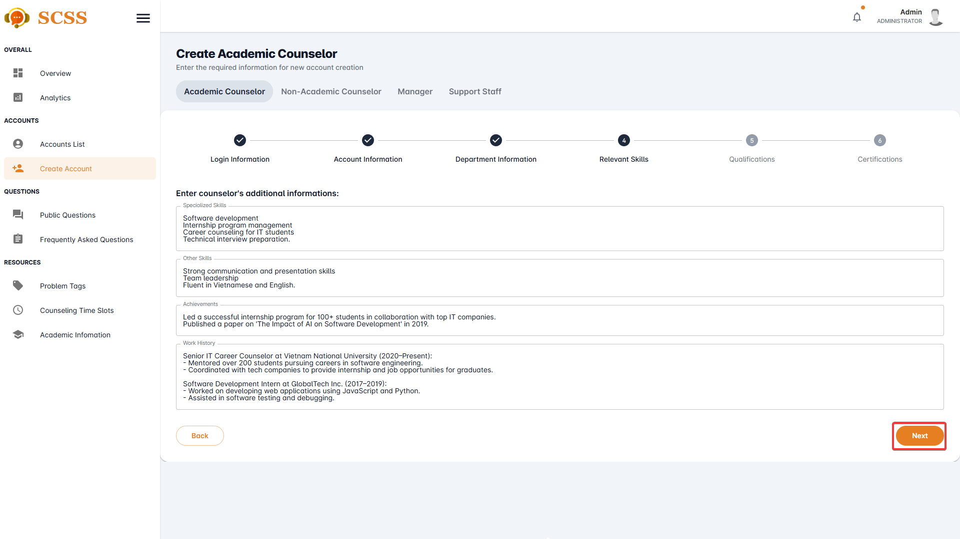

**Step 9:** Add “qualification” by pressing the “Add qualification” button and fill out “Degree”, “Institution”, “Field of study”, “Year of graduation”, and “Qualification’s image” then press the “Add” button.

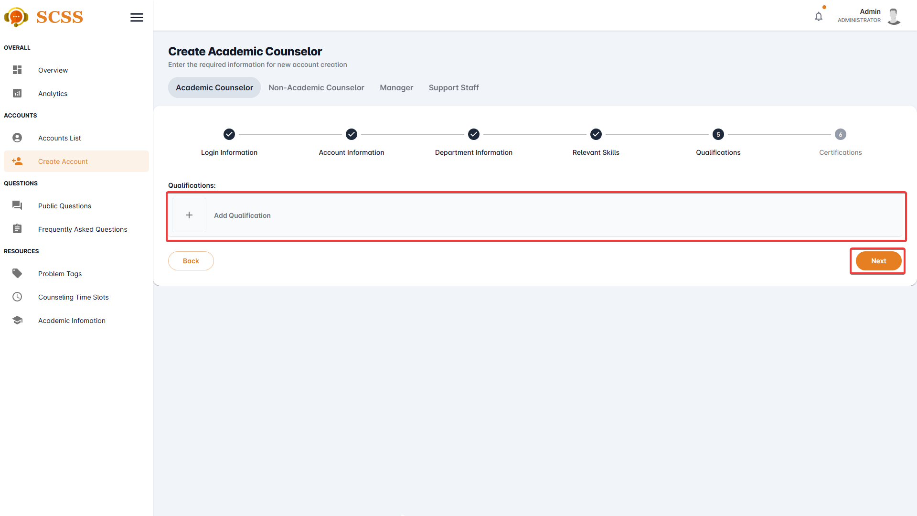

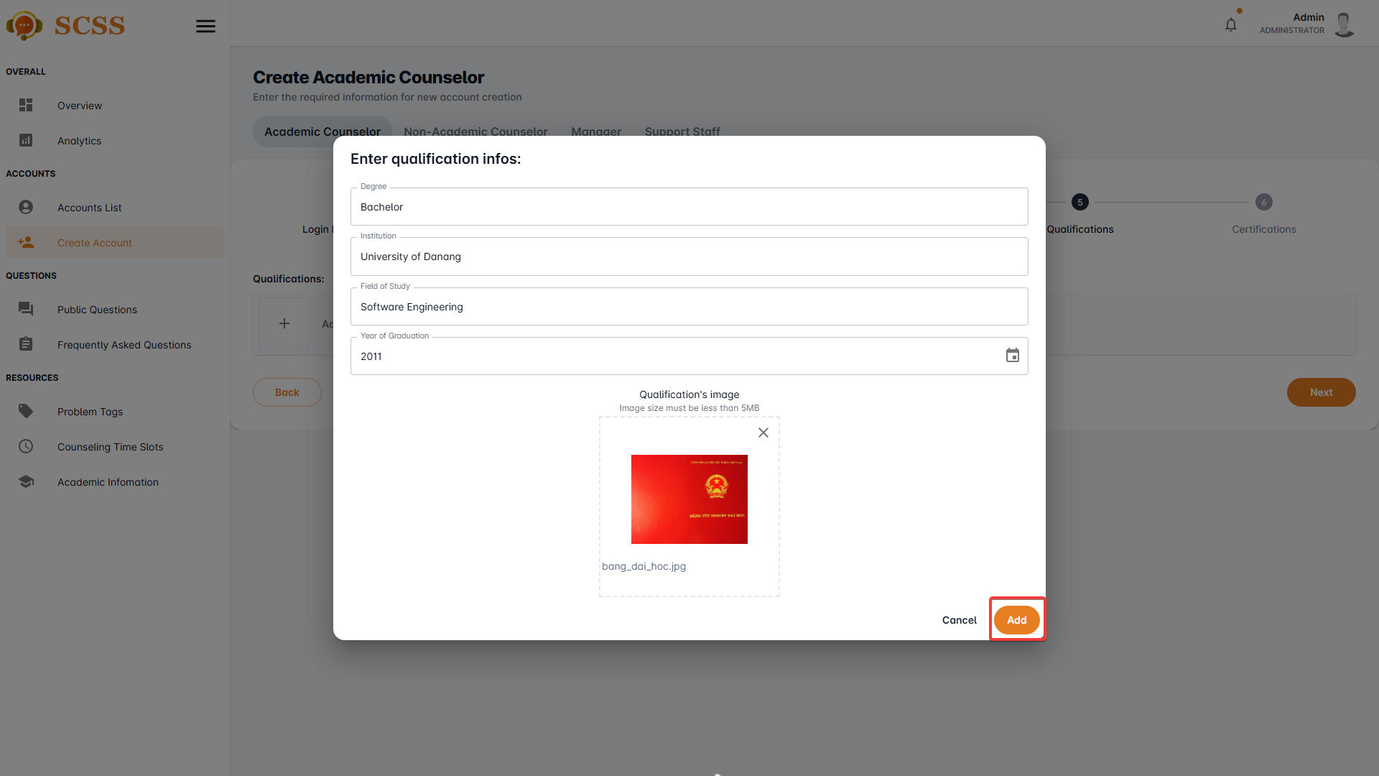

**Step 9:** Add “certification” by pressing the “Add certification” button and fill out “Certification’s name”, “Certification’s organization” and “Certification’s Image”, then press the “Add” button.

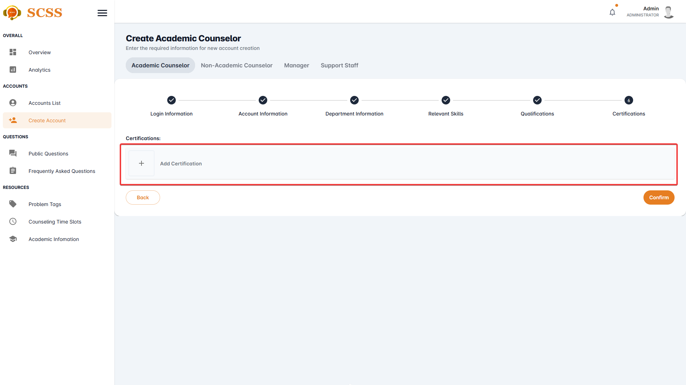

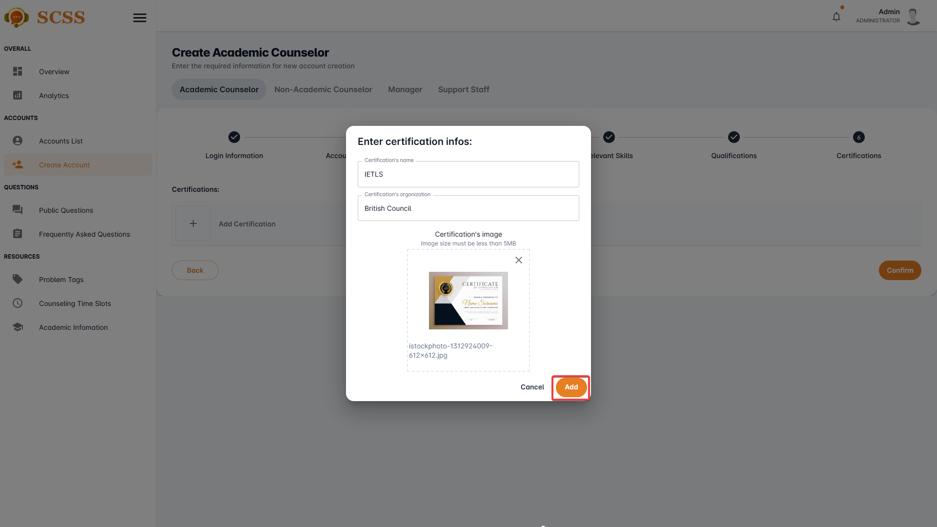

**Step 10:** Press the “Confirm” button after all the required fields have been filled out.

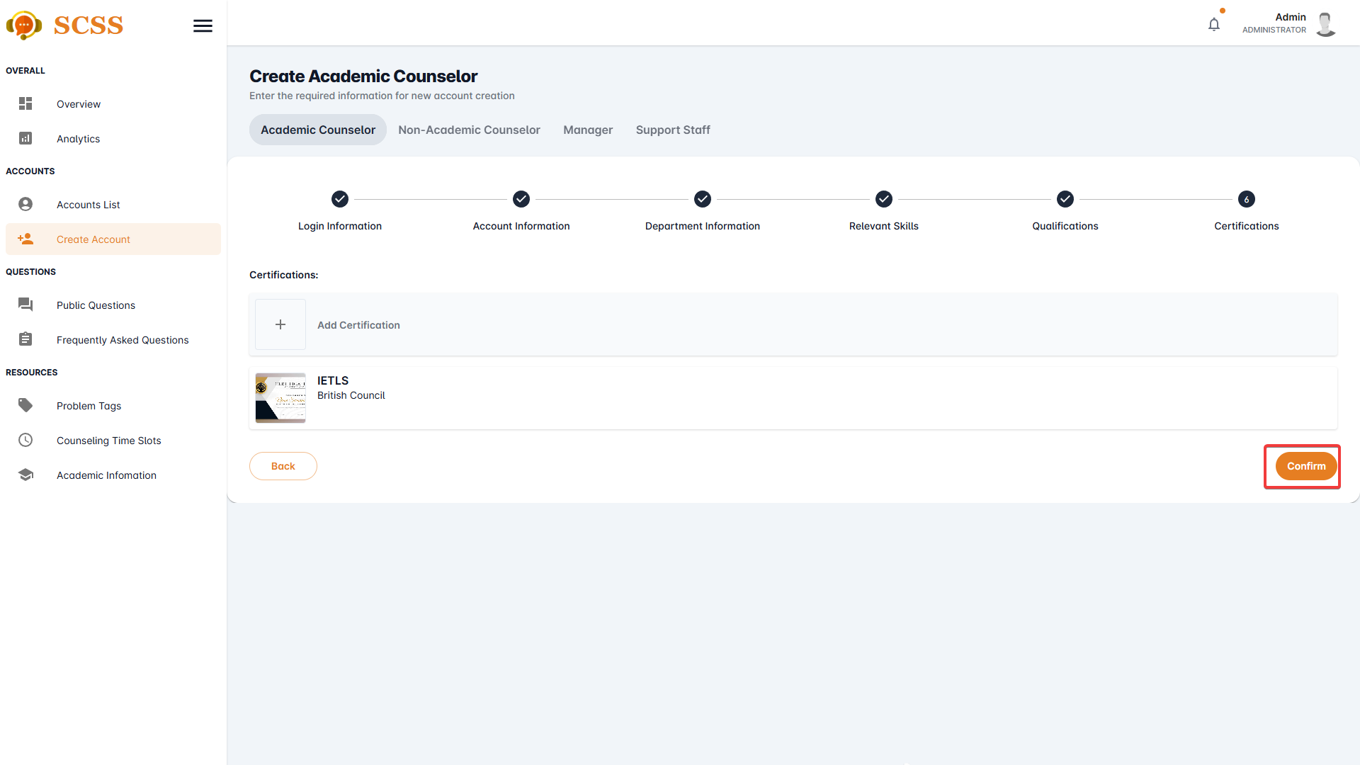

**Step 11:** Press the “OK” button after a success dialog is shown to complete creating a counselor.

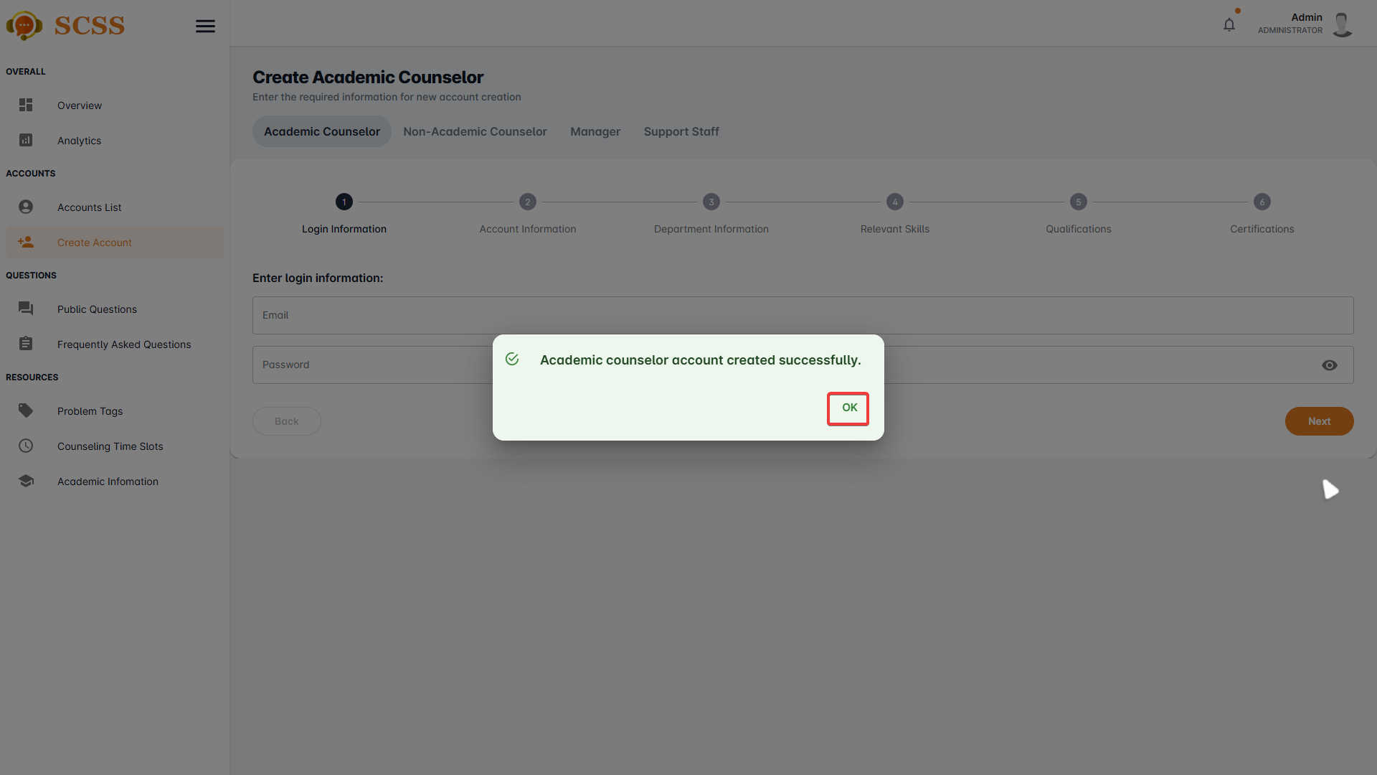

##### 3.2.6.2. Create manager/support staff account

3.2.6.2.1. Description

Use this guide so administrators can create manager or support staff accounts.

3.2.6.2.2. Guide Steps

**Step 1**: Access SCSS at http://scss-fe.azurewebsites.net/. Then fill in “Email” and “Password” of the administrator account.



**Step 2:** Click the “Sign in ” button.



**Step 3:** From the homepage, choose “Create Account” from the left sidebar.



**Step 4:** Select “Manager” or “Support staff” tab accordingly.

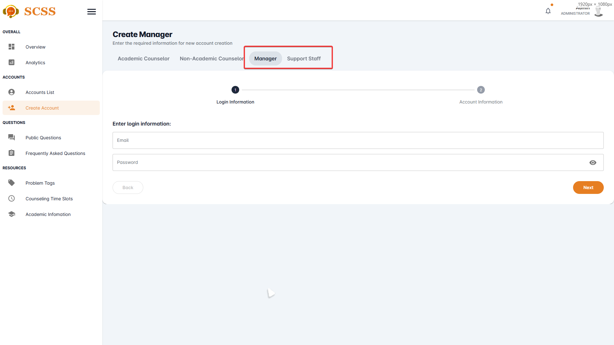

**Step 5:** Fill out “Email”, “Password” fields and press the “Next” button at the bottom of the form when all the fields shown have been filled.

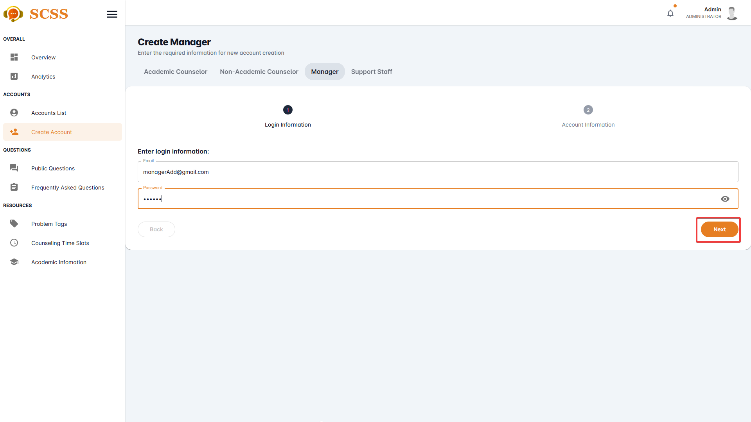

**Step 6:** Fill out “Full name”, “Phone number”, “Email”, “Gender”, “Date of birth”, “Email”, “Password”, and “Avatar” field and press the “Next” button at the bottom of the form when all the fields shown have been filled.

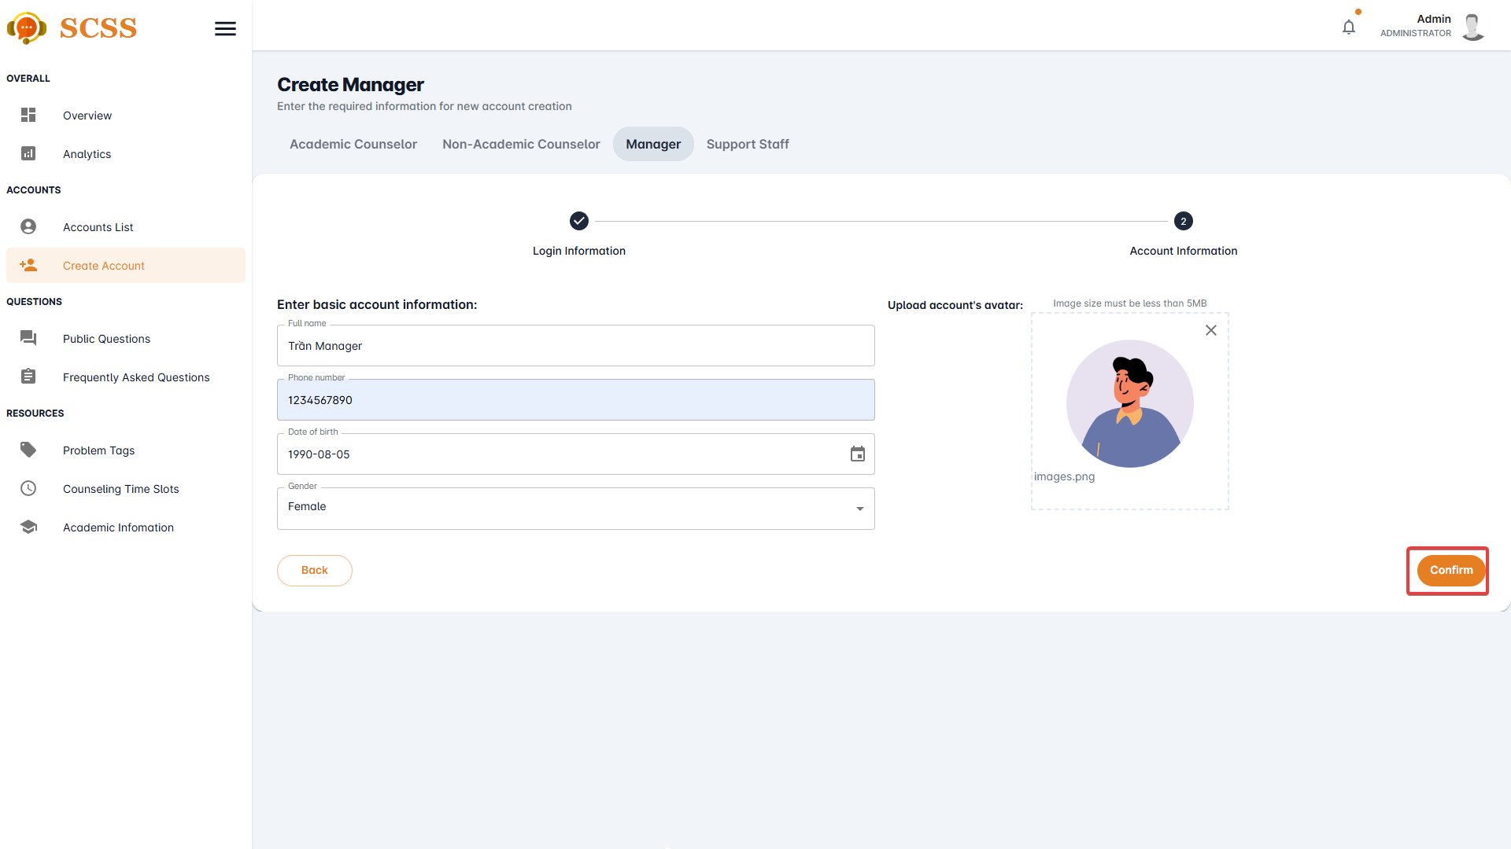

**Step 7:** Press the “OK” button after a success dialog is shown to complete creating an account.

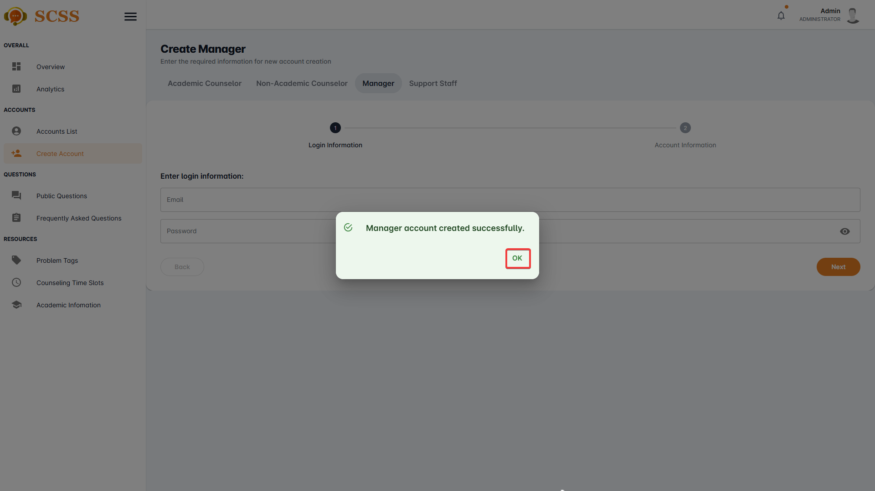

##### 3.2.6.3. Update account

3.2.6.3.1. Description

Use this guide so administrators can update accounts.

3.2.6.3.2. Guide Steps

**Step 1**: Access SCSS at http://scss-fe.azurewebsites.net/. Then fill in “Email” and “Password” of the administrator account.



**Step 2:** Click the “Sign in ” button.



**Step 3:** From the homepage, choose “Accounts List” from the left sidebar.

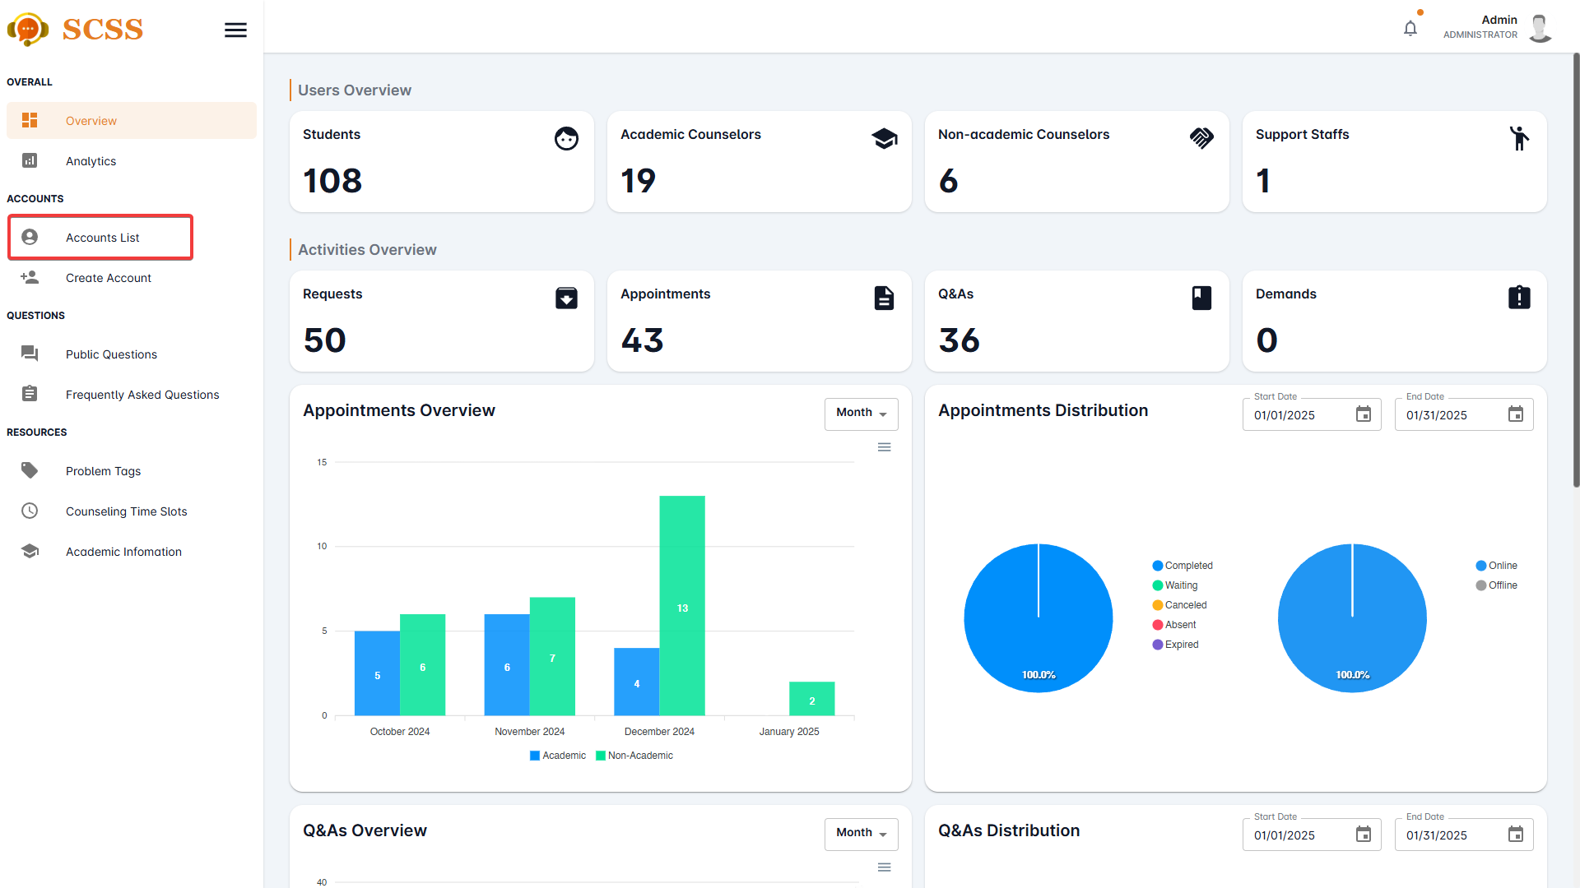

**Step 4:** Press the underlined name of the selected account.

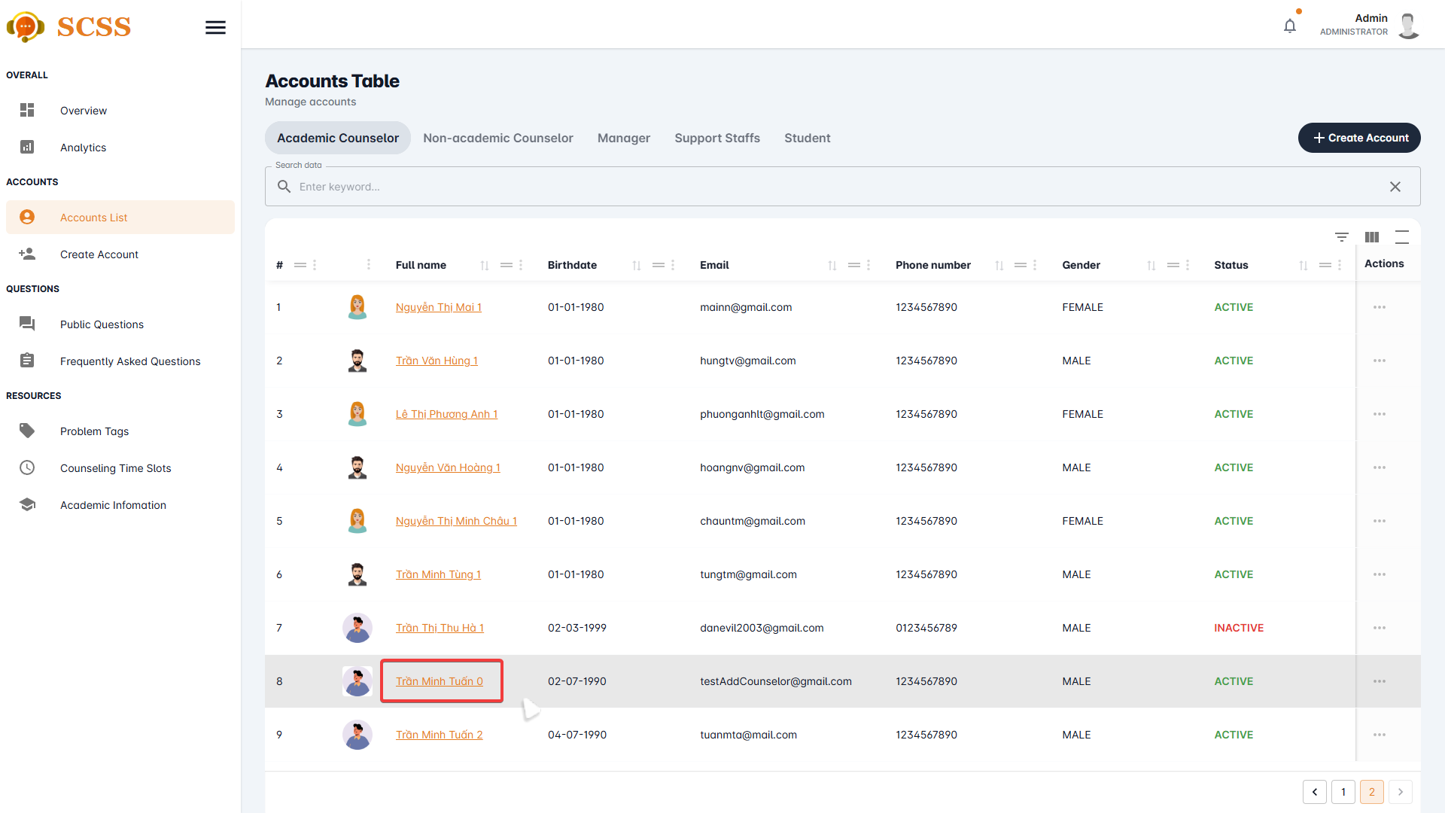

**Step 5:** Fill out the fields that need to be updated and press the “Update” button.

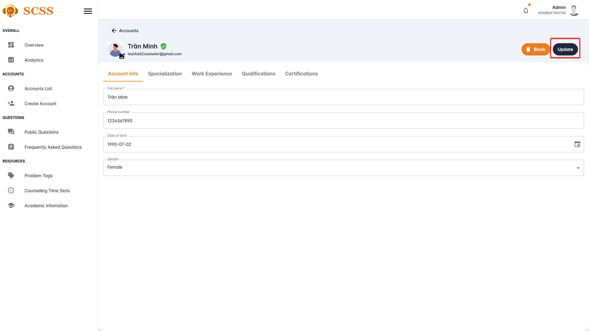

**Step 6:** Press the “OK” button after a success dialog is shown to complete creating an account.

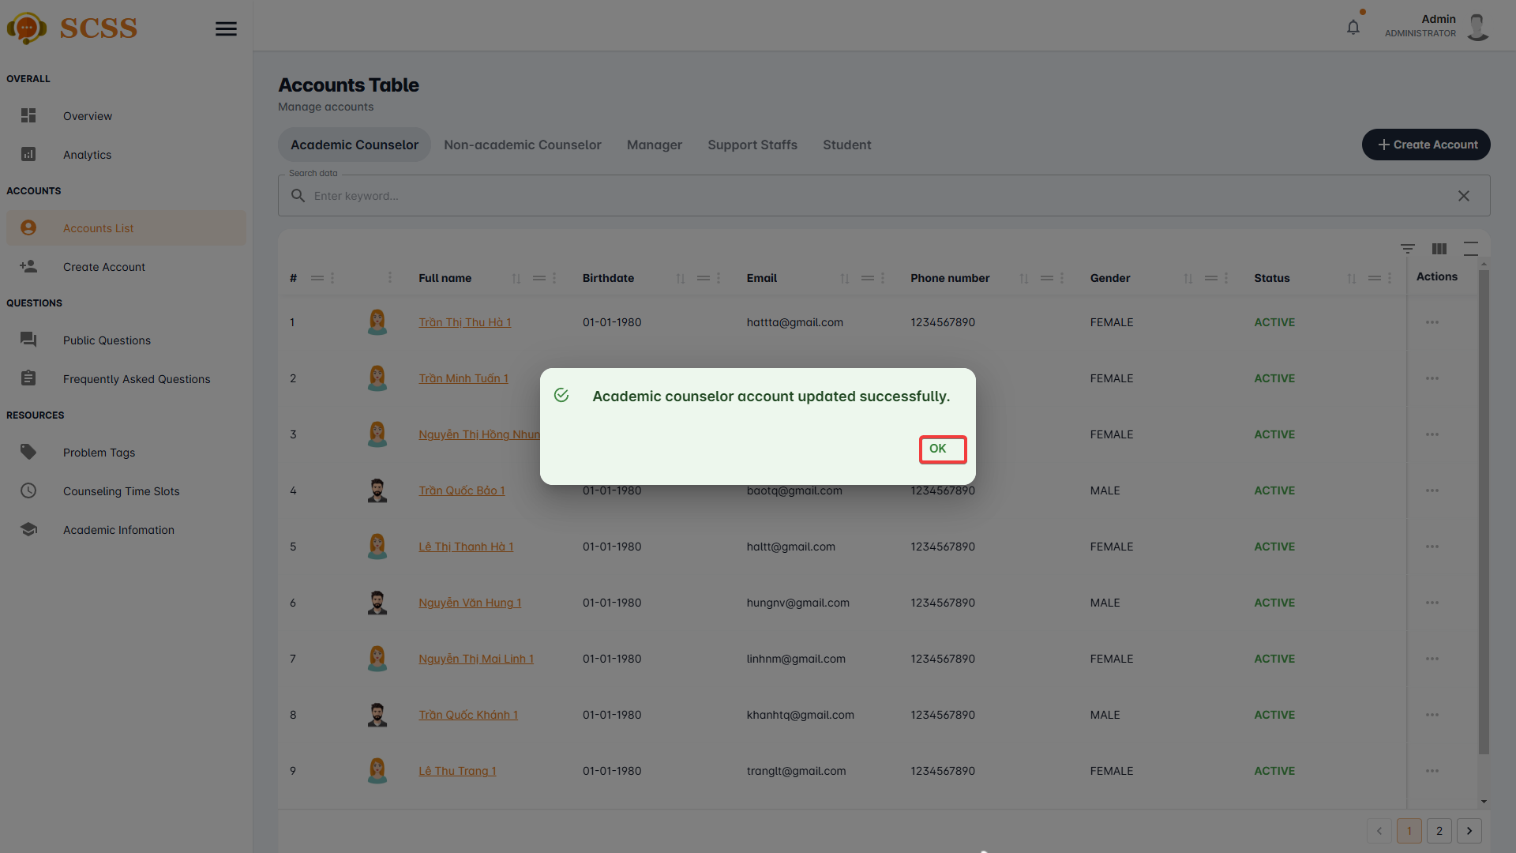

##### 3.2.6.4. Block/Unblock accounts

3.2.6.4.1. Description

Use this guide so administrators can block/unblock accounts.

3.2.6.4.2. Guide Steps

**Step 1**: Access SCSS at http://scss-fe.azurewebsites.net/. Then fill in “Email” and “Password” of the administrator account.



**Step 2:** Click the “Sign in ” button.



**Step 3:** From the homepage, choose “Accounts List” from the left sidebar.



**Step 4:** Press the”...” button in the row of the selected account.

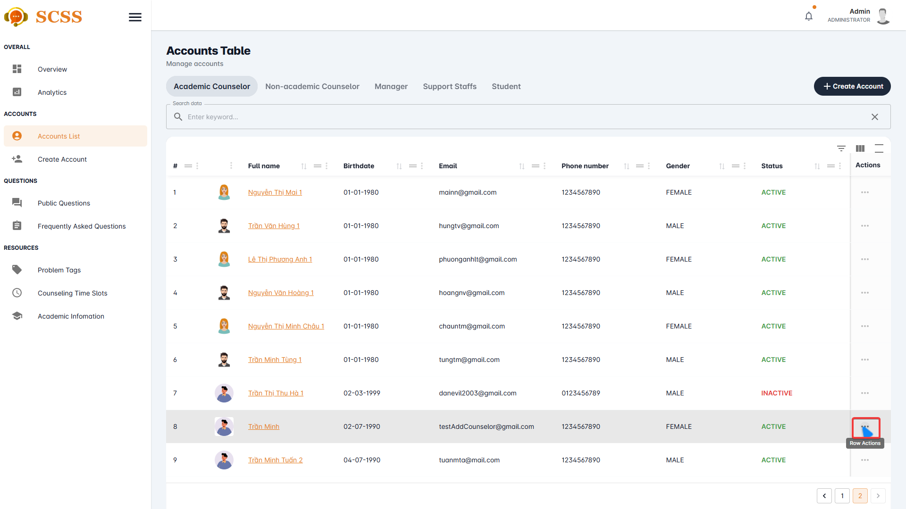

**Step 5:** Press the “Block” or “Unblock” button.

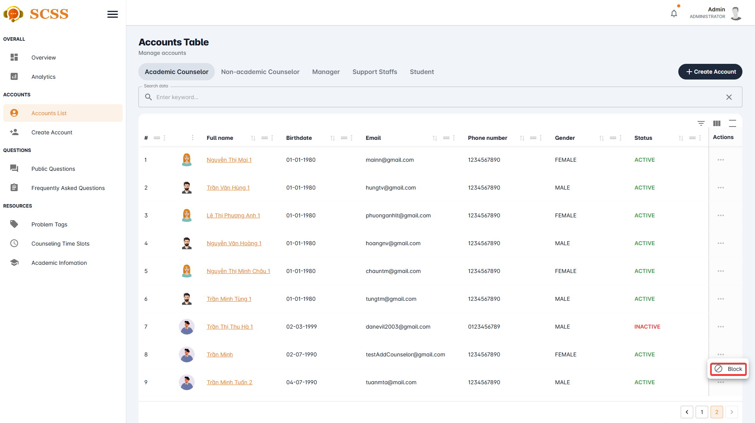

**Step 6:** Press the “Confirm” button.

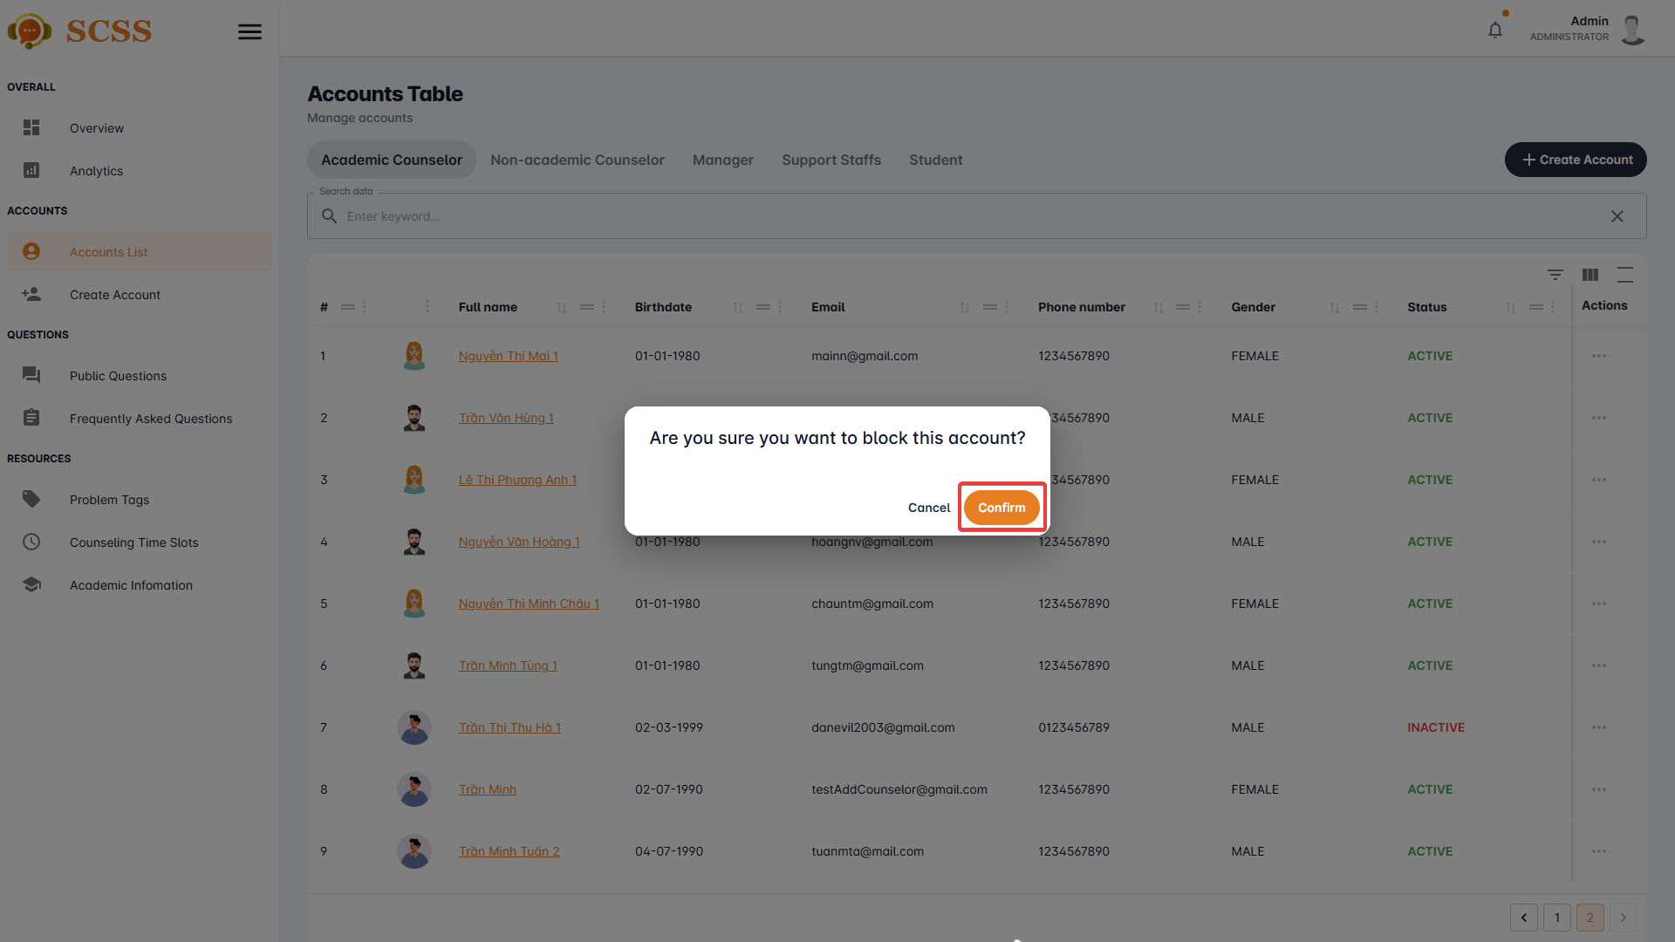

**Step 7:** Press the “OK” button.

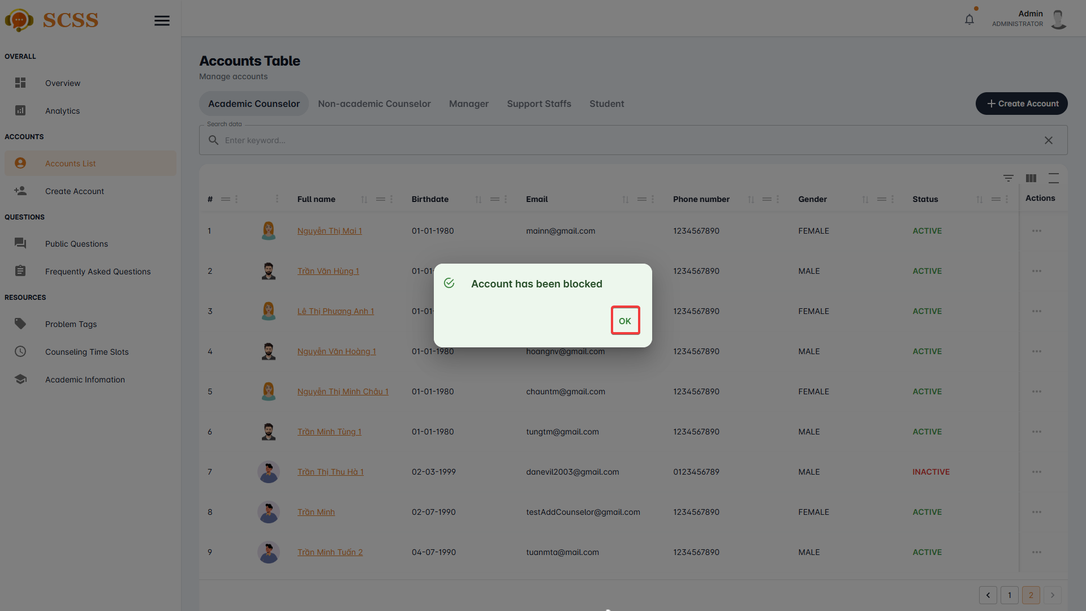

#### 3.2.7. Resource Management

##### 3.2.7.1. Create problem tag

3.2.7.1.1. Description

Use this guideline to create a problem tag using an administrator account.

3.2.7.1.2. Guide Steps

**Step 1**: Access SCSS at http://scss-fe.azurewebsites.net/. Then fill in “Email” and “Password” of the administrator account.



**Step 2:** Click the “Sign in ” button.



**Step 3:** From the homepage, choose “Problem Tag” from the left sidebar.

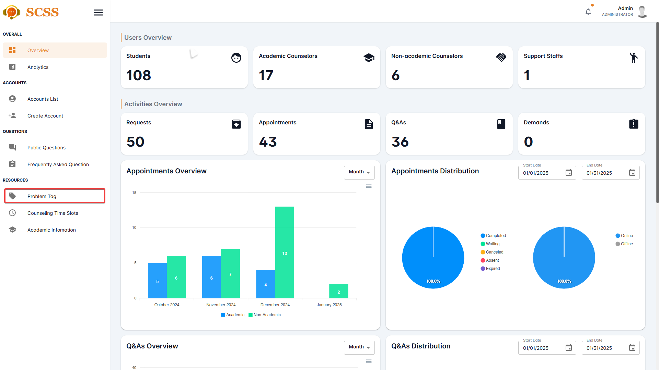

**Step 4:** Select “Tag” tab.

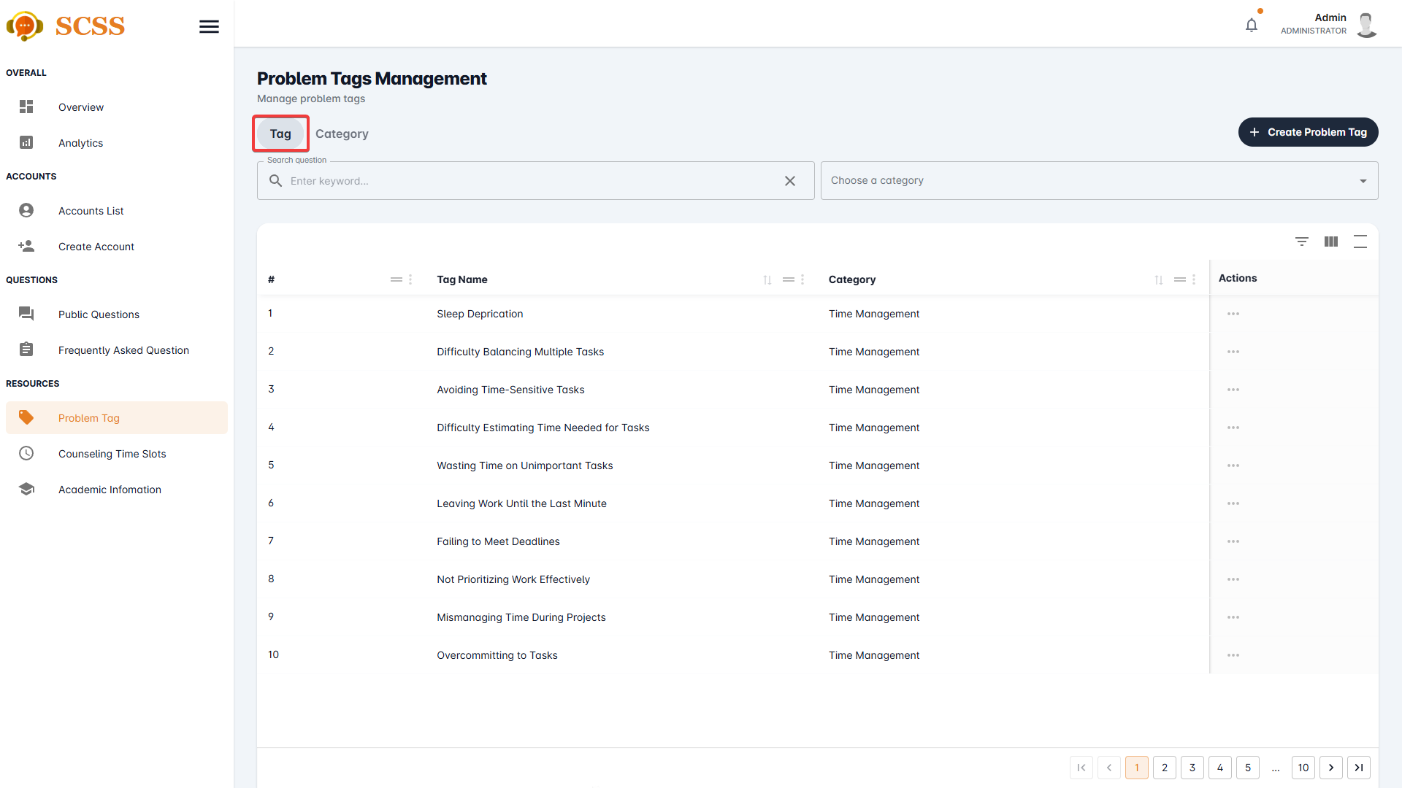

**Step 5:** Press the “Create Problem Tag” button.

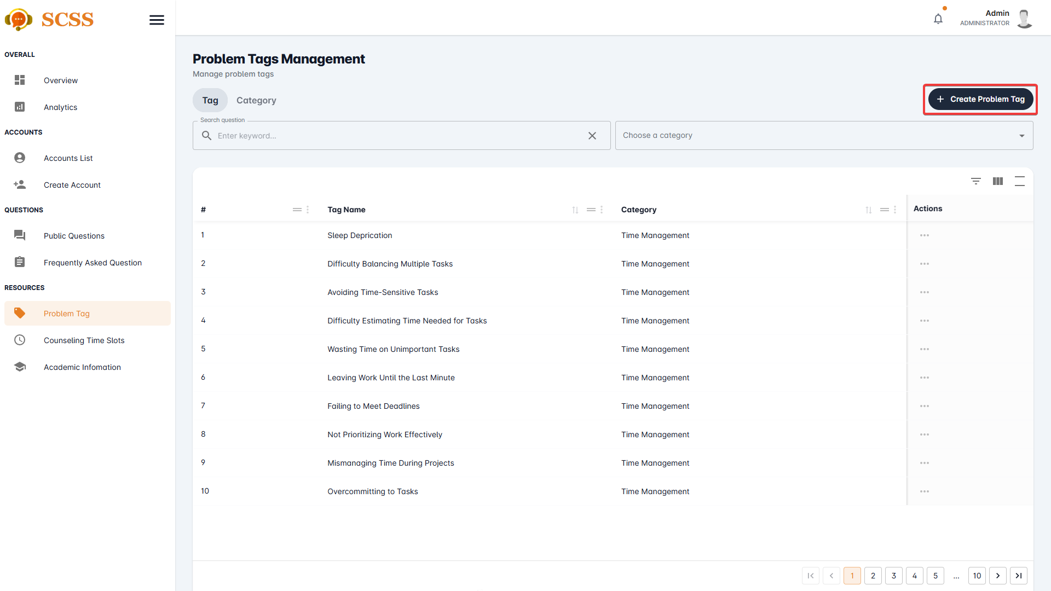

**Step 6:** Fill out the “Problem tag name”, “Point”, and select a “Category”, then press the “Confirm” button.

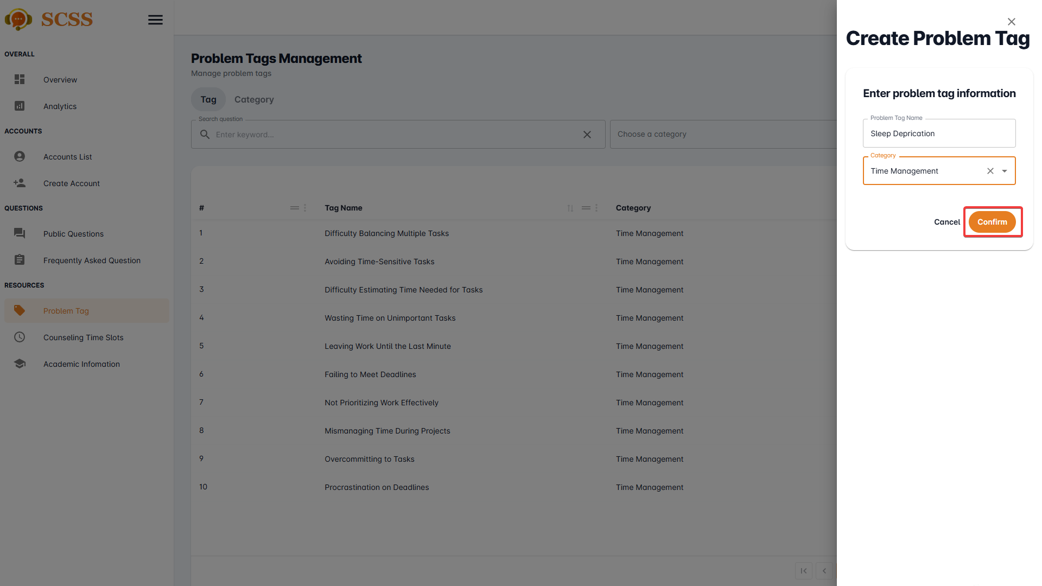

**Step 7:** Press the “OK” button after a success dialog is shown to complete creating a problem tag.

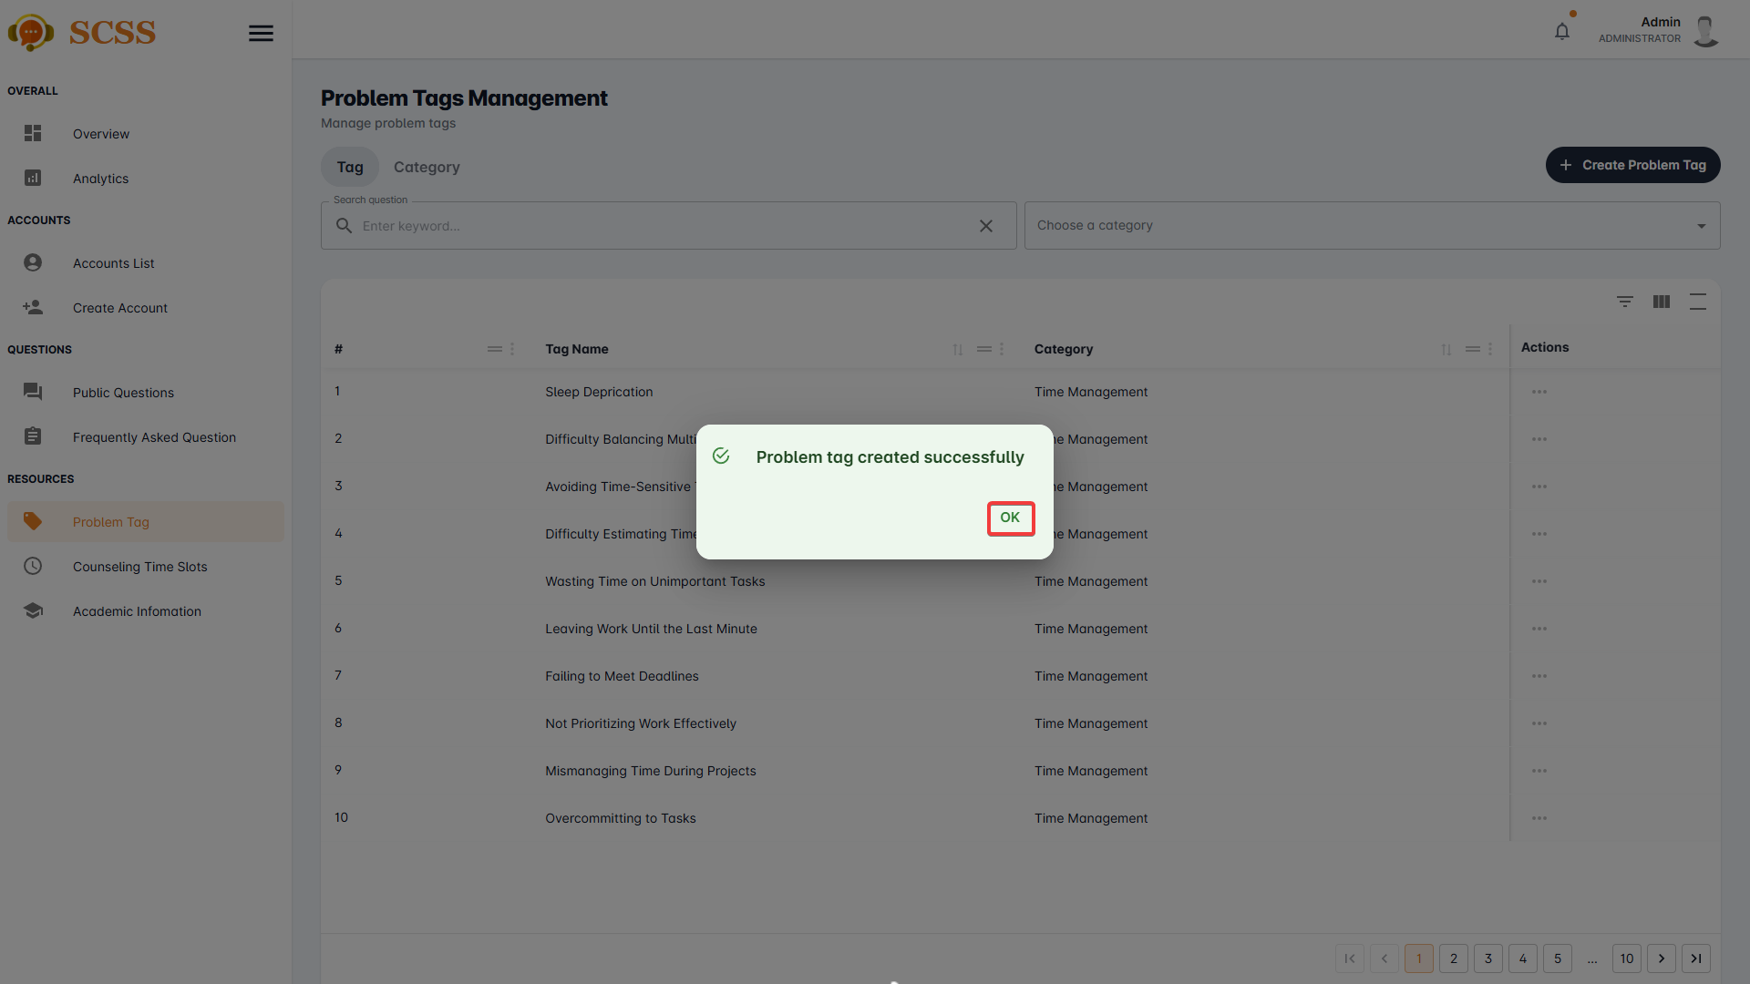

##### 3.2.7.2. Create problem tag’s category

3.2.7.2.1. Description

Use this guideline to create a problem tag’s category using an administrator account.

3.2.7.2.2. Guide Steps

**Step 1**: Access SCSS at http://scss-fe.azurewebsites.net/. Then fill in “Email” and “Password” of the administrator account.



**Step 2:** Click the “Sign in ” button.



**Step 3:** From the homepage, choose “Problem Tag” from the left sidebar.



**Step 4:** Select “Category” tab.

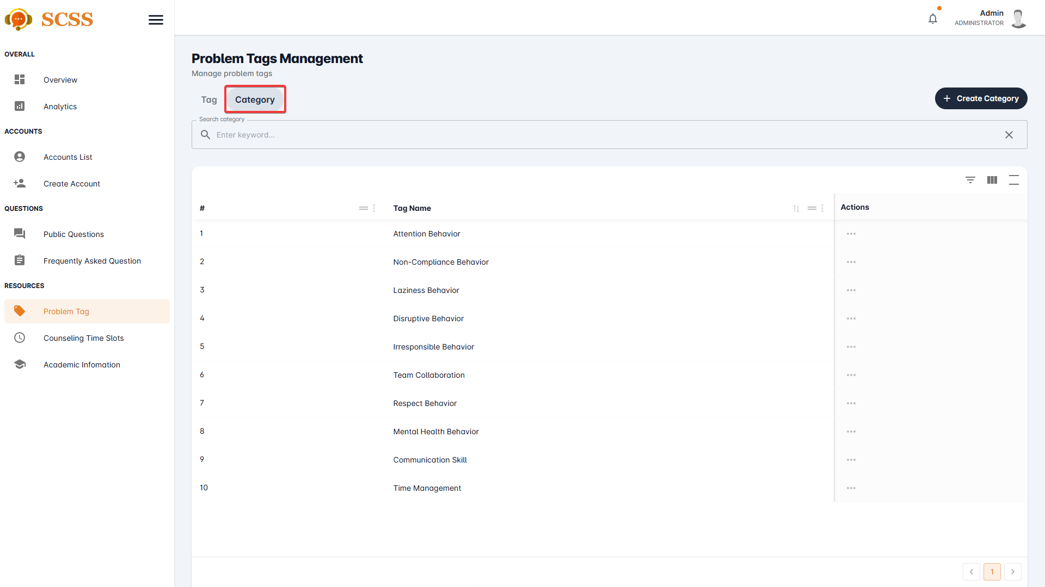

**Step 5:** Press the “Create Category” button.

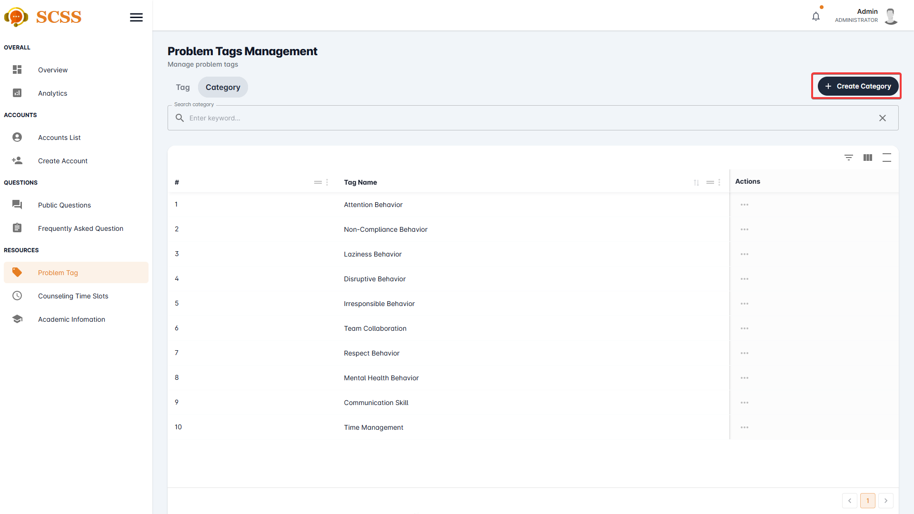

**Step 6:** Fill out the “Category name” field, then press the “Confirm” button.

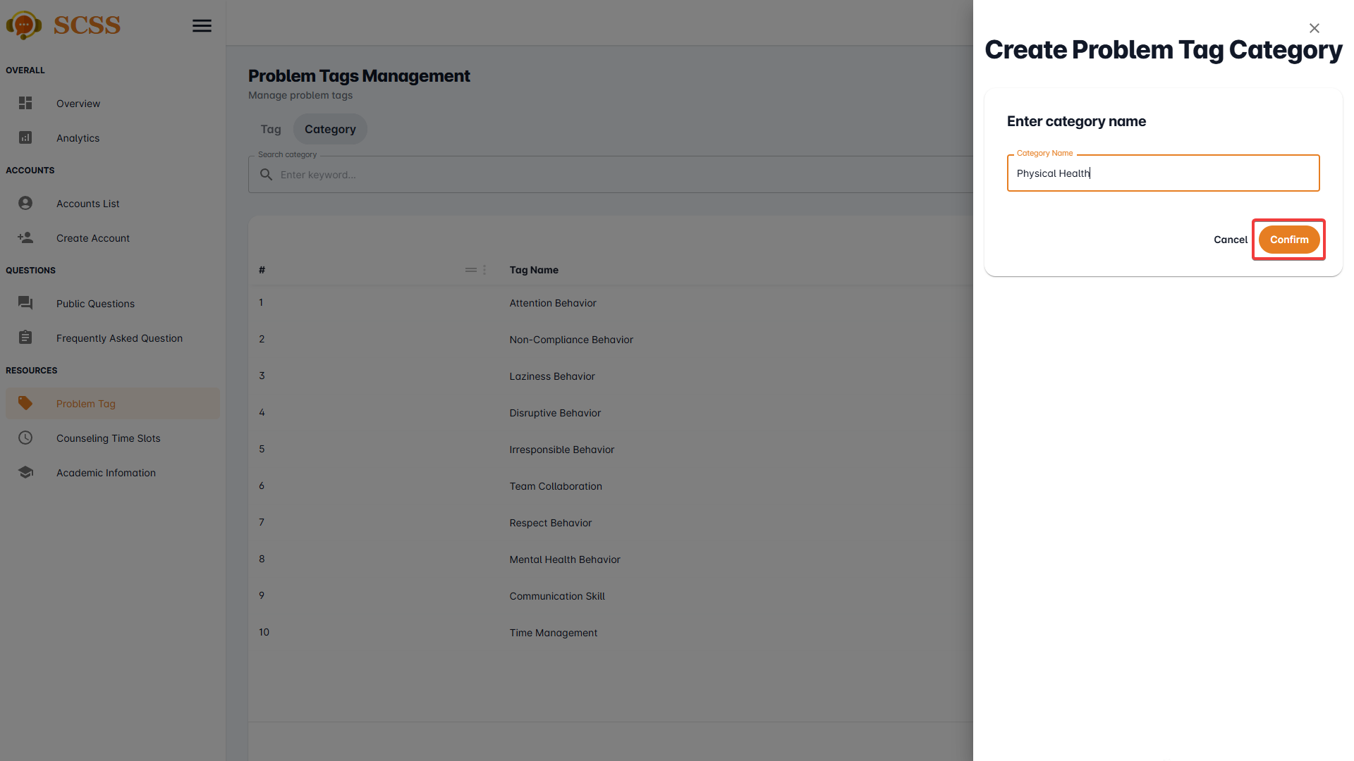

**Step 7:** Press the “OK” button after a success dialog is shown to complete creating a problem tag’s category

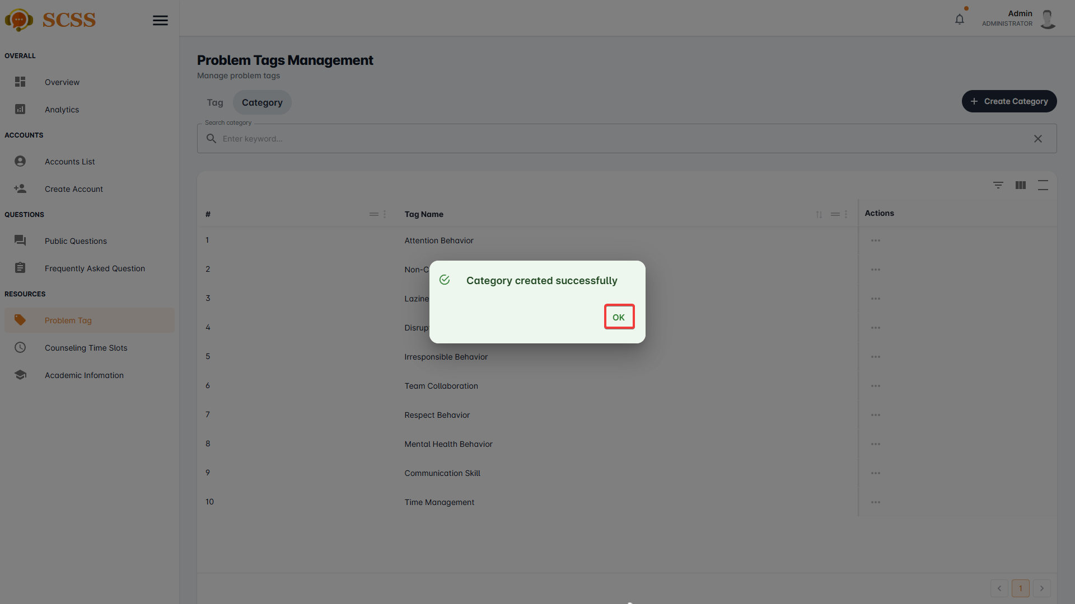.

##### 3.2.7.3. Create counseling time slot

3.2.7.3.1. Description

Use this guideline to create a counseling time slot using an administrator account.

3.2.7.3.2. Guide Steps

**Step 1**: Access SCSS at http://scss-fe.azurewebsites.net/. Then fill in “Email” and “Password” of the administrator account.



**Step 2:** Click the “Sign in ” button.



**Step 3:** From the homepage, choose “Counseling Time Slots” from the left sidebar.

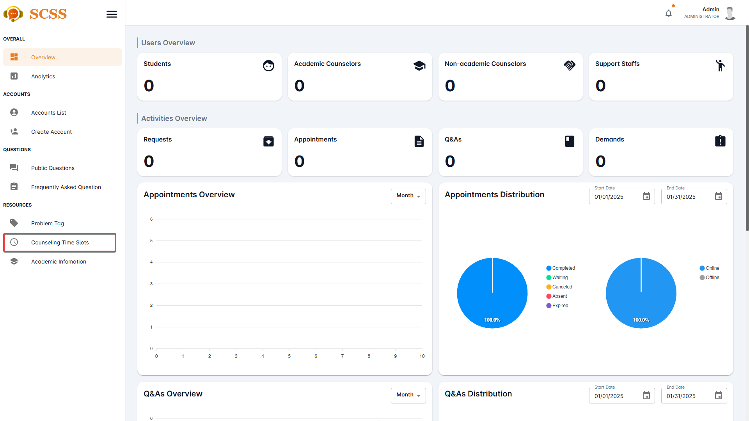

**Step 4:** Press the “Add Time Slot” button.

.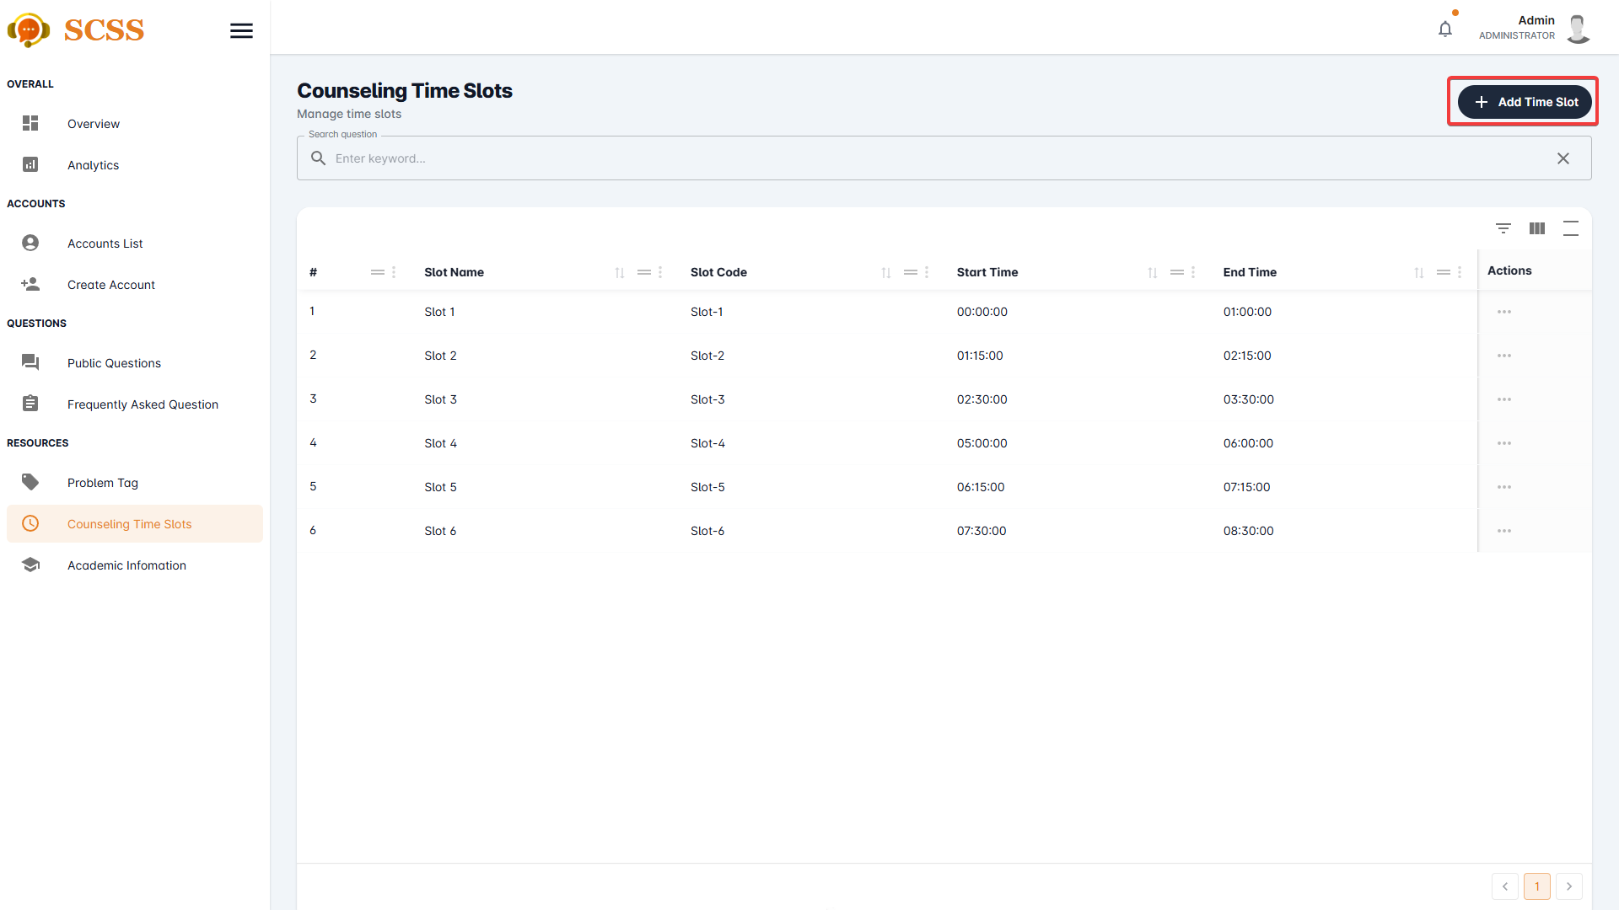

**Step 5:** Fill out the “Slot name”, “Slot code”, “Start time”, and “End time” fields, then press the “Confirm” button.

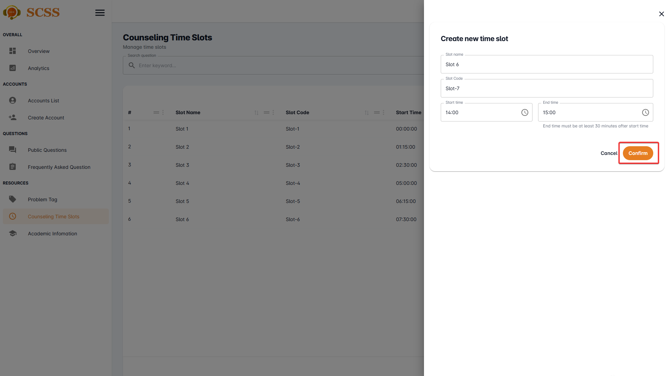

**Step 6:** Press the “OK” button after a success dialog is shown to complete creating a counseling time slot.

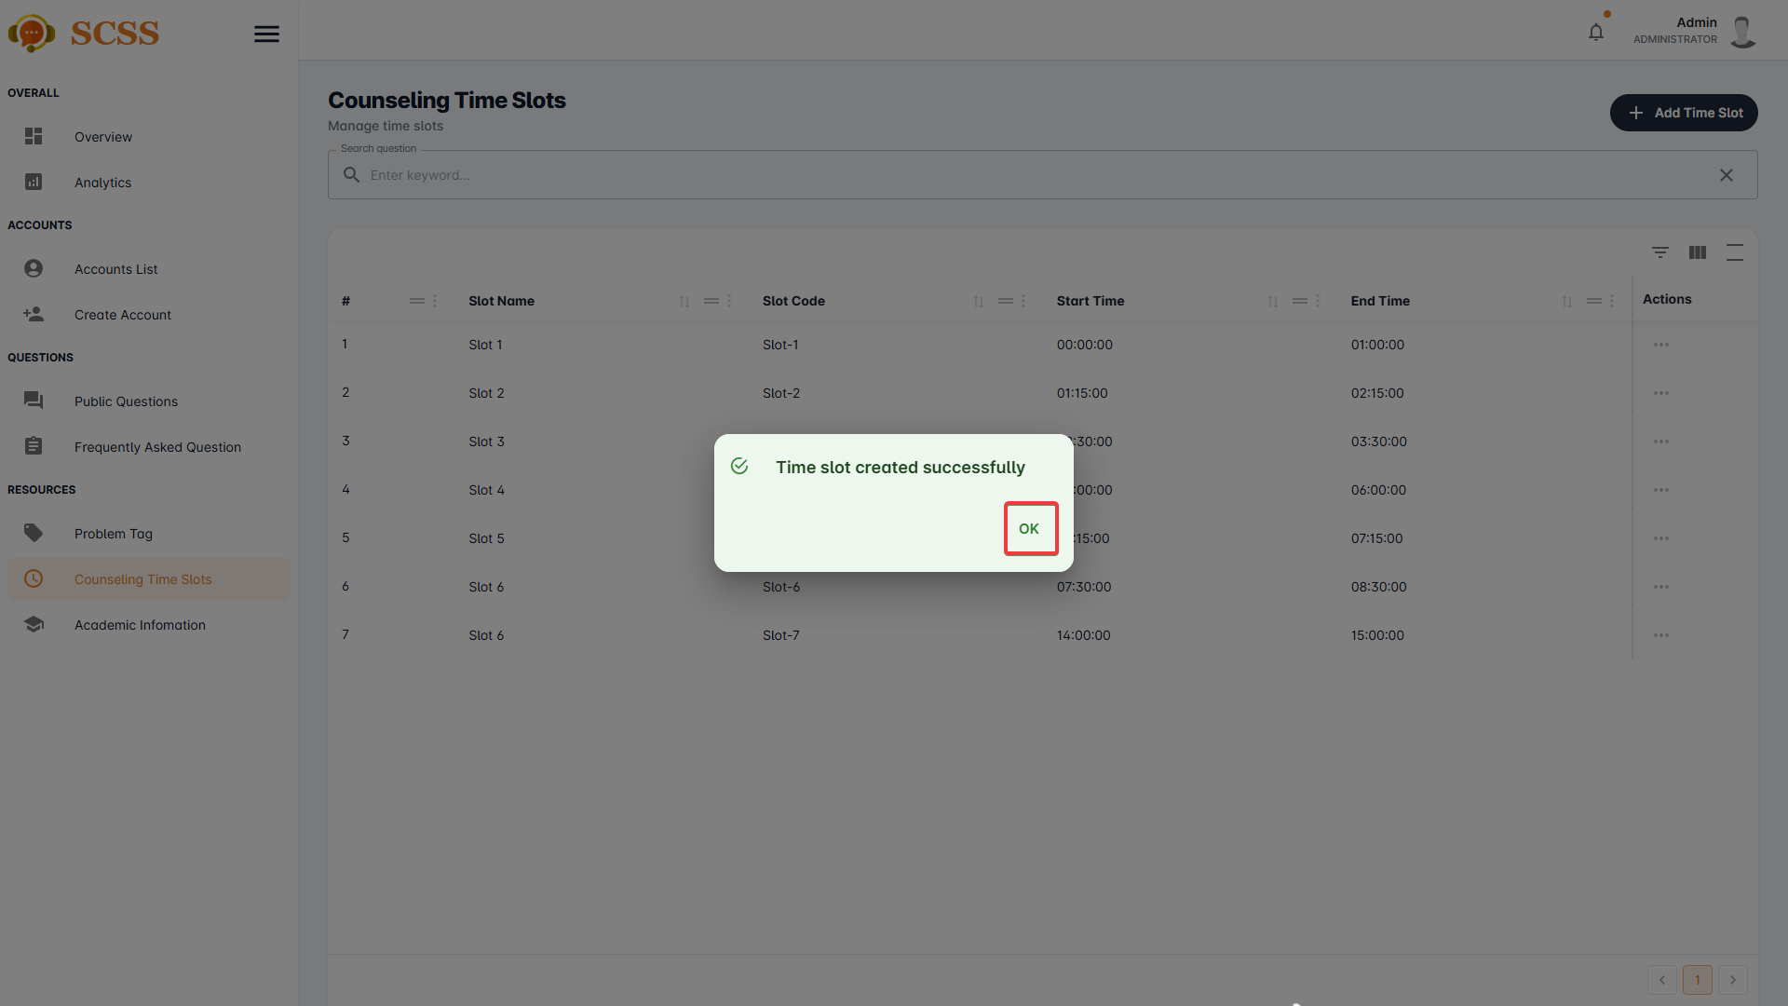

##### 3.2.7.4. Remove problem tag’s category

3.2.7.4.1. Description

Use this guideline to remove a problem tag’s category using an administrator account.

3.2.7.4.2. Guide Steps

**Step 1**: Access SCSS at http://scss-fe.azurewebsites.net/. Then fill in “Email” and “Password” of the administrator account.



**Step 2:** Click the “Sign in ” button.



**Step 3:** From the homepage, choose “Problem Tag” from the left sidebar.



**Step 4:** Select “Category” tab.



**Step 5:** Press the “...” button under the actions column, in the row of the selected category.

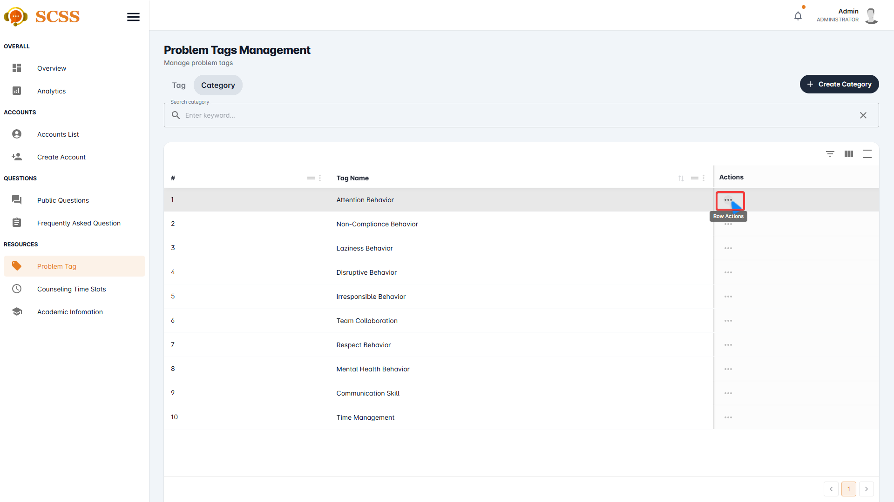

**Step 6:** Press the “Delete” button.

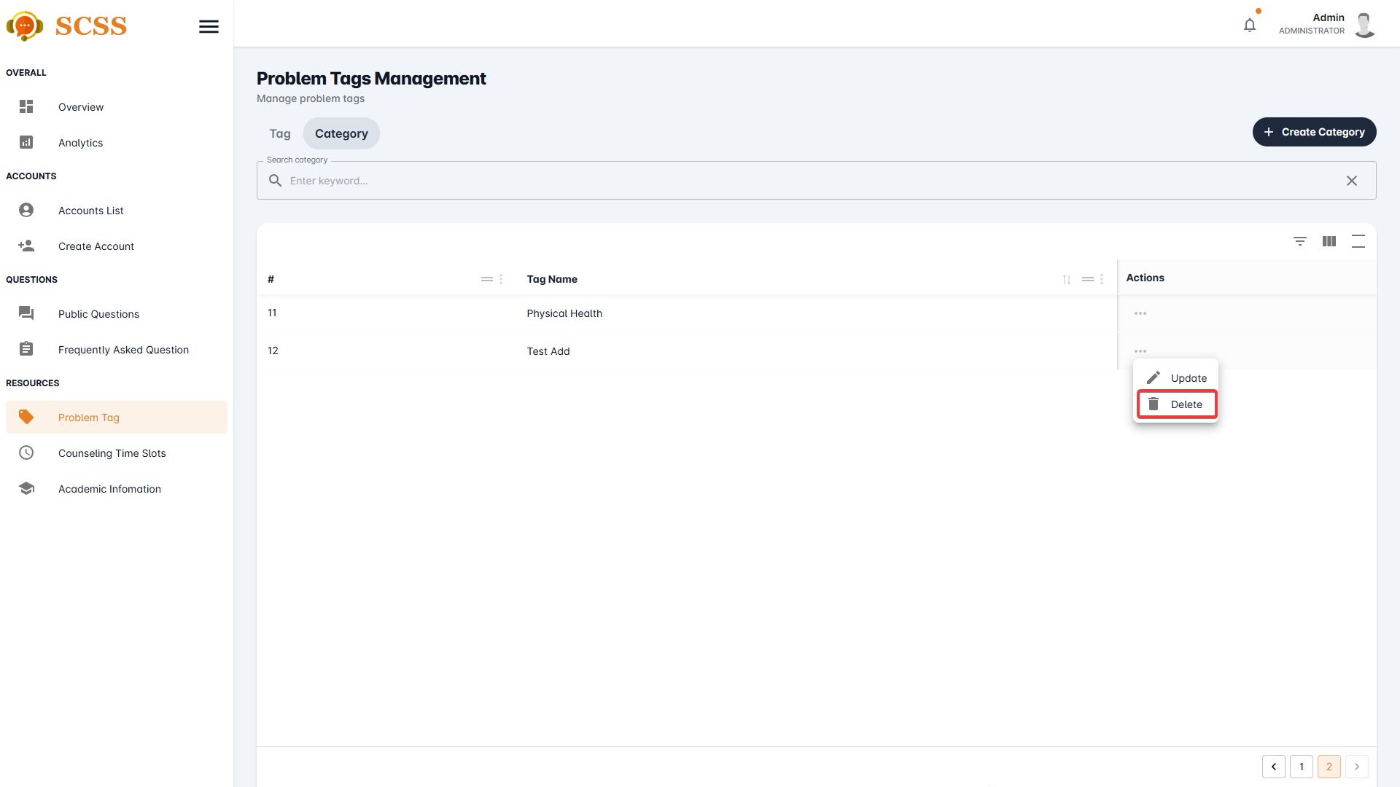

**Step 7:** Press the “Confirm” button.

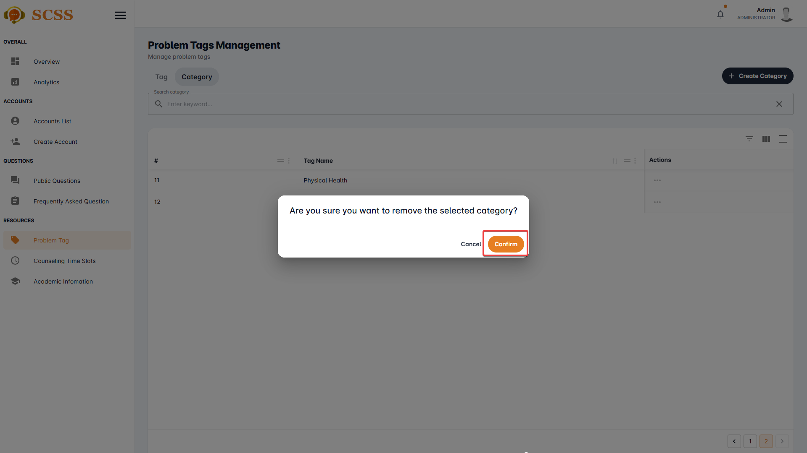

**Step 8:** Press the “Ok” button to complete removing a category.

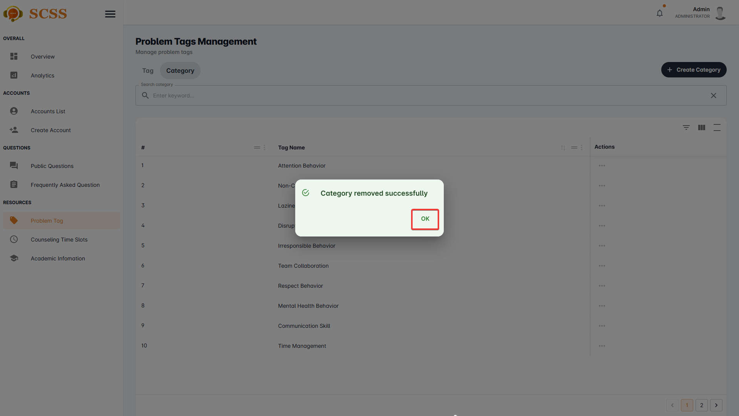

##### 3.2.7.5. Remove problem tag

3.2.7.5.1. Description

Use this guideline to remove a problem tag’s category using an administrator account.

3.2.7.5.2. Guide Steps

**Step 1**: Access SCSS at http://scss-fe.azurewebsites.net/. Then fill in “Email” and “Password” of the administrator account.



**Step 2:** Click the “Sign in ” button.



**Step 3:** From the homepage, choose “Problem Tag” from the left sidebar.



**Step 4:** Select “Tag” tab.



**Step 5:** Press the “...” button under the actions column, in the row of the selected problem tag.

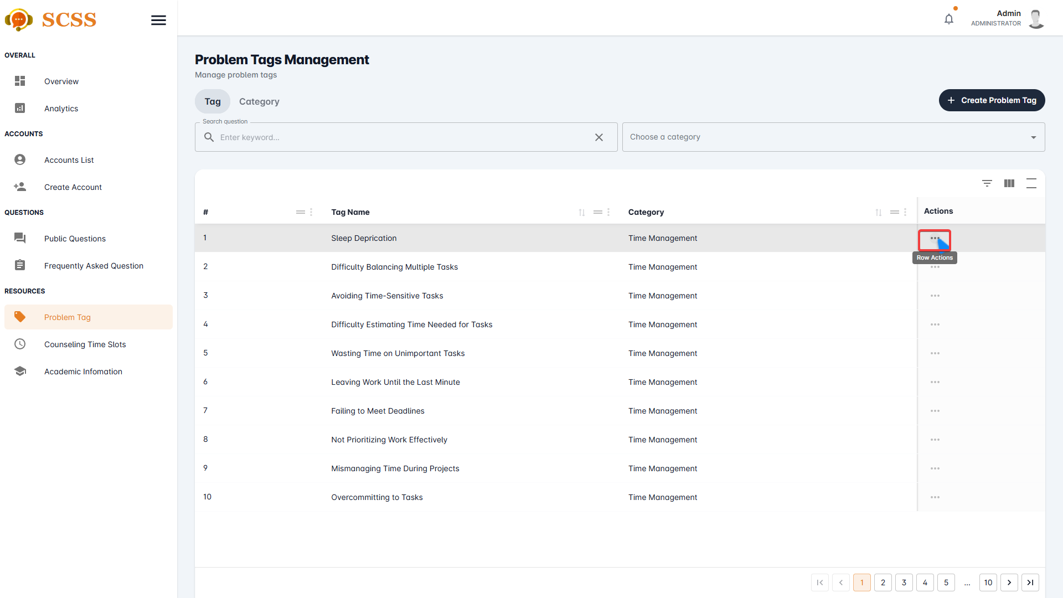**Step 6:** Press the “Delete” button.



**Step 7:** Press the “Confirm” button.

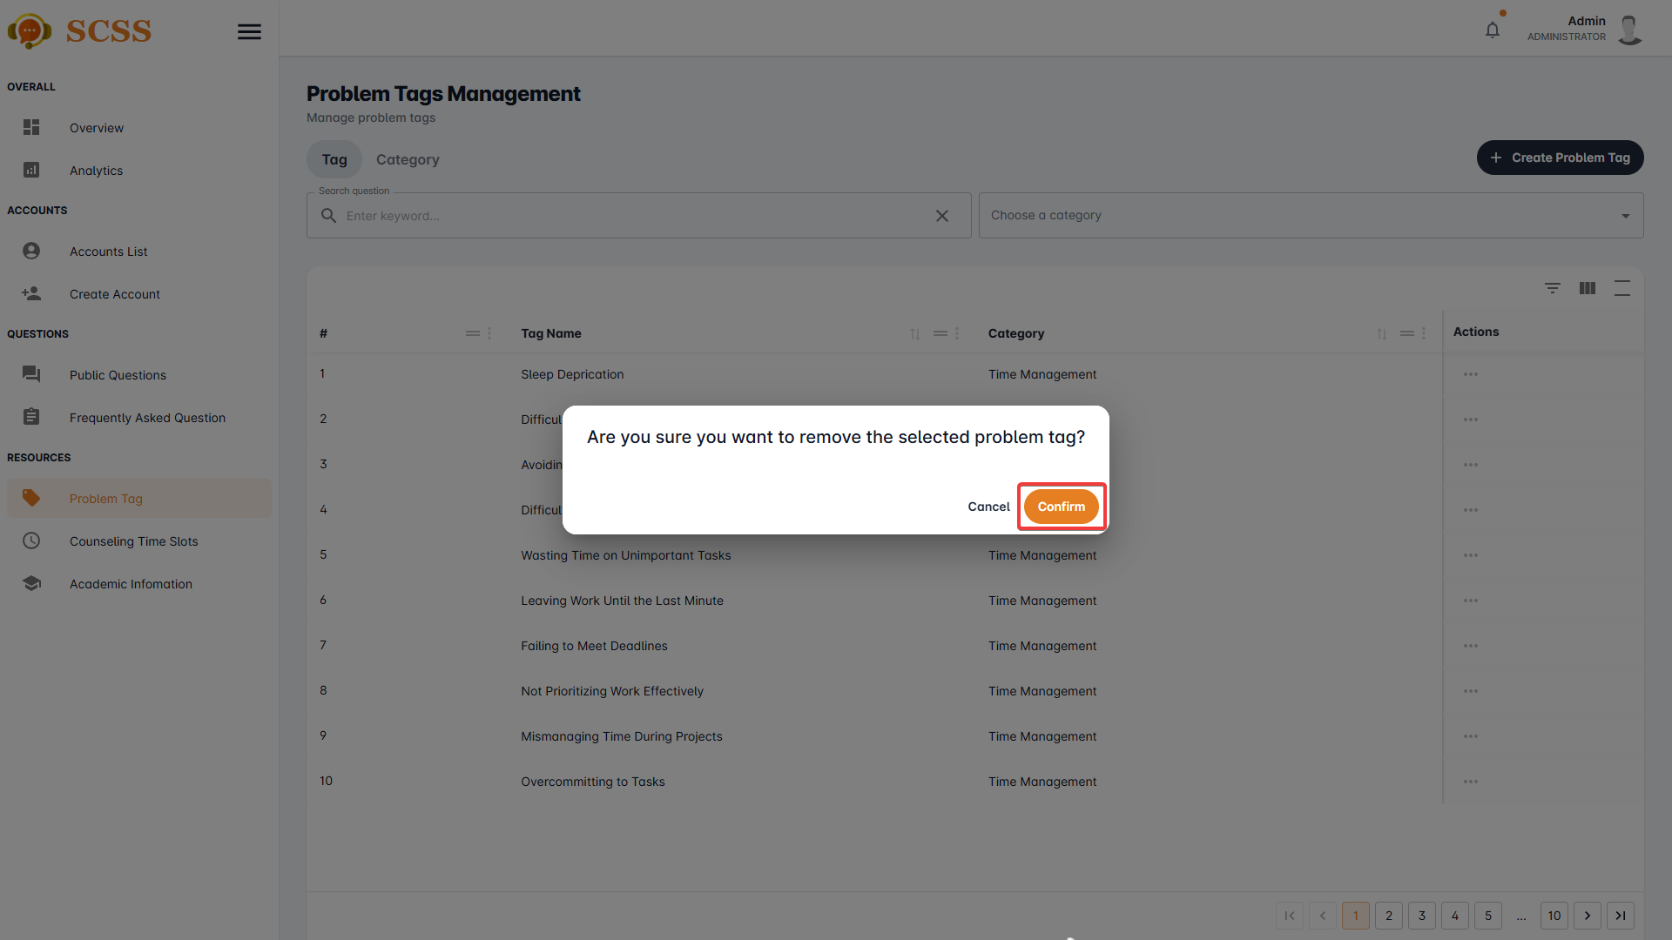

**Step 8:** Press the “Ok” button to complete removing a problem tag.

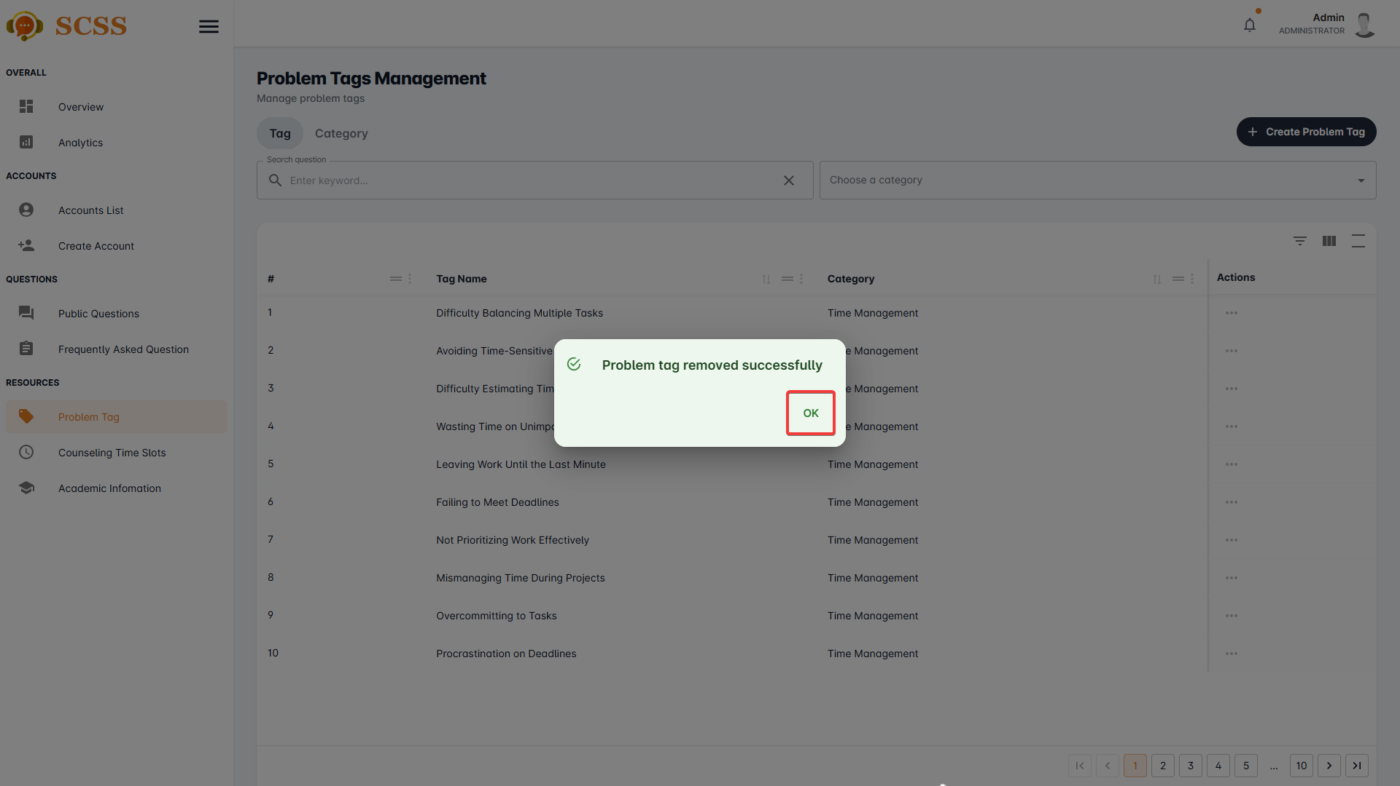

##### 3.2.7.6. Remove counseling time slot

3.2.7.6.1. Description

Use this guideline to remove a counselling time slot using an administrator account.

3.2.7.6.2. Guide Steps

**Step 1**: Access SCSS at http://scss-fe.azurewebsites.net/. Then fill in “Email” and “Password” of the administrator account.



**Step 2:** Click the “Sign in ” button.



**Step 3:** From the homepage, choose “Counseling Time Slots” from the left sidebar.



**Step 4:** Press the “...” button under the actions column, in the row of the selected problem tag.

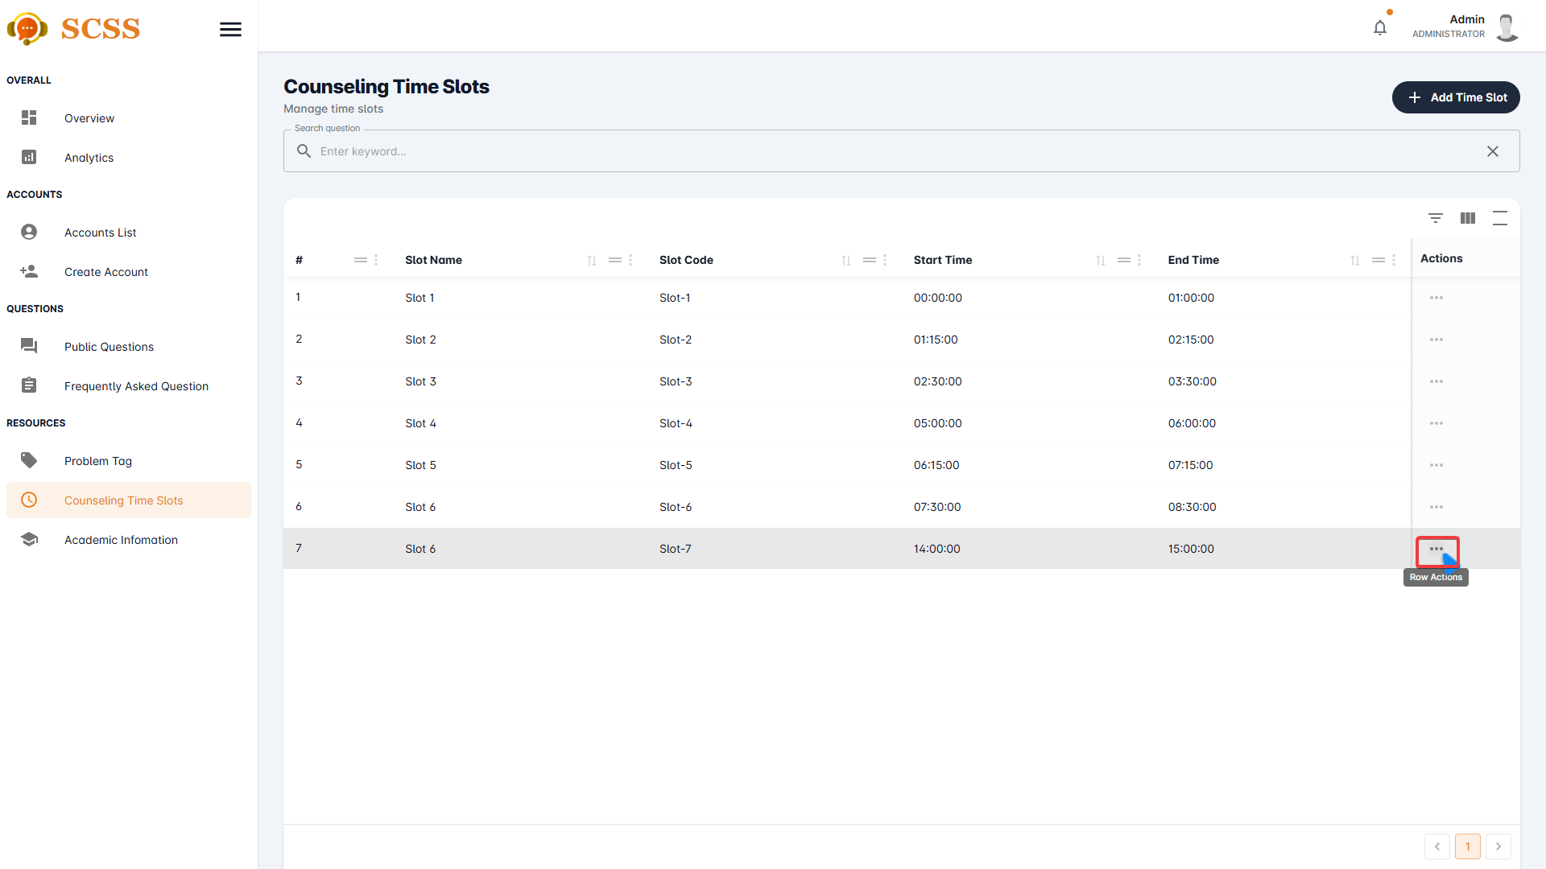**Step 5:** Press the “Delete” button.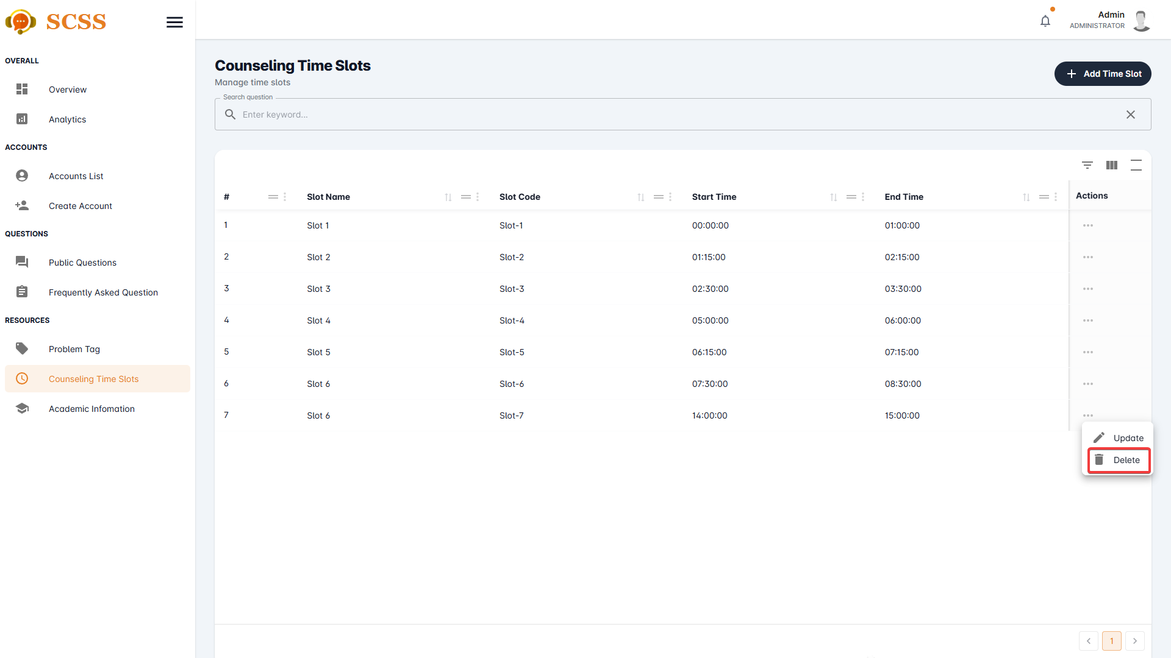

**Step 6:** Press the “Confirm” button.

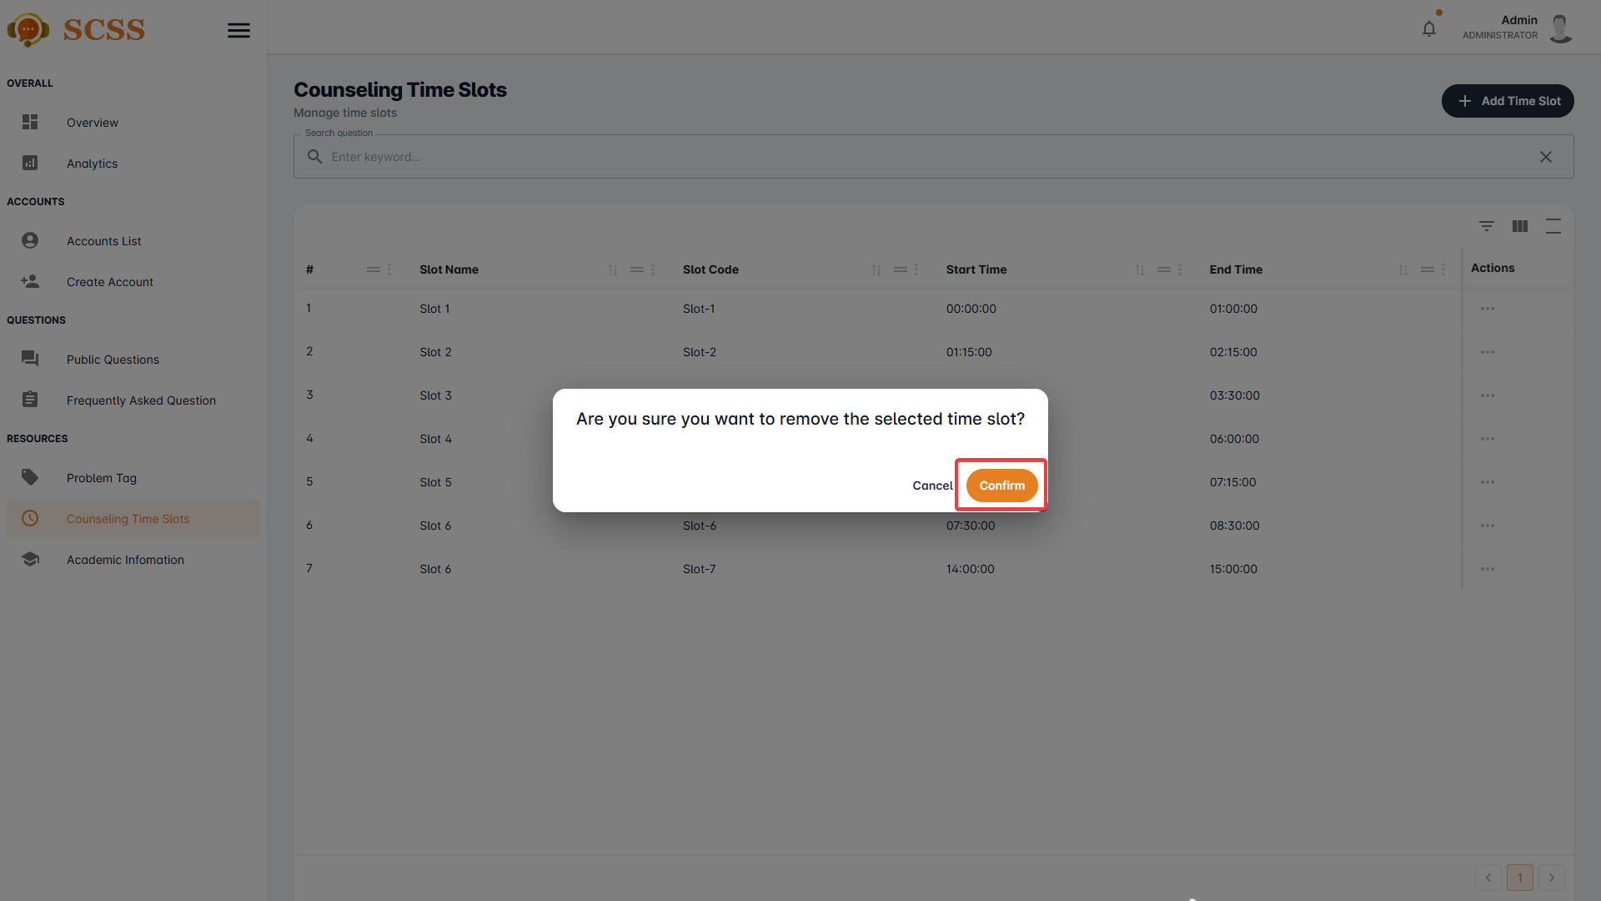

**Step 7:** Press the “Ok” button to complete removing a time slot.

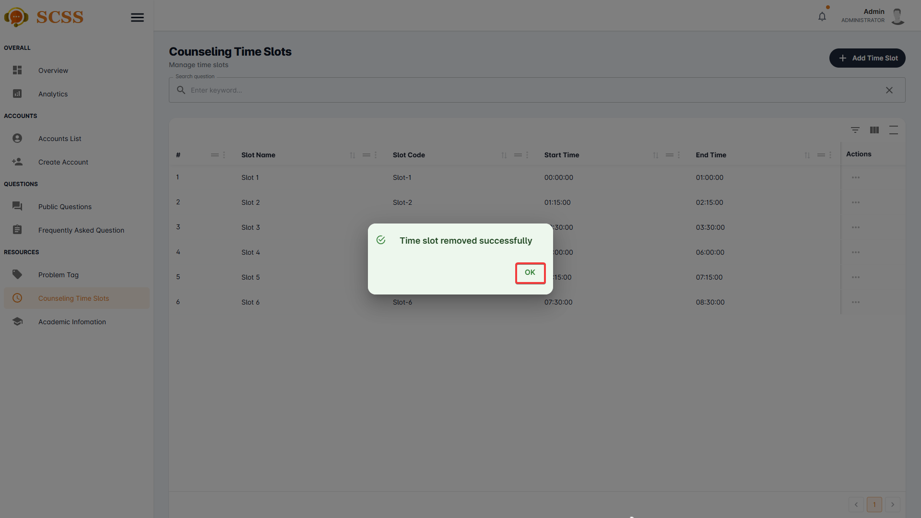

##### 3.2.7.7. Update problem tag

3.2.7.7.1. Description

Use this guideline to update a problem tag using an administrator account.

3.2.7.7.2. Guide Steps

**Step 1**: Access SCSS at http://scss-fe.azurewebsites.net/. Then fill in “Email” and “Password” of the administrator account.



**Step 2:** Click the “Sign in ” button.



**Step 3:** From the homepage, choose “Problem Tag” from the left sidebar.



**Step 4:** Select “Tag” tab.



**Step 5:** Press the “...” button under the actions column, in the row of the selected problem tag.

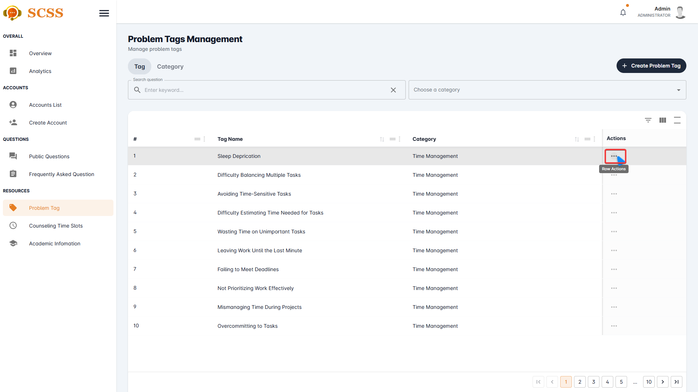

**Step 6:** Press the “Update” button.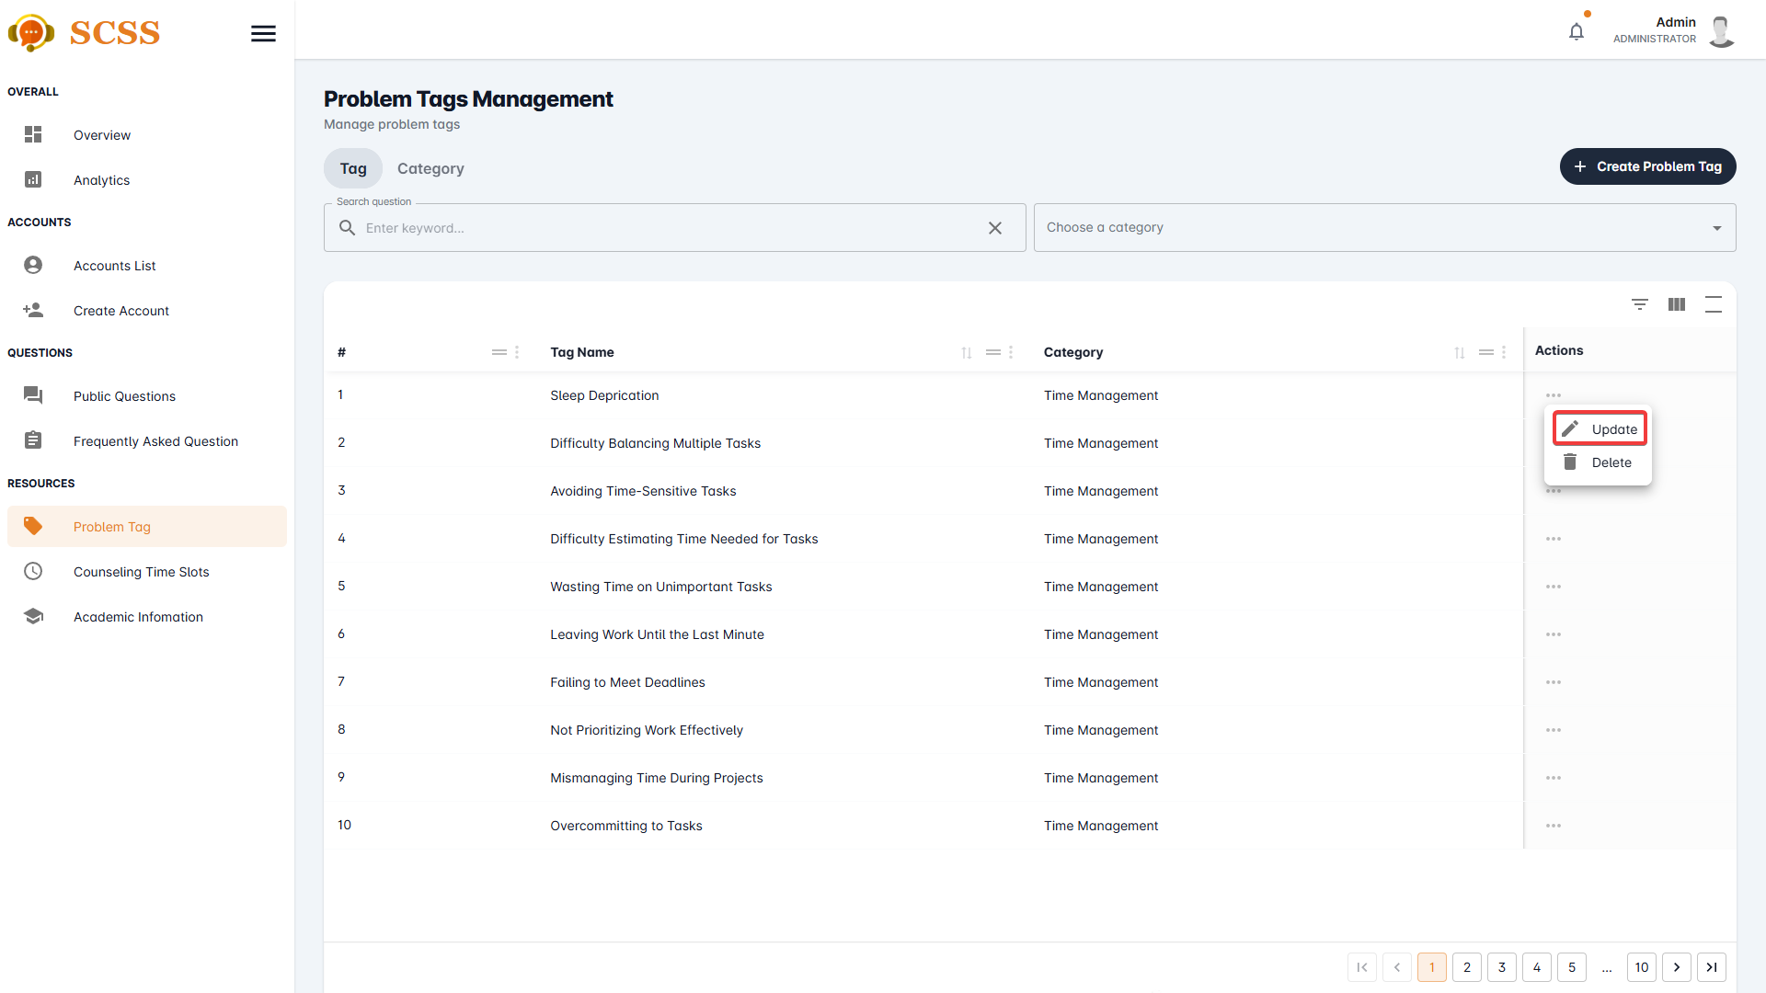

**Step 7:** Fill out the “Problem tag name”, “Point”, and select a “Category”, then press the “Confirm” button.

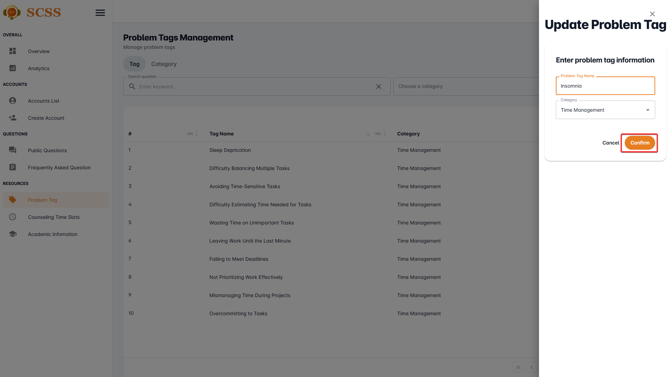

**Step 8:** Press the “OK” button after a success dialog is shown to complete updating a problem tag.

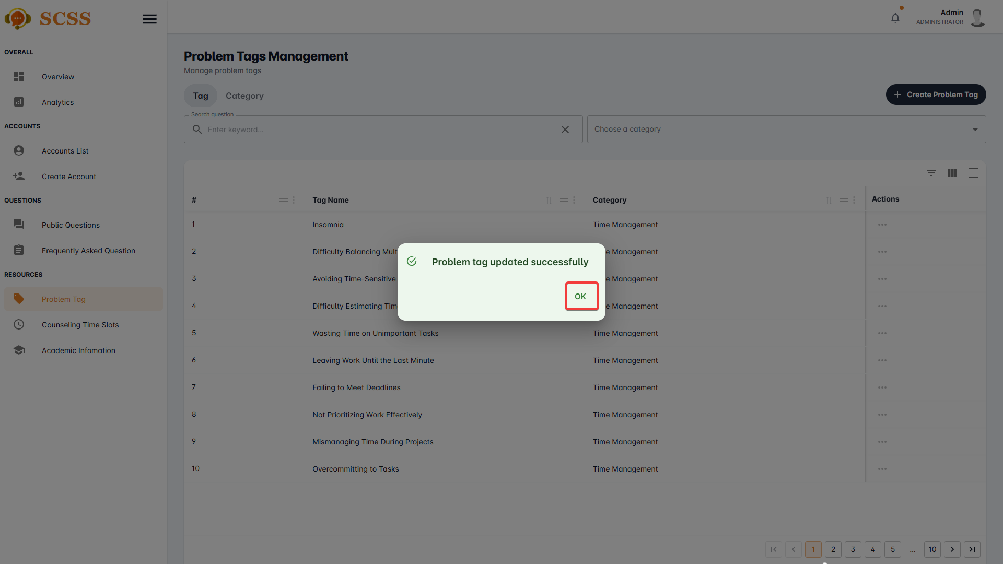

##### 3.2.7.8. Update problem tag’s category

3.2.7.8.1. Description

Use this guideline to update a problem tag’s category using an administrator account.

3.2.7.8.2. Guide Steps

**Step 1**: Access SCSS at http://scss-fe.azurewebsites.net/. Then fill in “Email” and “Password” of the administrator account.



**Step 2:** Click the “Sign in ” button.



**Step 3:** From the homepage, choose “Problem Tag” from the left sidebar.



**Step 4:** Select “Category” tab.



**Step 5:** Press the “...” button under the actions column, in the row of the selected problem tag.

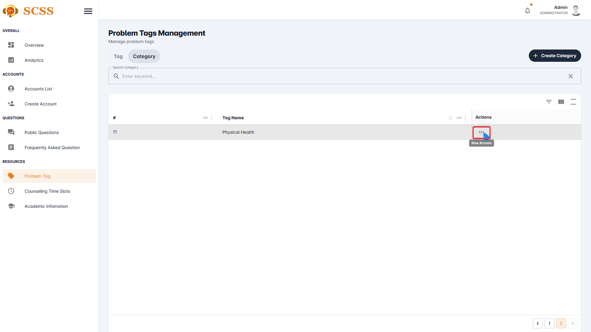

**Step 6:** Press the “Update” button.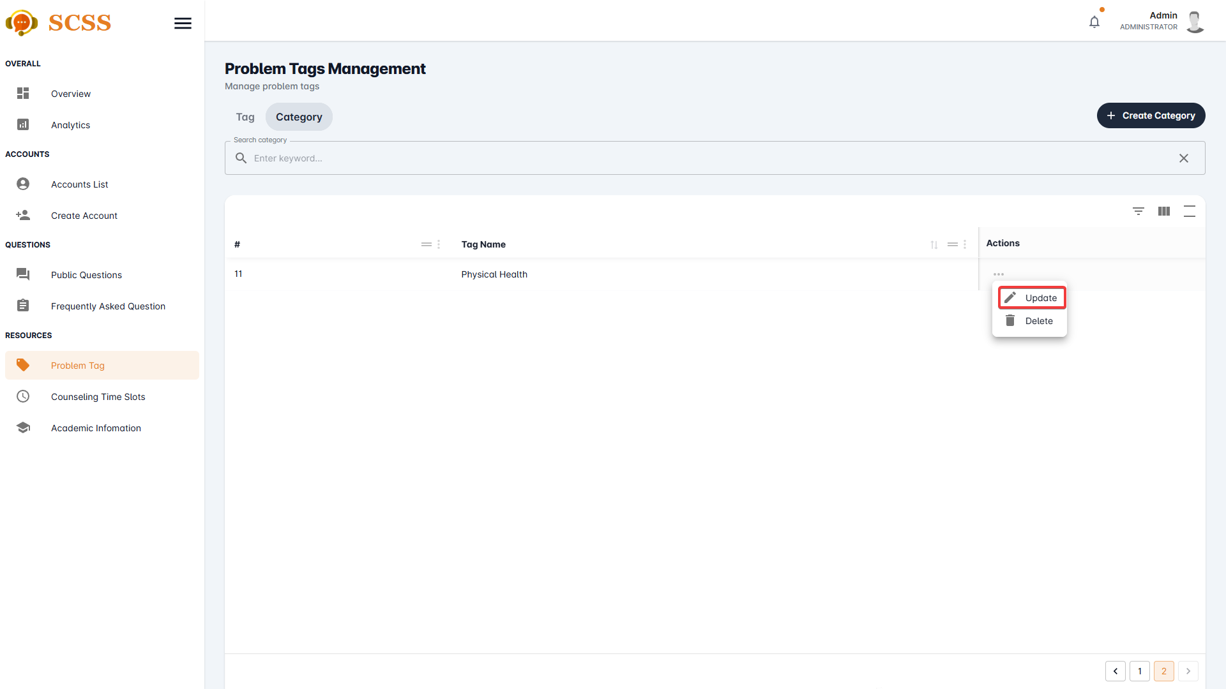

**Step 7:** Fill out the “Category name” field, then press the “Confirm” button.

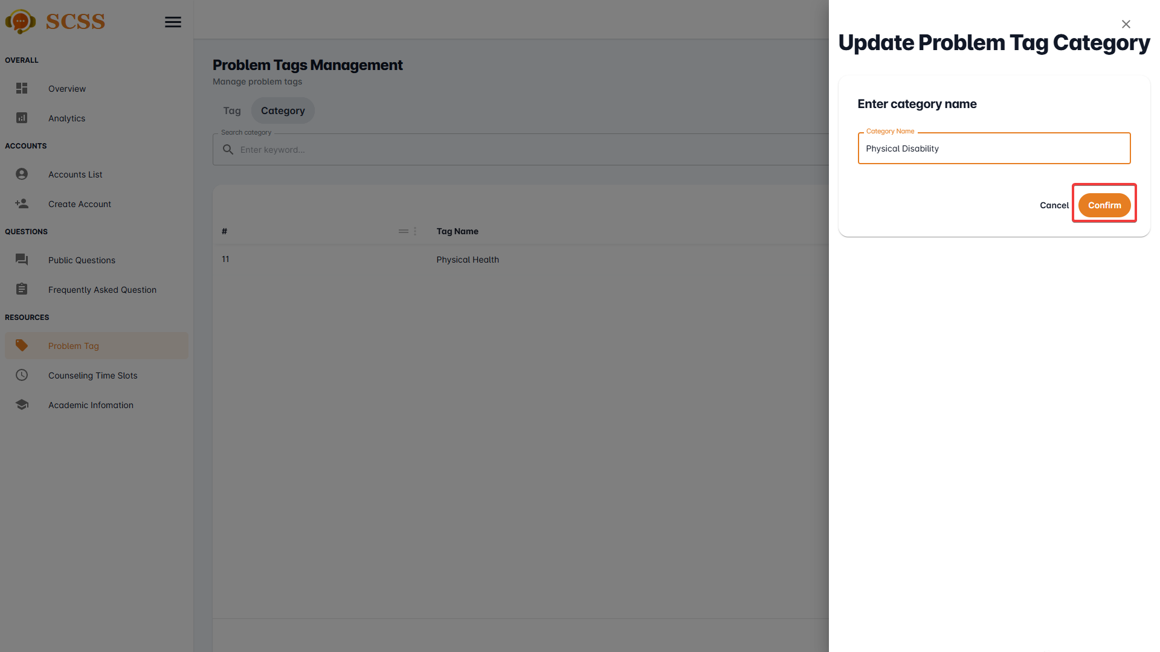

**Step 8:** Press the “OK” button after a success dialog is shown to complete creating a problem tag’s category.

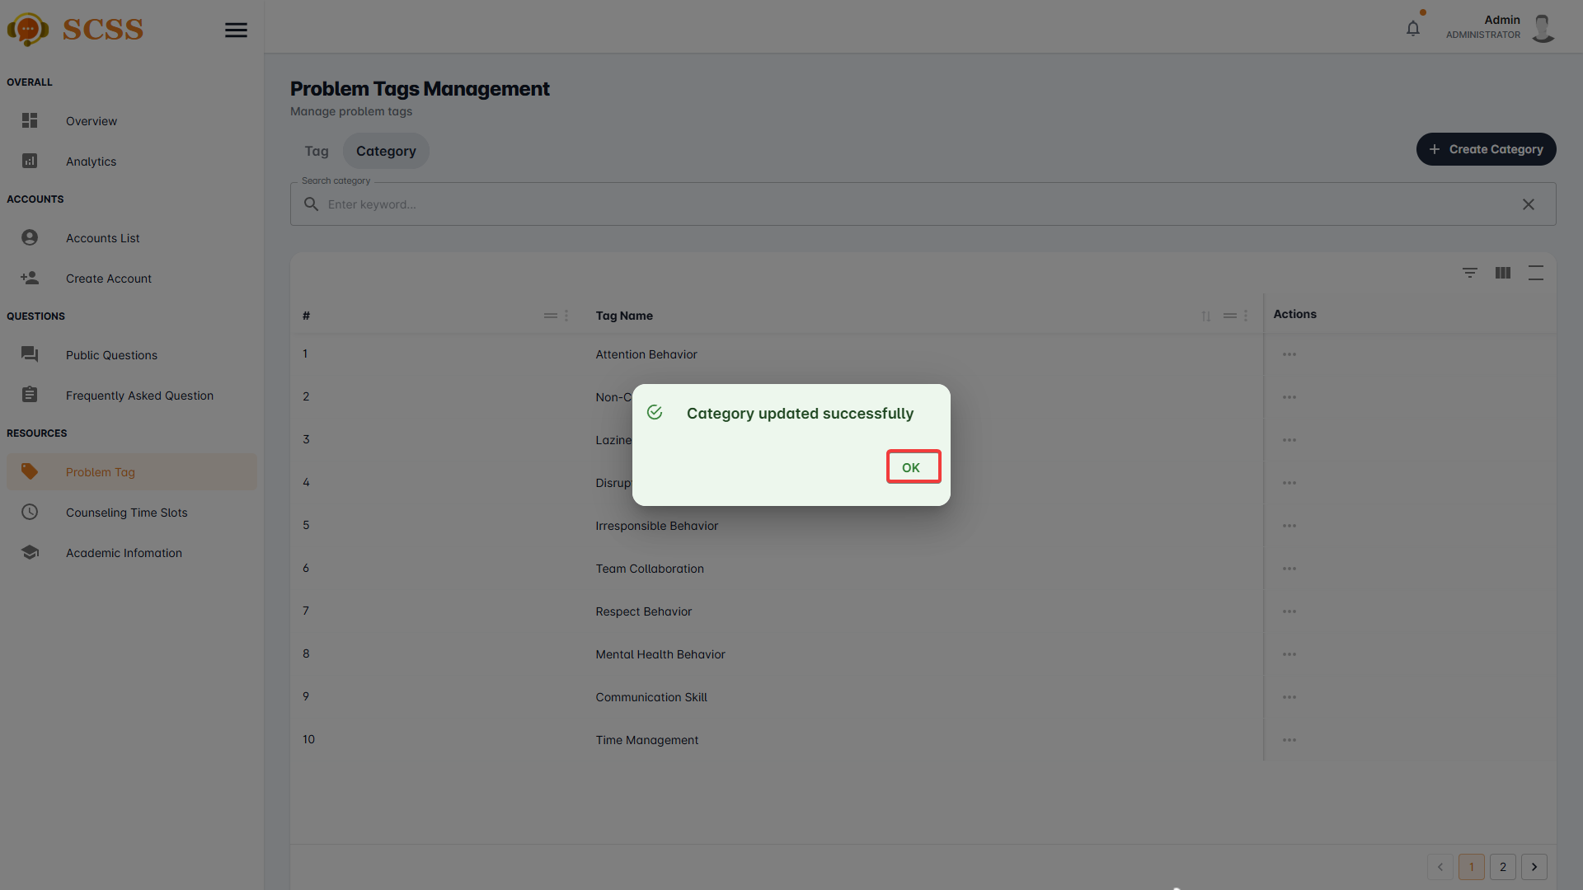

##### 3.2.7.9. Update counseling time slot

3.2.7.9.1. Description

Use this guideline to update a counseling time slot using an administrator account.

3.2.7.9.2. Guide Steps

**Step 1**: Access SCSS at http://scss-fe.azurewebsites.net/. Then fill in “Email” and “Password” of the administrator account.



**Step 2:** Click the “Sign in ” button.



**Step 3:** From the homepage, choose “Counseling Time Slots” from the left sidebar.



**Step 4:** Press the “...” button under the actions column, in the row of the selected counselling time slot.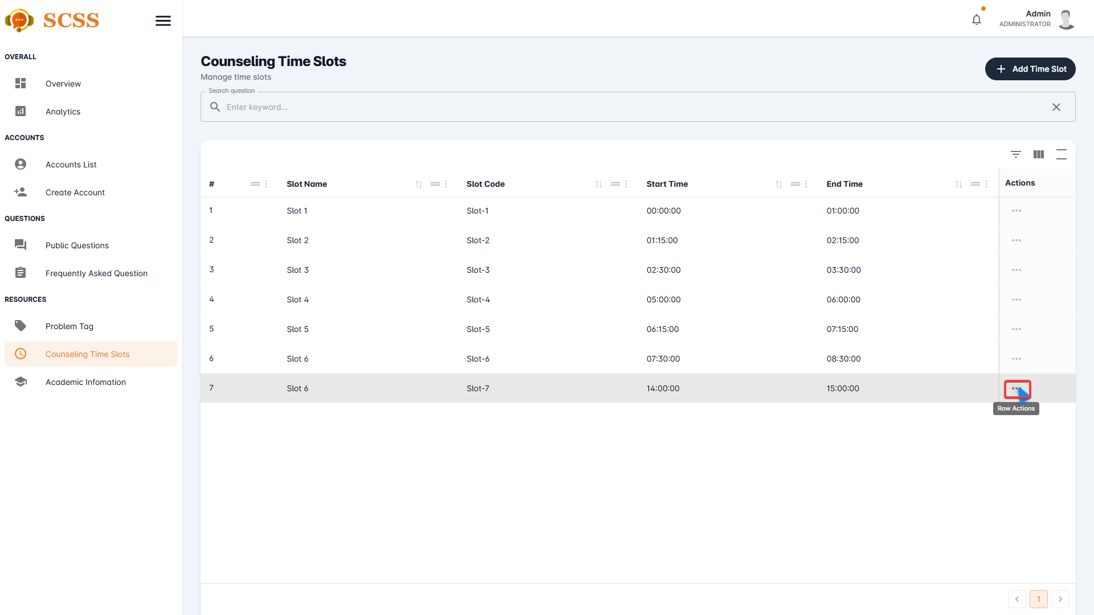

**Step 5:** Press the “Update” button.

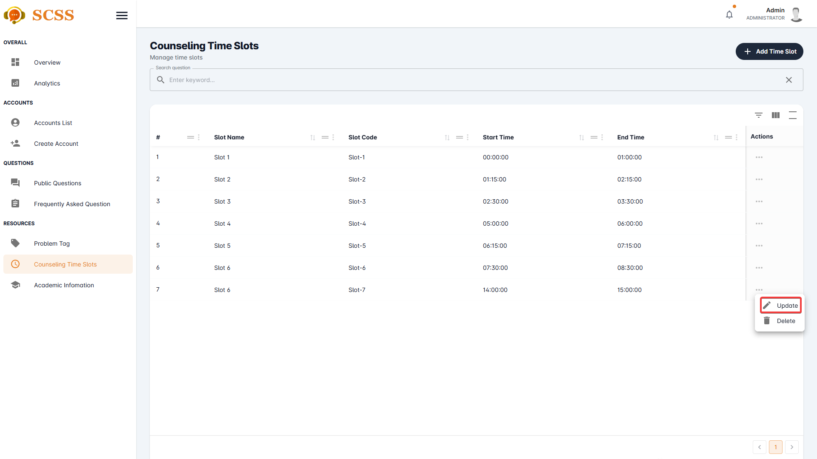

**Step 6:** Fill out the “Slot name”, “Slot code”, “Start time”, and “End time” fields, then press the “Confirm” button.

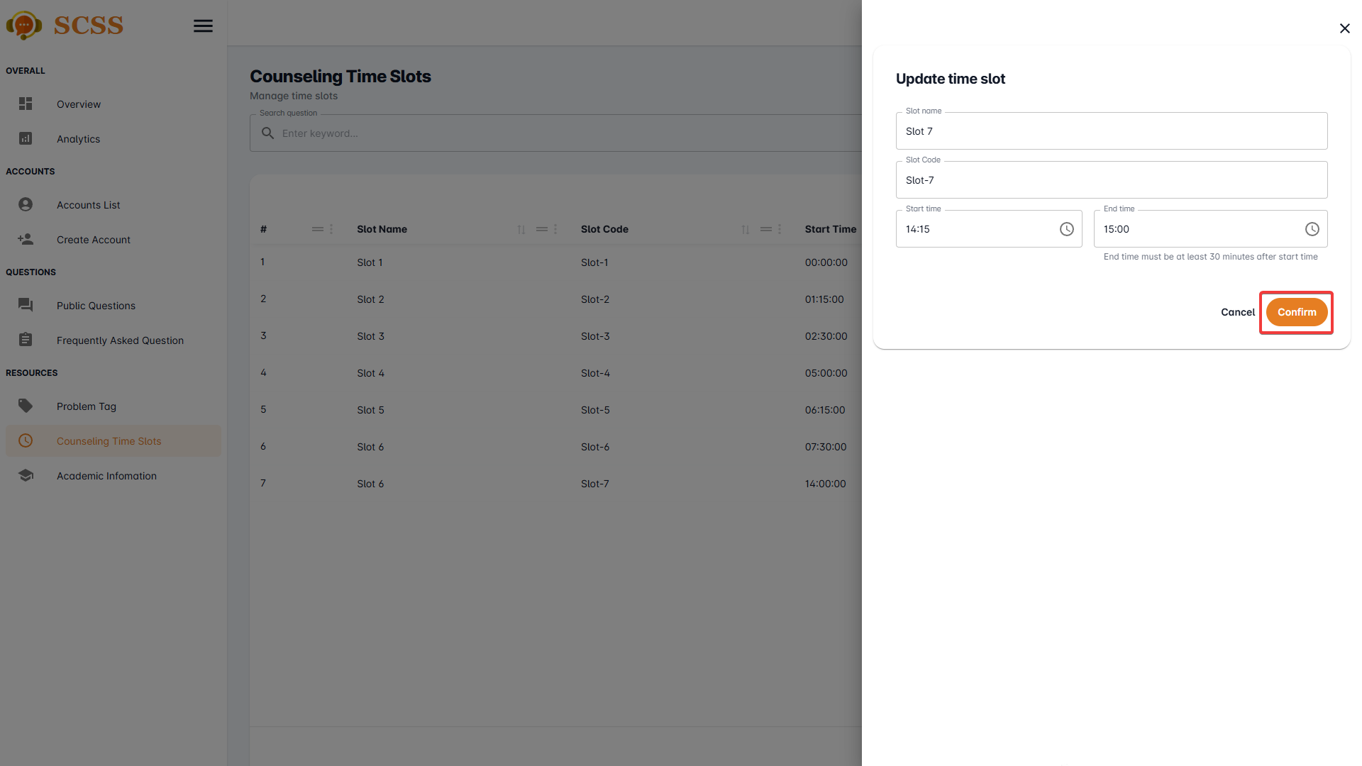

**Step 7:** Press the “OK” button after a success dialog is shown to complete creating a counseling time slot.

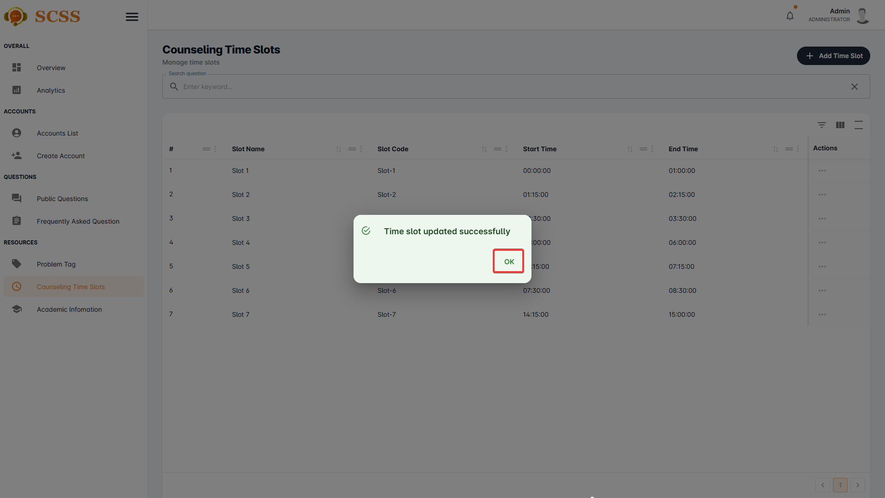

##### 3.2.7.10. View academic information

3.2.7.10.1. Description

Use this guideline to view academic information using an administrator account.

3.2.7.10.2. Guide Steps

**Step 1**: Access SCSS at http://scss-fe.azurewebsites.net/. Then fill in “Email” and “Password” of the administrator account.



**Step 2:** Click the “Sign in ” button.



**Step 3:** From the homepage, choose “Academic Information” from the left sidebar.

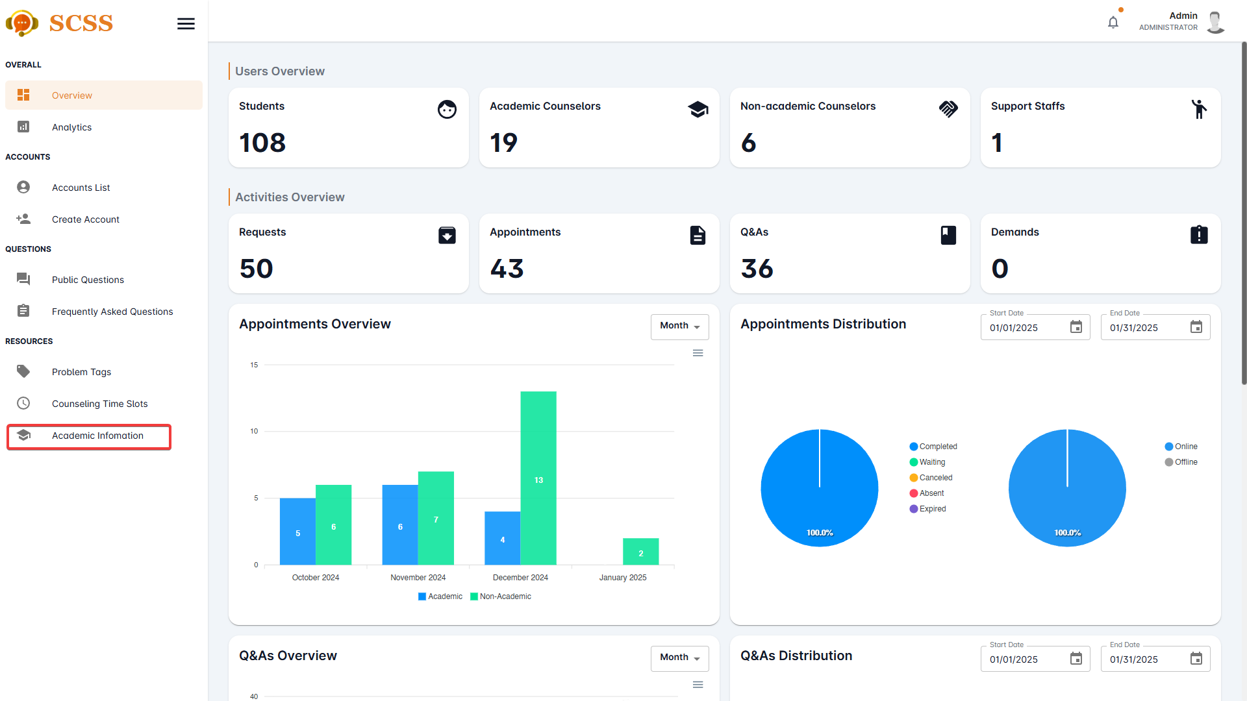

**Step 4:** Select “Department”, “Major, “Specialization”, or “Semester” tab in accordance with the data you want to view.

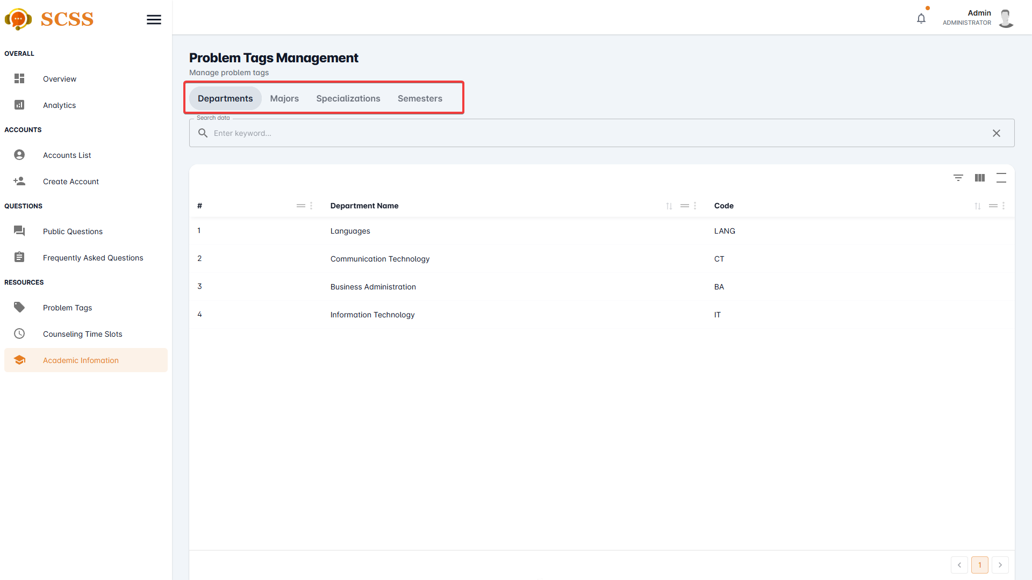

#### 3.2.8. Question Management

##### 3.2.8.1. Update public question’s public status.

3.2.8.1.1. Description

Use this guideline to update a public question’s public status using an administrator account.

3.2.8.1.2. Guide Steps

**Step 1**: Access SCSS at http://scss-fe.azurewebsites.net/. Then fill in “Email” and “Password” of the administrator account.



**Step 2:** Click the “Sign in ” button.



**Step 3:** From the homepage, choose “Public Questions” from the left sidebar.

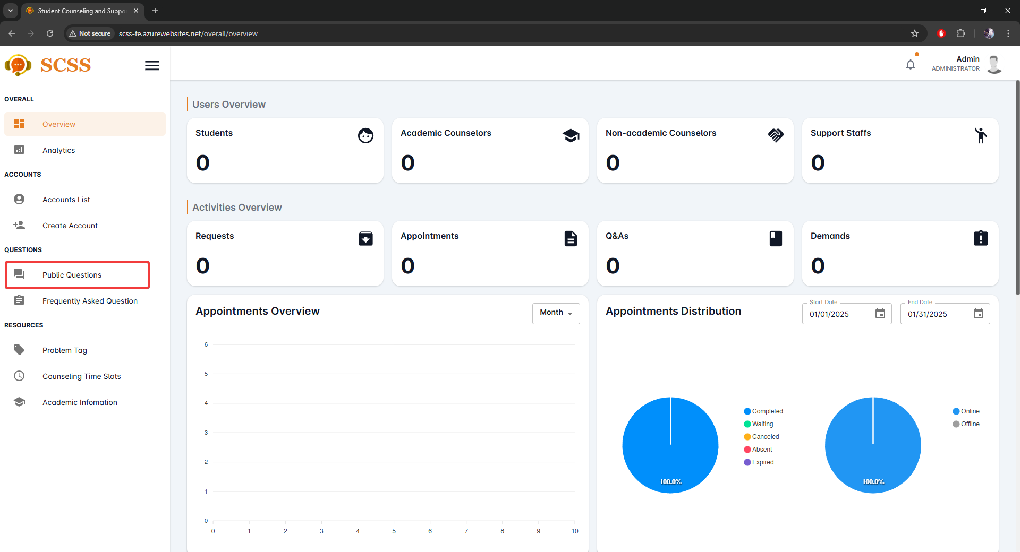

**Step 4:** Press the “...” button under the actions column, in the row of the selected question.

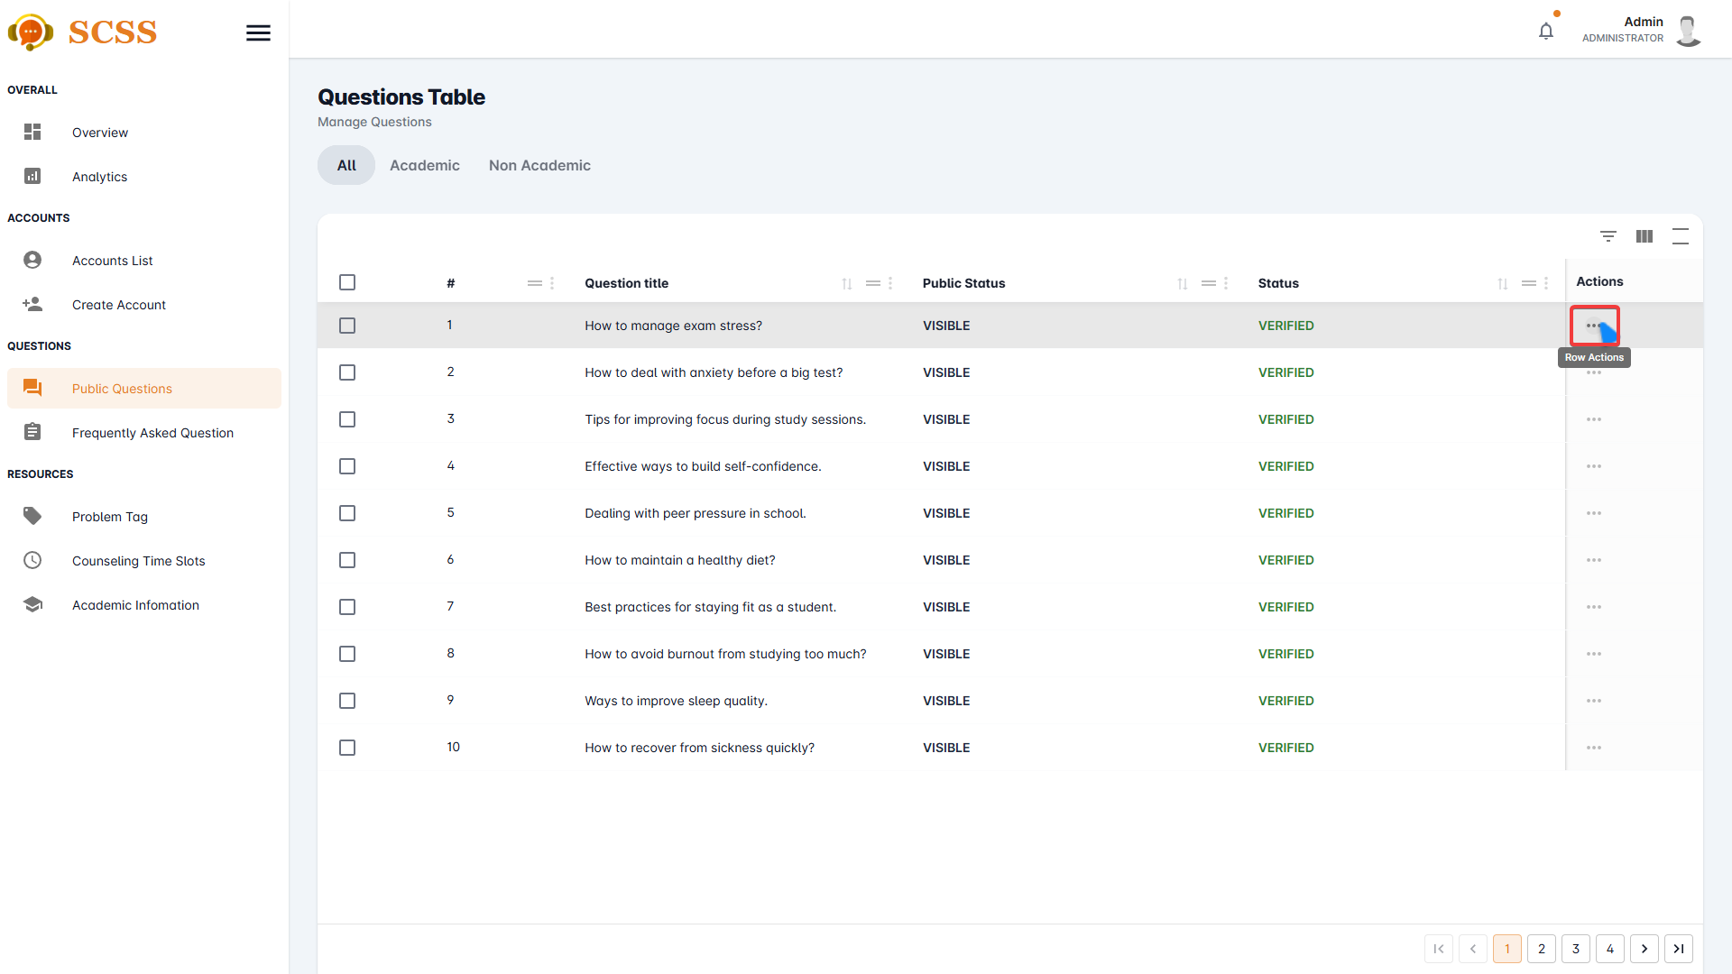

**Step 5:** Press “Update public status” button

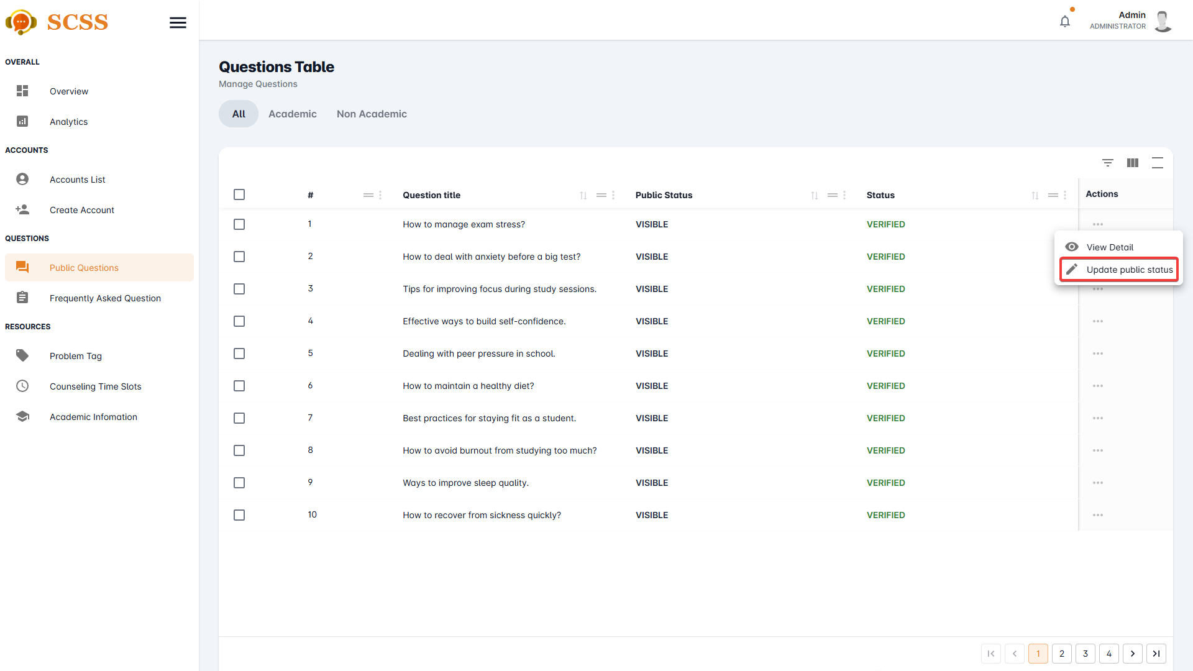

**Step 6:** Select a new status and press “Confirm” button.

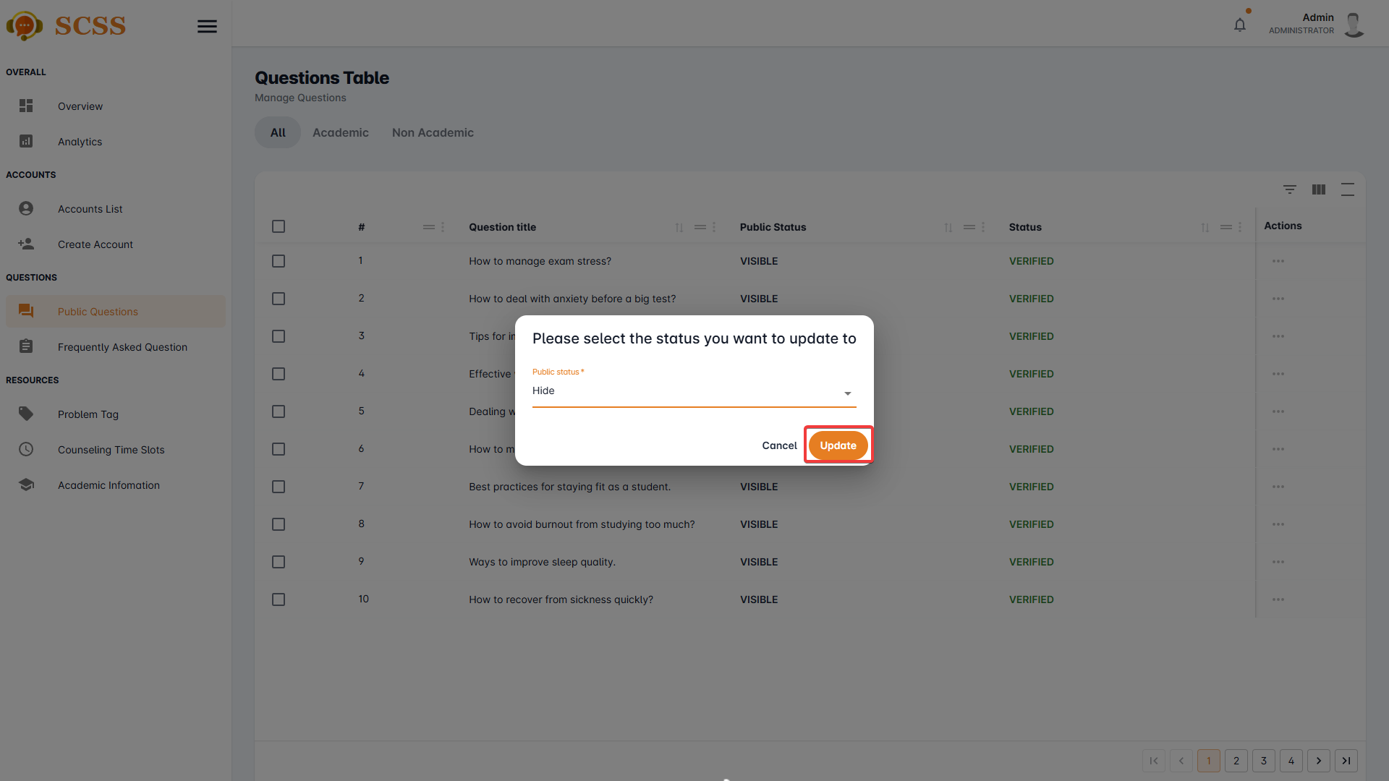

**Step 7:** Press “Ok”.

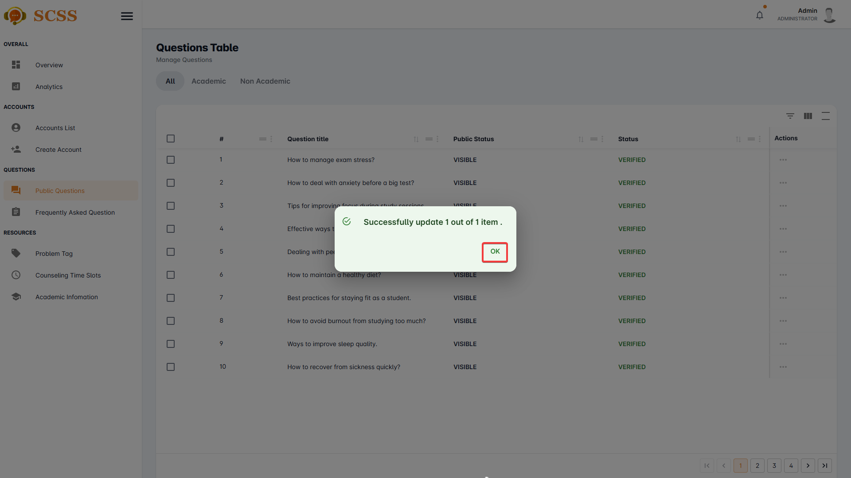

##### 3.2.8.2. Update frequently asked question’s visibility status.

3.2.8.2.1. Description

Use this guideline to update a frequently asked question’s visibility status using an administrator account.

3.2.8.2.2. Guide Steps

**Step 1**: Access SCSS at http://scss-fe.azurewebsites.net/. Then fill in “Email” and “Password” of the administrator account.



**Step 2:** Click the “Sign in ” button.



**Step 3:** From the homepage, choose “Frequently Asked Questions” from the left sidebar.

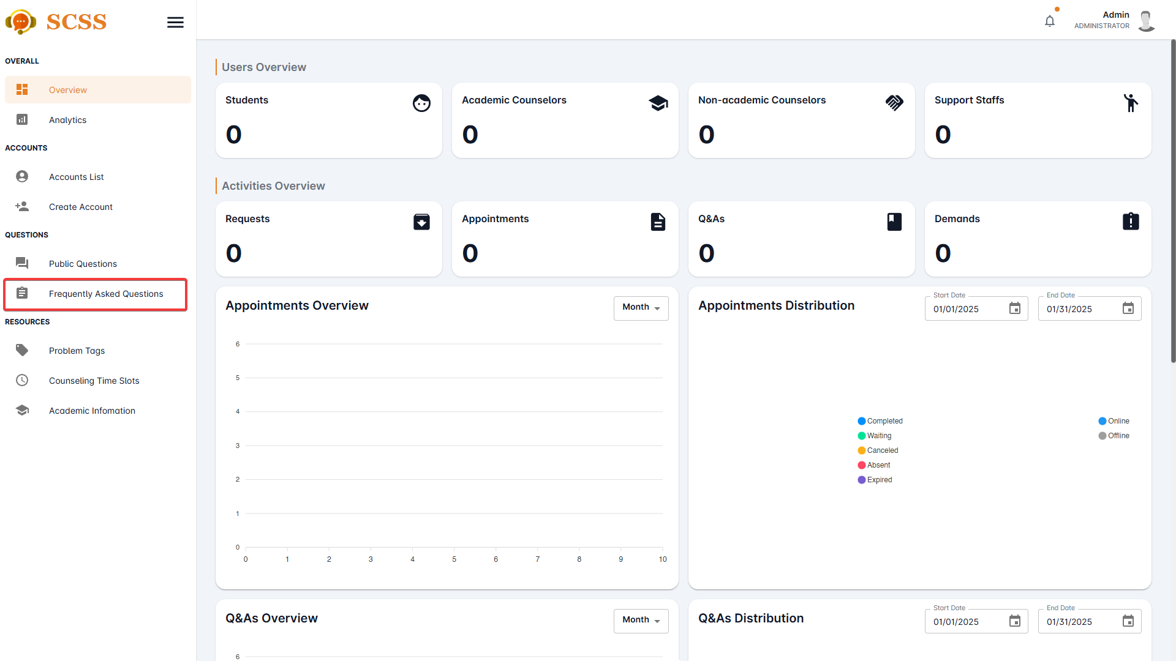

**Step 4:** Press the “...” button under the actions column, in the row of the selected question.

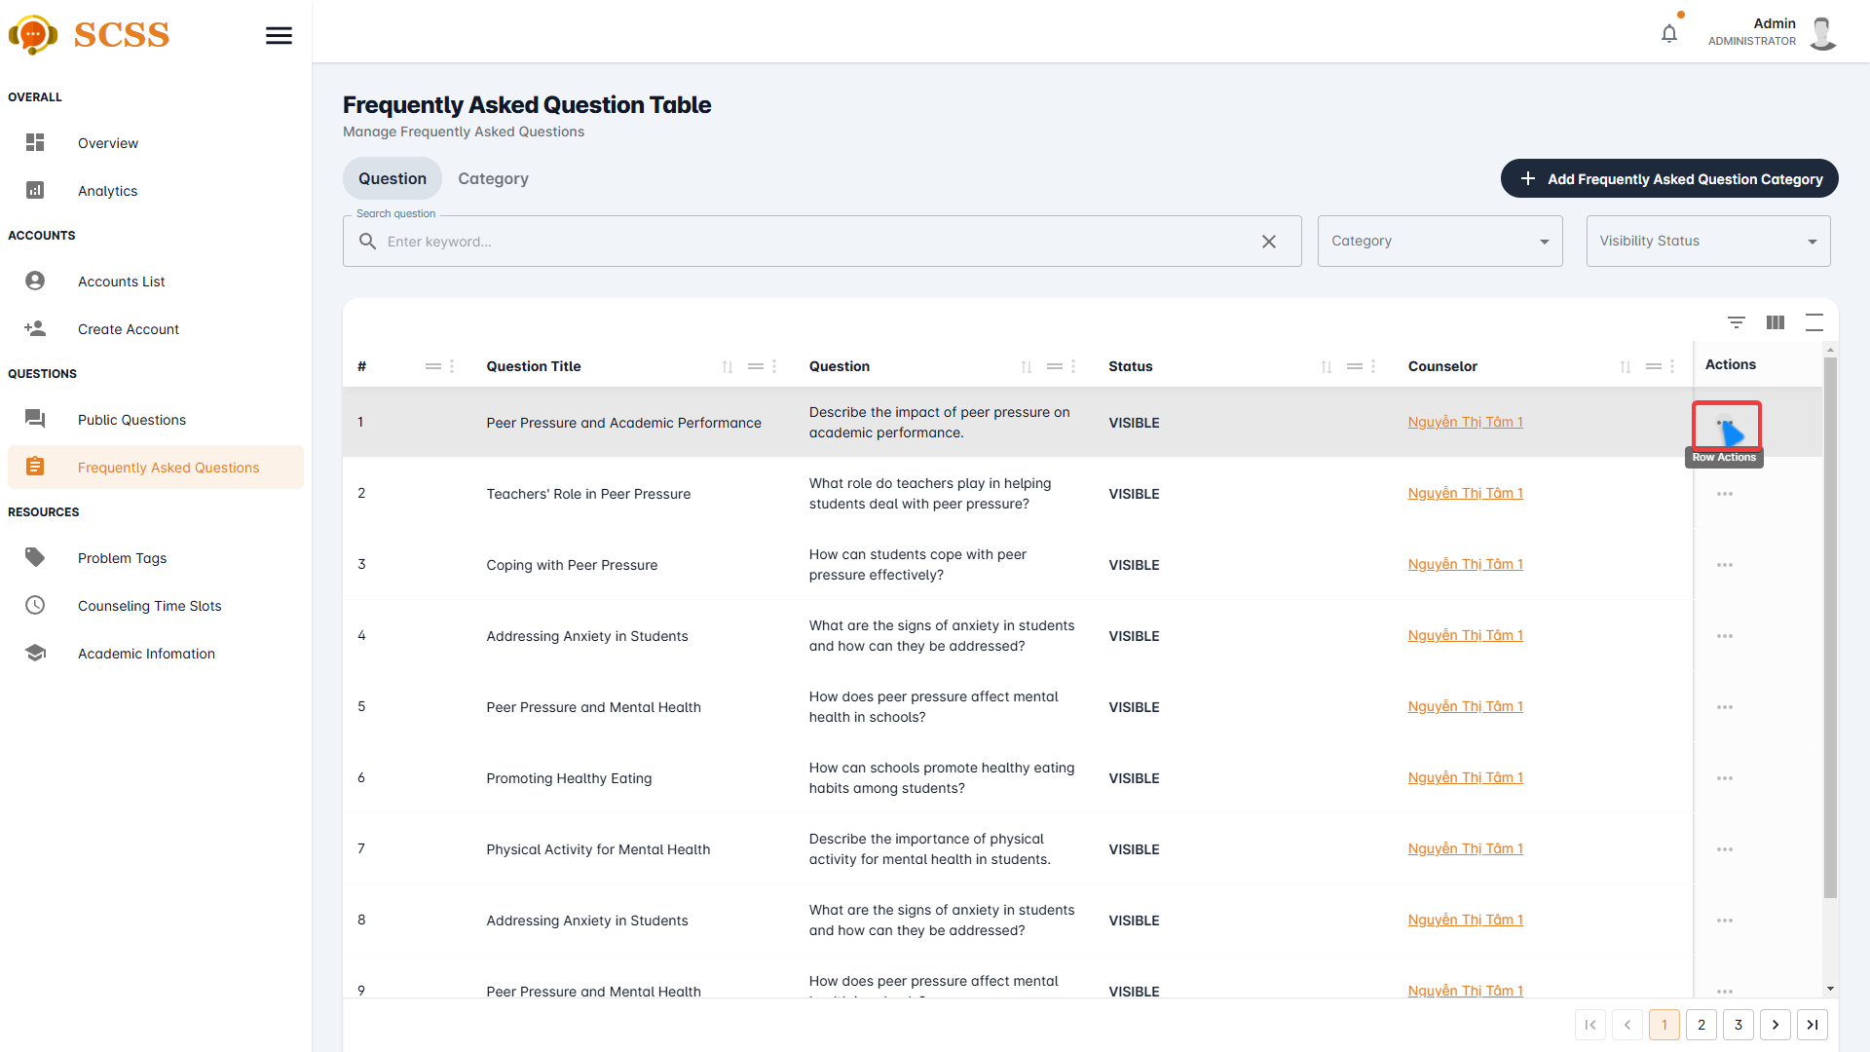

**Step 5:** Press “Update visibility status” button

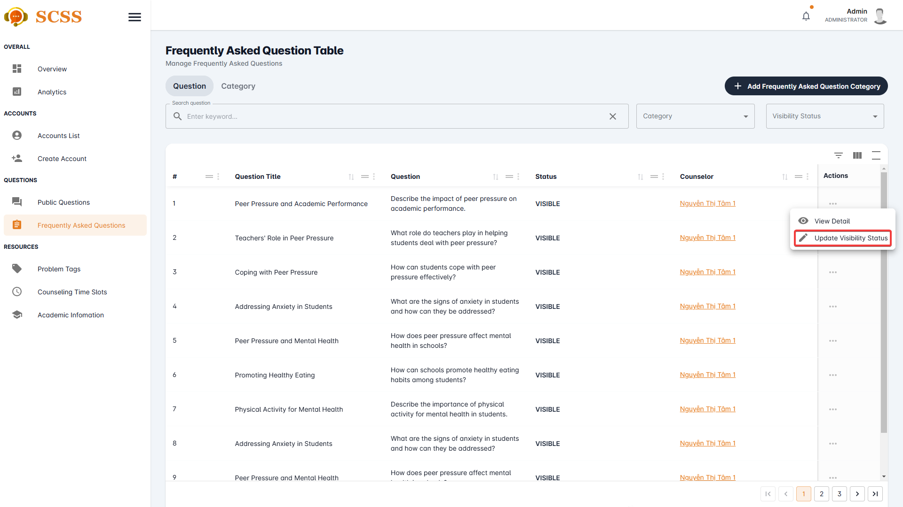

**Step 6:** Select a new status and press “Confirm” button.

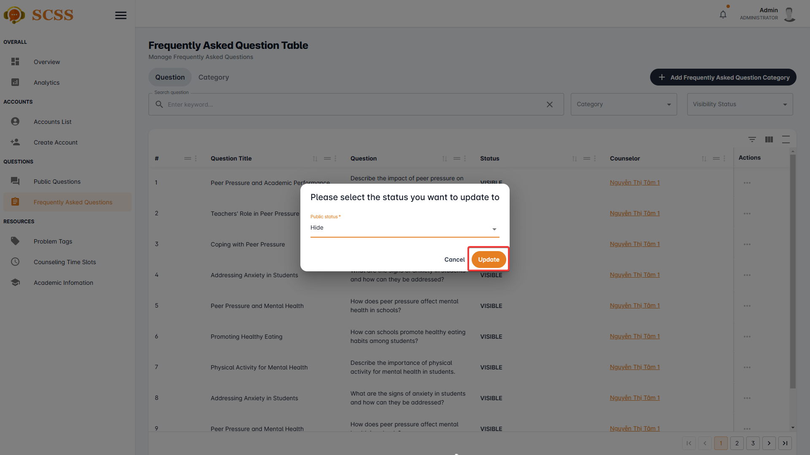

**Step 7:** Press “Ok”.

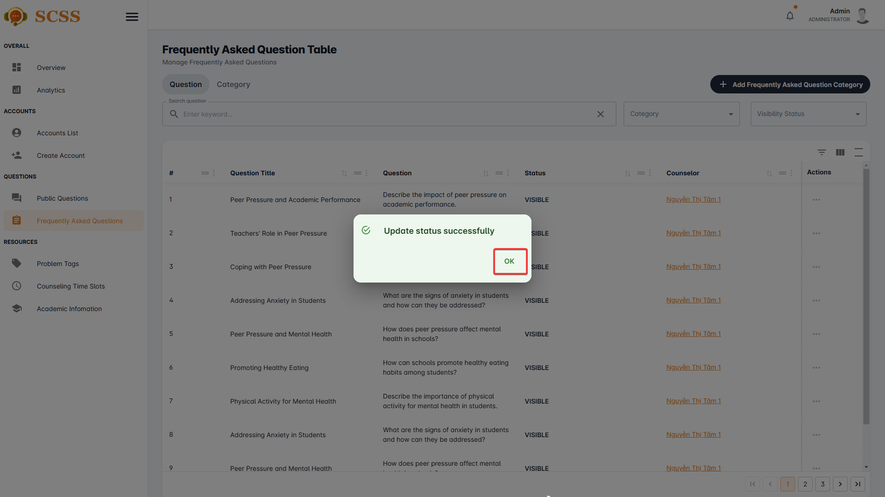

##### 3.2.8.3. Create frequently asked question’s category.

3.2.8.3.1. Description

Use this guideline to create frequently asked question’s category using an administrator account.

3.2.8.3.2. Guide Steps

**Step 1**: Access SCSS at http://scss-fe.azurewebsites.net/. Then fill in “Email” and “Password” of the administrator account.



**Step 2:** Click the “Sign in ” button.



**Step 3:** From the homepage, choose “Frequently Asked Questions” from the left sidebar.



**Step 4:** Press the “Add Frequently Asked Question Category” button.

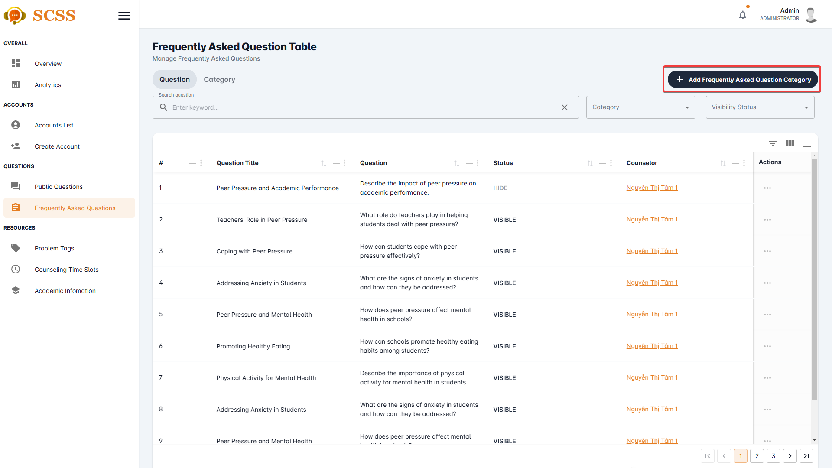

**Step 5:** Fill in “Category’s name” and select “Type”, then press the “Confirm” button.

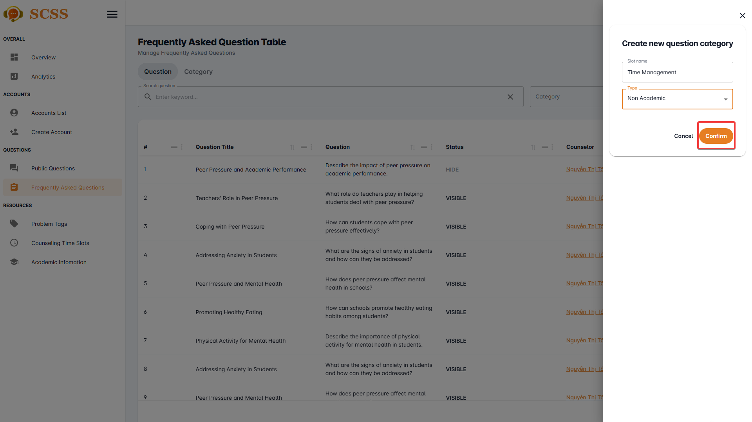

**Step 6:** Press “Ok”.

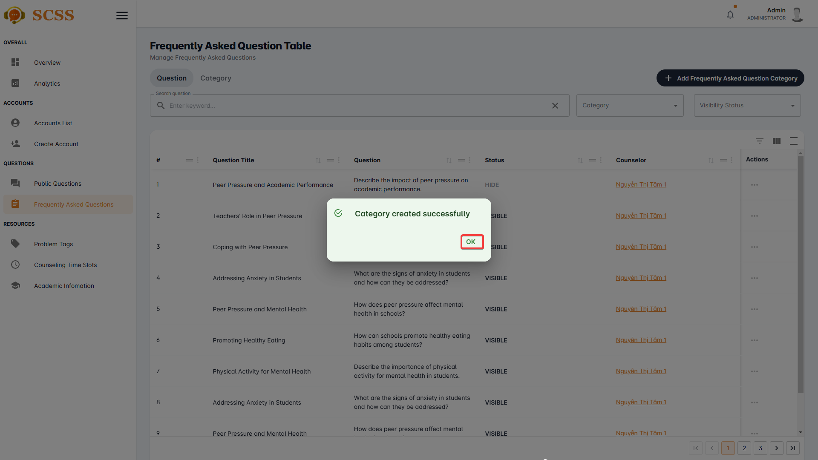

##### 3.2.8.4. Update frequently asked question’s category.

3.2.8.4.1. Description

Use this guideline to update a frequently asked question’s category using an administrator account.

3.2.8.4.2. Guide Steps

**Step 1**: Access SCSS at http://scss-fe.azurewebsites.net/. Then fill in “Email” and “Password” of the administrator account.



**Step 2:** Click the “Sign in ” button.



**Step 3:** From the homepage, choose “Frequently Asked Questions” from the left sidebar.



**Step 3:** Select the “Category” tab.

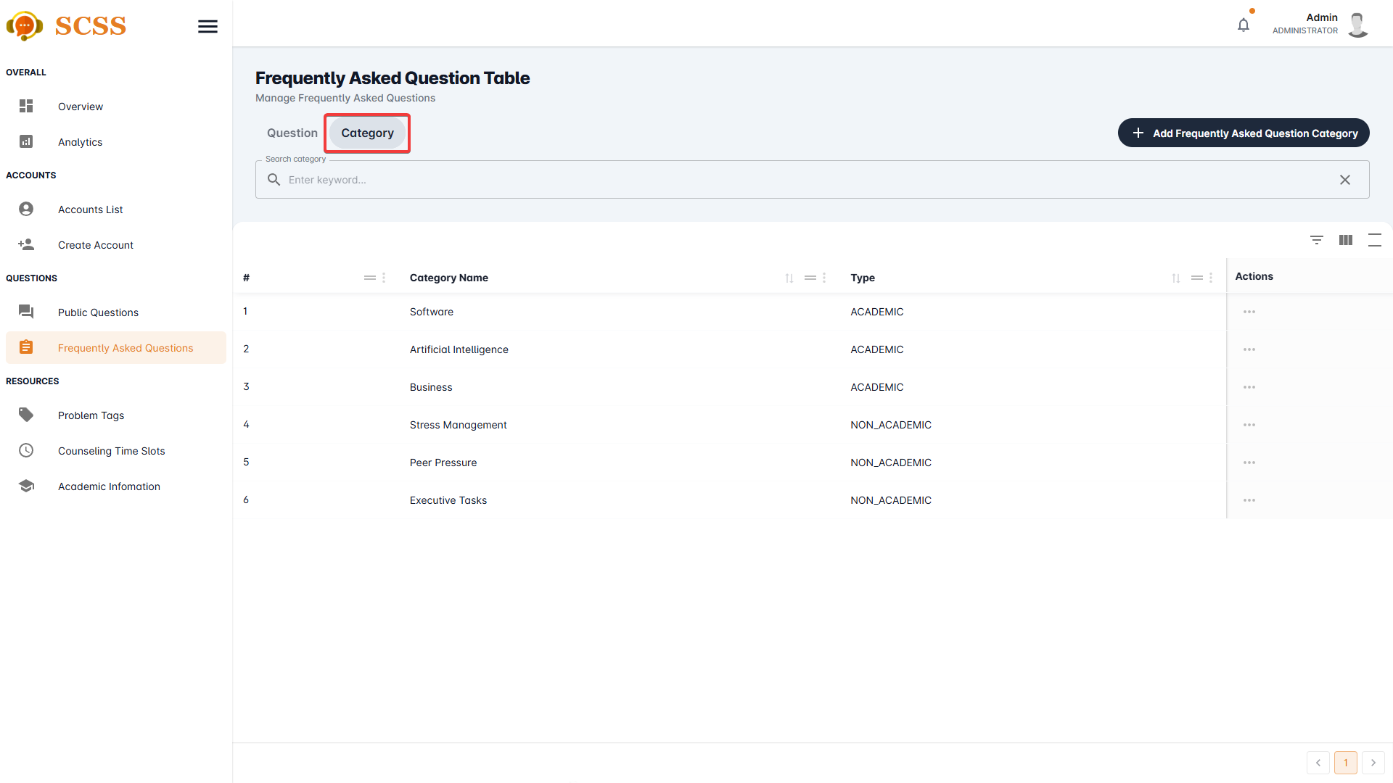

**Step 5:** Press the “...” button, in the row of the selected category.

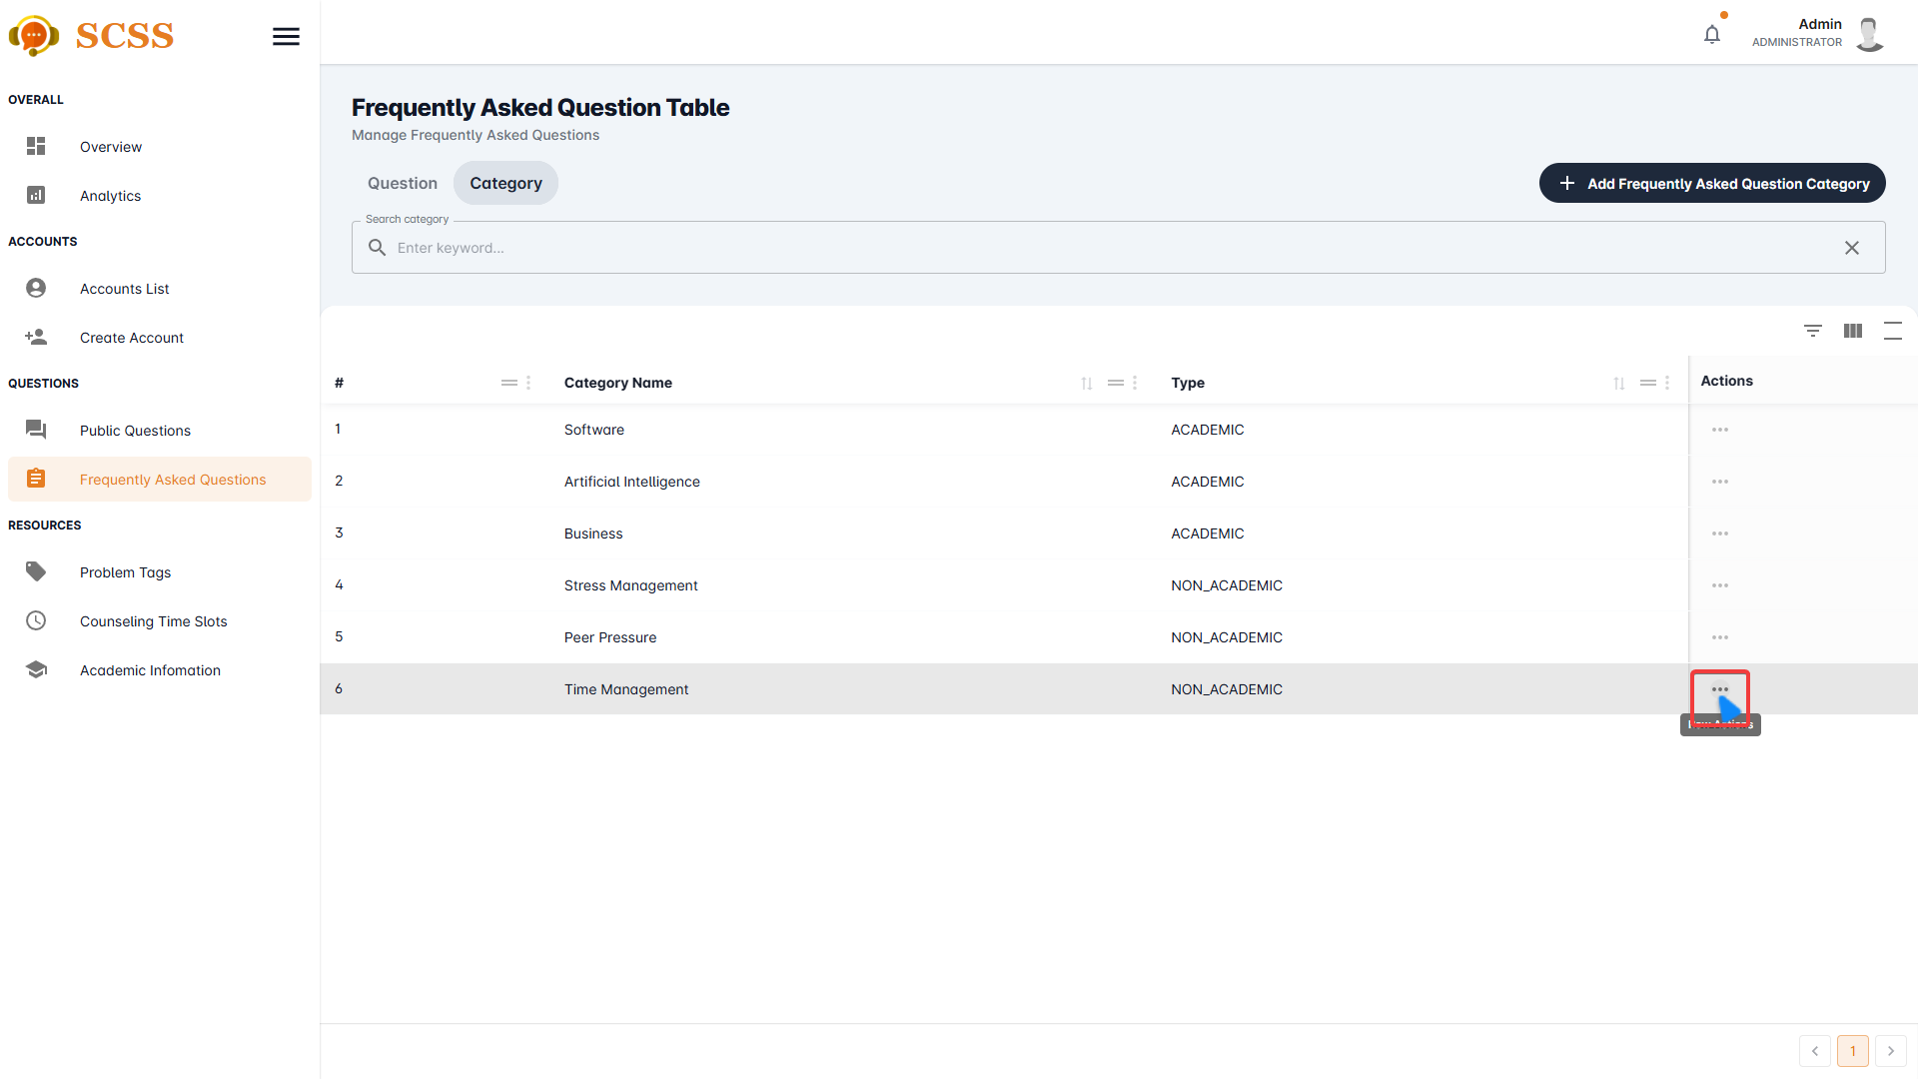

**Step 6:** Select the “Update” button.

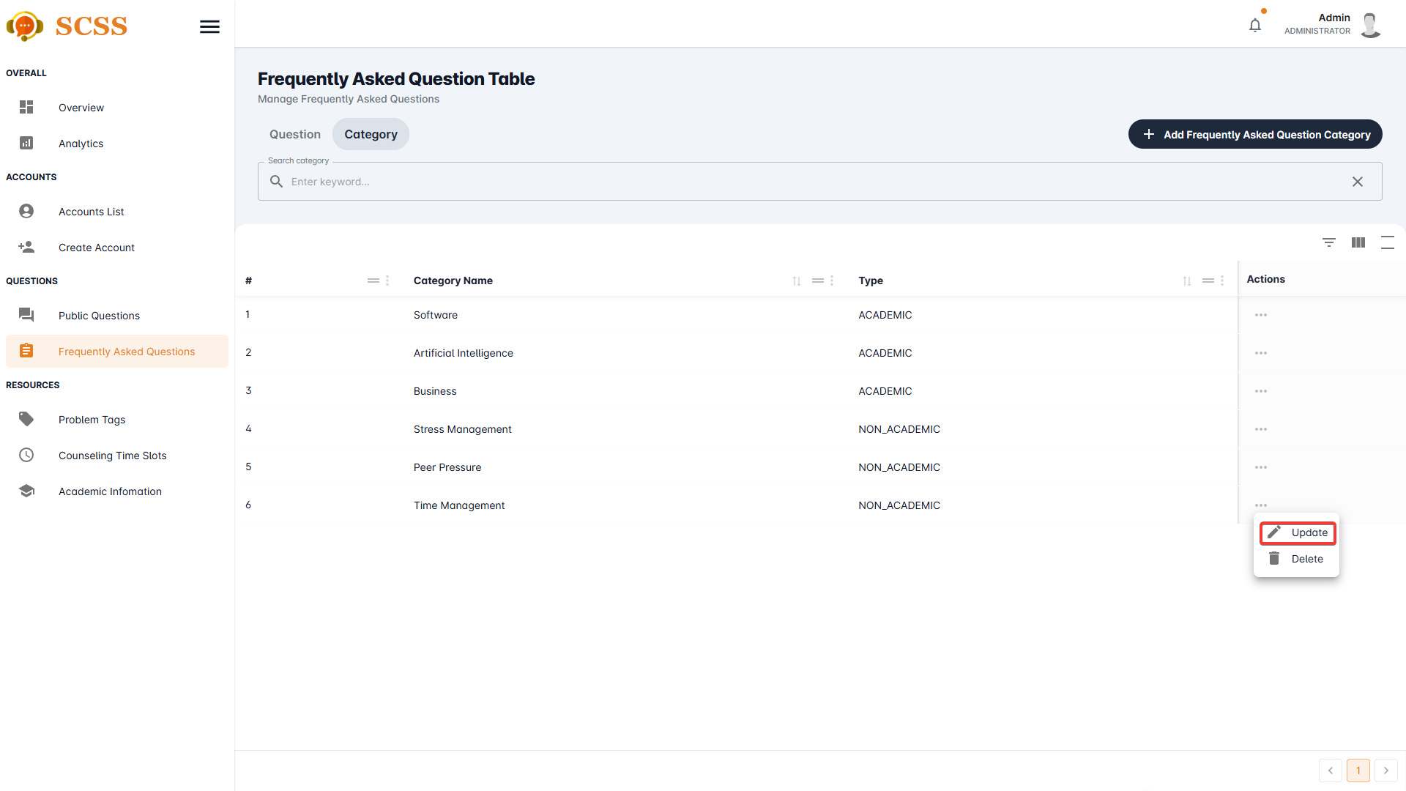

**Step 7:** Fill in “Category’s name” and select “Type”, then press “Confirm” button.

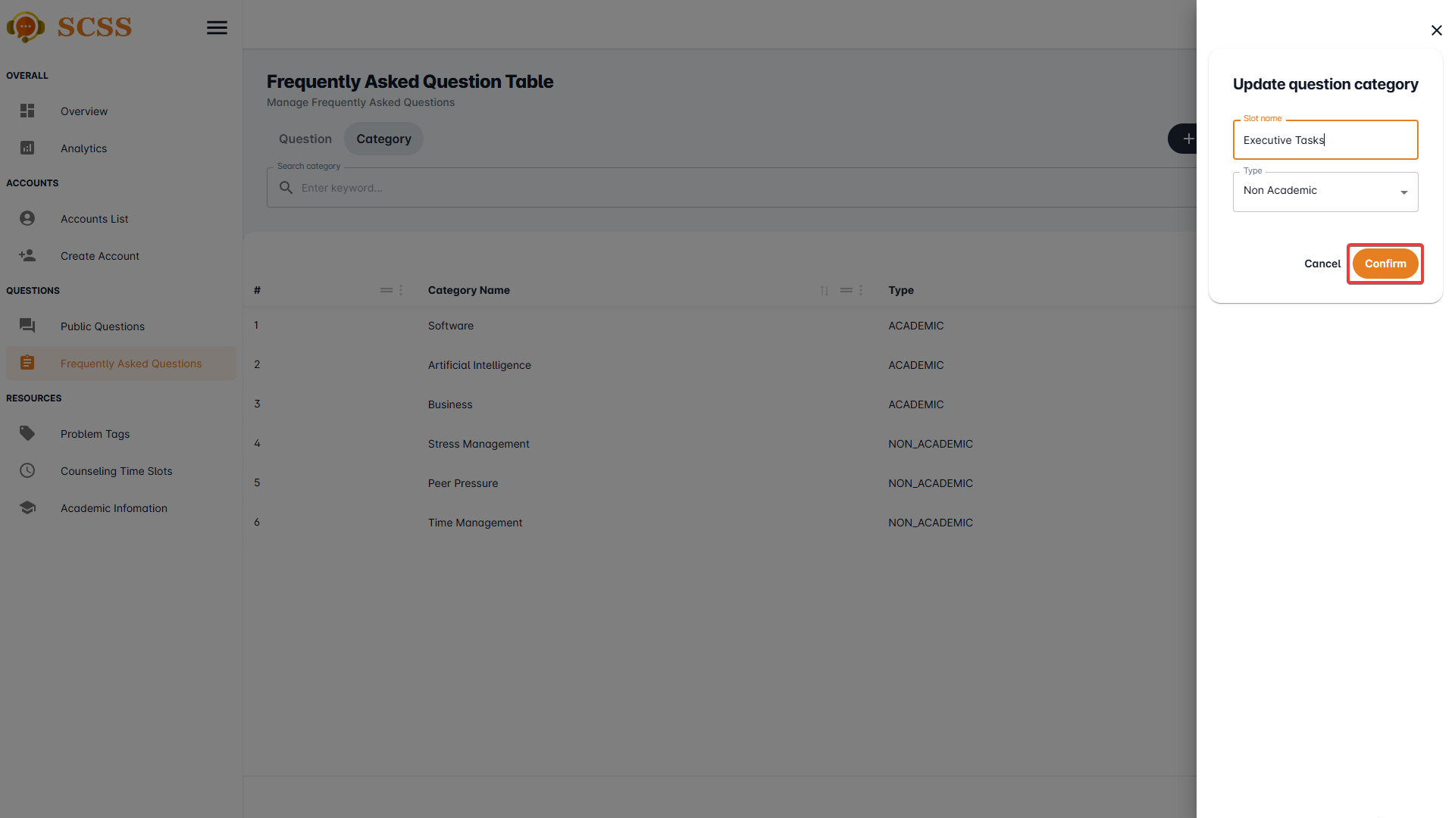

**Step 8:** Press “Ok”.

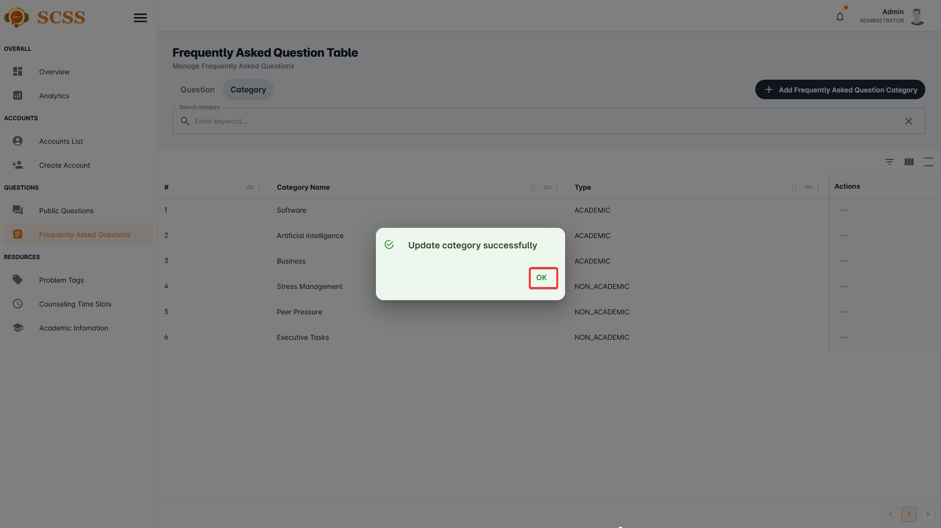

##### 3.2.8.5. Remove frequently asked question’s category.

3.2.8.5.1. Description

Use this guideline to remove a frequently asked question’s category using an administrator account.

3.2.8.5.2. Guide Steps

**Step 1**: Access SCSS at http://scss-fe.azurewebsites.net/. Then fill in “Email” and “Password” of the administrator account.



**Step 2:** Click the “Sign in ” button.



**Step 3:** From the homepage, choose “Frequently Asked Questions” from the left sidebar.



**Step 3:** Select the “Category” tab.



**Step 5:** Press the “...” button, in the row of the selected category.



**Step 6:** Select the “Delete” button.

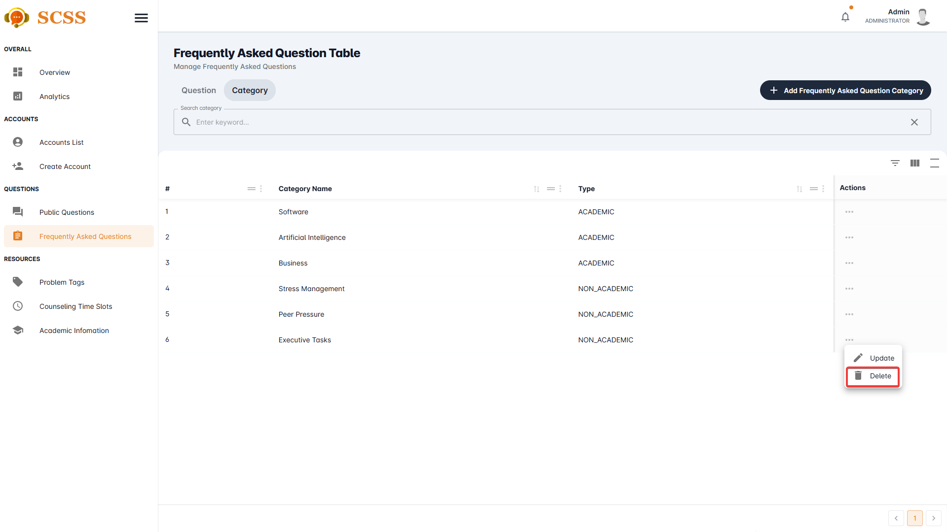

**Step 7:** Press the “Confirm” button.

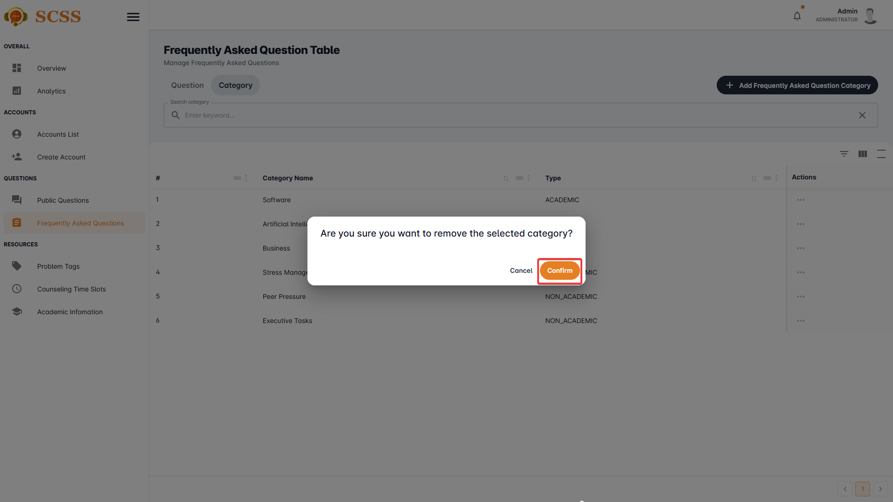

**Step 8:** Press “Ok”.

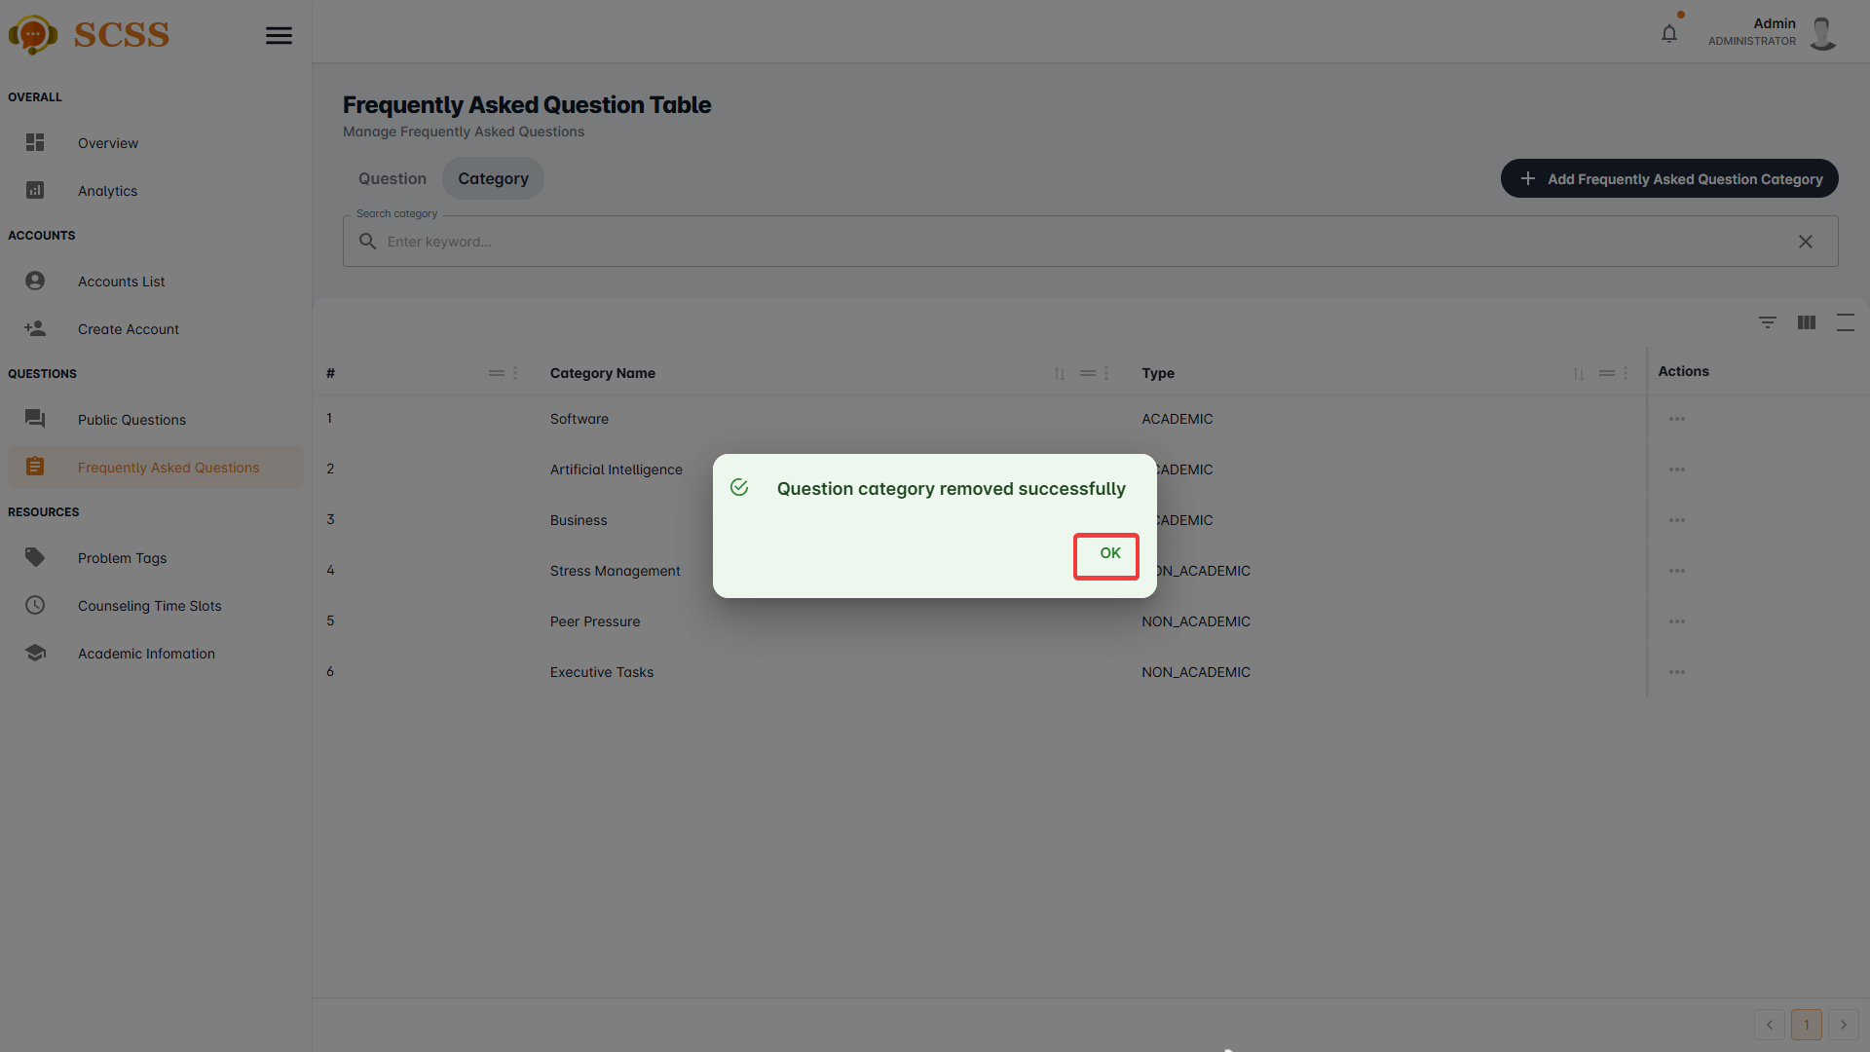

#### 3.2.9. Analytics View

##### 3.2.9.1. View analytics

3.2.9.1.1 Description

Use this guideline to view analytics.

3.2.9.1.2 . Guide Steps:

**Step 1**: Access SCSS at http://scss-fe.azurewebsites.net/. Then fill in “Email” and “Password” of the manager or admin account.



**Step 2:** Click the “Sign in ” button.



**Step 3:** From the homepage, choose “Analytics” from the left sidebar.



##### 3.2.9.2. View overview

3.2.9.2.1 Description

Use this guideline to view overview.

3.2.9.2.2 . Guide Steps:

**Step 1**: Access SCSS at http://scss-fe.azurewebsites.net/. Then fill in “Email” and “Password” of the manager or admin account.



**Step 2:** Click the “Sign in ” button.



**Step 3:** From the homepage, choose “Overview” from the left sidebar.



### 3.3. Mobile Application

#### 3.3.1. Authentication

##### 3.3.1.1. Login

3.3.1.1.1. Description

Use this guideline to login into SCSS with an email account. This mobile application supports login with email account that has been added as a counselor and a student.

3.3.1.1.2. Guide Steps

**Step 1:** Access SCSS at mobile application**.** Then fill in “Email” and “Password”

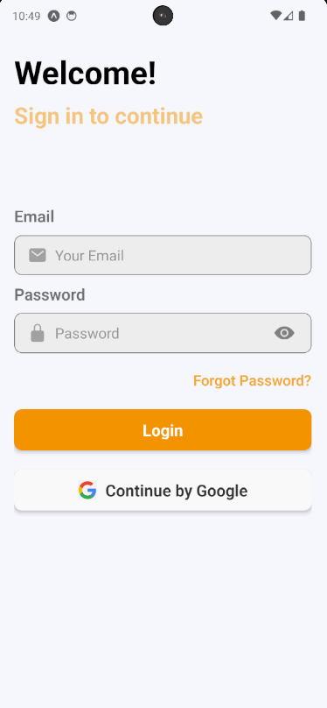

**Step 2:** Press “Login” Button

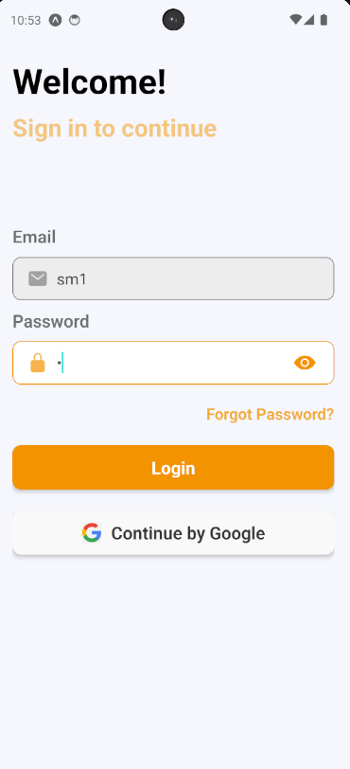

After logging in successfully, user is directed to the Home screen with account authenticated.

##### 3.3.1.2. Reset Password

3.3.1.2.1. Description

Use this guide so users can reset their email account password when they forget their password.

**Step 1:** Access SCSS at mobile application**.** Then press “Forgot password?”.

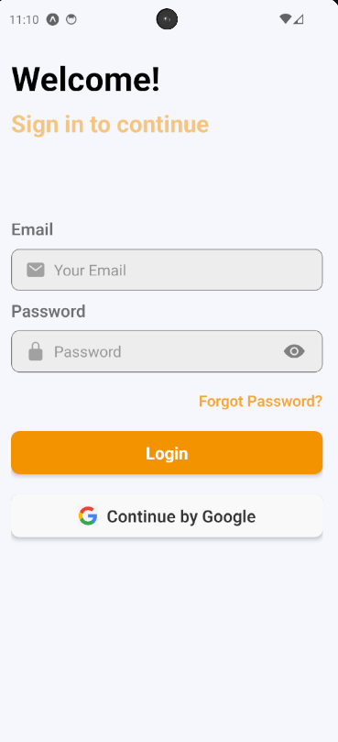

**Step 2:** Then fill in “Email”

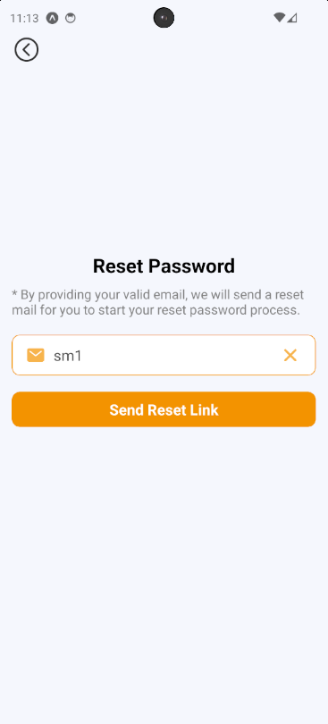

**Step 3**: Press “Send Reset Link” button

After sending the email successfully, the user is redirected to the Verify OTP Page with the email that sent the OTP authentication code.

##### 3.3.1.3. Edit Password

3.3.1.3.1. Description

Use this guide so users can update their email account password when they want to edit their password.

This web application supports updating passwords for actors: Counselor and student.

3.3.1.3.2. Guide Steps

Step 1: Access SCSS at mobile application. After logging in successfully, press the avatar image on the up-right corner of the screen.

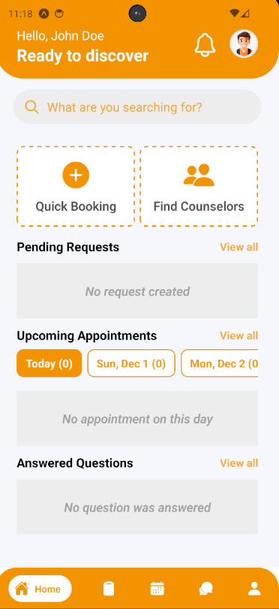

After pressing, it will navigate the user to Profile Screen.

**Step 2:** Press Change Password to navigate to Change Password Screen

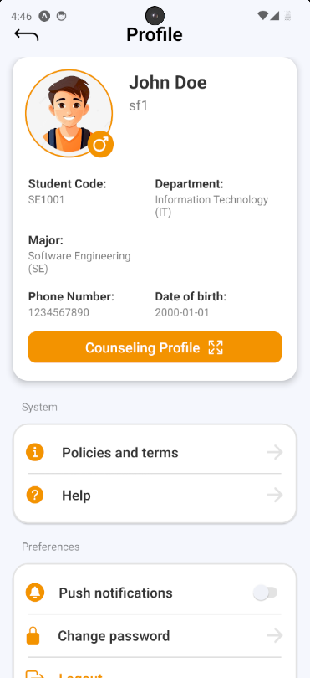

**Step 3:** Fill in “Current password”, “New password” and “Confirm password”, then press “Save Changes” button

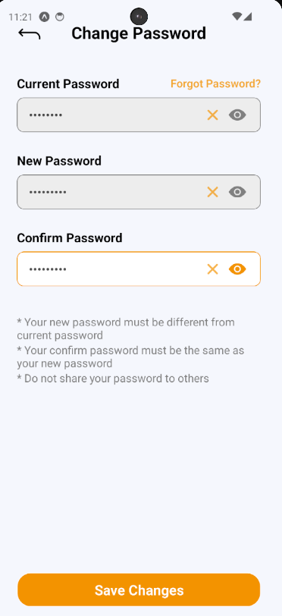

#### 3.3.2. Booking counseling appointment

##### 3.3.2.1. Quick booking a counselor

3.3.2.1.1. Description

Use this guideline to log into the SCSS student account to book counseling appointments quickly.

**Step 1:** Access SCSS at mobile application**.** Then fill in “Email” and “Password” of the student account



**Step 2:** Press “Login” Button



**Step 3:** From Home Screen, choose “Quick Booking” to quickly navigate to Quick Booking Screen

.

**Step 4:** Select and fill in all the required information to booking counseling appointment in the corresponding sequence: “Enter Reason” (mean Reason for booking appointment), “Select date”, “Select slot time”, “Select couselor's gender (optional)”

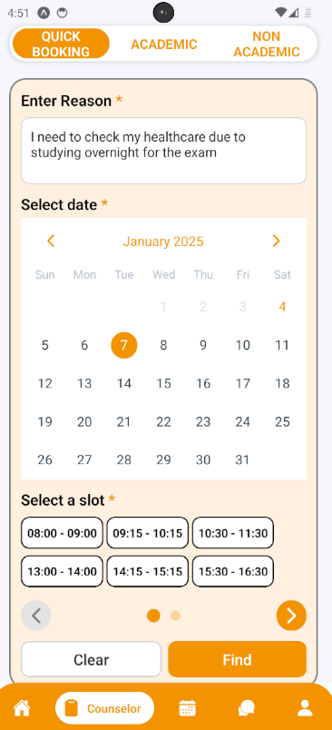

**Step 5:** After selecting and filling all the required information, press “Find” to find a counselor.

**Step 6:** The system will match you with a counselor, and you can then select a counseling type: 'Online' or 'Offline.' After that, press the ‘Booking Appointment' button. A confirmation will appear for you to check again inputted information. Press “Yes” to proceed with booking appointment or “No” to proceed with cancel booking

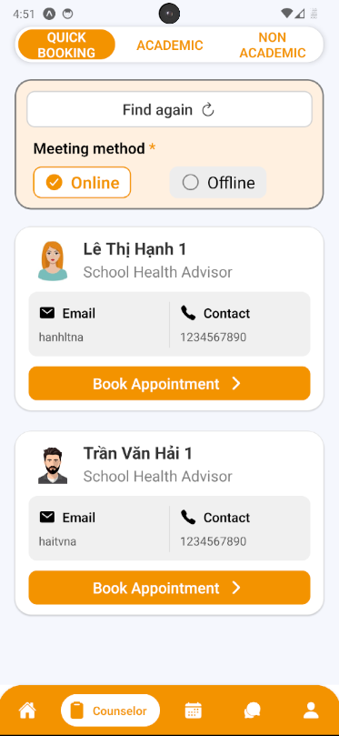

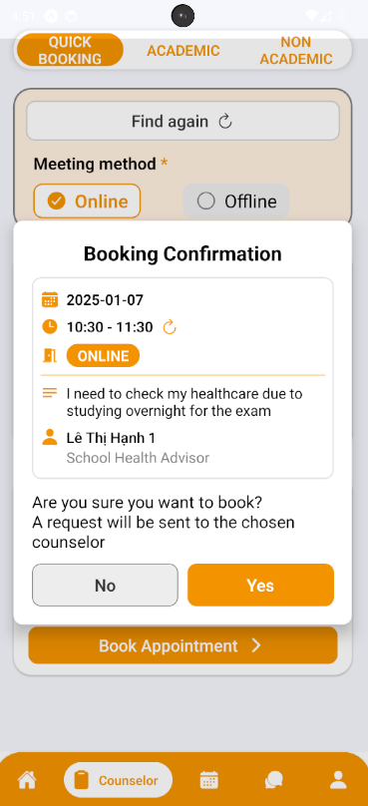

**Step 7:** After pressing “Yes” to proceed with booking an appointment, a success message will appear and you can see your sent request by pressing “See your requests” or just stay at this screen by pressing “Return” button

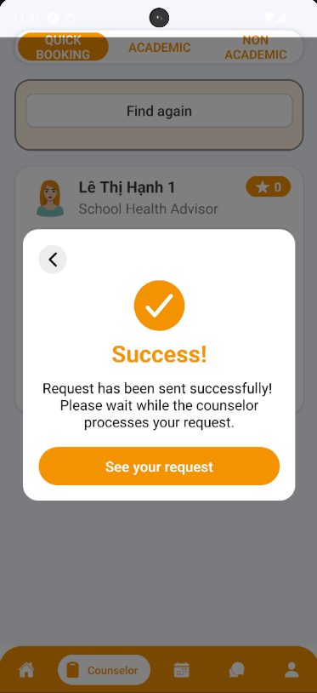

##### 3.3.2.2. Booking a specific counselor

3.3.2.2.1. Description

Use this guideline to log into the SCSS student account to book a specific counselor.

**Step 1:** Access SCSS at mobile application**.** Then fill in “Email” and “Password” of the student account



**Step 2:** Press “Login” Button



**Step 3:** From Home Screen, choose “Find Counselor” to quickly navigate to Academic Screen

.

**Step 4:** From Academic Screen, you can choose filter options to narrow down counselors based on the preferences of students, including availability, academic fields/expertise, rating, counseling type, gender or search by keyword.

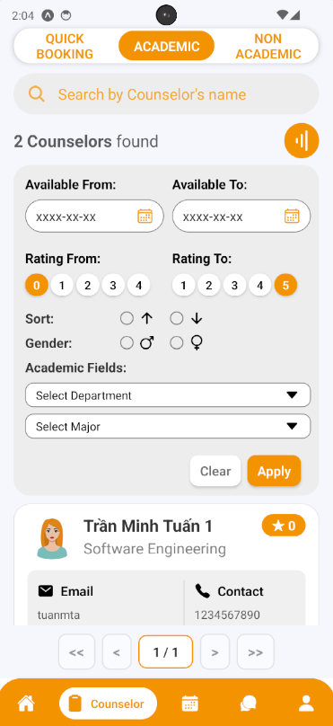

**Step 5:** Select a counselor by pressing the button “Book Appointment”

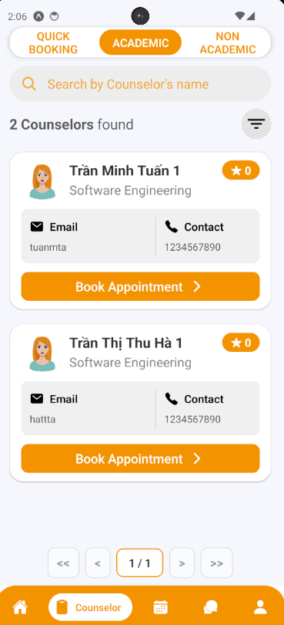

**Step 6:**  See through the selected counselor information and fill in all the required information to book an appointment including: “Select date”, “Select slot”, “Select meeting type“, and “Reason“:

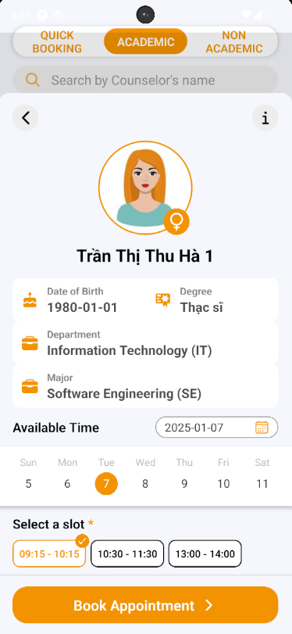

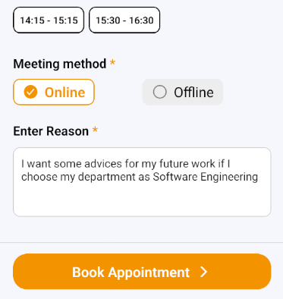

**Step 7:** Press “Book Appointment”. A confirmation will appear for you to check again inputted information. Press “Yes” to proceed with booking the appointment or “No” to proceed with cancel booking

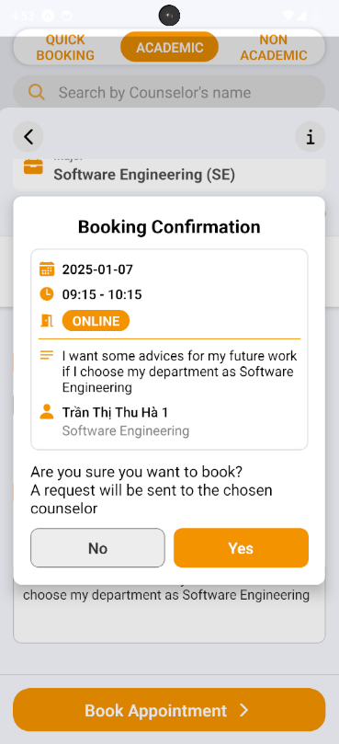

**Step 8:** After pressing “Yes” to proceed with booking an appointment, a success message will appear and you can see your sent request by pressing “See your requests” or just stay at this screen by pressing “Return” button

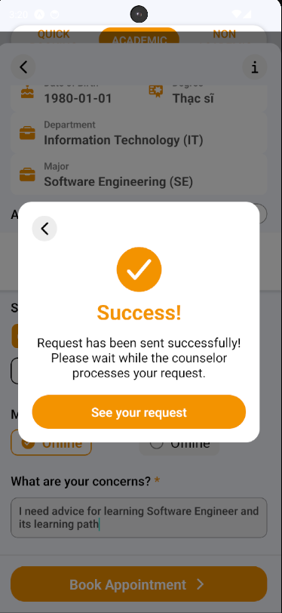

##### 3.3.2.3. Approve Appointment Request

3.3.2.3.1. Description

Use this guideline to log into the SCSS counselor account to approve student appointment request.

**Step 1:** Access SCSS at mobile application**.** Then fill in “Email” and “Password” of the counselor account



**Step 2:** Press “Login” Button

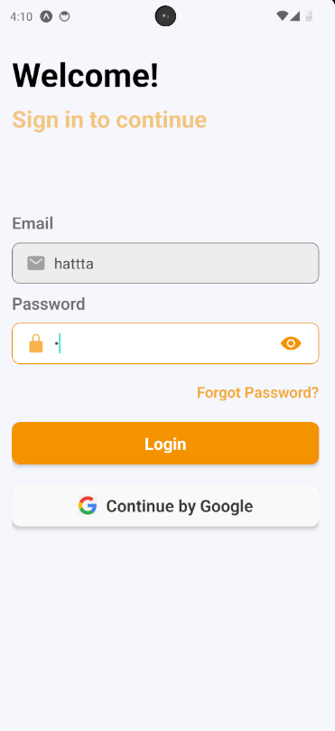

**Step 3:** From Home Screen:

Option 1: Choose Tab number 5 (personal icon) at the bottom of the screen to navigate to Personal Screen and from that screen will navigate to Request Screen 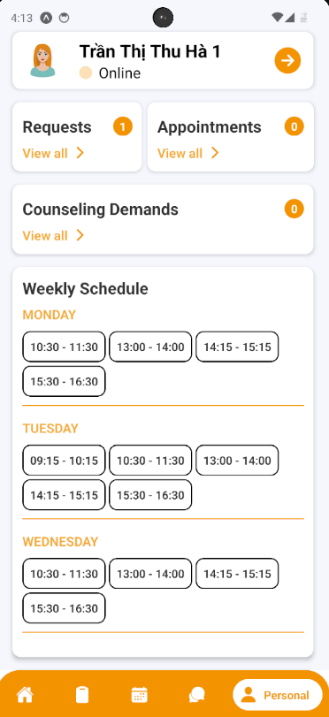

Option 2: For quick navigation, press View all at Pending Request to navigate to Request Screen

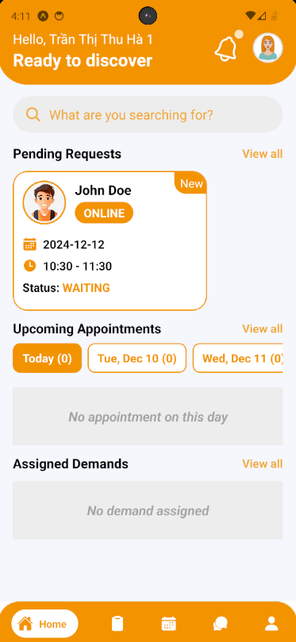

**Step 4:** In Request Screen, find a request using filter section by request date, meeting method, and status

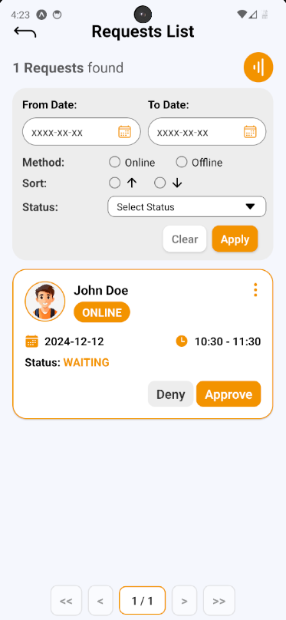

**Step 5:** After finding and considering student request, press Approve Button on request card, a request approve confirmation will open. Based on the meeting method, this confirmation require the counselor provide Meet URL (if Online) or Address (if Offline). After fill required field, press “Yes” Button to approve request, and “No” Button to cancel confirmation

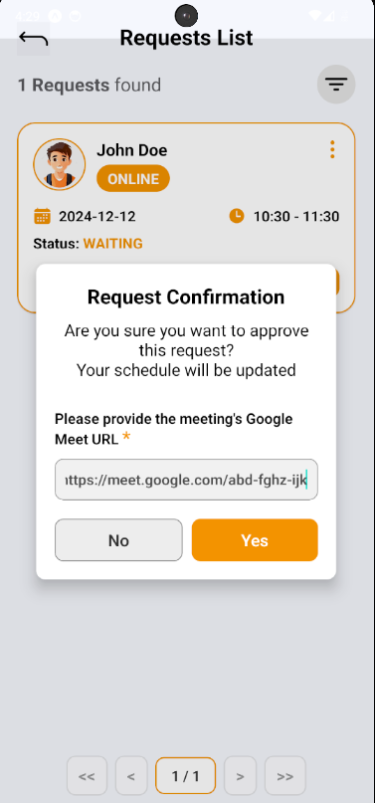

**Step 6:** After approving student request, student request’s status is updated to “APPROVED”, appointment and schedule of both student and counselor will update. To see appointment list, access though navigate to appointment section in Personal Screen.

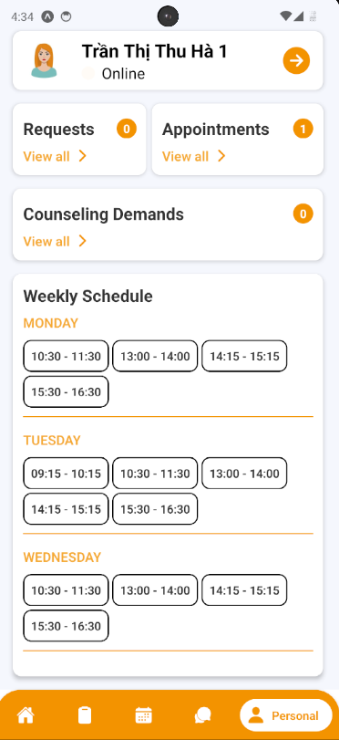

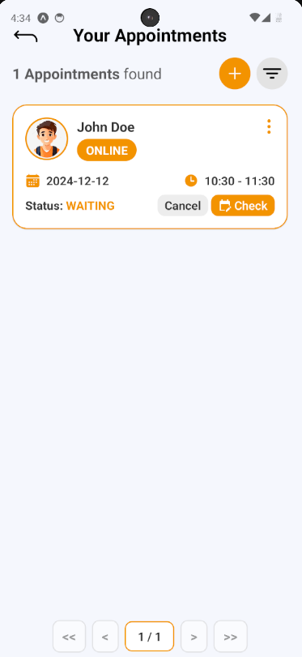

**Step 7:** Choose Tab number 3 (calendar icon) at the bottom of the screen to navigate to Schedule Screen to view appointment schedule

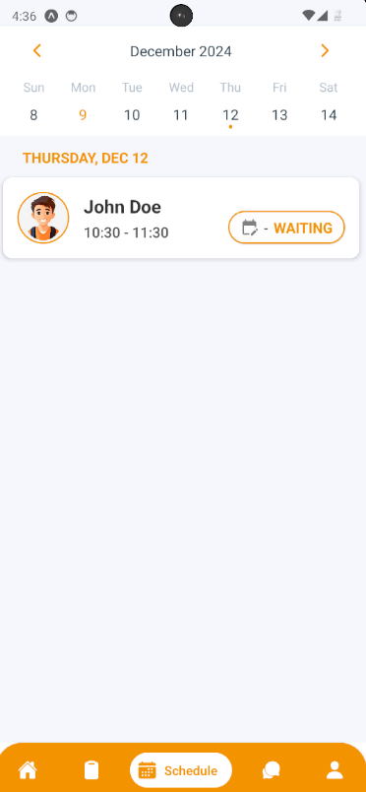

##### 3.3.2.4. Deny Appointment Request

3.3.2.4.1. Description

Use this guideline to log into the SCSS counselor account to deny student appointment request.

**Step 1:** Access SCSS at mobile application**.** Then fill in “Email” and “Password” of the counselor account



**Step 2:** Press “Login” Button



**Step 3:** From Home Screen:

Option 1: Choose Tab number 5 (personal icon) at the bottom of the screen to navigate to Personal Screen and from that screen will navigate to Request Screen

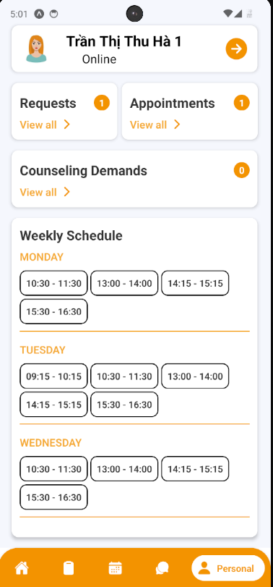

Option 2: For quick navigation, press View all at Pending Request to navigate to Request Screen

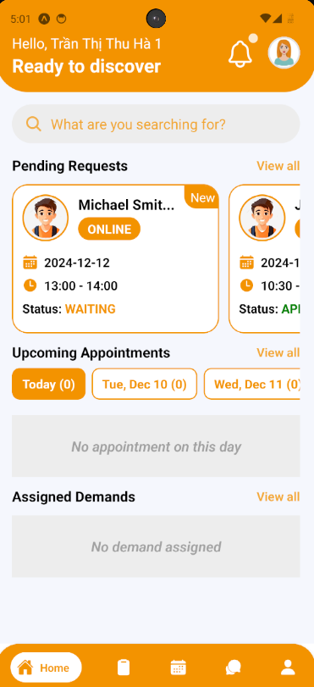

**Step 4:** In Request Screen, find a request using filter section by request date, meeting method, and status

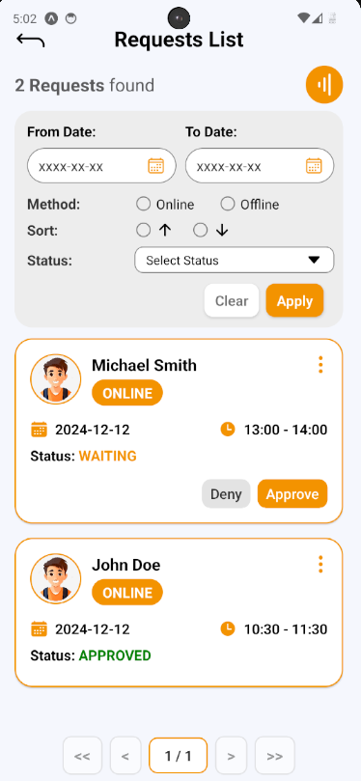

**Step 5:** After finding and considering student request, press Deny Button on request card, a request deny confirmation will open. Press “Yes” Button to deny request, and “No” Button to cancel confirmation

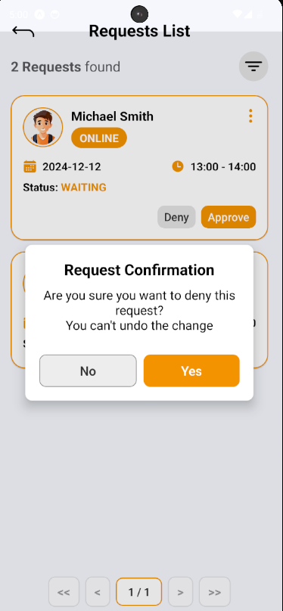

**Step 6:** After denying student request, student request’s status is updated to “DENIED”

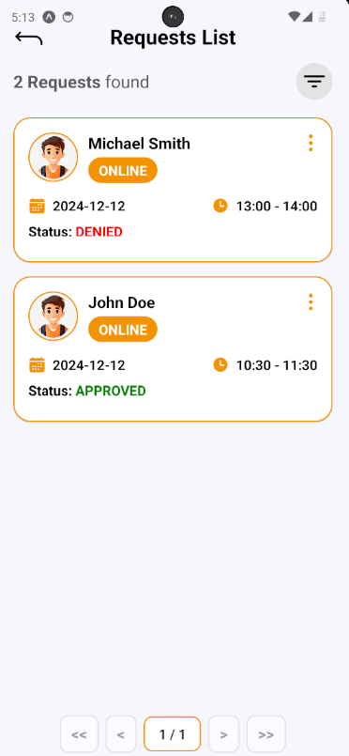

##### 3.3.2.5. Take Attendance for Appointment

3.3.2.5.1. Description

Use this guideline to log into the SCSS counselor account to take attendance for appointment

**Step 1:** Access SCSS at mobile application**.** Then fill in “Email” and “Password” of the counselor account



**Step 2:** Press “Login” Button



**Step 3:** From Home Screen:

Option 1: Choose Tab number 5 (personal icon) at the bottom of the screen to navigate to Personal Screen and from that screen will navigate to Appointment Screen

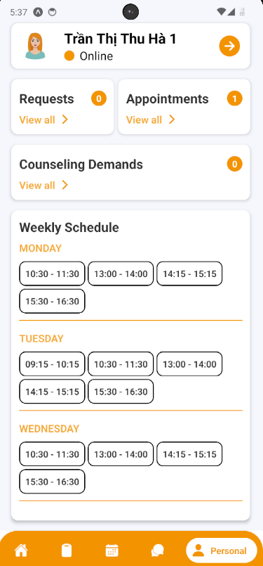

Option 2: For quick navigation, press View all at Upcoming Appointments to navigate to Appointment Screen



**Step 4:** In Appointment Screen, find an appointment using filter section by meeting date, and status

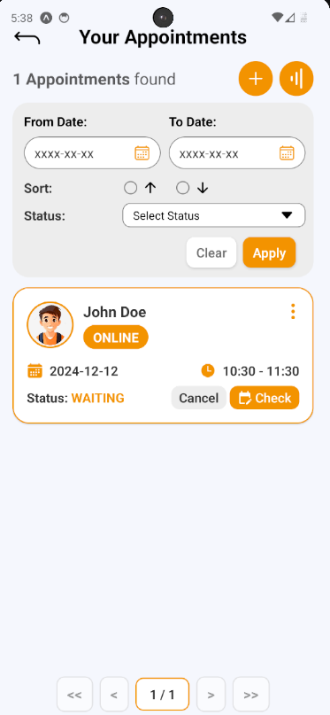

**Step 5:** After finding appointment, press “Check” Button to open Take Attendance section on appointment card, a take attendance confirmation will open. Press “ATTEND” or “ABSENT” to change status of chosen appointment

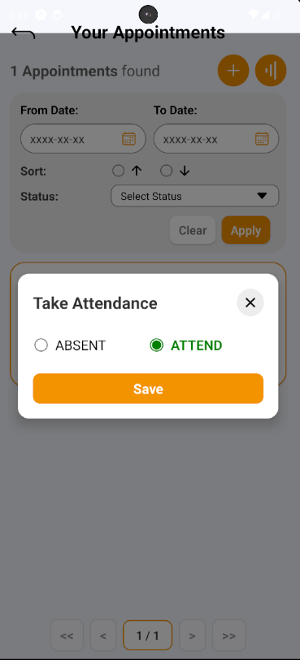

**Step 6:** After taking attendance, the status of appointment will change to “ATTEND” or “ABSENT”

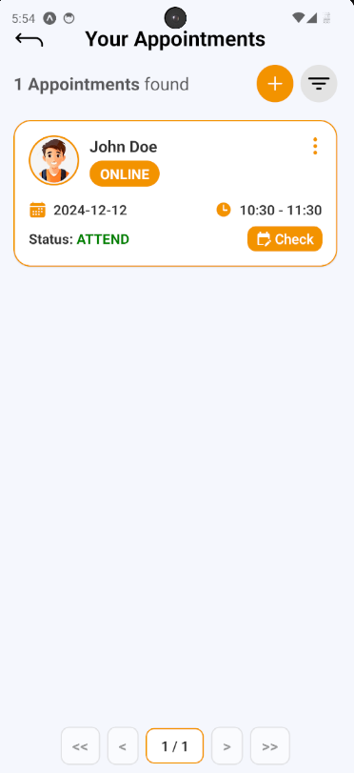

##### 3.3.2.6. Write Feedback for Appointment

3.3.2.6.1. Description

Use this guideline to log into the SCSS student account to write feedback for appointment

**Step 1:** Access SCSS at mobile application**.** Then fill in “Email” and “Password” of the student account



**Step 2:** Press “Login” Button



**Step 3:** From Home Screen:

Option 1: Choose Tab number 5 (personal icon) at the bottom of the screen to navigate to Personal Screen and from that screen will navigate to Appointment Screen

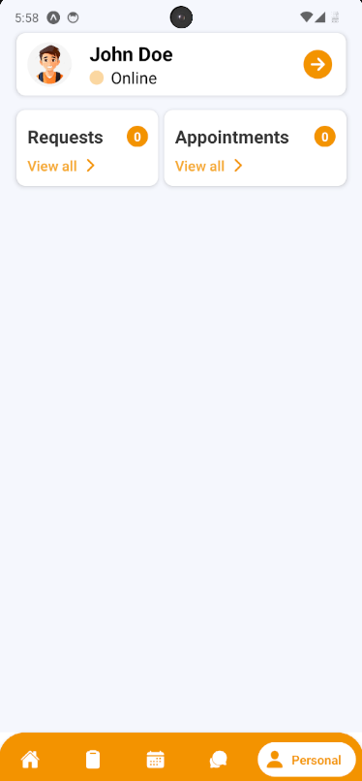

Option 2: For quick navigation, press View all at Upcoming Appointments to navigate to Appointment Screen

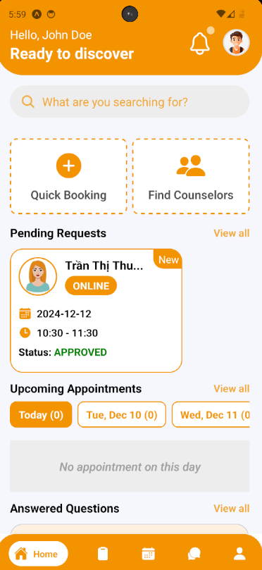

**Step 4:** In Appointment Screen, find an appointment using filter section by meeting date, and status

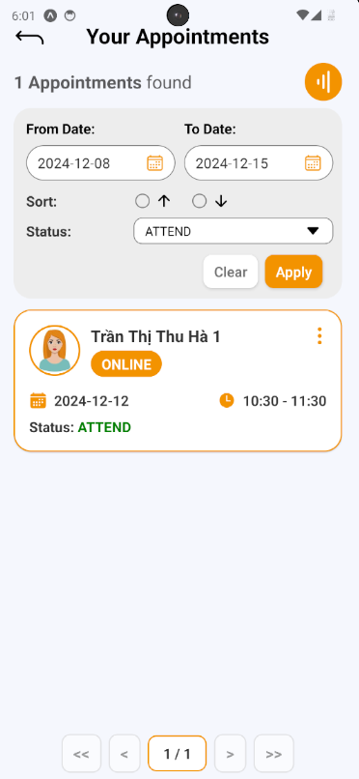

**Step 5:** After finding a appointment (which status is “ATTEND”), press Info Button (shown as “vertical-ellipsis” icon) to show that appointment information

**Step 6:** In that appointment information, there’s a section called “Leave a review”, press it and open “Write a review” confirmation.

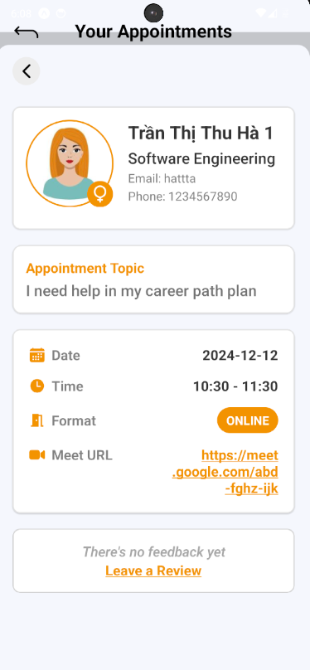

**Step 7:** Fill in feedback content include message and rating. Then submit it by pressing “Save” Button, or cancel by pressing “Cancel” Button

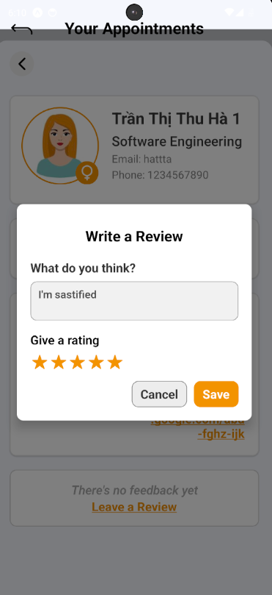

**Step 8:** View feedback after submitting in appointment information.

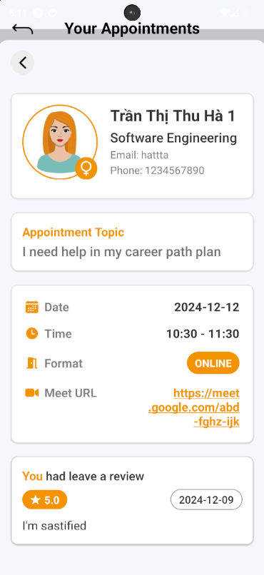

##### 3.3.2.7. Write Report for Appointment

3.3.2.7.1. Description

Use this guideline to log into the SCSS counselor account to write report for appointment

**Step 1:** Access SCSS at mobile application**.** Then fill in “Email” and “Password” of the counselor account



**Step 2:** Press “Login” Button



**Step 3:** From Home Screen:

Option 1: Choose Tab number 5 (personal icon) at the bottom of the screen to navigate to Personal Screen and from that screen will navigate to Appointment Screen 

Option 2: For quick navigation, press View all at Upcoming Appointments to navigate to Appointment Screen



**Step 4:** In Appointment Screen, find an appointment using filter section by meeting date, and status

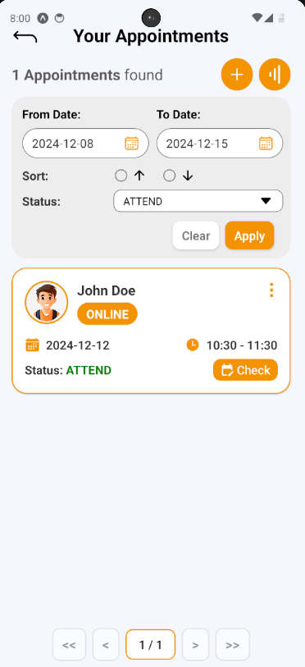

**Step 5:** After finding a appointment (which status is “ATTEND”), press Info Button (shown as “vertical-ellipsis” icon) to show that appointment information

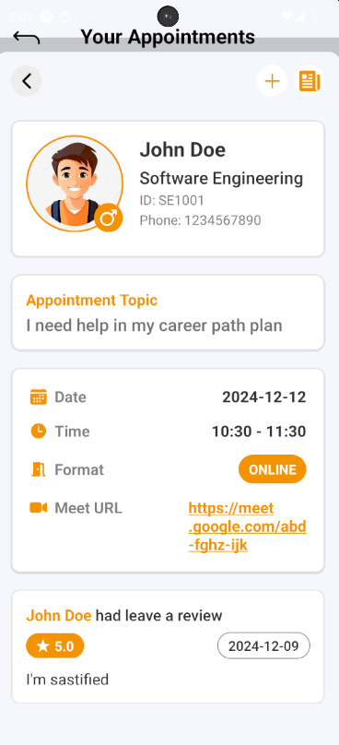

**Step 6:** After appointment information open, press “Add” Button (shown as an icon with the “+” symbol) to open Create Report section

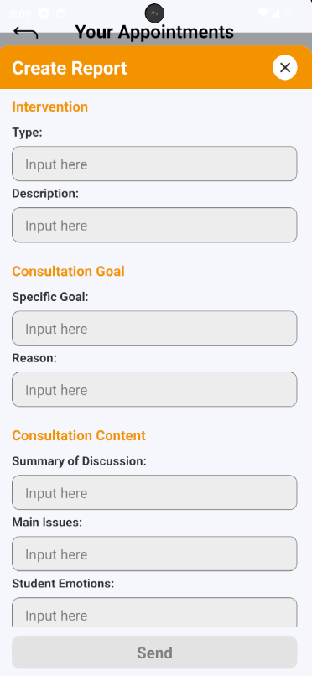

**Step 7:** After filling all required fields, press “Send” button to create report for chosen appointment

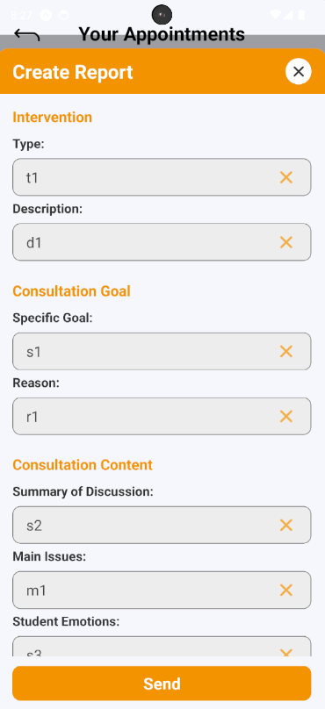

**Step 8:** After creating report successfully, press “Report” Button (shown as “newspaper” icon) to view appointment report



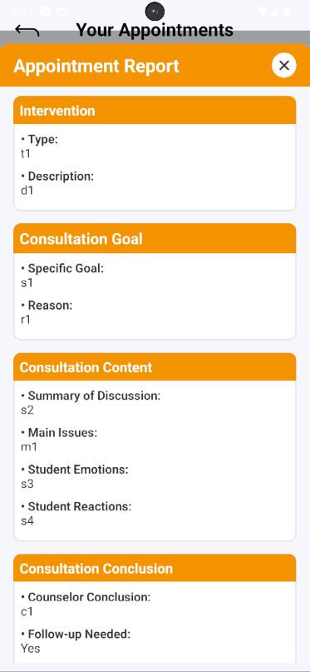

##### 3.3.2.8. Cancel Appointment

3.3.2.8.1. Description

Use this guideline to log into the SCSS student or counselor account to cancel an appointment

**Case 1:**

**Step 1:** Access SCSS at mobile application**.** Then fill in “Email” and “Password” of the student account



**Step 2:** Press “Login” Button



**Step 3:** From Home Screen:

Option 1: Choose Tab number 5 (personal icon) at the bottom of the screen to navigate to Personal Screen and from that screen will navigate to Appointment Screen

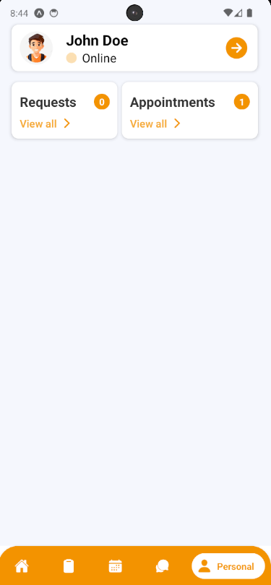

Option 2: For quick navigation, press View all at Upcoming Appointments to navigate to Appointment Screen

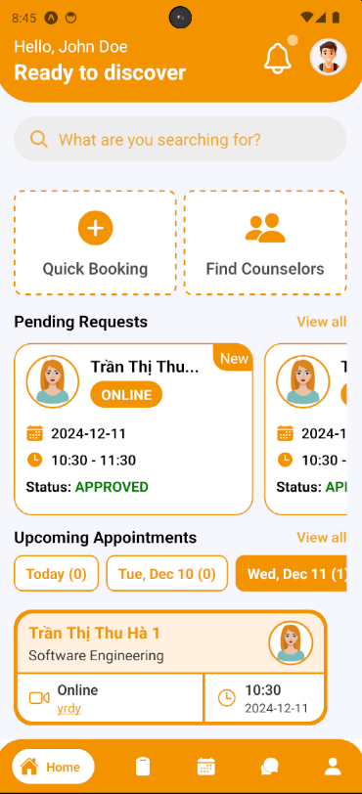

**Step 4:** In Appointment Screen, find an appointment using filter section by request date, and status

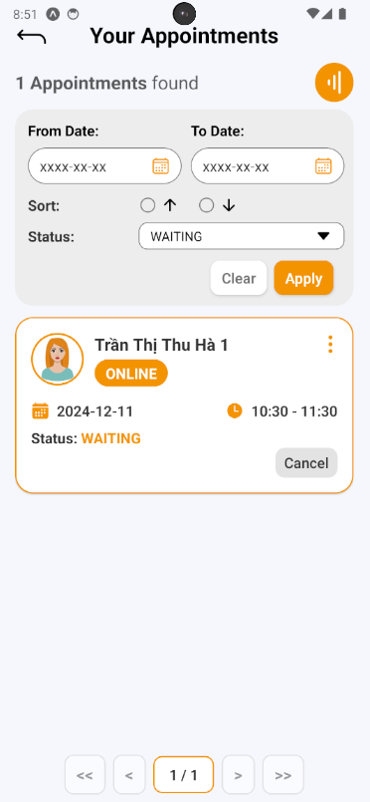

**Step 5:** After finding appointment, press “Cancel” Button to open Cancel Appointment section on appointment card, a cancel appointment confirmation will open. Fill in reason then press “Yes” Button to cancel appointment, and “No” Button to cancel confirmation

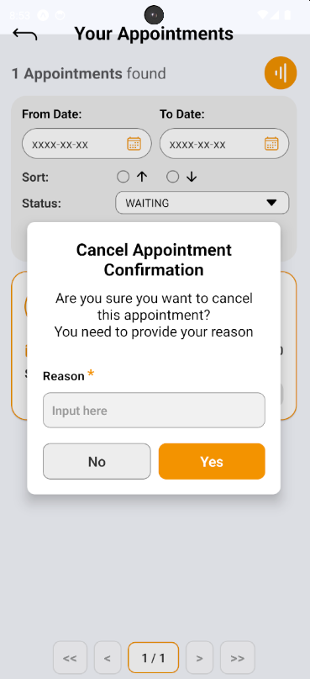

**Step 6:** After cancelling appointment successfully, the appointment’s status change to “CANCELED”, then press “Info” Button (shown as “vertical-ellipsis” icon) and view canceled reason

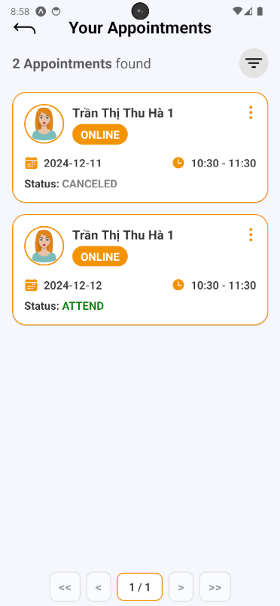

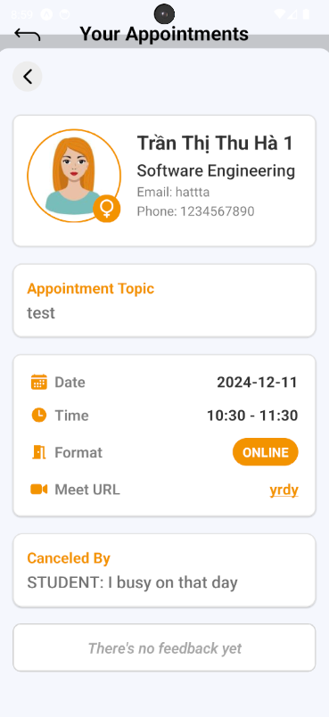

**Case 2:**

**Step 1:** Access SCSS at mobile application**.** Then fill in “Email” and “Password” of the counselor account



**Step 2:** Press “Login” Button



**Step 3:** From Home Screen:

Option 1: Choose Tab number 5 (personal icon) at the bottom of the screen to navigate to Personal Screen and from that screen will navigate to Appointment Screen

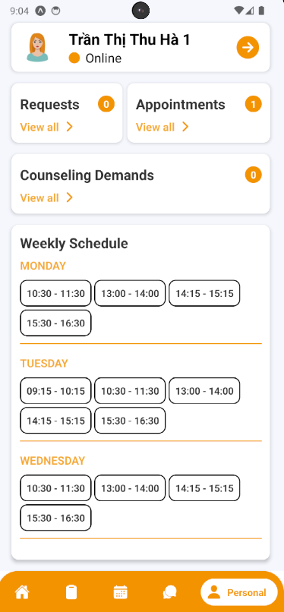

Option 2: For quick navigation, press View all at Upcoming Appointments to navigate to Appointment Screen

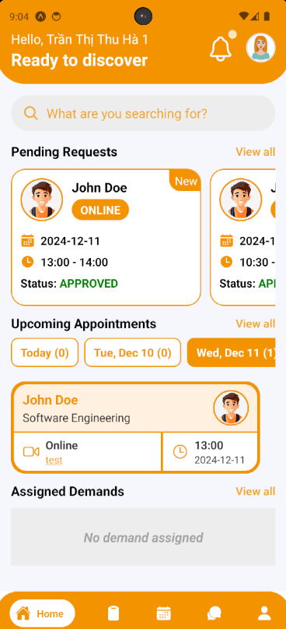

**Step 4:** In Appointment Screen, find an appointment using filter section by request date, and status

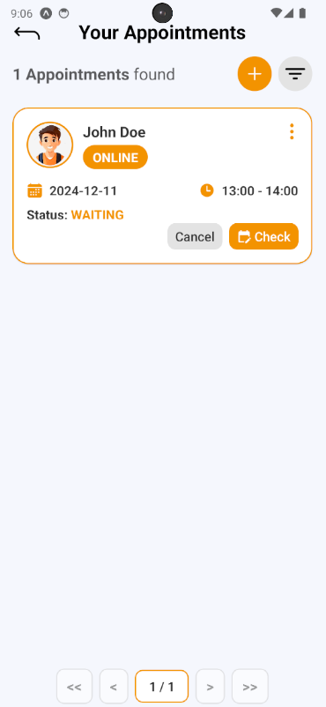

**Step 5:** After finding appointment, press “Cancel” Button to open Cancel Appointment section on appointment card, a cancel appointment confirmation will open. Fill in reason then press “Yes” Button to cancel appointment, and “No” Button to cancel confirmation

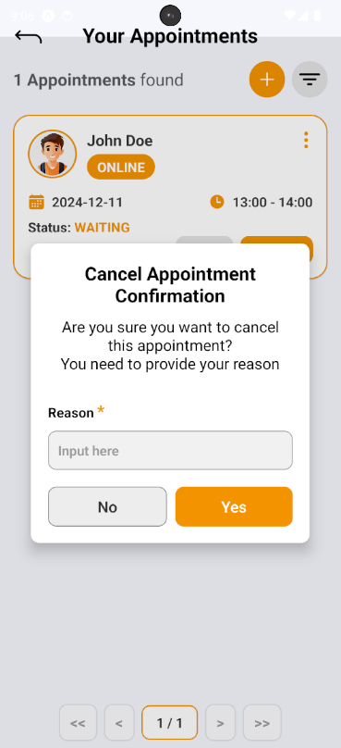

**Step 6:** After cancelling appointment successfully, the appointment’s status change to “CANCELED”, then press “Info” Button (shown as “vertical-ellipsis” icon) and view canceled reason

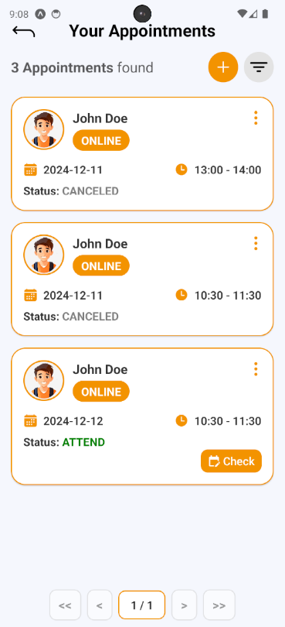

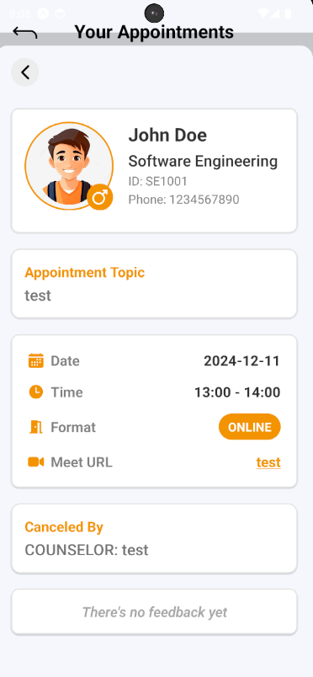

#### 3.3.3. Question and Answer

##### 3.3.3.1. Create a question

3.3.3.1.1. Description

Use this guideline to create a question for the counselor

3.3.3.1.2. Guide Steps:

**Step 1:** Access SCSS at mobile application**.** Then fill in “Email” and “Password” of the student account



**Step 2:** Press “Login” Button



**Step 3:** From Home Screen, choose Tab number 4 (chat-bubble icon) at the bottom of the screen to navigate to My Q&A Screen

.

**Step 4:** In My Q&A Screen, press “Add” button (shown as an icon with the “+” symbol) to open Create Question section

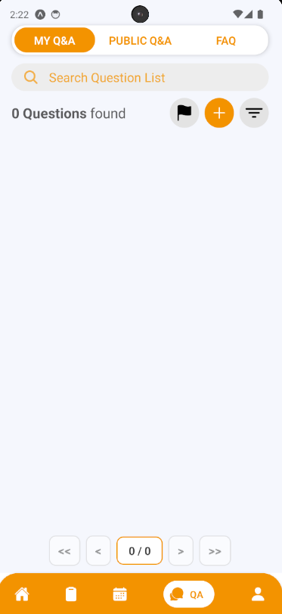

**Step 5:** Choose the question type and fill in the question title, content if there are similar questions, it will be suggested to students before submitting in case there are duplicate question. Then after fill all required fields, press “Create Question” Button

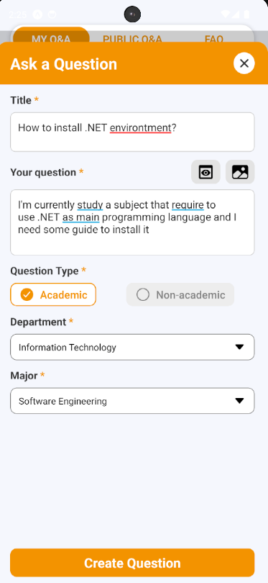

**Step 6:** View a list of suggestion questions that similar to your question, if you don’t find satisfied answer, press “Continue to Proceed?” button

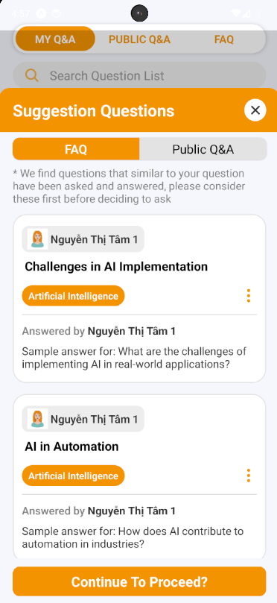

**Step 7:** A confirmation will open, press “Yes” to create question

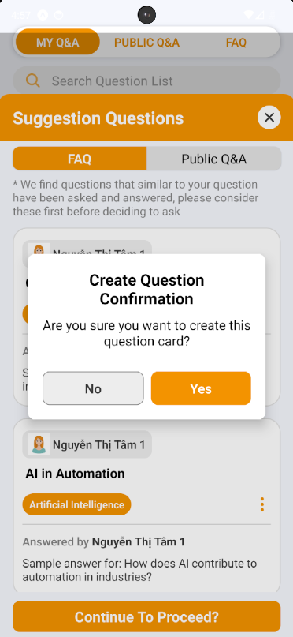

**Step 8:** View your created question, and information of counselor that currently in charge of this question.

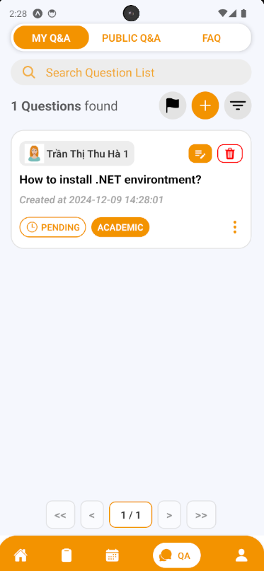

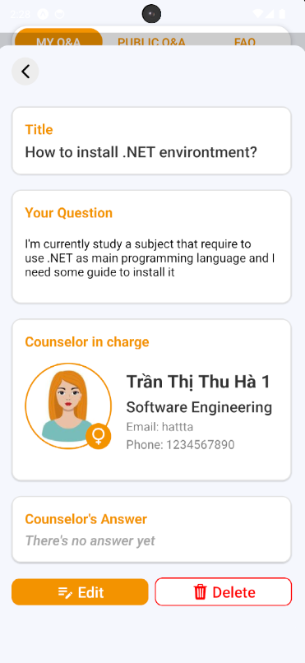

##### 3.3.3.2. Edit a question

3.3.3.2.1. Description

Use this guideline to edit your question’s content

3.3.3.2.2. Guide Steps:

**Step 1:** Access SCSS at mobile application with student account**.** Navigate to My Q&A screen, and press “Edit” (shown as “pencil-note” icon) to open Edit Question section that lay on the question card, or inside the information of question card





**Step 2:** You can see current question information inside these input field and you can change it (some fields are required, so it can not empty). Then after fill all required fields, press “Edit” Button.

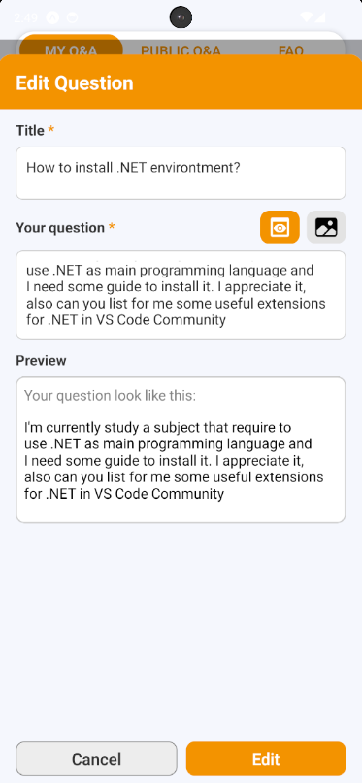

**Step 3:** View your question after editing.

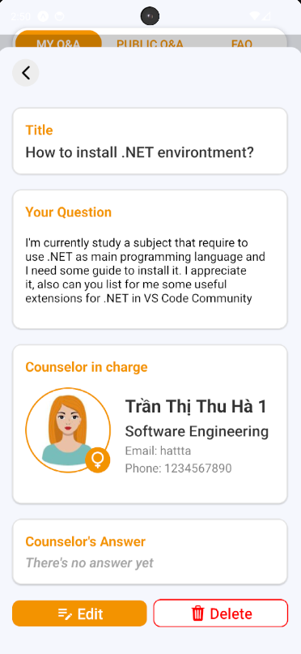

##### 3.3.3.3. Delete a question

3.3.3.3.1. Description

Use this guideline to delete your question

3.3.3.3.2. Guide Steps:

**Step 1:** Access SCSS at mobile application with student account**.** Navigate to My Q&A screen, and press “Delete” (shown as an icon with the “trash” symbol) to open Delete Question section that lay on the question card, or inside the information of question card





**Step 2:** After pressing, Delete Question Confirmation will open. If you want to delete your question press “Yes” Button to delete it, and “No” Button if not. After deleting successfully, that question will be disappear of My Q&A screen

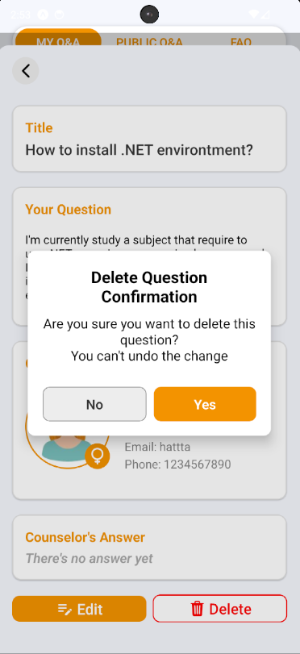

##### 3.3.3.4. Answer a question

3.3.3.4.1. Description

Use this guideline to answer a question

3.3.3.4.2. Guide Steps:

**Step 1:** Access SCSS at mobile application**.** Then fill in “Email” and “Password” of the counselor account



**Step 2:** Press “Login” Button



**Step 3:** From Home Screen, choose Tab number 4 (chat-bubble icon) at the bottom of the screen to navigate to My Q&A Screen

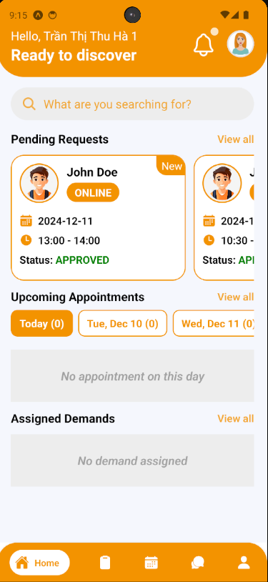

**Step 4:** In My Q&A Screen, find a question using filter section by student code

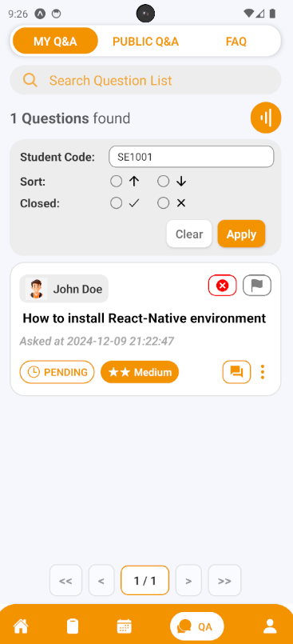

**Step 5:** After finding question, press “Answer” Button (shown as “text-box” icon) to open Answer Question section.

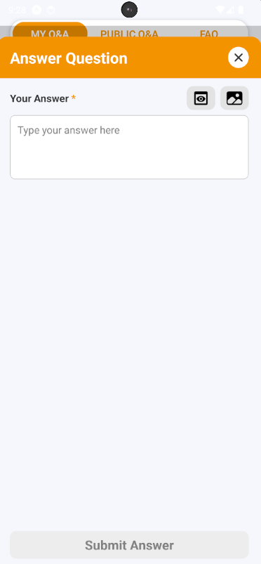

**Step 6:** After filling answer, press “Submit Answer” Button to submit answer for the chosen question

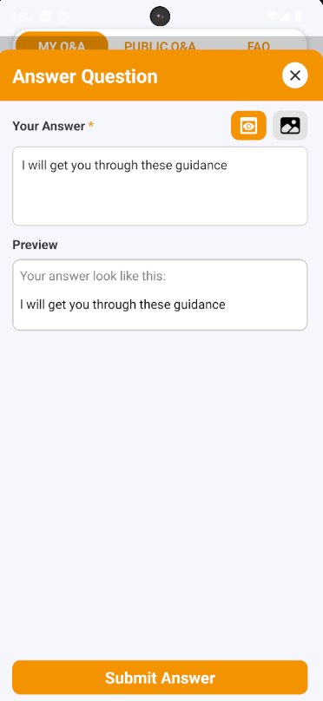

**Step 6:** After answering question, view your answer on the question card or by pressing “Info” Button (shown as “vertical-ellipsis” icon ) to show question information

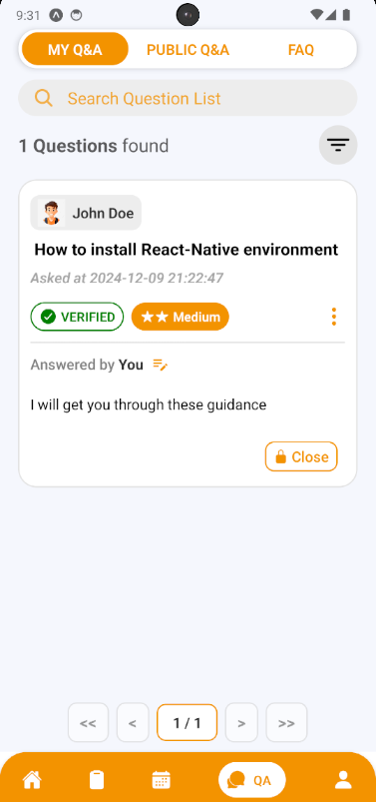

##### 3.3.3.5. Edit Answer of a question

3.3.3.5.1. Description

Use this guideline to edit answer of a question

3.3.3.5.2. Guide Steps:

**Step 1:** Access SCSS at mobile application with counselor account**.** Navigate to My Q&A screen, and press “Edit” (shown as “pencil” icon) to open Edit Answer section that lay on the question card



**Step 2:** You can see current answer information inside this input field and you can change it (this field is required, so it can not empty). Then after fill all required fields, press “Edit” Button.

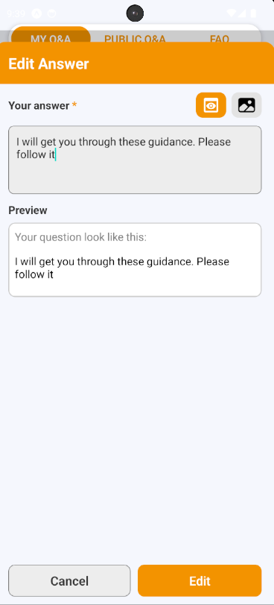

**Step 3:** View your answer after editing.

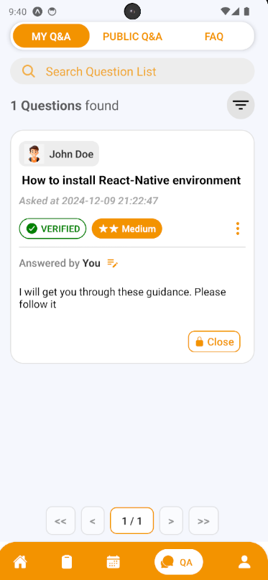

##### 3.3.3.6. Create a chat session

3.3.3.6.1. Description

Use this guideline to create a chat session for your question

3.3.3.6.2. Guide Steps:

**Step 1:** Access SCSS at mobile application with student account**.** Navigate to My Q&A screen, and press “Start a chat” (shown as “chat-bubble” icon) to open Create Chat Session section that lay on the question card (this button will only show when this question is verified and has already answered by counselor in charge)

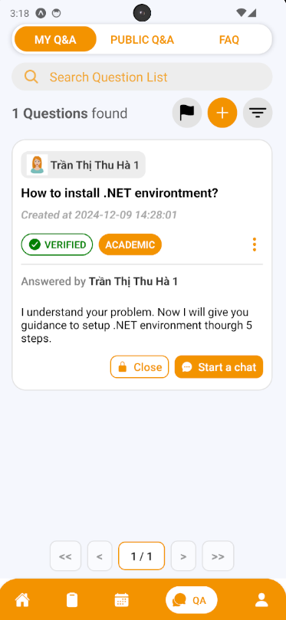

**Step 2:** After pressing, Start a Conversation Session Confirmation will open. If you want to start a chat inside your question press “Yes” Button to create it, and “No” Button if not. After creating successfully, that chat session will show on the screen and can be open through Chat Button.

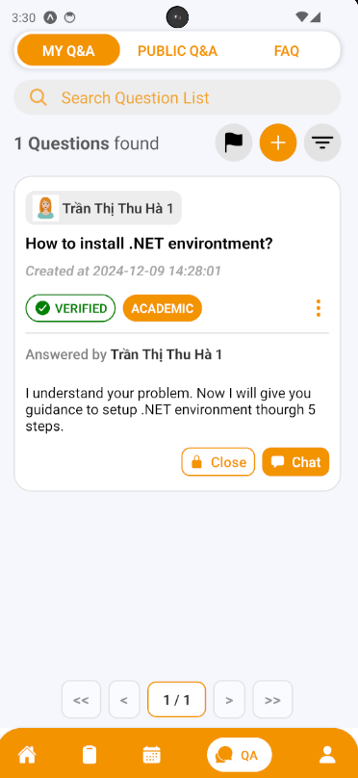

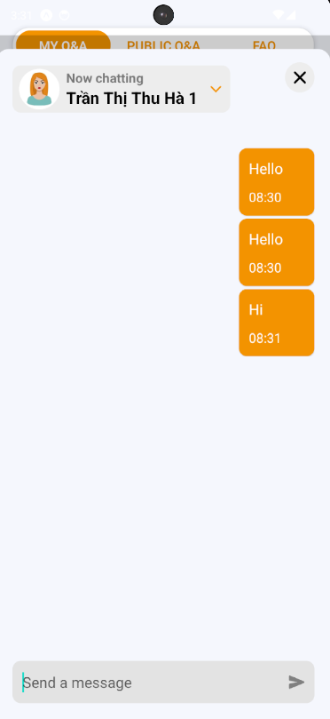

##### 3.3.3.7. Accept a question’s answer

3.3.3.7.1. Description

Use this guideline to close your question

3.3.3.7.2. Guide Steps:

**Step 1:** Access SCSS at mobile application with student account**.** Navigate to My Q&A screen, and press “Accept Answer” to open Accept Answer section that lay on the question card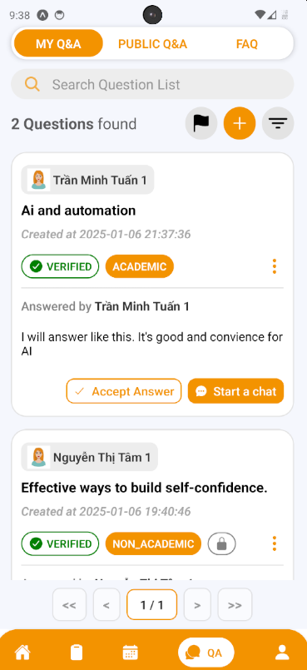

**Step 2:** After pressing, Accept Answer Confirmation will open. If you want to accept the question’s answer press “Yes” Button to accept it, and “No” Button if not.

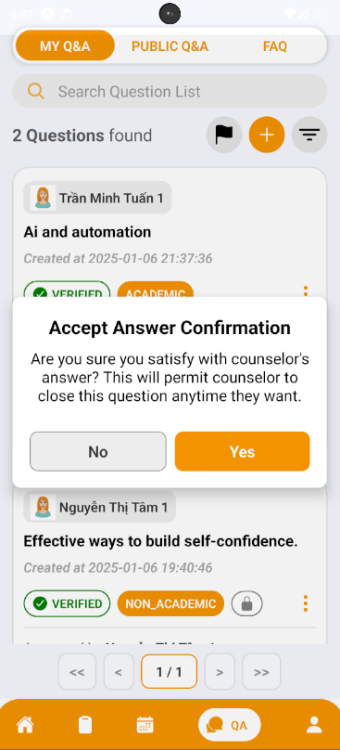

**Step 3:**  After accepting answer, Counselor will receive accepted question’s answer from Student, then Counselor can ready to close question

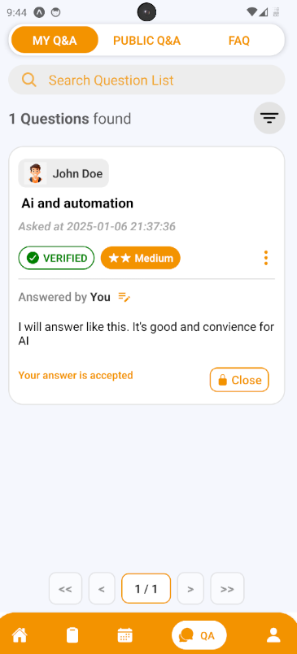

##### 3.3.3.8. Close a question

3.3.3.8.1. Description

Use this guideline to close your question

3.3.3.8.2. Guide Steps:

**Case 1:**

**Step 1:** Access SCSS at mobile application with student account**.** Navigate to My Q&A screen, and press “Close” (shown as “lock” icon) to open Close Question section that lay on the question card, or inside the information of question card



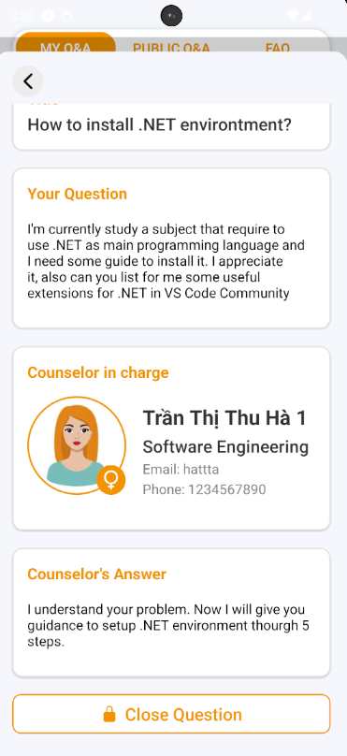

**Step 2:** After pressing, Close Question Confirmation will open. If you want to close your question press “Yes” Button to close it, and “No” Button if not.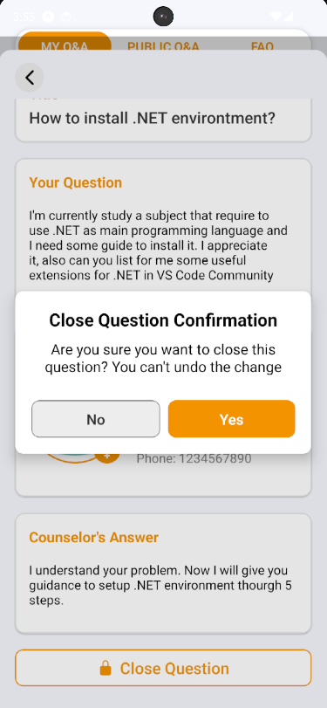

**Step 3:**  After closing successfully, that question will be closed, and cannot chat anymore

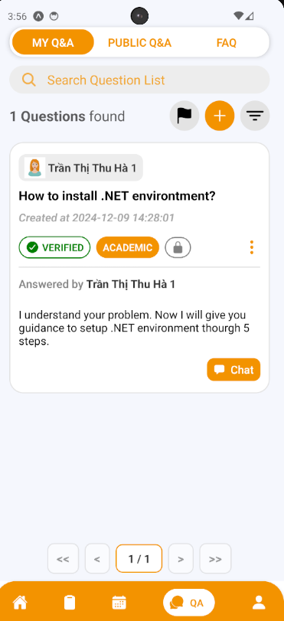

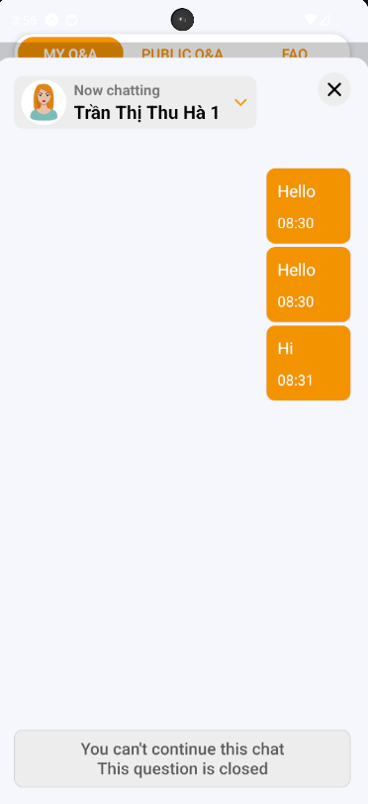

**Case 2:**

**Step 1:** Access SCSS at mobile application with counselor account**.** Navigate to My Q&A screen, and press “Close” (shown as “lock” icon) to open Close Question section that lay on the question card, or inside the information of question card

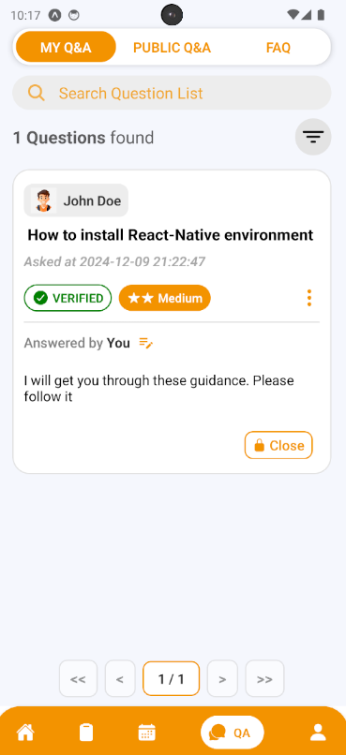

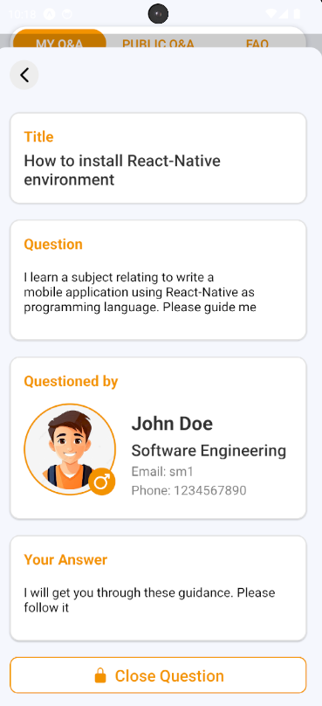

**Step 2:** After pressing, Close Question Confirmation will open. If you want to close your question press “Yes” Button to close it, and “No” Button if not.

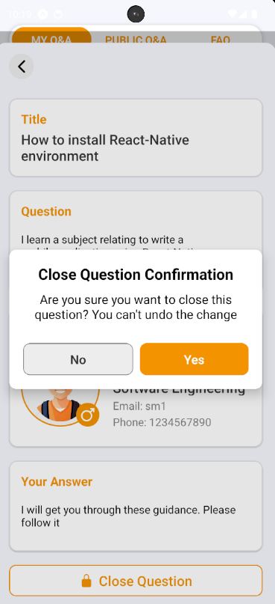

**Step 3:**  After closing successfully, that question will be closed, and cannot chat anymore

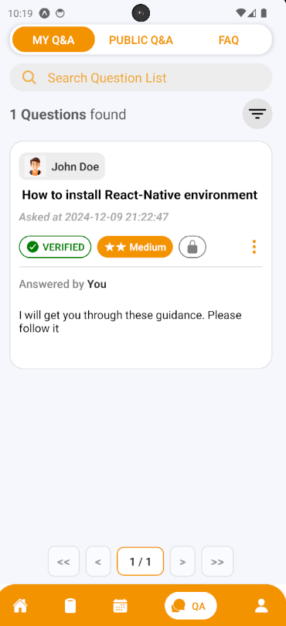

##### 3.3.3.9. Create a contribution question

3.3.3.9.1. Description

Use this guideline to create a contribution question

3.3.3.9.2. Guide Steps:

**Step 1:** Access SCSS at mobile application**.** Then fill in “Email” and “Password” of the counselor account



**Step 2:** Press “Login” Button



**Step 3:** From Home Screen, choose Tab number 4 (chat-bubble icon) at the bottom of the screen to navigate to My Q&A Screen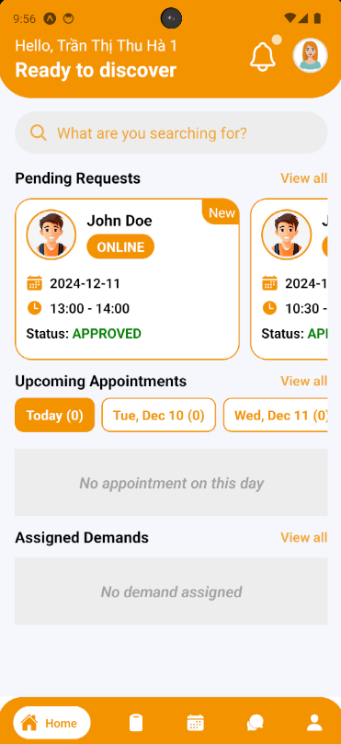

**Step 4:** In My Q&A Screen, swipe to the right to navigate to FAQ Screen

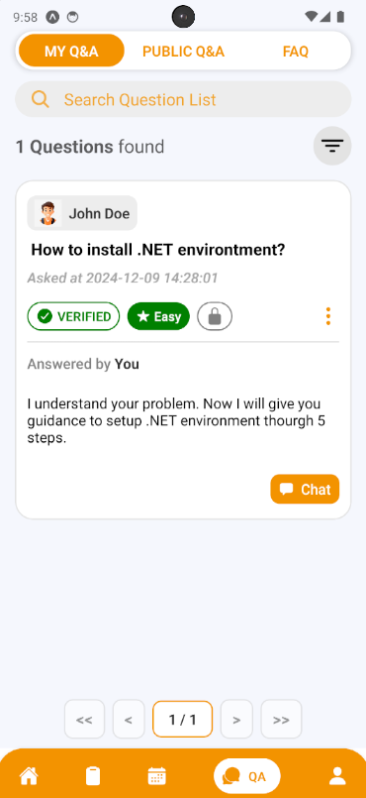

**Step 5:** In FAQ Screen, press “Add” button (shown as an icon with the “+” symbol) to open Contribute Question section

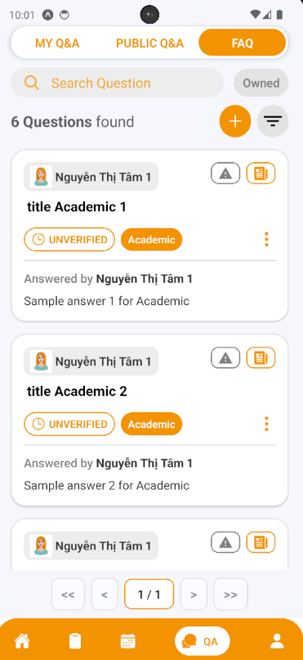

**Step 6:** Choose the question type and fill in the question title, content, category and answer if there are similar questions, it will be suggested to students before submitting in case there are duplicate question. Then after fill all required fields, press “Create Question” Button

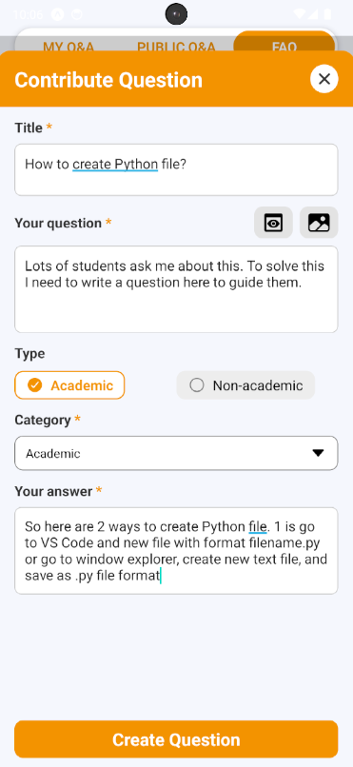

**Step 7:** View your created question, and information of this question.

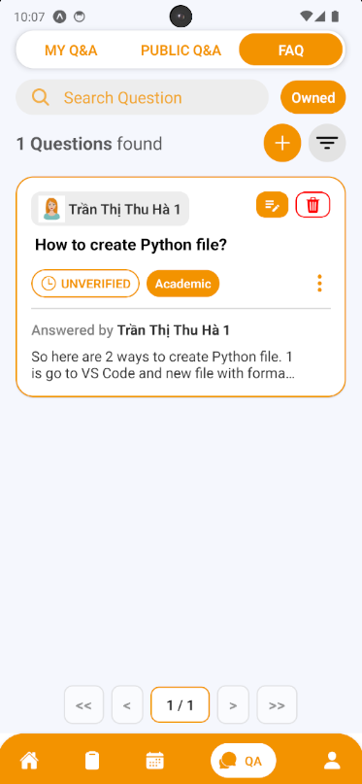

##### 3.3.3.10. Edit a contribution question

3.3.3.10.1. Description

Use this guideline to edit your contribution question

3.3.3.10.2. Guide Steps:

**Step 1:** Access SCSS at mobile application with counselor account**.** Navigate to My Q&A screen, then swipe to the right to navigate to FAQ Screen and press “Edit” (shown as “pencil-note” icon) to open Edit Question section that lay on the question card, or inside the information of question card

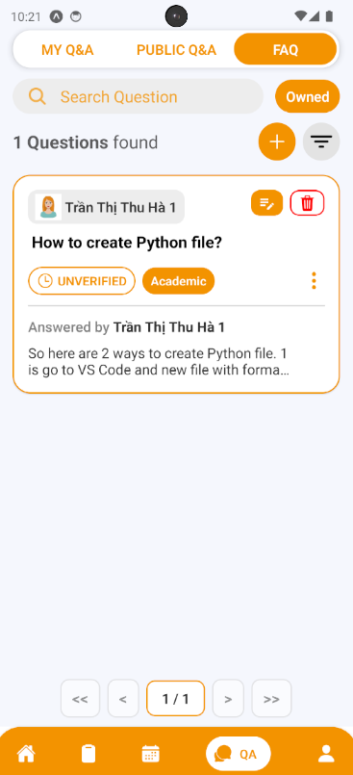

**Step 2:** You can see current question information inside these input field and you can change it (some fields are required, so it can not empty). Then after fill all required fields, press “Edit” Button.

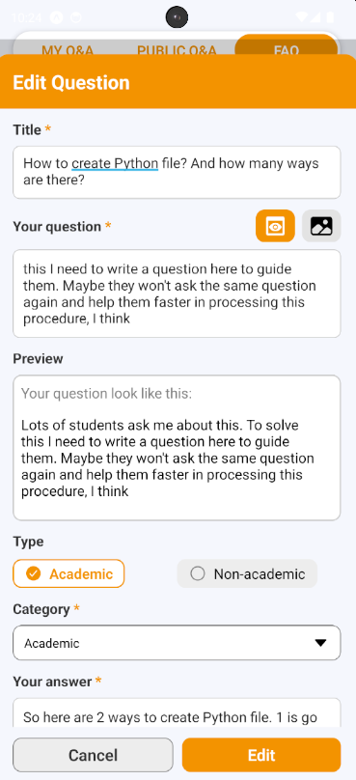

**Step 3:** View your question after editing.

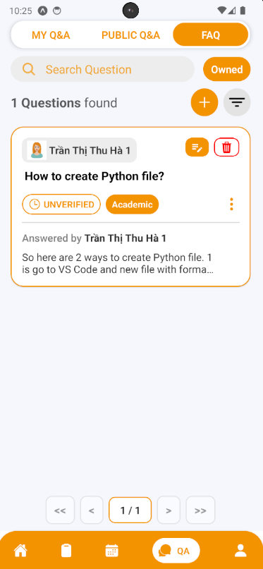

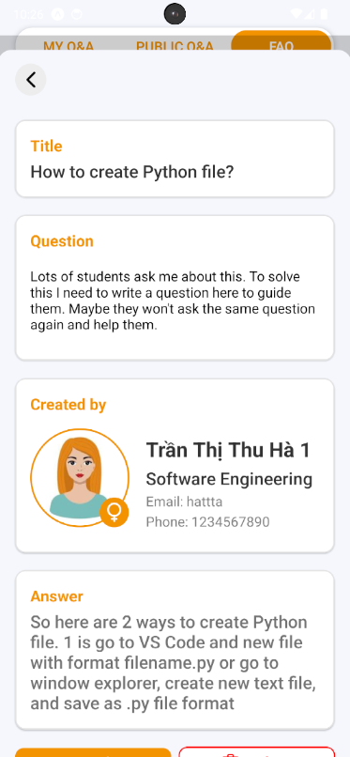

##### 3.3.3.11. Delete a contribution question

3.3.3.11.1. Description

Use this guideline to delete your contribution question

3.3.3.11.2. Guide Steps:

**Step 1:** Access SCSS at mobile application with counselor account**.** Navigate to My Q&A screen, then swipe to the right to navigate to FAQ Screen and press “Delete” (shown as an icon with the “trash” symbol) to open Delete Question section that lay on the question card, or inside the information of question card

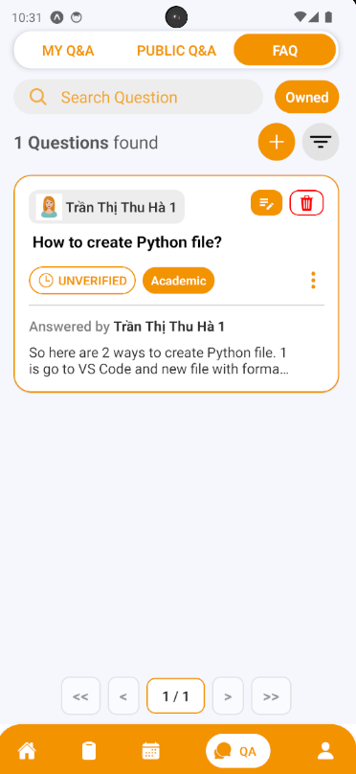

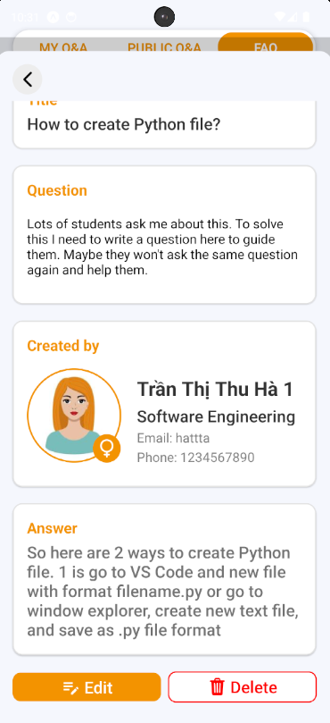

**Step 2:** After pressing, Delete Question Confirmation will open. If you want to delete your question press “Yes” Button to delete it, and “No” Button if not. After deleting successfully, that question will be disappear of FAQ screen

#### 3.3.4. Counseling Demands

##### 3.3.4.1. View Demands List

3.3.4.1.1. Description

Use this guideline to view demands list that assigned to specific counselor

3.3.4.1.2. Guide Steps:

**Step 1:** Access SCSS at mobile application**.** Then fill in “Email” and “Password” of the counselor account



**Step 2:** Press “Login” Button



Option 1: Choose Tab number 5 (personal icon) at the bottom of the screen to navigate to Personal Screen and from that screen will navigate to Counseling Demands Screen

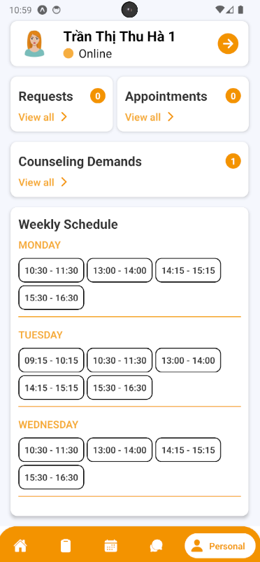

Option 2: For quick navigation, press View all at Assigned to navigate to Counseling Demands Screen

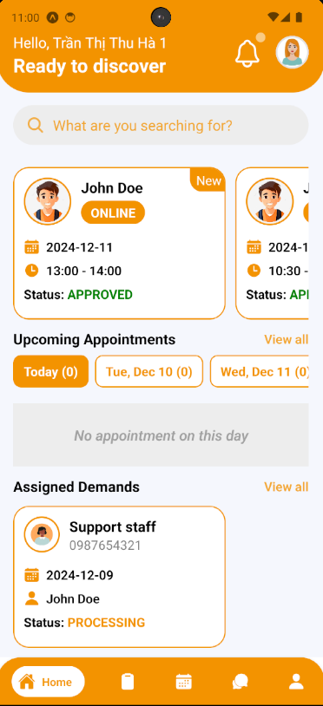

**Step 4:** In Counseling Demands Screen, find a demand using filter section by status

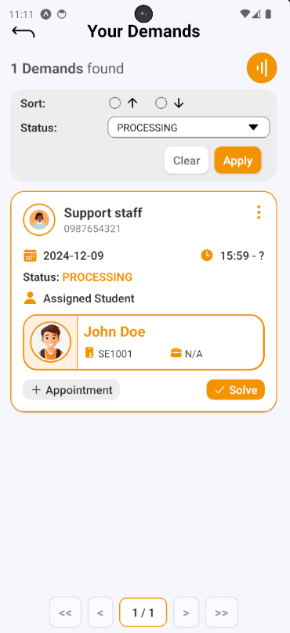

##### 3.3.4.2. Create Appointment through Demand

3.3.4.2.1. Description

Use this guideline to create appointment through demand

3.3.4.2.2. Guide Steps:

**Step 1:** After finding demand, press “Create Appointment” Button on demand card to open Create Appointment section.



**Step 2:** Filling all required fields including date, time, meeting method, Meet Url/Address, Purpose and Student information (assigned through demand). After filling done, press “Create Appointment” Button to create appointment.

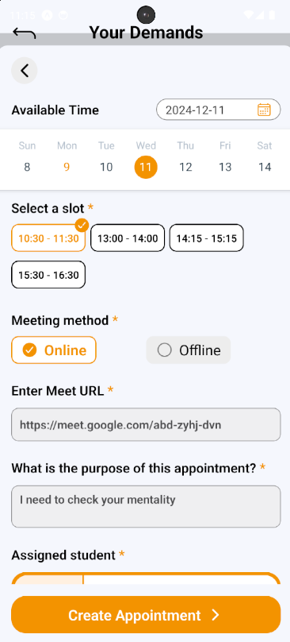

**Step 3:** View new appointment created in Appointment Screen

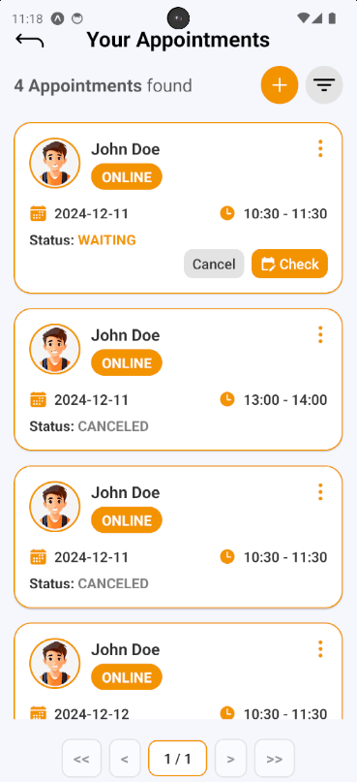

##### 3.3.4.3. Solve Demand

3.3.4.3.1. Description

Use this guideline to solve demand

3.3.4.3.2. Guide Steps:

**Step 1:** After finding demand, press “Solve” Button on demand card to open Solve Demand section.

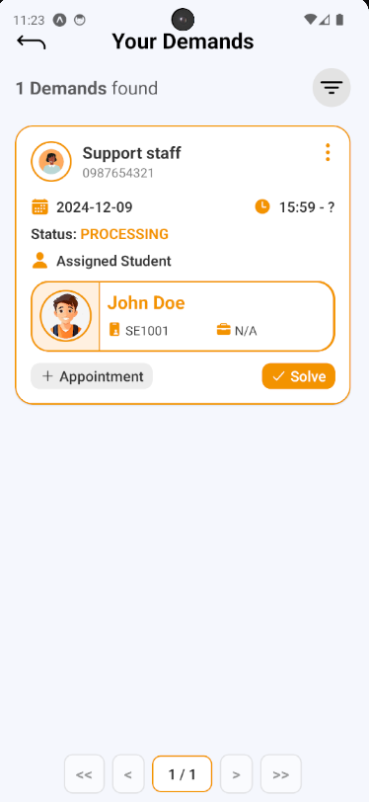

**Step 2:** After pressing, a Solve Demand Confirmation will open, fill your note, then press “Yes” Button to solve this demand, and “No” Button to cancel solve

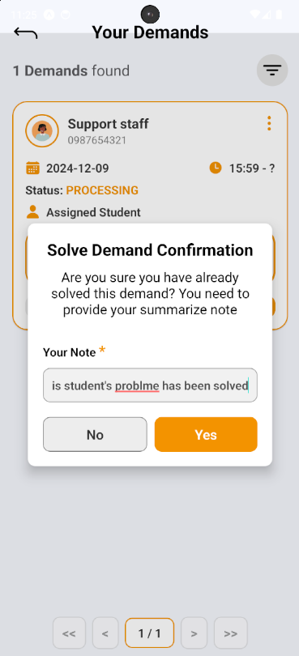

**Step 3:** The solved demand will be marked with “DONE” status

